**SUPPORTING INFORMATION FOR**

**Complete mineralization of acetic acid using catalytic ozonation with a high energy efficiency enhanced by MnO2/γ-Al2O3**

Ruiyun Meng1 • Shuiliang Yao 1,2,* • Erhao Gao 1,2 • Zuliang Wu 1,2 • Jing Li 1,2 • Erdeng Du1

1 School of Environmental and Safety Engineering, Changzhou University, Jiangsu 213164, China

2 Advanced Plasma Catalysis Engineering Laboratory for China Petrochemical Industry, Jiangsu 213164, China

**\*Corresponding author**

**Shuiliang Yao**

School of Environmental and Safety Engineering

Changzhou University

No. 21, Gehu Middle Road, Wujin District, Changzhou, Jiangsu 213164

People’s Republic of China

Email: yaos@cczu.edu.cu (Yao S)

Phone: +13738109696

**S1: Additional experimental results**



**Fig. S1** O3 concentration and O3 concentration drop as a function of time during acetic acid ozonation without a catalyst



**Fig. S2** Influence of ozonation temperature on acetic acid degradation without catalyst. Experimental condition: acetic acid concentration: 1.0 g L–1, initial pH: 3.42, O3 concentration: 30.0-40.0 g Nm–3



**Fig. S3** O3 concentration drops at various ozonation time (a) and at different ozonation temperatures (b). Experimental condition: with catalyst as per Fig. 4g; without catalyst as per Fig. S2



**Fig. S4** The influence of initial pH on the energy efficiency of acetic acid. Experimental condition: acetic acid concentration: 1.0 g L–1, 3.0 g 1.0wt.% MnO2/γ-Al2O3 catalyst dosage, 30.0-40.0 g Nm–3 O3 concentration, 25 °C ozonation temperature

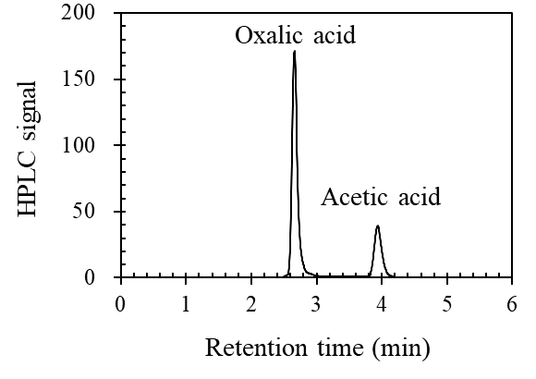

**Fig. S5** HPLC spectrum of a liquid sample after 120-min acetic acid ozonation