Supporting Table 1: Comparison of rural-urban classification indexes: United States, Midwest, and Wisconsin. Rural-Urban classification indexes in use in current cancer research and the amount and percentage of total land area, number of geographical units, and population that each index allocates to urban and rural codes. Indexes include: Urban Rural Classification of Urban Areas and Urban Clusters (UACE), Frontier and Remote Area Codes (FAR), Rural-Urban Commuting Area (RUCA), ZIP Code Tabulation Area Rural-Urban Commuting Area (RUCA(z)), Rural-Urban Continuum Codes (RUCC), Urban Influence Codes (UIC), National Center for Health Statistics (NCHS) Urban-Rural Classification Scheme for Counties, Core Based Statistical Areas (CBSA), and Index of Relative Rurality (IRR). RUCA codes are divided into rural and urban groupings based on 2 separate processes, represented as option 1 and option 2 for each the census-tract and ZCTA-based codes. The year in parentheses indicates the version of the index that was used. Midwest states include North Dakota, South Dakota, Nebraska, Kansas, Minnesota, Iowa, Missouri, Wisconsin, Illinois, Michigan, Indiana, and Ohio.

Supporting Table 1: Comparison of rural-urban classification indexes: United States, Midwest, and Wisconsin.
 |  |  |  |  | Land Area (square miles) |  |  |  | Geographical Units |  |  |  | Total Population
 |  |  |  |  | Urban |  | Rural |  | Urban |  | Rural |  | Urban |  | Rural
Index | Geographical Unit | Urban Codes | Rural Codes | Region | Square Miles | % of Total | Square Miles | % of Total | Count | % of Total | Count | % of Total | Total | % of Total | Total | % of Total | Papers
UACE  (2010) | Census Blocks | Urban Area  Urban Cluster | None | USA | 106,386 | 3.0% | 3,425,519 | 97.0% |  |  |  |  | 249,253,271 | 80.7% | 59,492,267 | 19.3% | Johnson 2016¹  Pruitt 2015²  Virani 2011³
 |  |  |  | Midwest | 23,013 | 3.1% | 727,510 | 96.9% |  |  |  |  | 50,771,646 | 75.9% | 16,155,355 | 24.1%
 |  |  |  | Wisconsin | 1,879 | 3.5% | 52,279 | 96.5% |  |  |  |  | 3,989,638 | 70.2% | 1,697,348 | 29.9%
FAR  (2010) | ZIP/  0.5^2  km grid | None | 1-4 | USA | 1,725,471 | 48.0% | 1,868,901 | 52.0% | 25,008 | 82.4% | 5,329 | 17.6% | 296,083,828 | 96.1% | 12,156,019 | 3.9% | Pruitt 2015²
 |  |  |  | Midwest | 419,503 | 54.7% | 347,517 | 45.3% | 7175 | 76.8% | 2172 | 23.2% | 62,923,209 | 94.1% | 3,955,309 | 5.9%
 |  |  |  | Wisconsin | 43,892 | 78.2% | 12,214 | 21.8% | 629 | 86.8% | 96 | 13.2% | 5,497,147 | 96.8% | 182,725 | 3.2%
RUCA  (2010)  (option 1) | Census  Tract | 1-3 | 4-10 | USA | 847,792 | 24.0% | 2,683,986 | 76.0% | 59,389 | 81.3% | 13,390 | 18.3% | 257,810,493 | 83.5% | 50,935,045 | 16.5% | Onega 2017⁴  Cetnar 2013⁵  White 2011⁶
 |  |  |  | Midwest | 170,061 | 22.7% | 580,432 | 77.3% | 12604 | 74.1% | 4409 | 25.9% | 50,817,496 | 75.9% | 16,109,505 | 24.1%
 |  |  |  | Wisconsin | 15,689 | 29.0% | 38,469 | 71.0% | 971 | 68.9% | 423 | 30.0% | 4,045,911 | 71.1% | 1,641,075 | 28.9%
RUCA  (2010)  (option 2) | Census  Tract | 1.0, 1.1, 2.0, 2.1, 3.0, 4.1, 5.1, 7.1, 8.1, and 10.1 | Others | USA | 921,261 | 26.1% | 2,610,517 | 73.9% | 60,026 | 82.5% | 12,753 | 17.5% | 260,671,526 | 84.4% | 48,074,012 | 15.6% | Bradley 2020⁷  Yaghjyan 2019
 |  |  |  | Midwest | 184,952 | 24.6% | 565,542 | 75.4% | 12743 | 74.9% | 4270 | 25.1% | 51,408,846 | 76.8% | 15,518,155 | 23.2%
 |  |  |  | Wisconsin | 16,483 | 30.4% | 37,675 | 69.6% | 987 | 70.8% | 407 | 29.2% | 4,124,850 | 72.5% | 1,562,136 | 27.5%
RUCA(z)  (2013)  (option 1) | ZCTA | 1-3 | 4-10 | USA |  |  |  |  | 24,497 | 59.7% | 16,553 | 40.3% |  |  |  |  | Hung 2020⁸  Onega 2019  Kinney 2016⁹
 |  |  |  | Midwest |  |  |  |  | 5362 | 47.1% | 6031 | 52.9%
 |  |  |  | Wisconsin |  |  |  |  | 408 | 45.6% | 487 | 54.4%
RUCA(z)  (2013)  (option 2) | ZCTA | 1.0, 1.1, 2.0, 2.1, 3.0, 4.1, 5.1, 7.1, 8.1, and 10.1 | Others | USA |  |  |  |  | 28,277 | 68.9% | 12,773 | 31.1% |  |  |  |  | Rogers 2020¹⁰  Freeman 2019¹¹  Markossian 2016¹²
 |  |  |  | Midwest |  |  |  |  | 6496 | 57.0% | 4897 | 43.0%
 |  |  |  | Wisconsin |  |  |  |  | 521 | 58.2% | 374 | 41.8%
RUCC  (2013) | County | 1-3 | 4-9 | USA | 978,308 | 27.7% | 2,553,597 | 72.3% | 1,167 | 37.1% | 1,976 | 62.9% | 262,452,132 | 85.1% | 43,293,406 | 15.0% | Gosain 2019¹³  Zahnd 2018¹⁴  Blake 2017¹⁵
 |  |  |  | Midwest | 182,601 | 24.3% | 567,922 | 75.7% | 302 | 28.6% | 753 | 71.4% | 51,690,737 | 77.2% | 15,236,264 | 22.8%
 |  |  |  | Wisconsin | 16,821 | 31.1% | 37,337 | 68.9% | 26 | 36.1% | 46 | 63.9% | 4,178,924 | 73.5% | 1,508,062 | 26.5%
UIC  (2013) | County | 1-2 | 3-12 | USA | 978,308 | 27.7% | 2,553,597 | 72.3% | 1,167 | 37.1% | 1,976 | 62.9% | 262,452,132 | 85.0% | 46,293,406 | 15.0% | Mobley 2019¹⁶  Cole 2013¹⁷  Baldwin 2013¹⁸
 |  |  |  | Midwest | 182,601 | 24.3% | 567,922 | 75.7% | 302 | 28.6% | 753 | 71.4% | 51,690,737 | 77.2% | 15,236,264 | 22.8%
 |  |  |  | Wisconsin | 16,821 | 31.1% | 37,337 | 68.9% | 26 | 36.1% | 46 | 63.9% | 4,178,924 | 73.5% | 1,508,062 | 26.5%
NCHS  URCSC  (2013) | County | 1-4 | 5-6 | USA | 978,308 | 27.7% | 2,553,597 | 72.3% | 1,167 | 37.1% | 1,976 | 62.9% | 262,452,132 | 85.0% | 46,293,406 | 15.0% | Garcia 2019¹⁹  Callaghan 2018²⁰
 |  |  |  | Midwest | 182,601 | 24.3% | 567,922 | 75.7% | 302 | 28.6% | 753 | 71.4% | 51,690,737 | 77.2% | 15,236,264 | 22.8%
 |  |  |  | Wisconsin | 16,821 | 31.1% | 37,337 | 68.9% | 26 | 36.1% | 46 | 63.9% | 4,178,924 | 73.5% | 1,508,062 | 26.5%
CBSA  (2013) | County | Metro Statistical Area  Micro Statistical Area | Non-core | USA | 1,674,010 | 47.4% | 1,857,895 | 52.6% | 1,808 | 57.5% | 1,335 | 42.5% | 289,606,345 | 93.8% | 19,139,193 | 6.2% | Yaghjyan 2019  Tran 2019²¹  Hashibe 2018²²
 |  |  |  | Midwest | 343,220 | 45.7% | 407,302 | 54.3% | 534 | 50.6% | 521 | 49.4% | 60,583,984 | 90.5% | 6,343,017 | 9.5%
 |  |  |  | Wisconsin | 27,836 | 51.4% | 26,321 | 48.6% | 40 | 55.6% | 32 | 44.4% | 4,957,944 | 87.2% | 729,042 | 12.8%
IRR  (2010) | County | Set: < 0.5000 | Set: >= 0.5000 | USA | 877,936 | 24.9% | 2,652,796 | 75.1% | 1,162 | 37.0% | 1,979 | 63.0% | 273,069,268 | 88.5% | 35,521,346 | 11.5% | Cohen 2017²³  Waldorf 2015
 |  |  |  | Midwest | 179,070 | 23.9% | 571,452 | 76.1% | 309 | 29.3% | 746 | 70.7% | 55,588,772 | 83.1% | 11,338,229 | 16.9%
 |  |  |  | Wisconsin | 18,579 | 34.3% | 35,579 | 65.7% | 29 | 40.3% | 43 | 59.7% | 4,631,271 | 81.4% | 1,055,715 | 18.6%

Supporting Table 2: Agreement between binary and ternary rural-urban indexes across census tracts, land area, and population for the United States and University of Wisconsin – Health Pancreatic Cancer Registry Patients. Count and percent agreement of census tracts, land area (square miles), population, and Registry patients across Rural-Urban Continuum Codes (RUCC), Urban Influence Codes (UIC), National Center for Health Statistics (NCHS) Urban-Rural Classification Scheme for Counties, Index of Relative Rurality (IRR), Rural-Urban Commuting Area (RUCA), and ZIP Code Tabulation Area Rural-Urban Commuting Area (RUCA(z)) when those indexes are treated as binary and ternary rural-urban variables. The Index of Relative Rurality was missing data for 0.1% of the US Population and Registry Patients.

Supporting Table 2: Agreement between binary and ternary rural-urban indexes across census tracts, land area, and population for the United States and University of Wisconsin – Health Pancreatic Cancer Registry Patients.
 |  |  |  | Land Area (square miles) |  |  | Census Tracts |  |  | Population |  |  | Registry Patients*
Variable Type | Indexes Included | Agreement and  Disagreement | Rural - Urban Category | Count | Percent | % agree- or  disagreement | Count | Percent | % agree- or  disagreement | Count | Percent | % agree- or  disagreement | Count | Percent | % agree- or  disagreement
Binary | RUCC, UIC, NCHS, IRR, RUCA | Agree | Metropolitan | 535,871 | 15.2% | 78.7% | 57,051 | 78.4% | 88.3% | 247,994,082 | 80.3% | 88.8% | 908 | 59.0% | 73.4%
 |  |  | Non-metropolitan | 2,242,865 | 63.5% |  | 7,242 | 10.0% |  | 26,248,722 | 8.5% |  | 222 | 14.4%
 |  | Disagree | Metropolitan &  Non-metropolitan | 751,869 | 21.3% | 21.3% | 8,448 | 11.6% | 11.6% | 34,347,840 | 11.1% | 11.1% | 408 | 26.5% | 26.5%
Binary | RUCC & RUCA | Agree | Metropolitan | 676,901 | 19.2% | 86.6% | 58,050 | 79.8% | 94.5% | 252,306,164 | 81.7% | 94.9% | 920 | 59.8% | 91.0%
 |  |  | Non-Metropolitan | 2,382,706 | 67.5% |  | 10,742 | 14.8% |  | 40,789,077 | 13.2% |  | 480 | 31.2%
 |  | Disagree | Metropolitan &  Non-metropolitan | 472,171 | 13.4% | 13.4% | 3,987 | 5.5% | 5.5% | 15,650,297 | 5.1% | 5.1% | 138 | 9.0% | 9.0%
Ternary | RUCC, UIC, NCHS, IRR, RUCA | Agree | Metropolitan | 535,871 | 15.2% | 41.3% | 57,051 | 78.4% | 81.8% | 247,994,082 | 80.3% | 83.4% | 908 | 59.0% | 60.4%
 |  |  | Micropolitan | 250,702 | 7.1% |  | 2,104 | 2.9% |  | 8,722,475 | 2.8% |  | 21 | 1.4%
 |  |  | Rural/Noncore | 672,911 | 19.1% |  | 399 | 0.5% |  | 886,289 | 0.3% |  | 1 | 0.1%
 |  | Disagree  (1 level) | Metropolitan & Micropolitan | 353,001 | 10.0% | 47.3% | 5,610 | 7.7% | 14.2% | 24,208,656 | 7.8% | 13.2% | 244 | 15.9% | 28.8%
 |  |  | Micropolitan & Rural/Noncore | 1,319,251 | 37.4% |  | 4,739 | 6.5% |  | 16,639,958 | 5.4% |  | 200 | 13.0%
 |  | Disagree  (2 levels) | Metropolitan & Rural/Noncore | 186,851 | 5.3% | 5.3% | 1,421 | 2.0% | 2.0% | 4,639,840 | 1.5% | 1.5% | 28 | 1.8% | 1.8%
 |  | Disagree  (all levels) | Metropolitan, Micropolitan, & Rural/Noncore | 212,017 | 6.0% | 6.0% | 1,417 | 1.9% | 1.9% | 5,499,314 | 1.8% | 1.8% | 136 | 8.8% | 8.8%
Ternary | RUCC & RUCA | Agree | Metropolitan | 676,901 | 19.2% | 54.1% | 58,050 | 79.8% | 88.3% | 252,306,164 | 88.4% | 88.8% | 920 | 59.8% | 74.9%
 |  |  | Micropolitan | 405,347 | 11.5% |  | 5,071 | 7.0% |  | 405,347 | 0.1% |  | 184 | 12.0%
 |  |  | Rural/Noncore | 827,415 | 23.4% |  | 1,177 | 1.6% |  | 827,415 | 0.3% |  | 49 | 3.2%
 |  | Disagree  (1 level) | Metropolitan & Micropolitan | 201,571 | 5.7% | 38.3% | 2,484 | 3.4% | 9.6% | 10,777,424 | 3.8% | 9.5% | 87 | 5.7% | 21.7%
 |  |  | Micropolitan & Rural/Noncore | 1,149,944 | 32.6% |  | 4,494 | 6.2% |  | 16,270,060 | 5.7% |  | 247 | 16.0%
 |  | Disagree  (2 levels) | Metropolitan & Rural/Noncore | 270,599 | 7.7% | 7.7% | 1,503 | 2.1% | 2.1% | 4,872,873 | 1.7% | 1.7% | 51 | 3.3% | 3.3%

* RUCA(z) was used in place of RUCA for the Registry Patients since patient ZIP codes were available in the registry and census tracts were not.

United States
Wisconsin
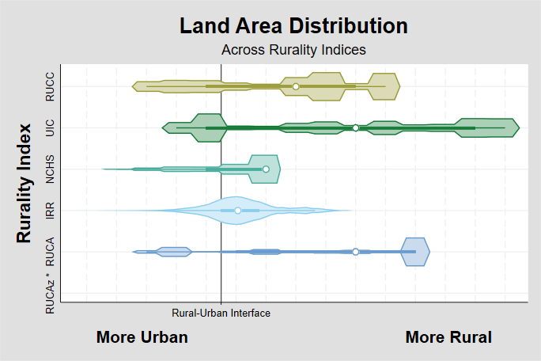
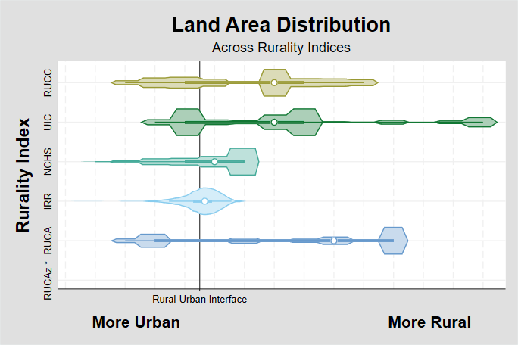
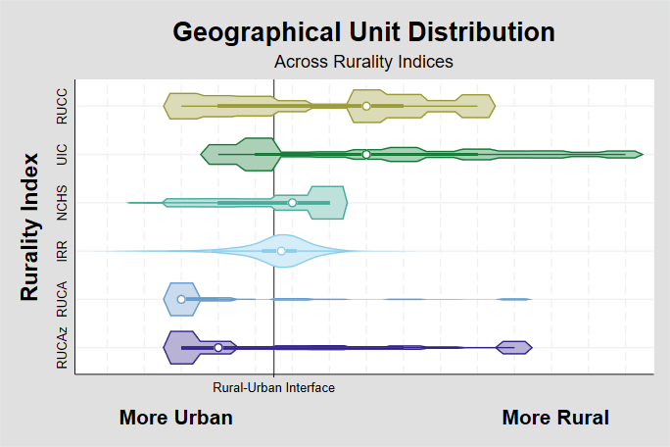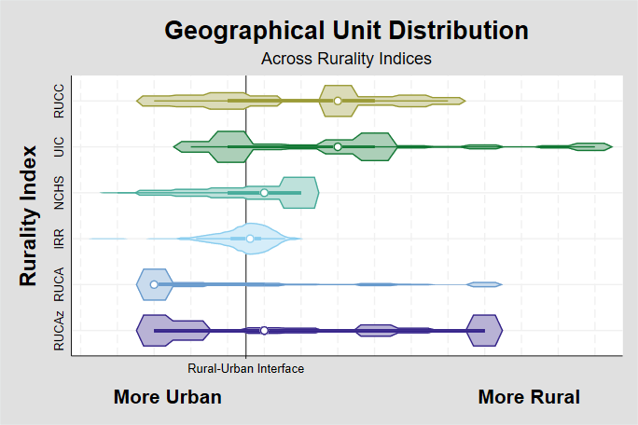
B
A
C
D
Geographical Units
Supporting Figure 1: Comparison of rural-urban indexes by land area and geographical unit distributions. Geographical unit is measured at the county-level for Rural-Urban Continuum Codes (RUCC), Urban Influence Codes (UIC), National Center for Health Statistics (NCHS) Urban-Rural Classification Scheme for Counties, and Index of Relative Rurality (IRR), census-tract level for Rural-Urban Commuting Area (RUCA), and ZIP Code Tabulation Area (ZCTA) level for ZCTA Rural-Urban Commuting Area (RUCA(z)) for the United States (A) and Wisconsin (B). Land area distributions are shown for the United States (C) and Wisconsin (D). Each index is standardized such that the ‘Rural-Urban Interface’ line lies between those values that the index has designated as urban (left of line) and rural (right of line). Center points indicate the median of the index, boxes indicate the inter-quartile range, and spikes indicate the upper- and lower-adjacent values (1.5 times the inter-quartile range).
* RUCA(z) is based on 2013 ZCTAs. Land Area data is not available at the ZCTA-level for 2013, so those distributions are excluded from the figure.
Land Area

Supporting Figure 2: Geographical unit distributions over time across the United States, Wisconsin, and University of Wisconsin – Health Pancreatic Cancer Registry Patients. Geographical unit is measured at the county-level for Rural-Urban Continuum Codes (RUCC), Urban Influence Codes (UIC), National Center for Health Statistics (NCHS) Urban-Rural Classification Scheme for Counties, and Index of Relative Rurality (IRR), census tract level for Rural-Urban Commuting Area (RUCA), and ZIP Code Tabulation Area (ZCTA) level for ZCTA Rural-Urban Commuting Area (RUCA(z)). Center points indicate the median of the index, boxes indicate the inter-quartile range, and spikes indicate the upper- and lower-adjacent values (1.5 times the inter-quartile range). Changes in the RUCC and UIC ranges are a result of changes in their respective methodologies.

United States
Wisconsin
Registry Patients
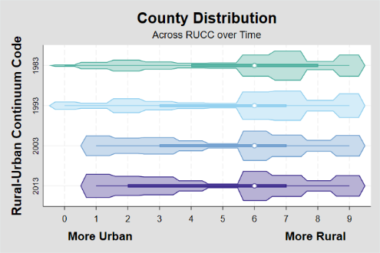
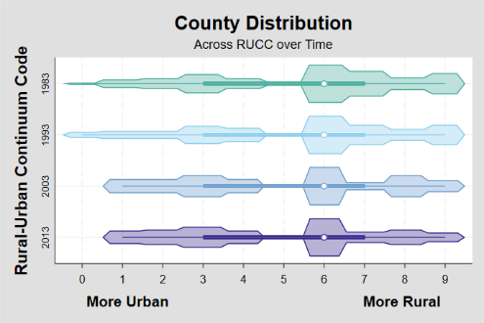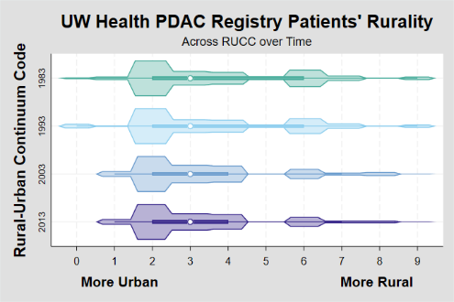
Rural-Urban
Continuum Code
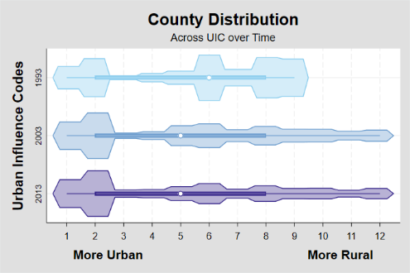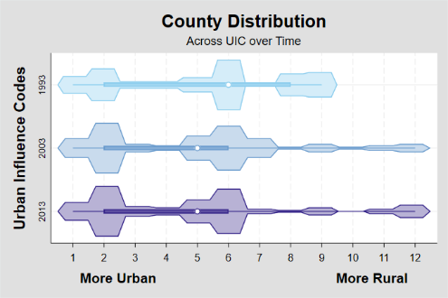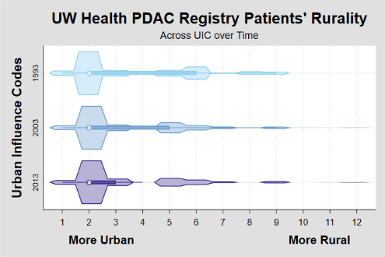
Urban Influence Codes
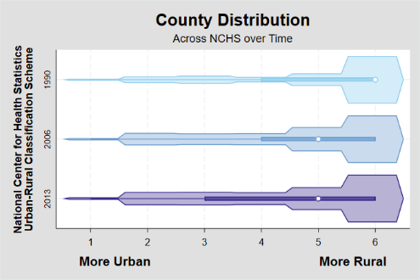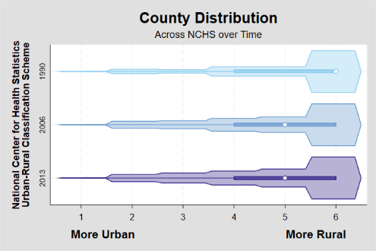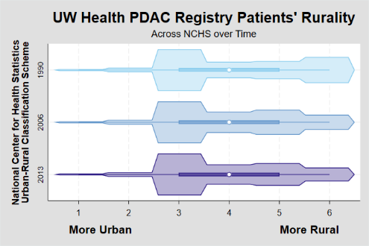
National Center for Health Statistics
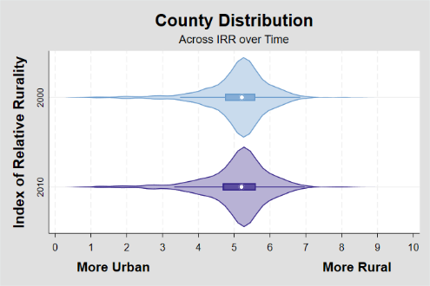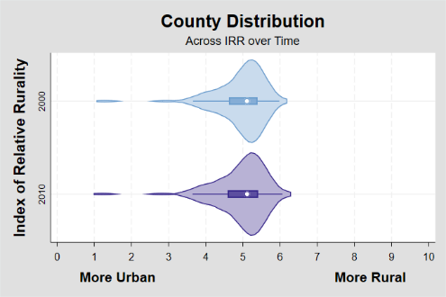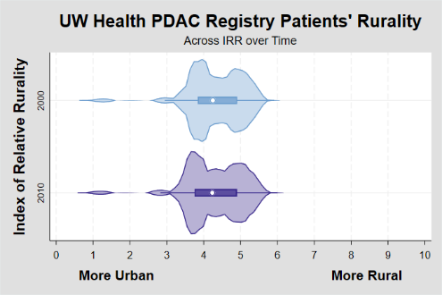
Index of Relative Rurality
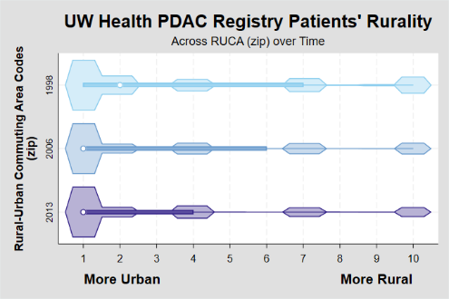
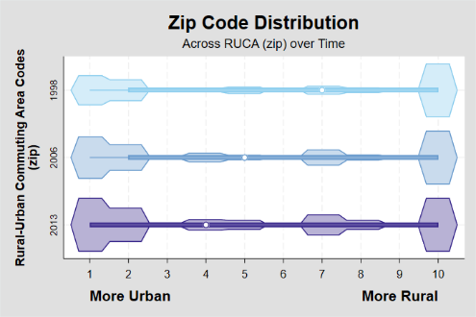
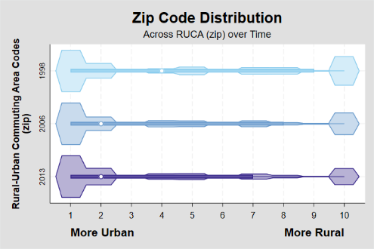
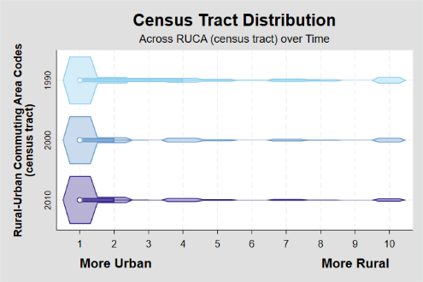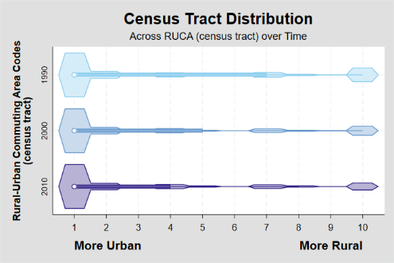
Rural-Urban Commuting Area

Rural-Urban Commuting Area (ZCTA)
Supporting Figure 2: Geographical unit distributions over time across the United States, Wisconsin, and University of Wisconsin – Health Pancreatic Cancer Registry Patients.

