New insights into the molecular mechanism behind mannitol and erythritol fructosylation by β-fructofuranosidase from Schwanniomyces occidentalis

David Rodrigo-Frutos¹, Elena Jiménez-Ortega², David Piedrabuena¹, Mercedes Ramírez-Escudero², Noa Míguez³, Francisco J. Plou³, Julia Sanz-Aparicio^{2*}, & María Fernández-Lobato^{1*}

¹Centro de Biología Molecular Severo Ochoa (CBMSO; UAM-CSIC), Departamento de Biología Molecular, Facultad de Ciencias, Universidad Autónoma de Madrid, Nicolás Cabrera 1, Madrid, 28049, Spain.
²Instituto de Física-Química Rocasolano (CSIC), Departamento de Cristalografía y Biología Estructural, Serrano 119, Madrid, 28006, Spain.
³Instituto de Catálisis y Petroleoquímica (ICP-CSIC), Marie Curie 2, Madrid, 28049, Spain
*Corresponding authors: J. Sanz-Aparicio (xjulia@iqfr.csic.es); M. Fernández-Lobato (mfernandez@cbm.csic.es)

-Table S1. Crystallographic statistics.
-Figure S1. Schematic view of the reactions catalyzed by Ffase on sucrose.
-Figure S2. HPLC chromatograms from transfructosylating reactions produced by N254T (a) or wild-type (b) Ffase variants.
-Figure S3. Mass spectrum of the reaction mixture obtained with the Ffase-N254T variant in reactions containing sucrose and erythritol.
-Figure S4. SDS-PAGE analysis of the purified Ffase variants.

Table S1. Crystallographic statistics.

Crystal data | Ffase-D50A / Fru-erythritol | Ffase-D50A / Sucrose
Space group | P 2₁ | P 2₁
Unit cell parameters
a (Å) | 60.48 | 60.90
b (Å) | 92.54 | 93.20
c (Å) | 116.11 | 116.61
β (º) | 104.71 | 104.90
Data collection
Beamline | XALOC  (ALBA) | XALOC  (ALBA)
Temperature (K) | 100 | 100
Wavelength (Å) | 0.97926 | 0.97926
Resolution (Å) | 49.33-1.88  (1.91-1.88) | 49.69-2.09  (2.13-2.09)
Data processing
Total reflections | 536923 (25965) | 369570 (22936)
Unique reflections | 98,961 (4791) | 74544 (4621)
Multiplicity | 5.4 (5.4) | 5.0 (5.0)
Completeness (%) | 98.6 (97.9) | 99.9 (99.8)
Mean I/σ (I) | 9.2 (3.0) | 8.6 (2.5)
R_{merge}† (%) | 12.3 (63.0) | 13.8 (56.9)
R_{pim}†† (%) | 5.9 (30.0) | 7.0 (28.6)
Molecules per ASU | 2 | 2
Refinement
R_{work} / R_{free}††† (%) | 15.39 /17.85 | 17.49/21.36
Nº of atoms/average B (Å²)
Protein | 8341/19.21 | 8308/20.28
Carbohydrate | 226/37.91 | 248/37.18
Water Molecules | 849/30.72 | 794/27.06
All atoms | 9416/20.69 | 9350/21.30
Ramachandran plot (%)
Favoured | 96 | 96
Outliers | 0 | 0
RMS deviations
Bonds (Å) | 0.0072 | 0.0065
Angles (°) | 1.4496 | 1.4589
PDB accession codes | 6S2B | 6S1T
Values in parentheses are for the high resolution shell
†R_{merge} = ∑_{hkl} ∑_{i} | I_{i}(hkl) – [I(hkl)]| / ∑_{hkl} ∑_{i} I_{i}(hkl), where I_{i}(hkl) is the ith measurement of reflection hkl and [I(hkl)] is the weighted mean of all measurements.
††R_{pim} = ∑_{hkl} [1/(N - 1)] 1/2 ∑_{i} | I_{i}(hkl) – [I(hkl)]| / ∑_{hkl} ∑_{i} I_{i}(hkl), where N is the redundancy for the hkl reflection.
†††R_{work} / R_{free} = ∑_{hkl} | Fo – Fc | / ∑_{hkl} | Fo |, where Fc is the calculated and Fo is the observed structure factor amplitude of reflection hkl for the working / free (5%) set, respectively.

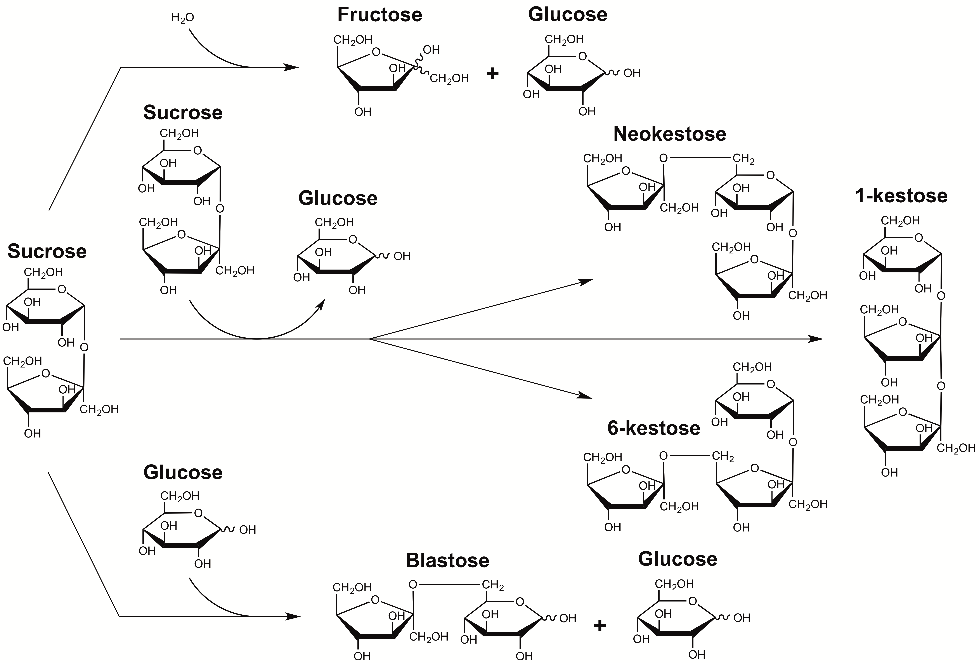

Figure S1. Schematic view of the reactions catalyzed by Ffase on sucrose. This enzyme cleaves the β-(2→1) linkage of sucrose (hydrolytic activity) and transfers the fructosyl moiety into a sucrose or a glucose unit (transferase activity) generating: blastose [β-D-Fru-(2→6)-Glc], neokestose [β-D-Fru-(2→6)-α-D-Glc-(1→2)-β-D-Fru], 1-kestose [β-D-Fru-(2→1)-β-D-Fru-(2→1)-α-D-Glc] and 6-kestose [β-D-Fru-(2→6)-β-D-Fru-(2→1)-α-D-Glc].

Figure S2. HPLC chromatograms from transfructosylating reactions produced by N254T (a) or wild type (b) Ffase variants. 10 U ml⁻¹ of pure enzyme was incubated in 200 g l⁻¹ sucrose and 500 g l-1 erythritol. Analyses were conducted at the point of maximum fructosyl-erythritol production. Upper right corners show a close-up view of the corresponding figures including the detector response range. Peaks assignations: (1) erythritol, (2) fructose, (3) glucose, (4) fructosyl-erythritol, (5) sucrose, (6) blastose, (7) potential (fructosyl)₂-erythritol, (8) neokestose, (9) 1-kestose, and (10) 6-kestose.

Figure S3. Mass spectrum of the reaction mixture obtained with the Ffase-N254T variant in reactions containing sucrose and erythritol. Reaction conditions: 1.5 ml mixtures containing 200 g l⁻¹ sucrose and 500 g l⁻¹ erythritol in 0.1 M sodium acetate at pH 5.5 were incubated at 50 ºC for 240 min. Molecular masses of chemical constituents plus sodium ion (~ 23 u) were detected in positive mode. Peaks of [M+Na]⁺ m/z of 365.1, 469.2, and 631.2 were assigned respectively as fructosyl-erythritol, potential (fructosyl)₂-erythritol, and negligible traces of hypothetical (fructosyl)₃-erythritol. Peaks of [M + Na]⁺ m/z of 145.0, 203.0, 365.1, 527.2, and 689.2 corresponds to erythritol, monosaccharides, disaccharides, trisaccharides, and minimal quantities of unidentified tetrasaccharides, respectively.

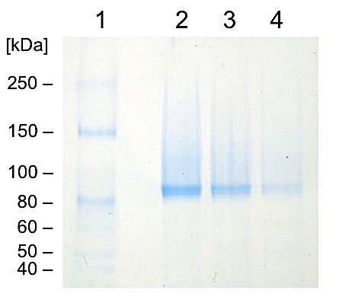

Figure S4. SDS-PAGE analysis of the purified Ffase variants. Lane 1: Unstained protein standards ranging 10-250 KDa (New England Biolabs Inc.; Ipswich, USA) used for molecular weight estimations. Lane 2-4: 0.5 µl of purified enzyme Ffase-D50A, -N254T, and -Q228E; respectively. Numbers at the left indicate the positions of molecular mass standards in KDa.

