Supporting Information:

Profiles of Volatile Biomarkers Detect Tuberculosis from Skin

Vishinkin R.¹, Busool R. ¹ Mansour E.¹, Fish F.¹, Esmail A.², Kumar P.³, Gharaa A.¹,
Cancilla J. C.⁴, Torrecilla J. S.⁵, Skenders G.⁶, Leja M.⁶, Dheda K.², Singh S.³ and Haick H.¹

- Department of Chemical Engineering and Russell Berrie Nanotechnology Institute, Technion-Israel Institute of Technology, Haifa 3200003, Israel.
- Lung Infection and Immunology Unit, Division of Pulmonology, Department of Medicine, University of Cape Town, Cape Town, South Africa.
- Division of Clinical Microbiology and Molecular Medicine, Department of Laboratory Medicine, All India Institute of Medical Sciences, New Delhi 110029, India.
- Scintillon Institute, San Diego, CA, USA.
- Department of Chemical Engineering, Complutense University of Madrid, Madrid 28040, Spain.
- Institute of Clinical and Preventive Medicine, University of Latvia, Riga, Latvia.

- Characterization of the studied populations
Tables S1 and S2 summarize all the baseline characteristics of the participants.

Table S1 South African population characterization summary.
 | Confirmed Pulmonary Active TB Patients | Non-TB Patients | Healthy Control
Number of patients | 109 | 105 | 106
Female : Male ratio | 35 : 74 | 43 : 62 | 84 : 22
Age  mean, years (s.d.) | 38.54 (12.03) | 40.35 (12.58) | 37.0 (10.09)
Country of birth | 109 South Africa | 104 South Africa  1 Congo | 99 South Africa  3 India,1 Zimbabwe  1 United Kingdom  1 Trinidad, 1 Sudan
Smoking status  Non-smokers: Smokers | 59 : 50 | 43 : 62 | 86 : 20
Smoking habits | 23 smoke 1-5 times/day  20 smoke 6-10 times/day  3 smoke 10-15 times/day  1 smokes 16-20 times/day | 26 smoke 1-5 times/day  20 smoke 6-10 times/day  8 smoke 10-15 times/day  2 smoke 16-20 times/day  2 smokes more than 20 times/day | 10 smoke 1-5 times/day  7 smoke 6-10 times/day  2 smoke 10-15 times/day  1 smokes 16-20 times/ day
HIV status  Positive: Negative | 55 : 54 | 36 : 69 | 18 : 88
Time since last wash, hr (s.d.) | 6.24 (6.76) | 8.028 (8.589) | 4.865 (3.29)
Time since last meal and, hr (s.d.) | 10:91 (7.79) | 12.815 (8.08) | 7.42 (6.82)
Main contain of last meal | 54 Meat, 30 sweet food, 18 vegetables, 7 other | 66 Meat, 12 sweet food, 7 vegetables, 20 other | 48 Meat, 23 sweet food, 25 vegetables, 10 other
TB family history | 23 | 21 | 14
QFT status  Pos. : Neg. : IND | 88 : 14 : 14 | 64 : 36 : 5 | 69 : 35 : 2
GeneXpert | 103 Pos.: 3 Neg. | 105 Neg. | n/a
Culture | 103 Pos. :4 Neg. :2 IND | 105 Neg. | n/a
Previous TB history | 25 | 3 | 13
Last alcohol consumption prior sampling | 70 without alcohol consumption.  1 two hours before  6 a day before  19 within a week  1 a month  6 more than two months | 75 without alcohol consumption.  15 a day before,  12 within a week  2 two weeks | 76 without alcohol consumption.  1 five hours before  12 a day before  11 within a week  4 within a month  3 more than two months
(2,6-diphenyl-p-phenyleneoxide)-based anterior arm headspace area samples | 92 | 10 | 91

Table S2 Indian population characterization summary.
 | Confirmed Pulmonary Active TB Patients | Non-TB Patients | Healthy Control
Number of patients | 107 | 103 | 106
Female : Male ratio | 28 : 79 | 27 : 76 | 26 : 80
Age  mean, years (s.d.) | 41.57 (17.34) | 42.37 (17.06) | 31.88 (8.93)
Country of birth | India | India | India
Smoking status  Non-smokers: Smokers | 96: 11 | 86: 17 | 85: 21
Smoking habits | 8 smoke 1-5 times/day  2 smoke 6-10 times/day  1 smoke 10-15 times/day | 11 smoke 1-5 times/day  3 smoke 6-10 times/day  2 smoke 10-15 times/day  1 smoke more than 20 times/day | 15 smoke 1-5 times/day  2 smoke 6-10 times/day  2 smoke 10-15 times/day  1 smoke 16-20 times/day  1 smoke more than 20 times/day
HIV status | 106 Neg. :1 IND | 103 Neg. | 106 Neg.
Time since last wash, hr (s.d.) | 25.72 (70.6) | 17.19 (21.47) | 5.83 (6.38)
Time since last meal and, hr (s.d.) | 10.89 (8.34) | 11.92 (8.02) | 4.52 (5.02)
Main contain of last meal | 68 meat  36 vegetables  3 other | 68 meat  24 vegetables  11 other | 59 meat  46 vegetables  1 other
TB family history | 18 | 18 | 9
QFT status  Pos. : Neg. : IND | 74 : 32 : 1 | 45 : 58 : 0 | 61 :44 : 1
GeneXpert | 92 Pos.: 15 Neg. | 103 Neg. | n/a
Culture | 97 Pos: 10 Neg | 103 Neg | n/a
Previous TB history | 26 | 29 | 6
Last alcohol consumption (days) | 99 without alcohol consumption.  1 within a day before  1 a week before  3 two week  3 two month | 94 without alcohol consumption.  1 a day before  5 within a week  2 two weeks  1 one month | 81 without alcohol consumption.  1 an hour before  4 a day before  13 within a week  3 two weeks  4 more than a month
(2,6-diphenyl-p-phenyleneoxide)-based anterior arm headspace area samples | 91 | 92 | 106

- Off-line tools for collecting VOCs from skin
In the literature review on the collection of skin VOCs, there are many different methods, usually involving uncomfortable sampling procedures, e.g. wrapping the desired area with a plastic bag. During the experiments, comfortable sampling methods that will increase the volunteer’s compliance were chosen. Two different absorbing materials were investigated and characterized. Protocols for fabrication, sampling, and storage for both materials were established.
  - Characterization of PDMS as a sampling tool
Several important parameters related to the Polydimethylsiloxane (PDMS) (Specialty Silicone Products Inc., USA) were investigated and optimized in order to fit as a sampling tool to detection of TB VOCs from the skin:
- PDMS Dimensions optimized to 2.5 cm X 0.5 cm with 0.017'' thickness.
- PDMS cleaning process was evaluated in a serial experiment using: 1) Decon 90 with distilled water; 2) acetone and methanol washing; and 3) Plasma process. The optimal cleaning process was Decon 90 with distilled water.
- Thermal conditioning process was examined in a range of temperatures from 180°C to 270°C, under a constant pure gas flow (Nitrogen or Helium) for up to 90 minutes. The optimal conditioning temperature was determined as 270°C, under a constant flow of Nitrogen for 60 minutes. An example of PDMS before and after thermal conditioning is showed in Figure S1. The abundance of the materials was significantly reduced after the conditioning process. The mutual materials between the two graphs are mostly silicon produces from the PDMS and Gas chromatography–mass spectrometry (GC-MS) column.
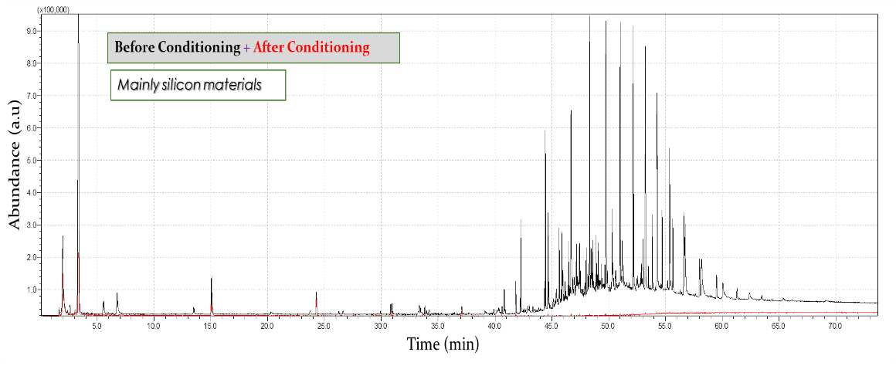

Fig. S1 GC MS chromatography for PDMS before the chosen conditioning process (black) and after conditioning process (red).

- Shelf-life of the conditioned PDMS sheets was also examined at 4°C storage conditions. It was found that the samples in the glass vials, sealed with parafilm be stored up to 8 months.
- Cover material/attachment procedure of PDMS to skin was tested to reduce the background noise during the sampling from both the cover itself and the environment. In the literature the cover material was a gauze pad¹; however, during our evaluation very noisy results were received. A series of experiments was held in which several different cover materials were tested including gauze pad, parafilm, and aluminum foil (see Fig. S2). A room sample was collected by hanging the PDMS in the room for the same duration of the experiment; the results are shown as a blue chromatogram in a case of aluminum foil (Fig. S2C). The marked areas in cases of gauze pad and Parafilm (Fig. S2B) highlight the high levels of the noise caused by the cover materials as the black chromatogram had the same abundance (or even higher) as the materials from the skin test. In the case of aluminum foil as a cover material, the noise levels are substantially negligible compared to the skin test. This indicates that the VOCs found in the skin sample are indeed VOCs emitted from the skin. As another control test, the room’s PDMS sample had a negligible VOC profile in comparison to the skin sample, indicating that an efficient cover that protects the skin sampling from air pollutants.

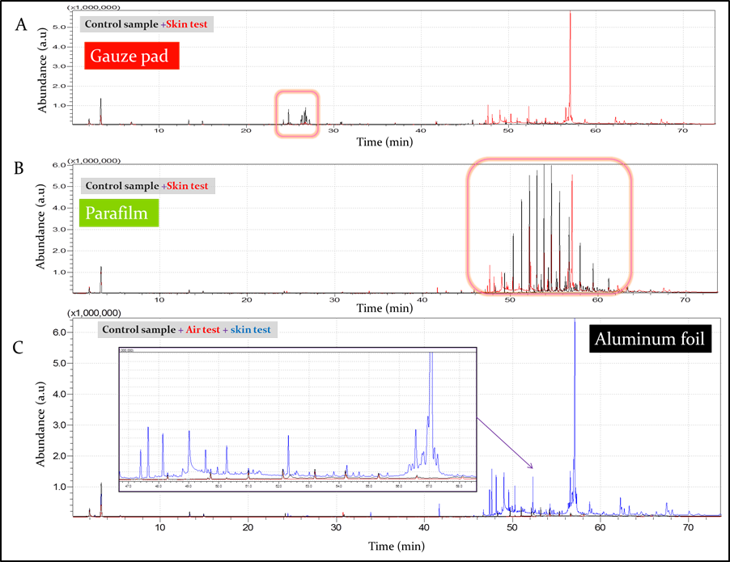
Fig. S2 GC-MS chromatography for PDMS with different cover materials: a Gauze pad; b Parafilm and c Aluminum foil. The insert in case c is an enlargement of the shown area in the chromatography
- Sample duration from the skin was done for 60 min similarly to the literature. No further investigation was conducted as increasing the sampling time might cause refusal among potential participants.
- As the distribution of secretion glands on the skin is heterogeneous, and therefore distinctive VOC profiles can be emitted from different parts of the body. As a result, we have sampled the skin in two regions including the bilateral inner arm (close to the armpit) and chest areas, as different VOC profiles are obtained.
The results showed a significant difference in the VOC profile between the inner arm and chest (see Fig. S3). The skin cleaning method prior the sampling increased significantly the repetitiveness of the results and significantly reduced the differences between the different lateral sampling positions. Moreover, the percentage of the unique VOCs from the skin increased following the cleaning process. Skin cleaning process was tested in a serial experiment using distilled water, commercial alcohol preps and combination of both with different waiting time before sampling. It was found out that the optimal skin cleaning process was with alcohol prep 5 min before sampling. The average percentage of relative standard deviations (RSD) was lower for the series of experiments with the cleaning process compared to the experiment without cleaning process (see Table S3).

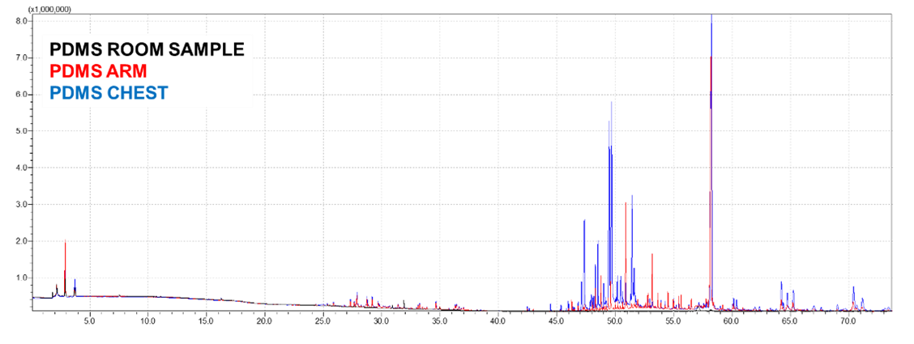
Fig. S3 VOC profiles by PDMS absorbing material from the chest area (blue), inner arm area (red) and a room sample as a control.

Table S3 Influence of the chosen cleaning method on the repetitiveness of the results and on the differences between the different sampling areas.
With cleaning method | Without cleaning method
158 | 148 | Total VOCs in the arm samples (excluding the silicones)
88% | 83% | Percentage of the exclusive VOCs to the arm samples
23% | 59% | Average percentage of relative standard deviation (RSD) of all the exclusive VOCs

  - Characterization of Tenax as a sampling tool
In order to increase the possibility to identify TB VOC profile via skin headspace, Tenax porous polymer (2,6-diphenyl-p-phenyleneoxide) (Buchem B.V. company) as additional absorbing material was used. As PDMS and Tenax have different VOC absorbing materials, the use of both had the potential to cover a chemically wider range of emitted VOCs from the skin. Tenax is known as an excellent absorbing material for detection of VOCs via exhaled breath², once the Tenax is trapped inside a glass tube. In order to adjust the use of such a powdery polymer for skin sampling, several alternatives were investigated.
Initially, a commercial tag, ‘ULTRA Passive Sampler for ppb-Level Organic Vapors’ (www.skcinc.com) was used to trap the Tenax and allow it to be near the skin headspace without a direct contact with the skin that may cause irritation. As expected, the results showed VOC profiles from both inner arm and chest area, which were significantly different from the profiles obtained with the PDMS (Fig. S4). Since the solution of such tags were extremely expensive and required purchase of hundreds of tags for the clinical study, more cost affordable approaches were tested. The Tenax polymer was trapped in home-made envelopes sealed with heat presser which were made from polymeric membranes in order to allow vapor transfer, while ensuring no direct contact between the Tenax and the skin. The tested membranes included polyester with different meshes (30 and 47 µ) as well as 5 µ Polyethersulfone membrane (PES) that can control the preferred polarity of the transferred gases for elimination of humidity effect. As can be seen from Fig. S5-S6, the skin VOC profiles obtained from Tenax with different envelops and Ultra tag are similar and there were no significant differences. As the PES membrane was hard to be sealed by heat, it was eliminated. 47µ polyester membrane was chosen due to high availability and low price.
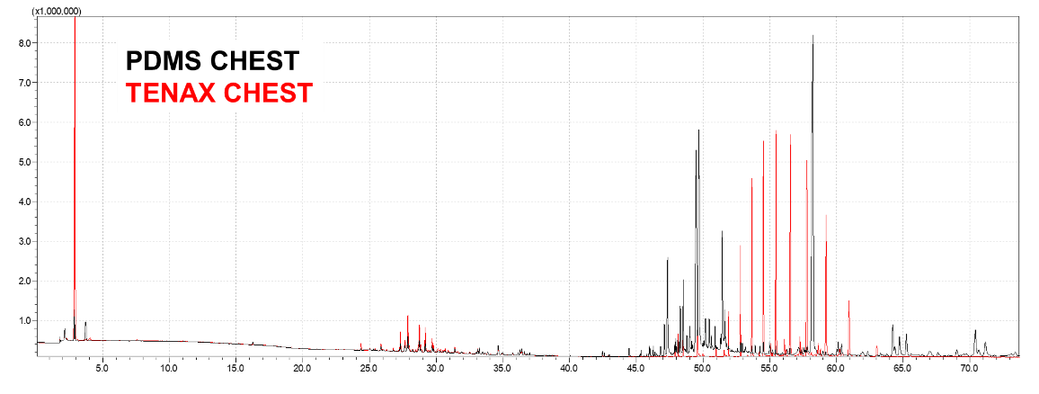
Fig. S4 Differences in the skin VOC profile at the same body location, chest area, between the two absorbing materials, PDSM (black) and Tenax (red).
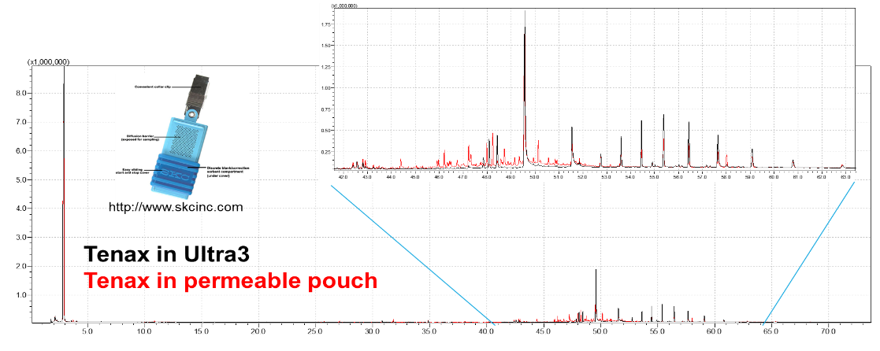
Fig. S5 Skin VOC profiles extracted by Tenax polymer inside Ultra tag (black) and polymeric envelope (red).
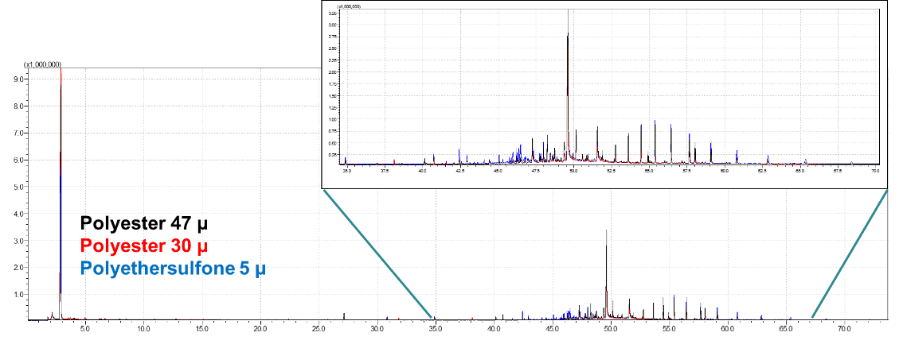
Fig. S6: Skin VOC profiles extracted by Tenax polymer inside 47µ polyester membrane (black), 30 µ polyester membrane (red) and 5µ Polyethersulfone membrane.

- The cleaning procedure of the polyester envelopes was evaluated and set to be the same as for the PDMS, expect for drying conditions of 100°C instead of 200°C. The Tenax polymer was chosen with the lowest available mesh (20/35), in order to ensure no direct contact with skin. 134±2 mg Tenax was thermally conditioned in a glass tube for the optimal duration of 3 hours at 300°C and 20 bar N₂ flow, after examining different combinations of time, temperature and pressure. Shelf-life examination was done at 4°C storage conditions. It was found that the samples in the glass vials, sealed with parafilm be stored up to 8 months, similarly to the PDMS.

  - Collection of skin headspace.
Each volunteer was sampled as follows:
- Two Tenax patches on the inner arm area
- Two Tenax patches on the chest area
- Two PDMS patches on the inner arm area
- Two PDMS patches on the chest area
- One Tenax patch for room sampling, placed on a table during the skin measurement as a reference.
- One PDMS patch for room sampling, placed on a table during the skin measurement as a reference.
The duplicates of the different absorbing materials are used for two lab instruments:
- GC-MS for detection and characterization the skin TB-VOCs; and
- Laboratory nanomaterial-based sensors array chamber for sensor performance assessment.

- Potential metabolic pathways associated with TB VOCs patterns
Acetic acid. Acetic acid was found to be with higher abundance among confirmed pulmonary active TB patients in comparison to control group of non-TB patients with healthy volunteers and room samples. The low abundance of this VOC in room samples, in comparison to skin samples, suggests an endogenous origin. According to the literature, there was a reported correlation between acetic acid and M. tuberculosis. It was found that acetic acid kills M. tuberculosis after exposure of 30 min to a 6% solution³. Its toxicity relates to pH levels and strong bactericidal activity. Furthermore, acetic acid, as a part of various metabolic pathways, was found to be emitted from both breath⁴ and skin^{5,6} of healthy volunteers, as well as from subjects with gastrointestinal and hepatic diseases⁷. Higher levels among confirmed active TB patients may be an evidence for the response of the immune system during the infection.
2-ethyl-1-hexanol. 2-ethyl-1-hexanol is an additional VOC that has had significantly increased abundance among confirmed pulmonary active TB patients, in comparison to other tested groups in South Africa. This compound was previously reported as TB-related VOC via exhaled breath of patients, indicating on the relevancy to the TB pathogenesis⁸. 2-ethyl-1-hexanol is also reported as VOC associated with cancer diseases and was detected in breath and urine^{9–12}. The presence of 2-ethyl-1-hexanol in the room samples is associated with a microbial degradation of plasticizers in indoor air¹³. Acetic acid and 2-ethyl-1-hexanol VOCs were found also among Indian samples; however, not with a statistically significant difference between confirmed pulmonary active TB patients and non-TB subjects. Differences in study population size, geographical location, cultural habits, pollution as well as food intake all may be responsible for this result.
Toluene. Interestingly, toluene was found to be with significantly higher abundance among confirmed pulmonary active TB patients in comparison with non-TB subjects and room samples, on both clinical sites obtaining also similar values. Toluene is known as an exogenous VOC associated with industry pollutions¹⁴, therefore its abundance among room samples is not negligible. Toluene degradation among M. tuberculosis strains is known¹⁵, as toluene is ubiquitous in the environment. Furthermore, toluene emission from both breath and skin has been reported in the literature.^{16–19} The degradation occurs in the human body normally by Cytochrome P450 isozymes in human liver microsomes^{20,21} and the normal degradation rates may be subjected to geographical differences²⁰. An inhibited influence of toluene on secretion of interferon-gamma (IFN-gamma), interleukin-4 (IL-4) and IL-13 was investigated in human peripheral blood mononuclear cells²². These factors were associated with inhibition of autophagy process during M. tuberculosis infection²³. The increased levels of toluene emission among confirmed active TB patients on both clinical sites may suggest toluene’s role both in bacterium metabolism and immune system during the infection.
Three additional VOCs were tentatively identified as TB-related among Indian population. For both cases, the abundance among confirmed pulmonary TB patients was higher in comparison with non-TB cases and room samples.
Ethyl-cyclopropane. Ethyl-cyclopropane is reported here for the first time as potential VOC biomarker. Nevertheless, cyclopropane and its derivatives as VOC emitted from breath, skin and feces has been already reported^{24–27}. M. tuberculosis has a unique cell wall structure that consists of mycolic acid. Cyclopropanated-mycolic acid are common membrane lipids that are found in various bacterial species but only in a limited number of eukaryotes^{28,29}. Though cyclopsropanated mycolic acids are presumed to be important in the TB pathogenesis, their specific role remains to be defined. Furthermore, it was shown that the host innate immune activation through cyclopropane modification of a glycolipid effector molecule^{30,31}. As a possible hypothesis, the increased levels of cyclopropane among TB subjects, emphasizes the critical key role of this compound in the infection progress.
Hexyl butyrate. This VOC is reported here for the first time as potential VOC biomarker. Nevertheless, this compound is related to lipid metabolism pathway and its derivatives were found in the exhaled breath of healthy subjects.¹⁶ Though it is lso known to has exogenous sources originated naturally from plans, serves as a food additive³², and can be found in cleaning and air care products³³.
Octanoic acid. This VOC is reported here for the first time as potential VOC biomarker. Similar to the Hexyl butyrate, octanoic acid has both endo- and exo-genous sources. Octanoic acid has exogenous sources originated from industrial products, cleaning and flavoring agents, paints and coatings that may explain the high levels at indoor air samples³⁴. Lower abundance among confirmed pulmonary active TB patients may be correlated to synthesis and deacylation of Ghrelin hormone that plays an important role in body's energy regulation and damaged during TB disease as Ghrelin levels are higher among patients in comparison to control subjects.^{35,36} Emission of octanoic acid was reported previously via both breath and skin secretion pathways.¹⁶

- Discriminant function analysis (DFA) analysis for offline measuring
The study population was randomly divided into a training group (70%) and blinded-test group (30%). The training group included 120 confirmed pulmonary active TB cases and 202 non-TB and healthy cases. The test group included 43% South African samples and 57% Indian samples, which translates to 52 confirmed pulmonary active TB cases and 87 non-TB and healthy cases. Analysis results established by 32 nanomaterial-based sensors conductivity features based on the following sensors: (i) Au nanoparticles covered with octadecanethiol, Tert-dodecanethiol, decanethiol, butanethiol, 2-Ethylhexanethiol, Dibutyl Disulfide, 2-Nitro-4-(trifluoromethyl)benzenethiol, 1,6 hexanedithiol, hexanethiol, benzylmercaptan, 4-Chlorobenzenemethanethiol, 3-Ethoxythiophenol;(ii) polymer composites: CB/(PPMA/PEI) Composite: a composite of black carbon with poly(propylene-urethaneureaphenyl-disulfide) PPUU-2S with/without poly(urethane-carboxyphenyl-disulfide) PUC-2 and (iii) random networks (RNs) of carbon nanotubes (CNTs) with crystal hexa-perihexabenzocoronene (HBC) with C12 chemiresistor (HBC-C12). Details regarding the fabrication and modification of the mentioned above sensors cab be found in refs ^{37–40}. The training set of samples for distinguishing confirmed pulmonary TB patients from non-TB and healthy control individuals provided 86.0% accuracy, 89.17% sensitivity, 84.16% specificity, 76.98% positive predictive value (PPV), and 92.9% negative predictive value (NPV) (Fig. S7a). Furthermore, the area under the curve of the receiver-operating curve (ROC) scored 0.93 indicating the ability of the model to discriminate between the TB disease statuses (Fig. S7b). The blind set for validation of the training set, based on the same quadratic DFA analysis, was able to discriminate between confirmed pulmonary active TB patients and controls with similar performance as in the training set. The analysis provided 81.97% PPV, 94.43% NPV with 87.35 % specificity, 96.15% sensitivity and 90.65% accuracy. The potential confounding factors and their influence on the model’s results were also evaluated by the DFA model. The results are displayed in Table S4 and no significant difference within each confounding factor was found.

a.
b.

Fig. S7: Quadratic DFA results of the global classifier. A Boxplot of the canonical score of the model. Each point represents one sample. The central dashed line represents Youden's cut-point. Samples above the cut-point are classified as Non-TB and healthy and samples below the cut-point are classified as confirmed pulmonary active TB samples. Non-TB and healthy samples of the test group are marked as open spheres, while confirmed pulmonary active TB samples of the test group are marked as closed spheres. b ROC curve of model. AUC= area under curve
Table S4 Confounding factors among both clinical sites and their DFA model accuracy.
Confounding factor | Model accuracy (%)
Gender | 48.37
Age (cut-point of the average age of 38 years) | 42.08
Place of birth | 38.48
HIV status | 62.61
QFT status | 56.14
Smoking status | 59.44
Last smoking time among smokers (cut-point 2h) | 42.86
Family TB history | 60.30
Last Bath (cut-point 8h) | 55.32
Tea/coffee Time (cut-point 2h) | 53.14
Meal time (cut-point 2h) | 49.67
Meal content: Meat | 48.59
Meal content: Spicy food | 57.92

- Wearable device
The internet of medical things IoMT device consists of a Data Acquisition System coupled with the electrodes–Microchip to pick up vital signals from the human body. The device is well equipped with an analog front end which facilitates the signal extraction and conditioning. The system also has an analog to digital device (ADC), for converting the extracted analog signal to digital form, and a microcontroller which sends digital signals to the Bluetooth transceiver, which enables communication with external devices, such as: android mobile devices, computer Bluetooth, etc. Furthermore, this device contains USB-HID capabilities that enable communication with computer hardware, if needed, and functions as a battery charger interface.
  - Board design review
    - Data Acquisition System
Figure S8 Data Acquisition System.
Data Acquisition part is the most significant in the system. It includes sensors that transform a stimulus into an electrical signal that can then be converted by an ADC into a digital signal for processing. In addition, these systems often need a way to adjust different parameters of their sensors (gain, offset, etc). A complete data acquisition solution should be able to address this sub-system as well as the analog to digital conversion of the signals. One of the most important building blocks in the data acquisition is the microcontroller unit MCU that is responsible of interconnecting the Bluetooth, ADC and the sensor. The following are the MCU features:
High-performance, Low-power Atmel® AVR® XMEGA® 8/16-bit Microcontroller
- Non-volatile Program and Data Memories
– 16K - 128KBytes of In-System Self-Programmable Flash
– 4K - 8KBytes Boot Code Section with Independent Lock Bits
– 1K - 2KBytes EEPROM
– 2K - 8KBytes Internal SRAM
- Peripheral Features
– Four-channel DMA Controller
– Eight-channel Event System
– Five 16-bit Timer/Counters
Three Timer/Counters with 4 Output Compare or Input Capture channels
Two Timer/Counters with 2 Output Compare or Input Capture channels
High-Resolution Extensions on all Timer/Counters
Advanced Waveform Extension on one Timer/Counter
– One USB device Interface
USB 2.0 full speed (12Mbps) and low speed (1.5Mbps) device compliant
32 Endpoints with full configuration flexibility
– Five USARTs with IrDA support for one USART
– Two Two-Wire Interfaces with dual address match (I2C and SMBus compatible)
– Two Serial Peripheral Interfaces (SPIs)
– AES and DES Crypto Engine
– CRC-16 (CRC-CCITT) and CRC-32 (IEEE 802.3) Generator
– 16-bit Real Time Counter with Separate Oscillator
– One Twelve-channel, 12-bit, 2MSPS Analog to Digital Converter
– One Two-channel, 12-bit, 1MSPS Digital to Analog Converter
– Two Analog Comparators with Window compare function, and current source feature
– External Interrupts on all General Purpose I/O pins
– Programmable Watchdog Timer with Separate On-chip Ultra Low Power Oscillator
– QTouch® library support Capacitive touch buttons, sliders and wheels Up to 64 sense channels
- Special Microcontroller Features
– Power-on Reset and Programmable Brown-out Detection
– Internal and External Clock Options with PLL and Prescaler
– Programmable Multi-level Interrupt Controller
– Five Sleep Modes
– Programming and Debug Interfaces PDI (Program and Debug Interface)
- I/O and Packages
– 34 Programmable I/O Pins
– 44 - lead TQFP
– 44 - pad VQFN/QFN
– 49 - ball VFBGA
- Operating Voltage
– 1.6 – 3.6V
- Operating Frequency
– 0 – 12MHz from 1.6V
– 0 – 32MHz from 2.7V

MCU Typical Applications
• Industrial control
• Climate control
• Low power battery applications
• Factory automation
• RF and ZigBee
• Power tools
• Building control
• USB Connectivity
• HVAC
• Board control
• Sensor control
• Utility Metering
• White Goods
• Optical
• Medical Applications

References
1. Riazanskaia, S., Blackburn, G., Harker, M., Taylor, D. & Thomas, C. L. The analytical utility of thermally desorbed polydimethylsilicone membranes for in-vivo sampling of volatile organic compounds in and on human skin. Analyst 133, 1020–1027 (2008).
2. Nakhleh, M. K. et al. Diagnosis and Classification of 17 Diseases from 1404 Subjects via Pattern Analysis of Exhaled Molecules. ACS Nano 11, 112–125 (2017).
3. Cortesia, C. et al. Acetic Acid, the active component of vinegar, is an effective tuberculocidal disinfectant. MBio 5, 1–4 (2014).
4. Phillips, M. et al. Variation in volatile organic compounds in the breath of normal humans. J. Chromatogr B Biomed. Sci . Appl. 729, 75–88 (1999).
5. Haze, S. et al. 2-Nonenal newly found in human body odor tends to increase with aging. ‎J. Investig. Dermatol. 116, 520–524 (2001).
6. Hartungen, E. v. et al. Proton-transfer-reaction mass spectrometry (PTR-MS) of carboxylic acids: Determination of Henry’s law constants and axillary odour investigations. ‎Int. J. Mass Spectrom. 239, 243–248 (2004).
7. Hicks, L. C. et al. Analysis of exhaled breath volatile organic compounds in inflammatory bowel disease: a pilot study. J. Crohns Colitis 9, 731–737 (2015).
8. Kolk, A. H. J. et al. Breath-based biomarkers for Tuberculosis. in 8371, 83710A–10 (International Society for Optics and Photonics, 2012).
9. Liu, H. et al. Investigation of volatile organic metabolites in lung cancer pleural effusions by solid-phase microextraction and gas chromatography/mass spectrometry. J. Chromatogr. B 945–946, 53–59 (2014).
10. Sponring, A. et al. Release of volatile organic compounds from the lung cancer cell line NCI-H2087 in vitro. Anticancer Res. 29, 419–26 (2009).
11. Barash, O. et al. Classification of lung cancer histology by gold nanoparticle sensors. Nanomedicine 8, 580–589 (2012).
12. del Nogal Sánchez, M., Hernández García, E., Pérez Pavón, J. L. & Moreno Cordero, B. Fast analytical methodology based on mass spectrometry for the determination of volatile biomarkers in saliva. Anal. Chem. 84, 379–385 (2012).
13. Nalli, S., Horn, O. J., Grochowalski, A. R., Cooper, D. G. & Nicell, J. A. Origin of 2-ethylhexanol as a VOC. Environ. Pollut. 140, 181–185 (2006).
14. Felzenszwalb, I. et al. Indoor air pollution: BTEX in occupational environments. in WIT Transactions on Ecology and the Environment 230, 279–289 (WIT Press, 2018).
15. Tay, S. T. et al. Two new Mycobacterium strains and their role in toluene degradation in a contaminated stream. Appl. Environ. Microbiol. 64, 1715–20 (1998).
16. de Lacy Costello, B. et al. A review of the volatiles from the healthy human body. J. Breath Res. 8, 1–29 (2014).
17. Peng, G. et al. Detection of lung, breast, colorectal and prostate cancers from exhaled breath using a single array of nanosensors. Br. J. Cancer 103, 542–551 (2010).
18. Poli, D. et al. Exhaled volatile organic compounds in patients with non-small cell lung cancer: cross sectional and nested short-term follow-up study. Respir. Res. 6, 71 (2005).
19. Peled, N. et al. Volatile fingerprints of cancer specific genetic mutations. Nanomedicine 9, 758–766 (2013).
20. Kim, H. et al. Cytochrome P450 isozymes responsible for the metabolism of toluene and styrene in human liver microsomes. Xenobiotica 27, 657–665 (1997).
21. Tassaneeyakul, W. et al. Human cytochrome P450 isoform specificity in the regioselective metabolism of toluene and o-, m- and p-xylene. J. Pharmacol. Exp. Ther. 276, 101–8 (1996).
22. Wichmann, G. et al. An experimental model for the determination of immunomodulating effects by volatile compounds. Toxicol. Vitr. 19, 685–693 (2005).
23. Harris, J. et al. T helper 2 cytokines inhibit autophagic control of intracellular Mycobacterium Tuberculosis. Immunity 27, 505–517 (2007).
24. Yeh, J.-J., Lin, C.-L., Hsu, C.-Y., Shae, Z. & Kao, C.-H. Statin for Tuberculosis and Pneumonia in Patients with Asthma⁻Chronic Pulmonary Disease Overlap Syndrome: A Time-Dependent Population-Based Cohort Study. J. Clin. Med. 7, (2018).
25. Abaffy, T. et al. Differential Volatile Signatures from Skin, Naevi and Melanoma: A Novel Approach to Detect a Pathological Process. PLoS One 5, e13813 (2010).
26. Phillips, M. et al. Volatile organic compounds in breath as markers of lung cancer: a cross-sectional study. Lancet 353, 1930–1933 (1999).
27. Phillips, M. et al. Volatile biomarkers in the breath of women with breast cancer. J. Breath Res. 4, 1–8 (2010).
28. Barkan, D., Hedhli, D., Yan, H.-G., Huygen, K. & Glickman, M. S. Mycobacterium tuberculosis lacking all mycolic acid cyclopropanation is viable but highly attenuated and hyperinflammatory in mice. Infect. Immun. 80, 1958–68 (2012).
29. Glickman, M. S., Cox, J. S. & Jacobs, W. R. A novel mycolic acid cyclopropane synthetase is required for cording, persistence, and virulence of Mycobacterium Tuberculosis. Mol. Cell. 5, 717–727 (2000).
30. Rao, V., Fujiwara, N., Porcelli, S. A. & Glickman, M. S. Mycobacterium Tuberculosis controls host innate immune activation through cyclopropane modification of a glycolipid effector molecule. J. Exp. Med. 201, 535–43 (2005).
31. Daffé, M., Quémard, A. & Marrakchi, H. Mycolic acids: From chemistry to biology. in Biogenesis of Fatty Acids, Lipids and Membranes (ed. Geiger, O.) 182–206 (Springer, Cham, 2019). doi:10.1007/978-3-319-50430-8_18
32. Api, A. M. et al. RIFM fragrance ingredient safety assessment, hexyl butyrate, CAS Registry Number 2639-63-6. Food and Chemical Toxicology 130, 110608 (2019).
33. Hexyl butyrate - Substance Information - ECHA. Available at: https://echa.europa.eu/substance-information/-/substanceinfo/100.018.306. (Accessed: 12th October 2020)
34. Salthammer, T. Emissions of Volatile Organic Compounds from Products and Materials in Indoor Environments. Handb. Environ. Chem. 4, 37–71 (2004).
35. Chang, S. W. et al. Gut Hormones, Appetite Suppression and Cachexia in Patients with Pulmonary TB. PLoS One 8, e54564 (2013).
36. Yurt, S. et al. The role of feed regulating peptides on weight loss in patients with pulmonary tuberculosis. Clin. Biochem. 46, 40–44 (2013).
37. Peng, G. et al. Diagnosing lung cancer in exhaled breath using gold nanoparticles. Nat. Nanotechnol. 4, 669–673 (2009).
38. Dovgolevsky, E., Tisch, U. & Haick, H. Chemically sensitive resistors based on monolayercapped cubic nanoparticles: Towards configurable nanoporous sensors. Small 5, 1158–1161 (2009).
39. Zilberman, Y., Ionescu, R., Feng, X., Müllen, K. & Haick, H. Nanoarray of polycyclic aromatic hydrocarbons and carbon nanotubes for accurate and predictive detection in real-world environmental humidity. ACS Nano 5, 6743–6753 (2011).
40. Huynh, T.-P. et al. Composites of Polymer and Carbon Nanostructures for Self-Healing Chemical Sensors. Adv. Mater. Technol. 1, (2016).

