Supplementary Information

Corresponding to
Novel thermo-electrochemical redox flow battery for continuous conversion of low-grade waste heat to power
Jorrit Bleeker ¹, Stijn Reichert ¹, Joost Veerman ², David A. Vermaas ^{1,*}
¹Department of Chemical Engineering, Delft University of Technology, 2629 HZ Delft, The Netherlands
²REDstack, Graaf Adolfstraat 35-G, 8606 BT Sneek, The Netherlands
email: d.a.vermaas@tudelft.nl

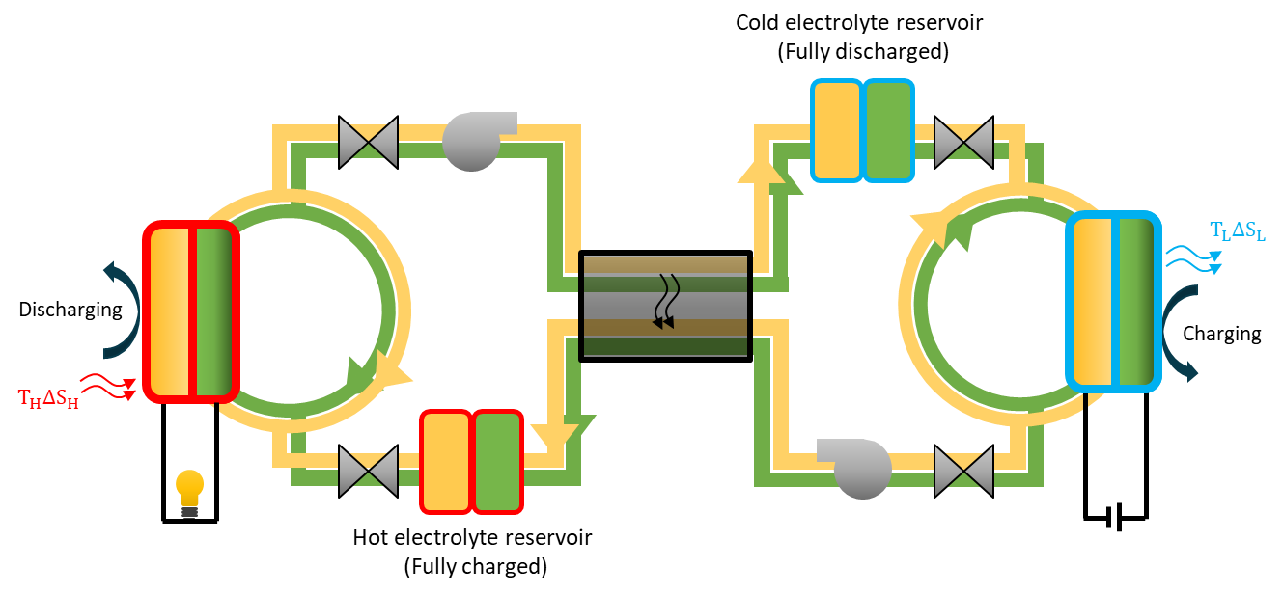
Figure S-1. Concept of thermally regenerative redox flow cycle operating in a batch mode. The figure illustrates the electrolyte circulation between a hot RFB (red, discharging) and a cold RFB (blue, charging at lower voltage), with a heat exchanger in the center. The electrolyte is circulated until it is fully discharged/charged before it will be pumped to the other reservoir of the other flow cell.
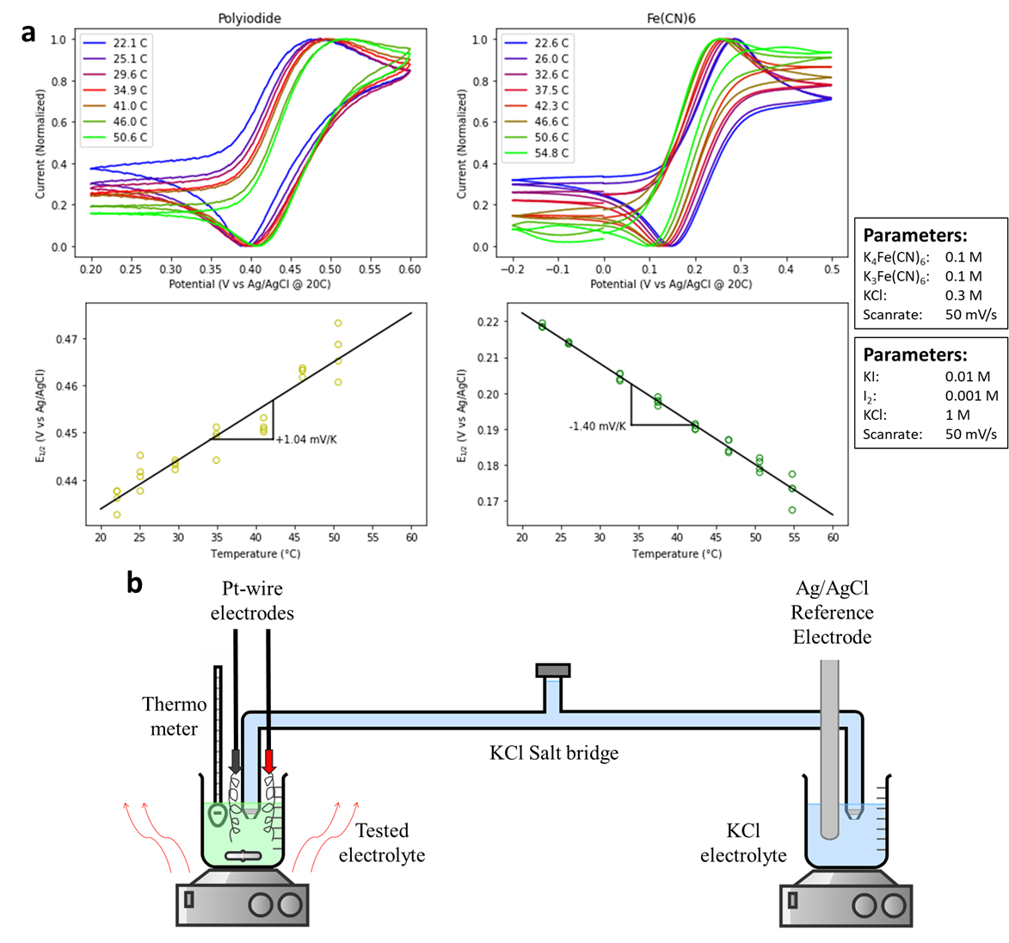
Figure S-2. a. Top panels: CV scans of the two electrolyte couples at different temperatures. Bottom panels: Half-cell potentials (from the CV scans) plotted against the temperature. The slope of the linear fit is the Seebeck coefficient.b. Schematic representation of the Seebeck coefficient measurement setup with a long salt bridge. The reference electrode is kept at room temperature, while the tested electrolyte is heated.

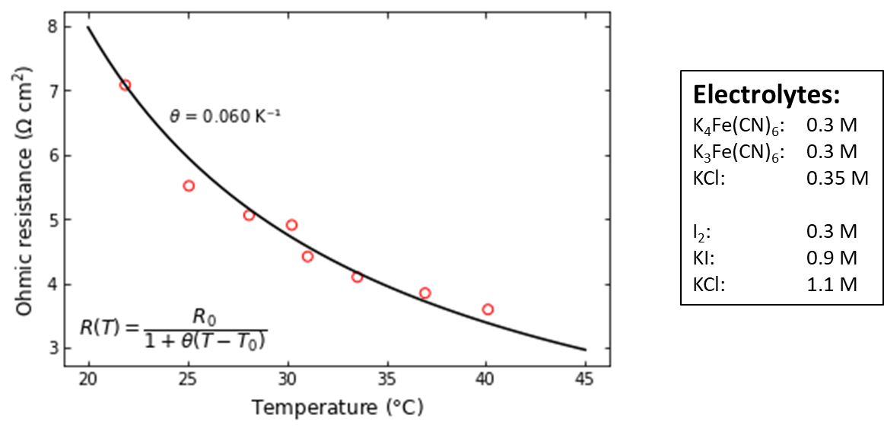
Figure S-3. Ohmic resistance of a single cell against temperature. The data was using the SciPy curve_fit in Python fitted to find parameter θ.

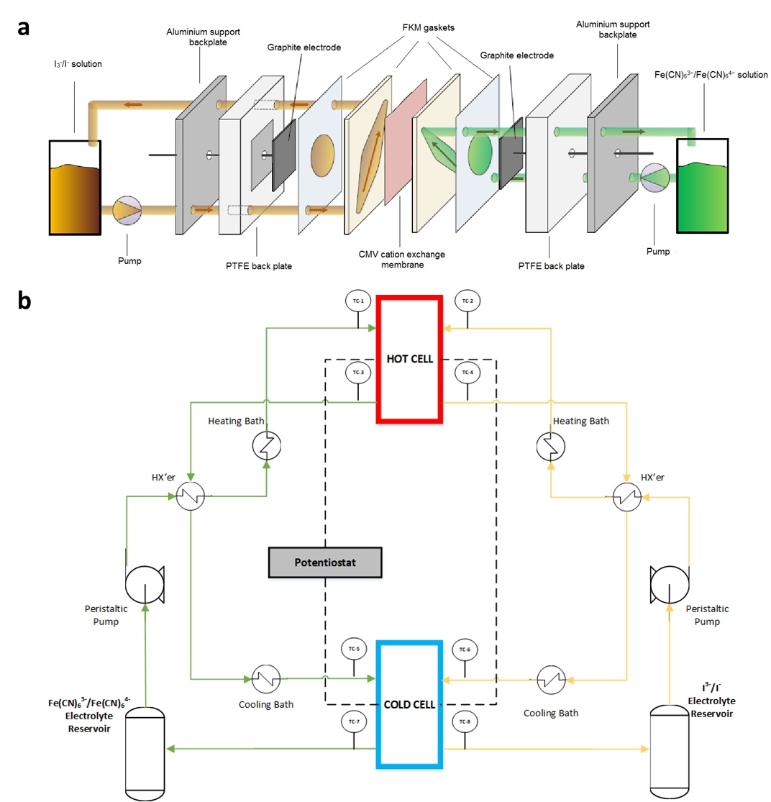
Figure S-4. a. Exploded view of the used flow cell setup. b. Schematic representation of the two flow cell proof of concept setup, which was used to convert heat into electricity.

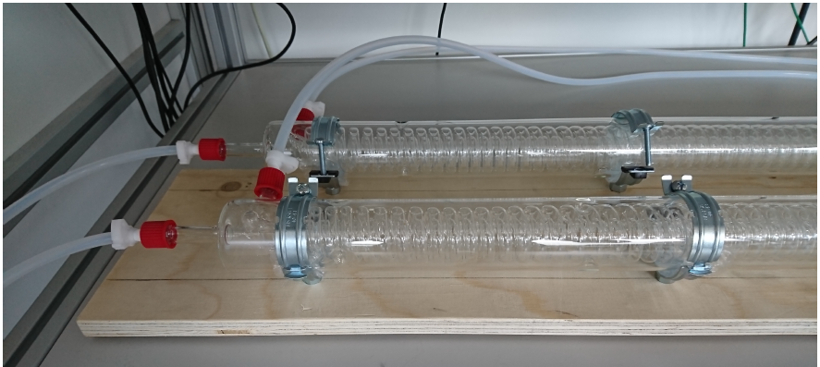
Figure S-5. Photograph of the glass heat exchangers

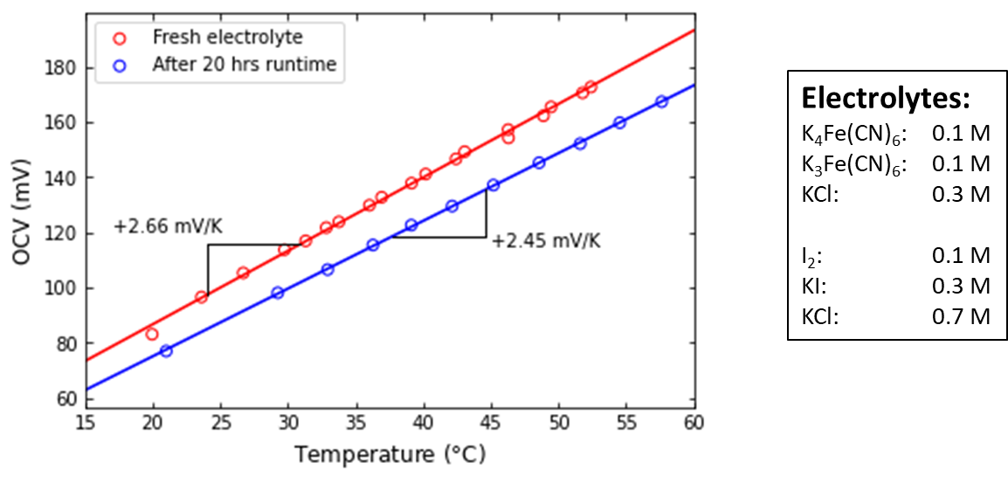
Figure S-6. Seebeck coefficient measured in fresh electrolyte and after 20 hours of measuring.

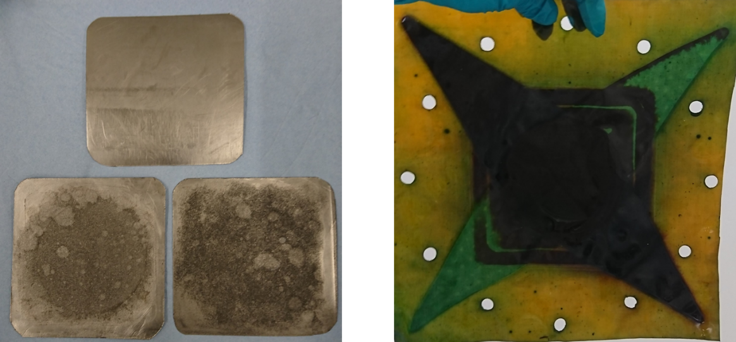
Figure S-7. Photos of the corrosion on the graphite electrodes (left) and the membrane (right)

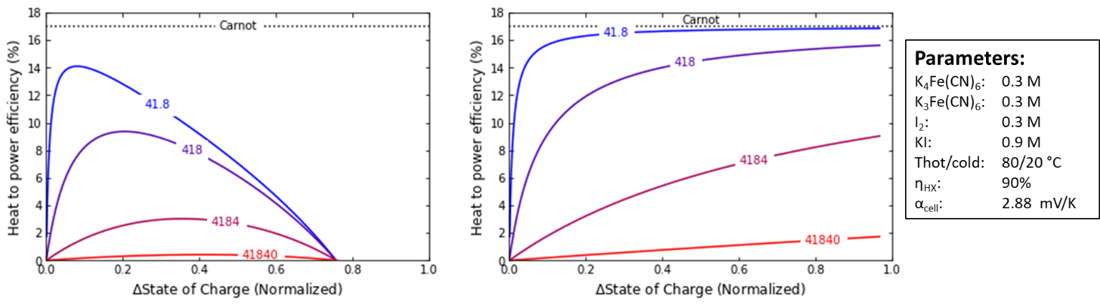
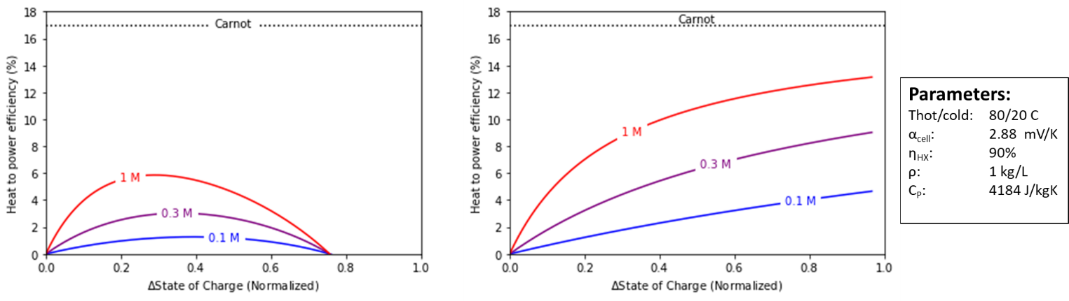
Figure S-8. Calculated effects of heat capacity (Top) and electrolyte concentration (bottom) on the heat to power efficiency. The left graphs are for a system operating in continuous mode, while the right graphs are for batch mode operation.
Note: Concentrations are written as per Fe(CN)₆ (i.e. 0.1 M = 0.1 M for Fe(CN)₆^{3-/4-}, I₂ and 0.3 M for KI)

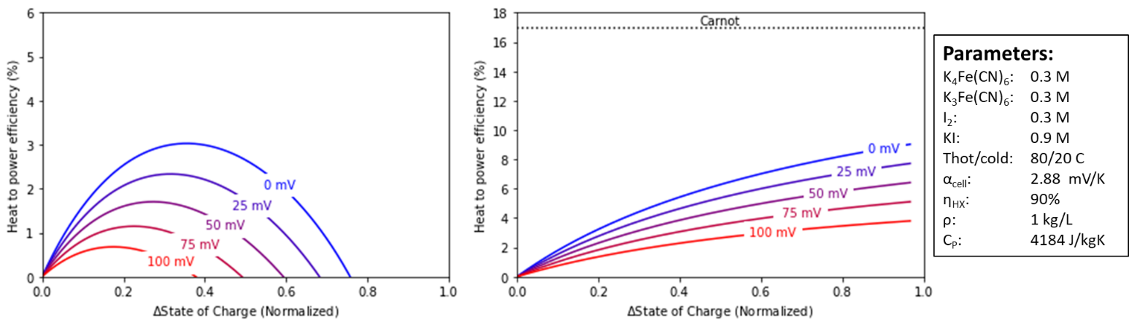
Figure S-9. Calculated effects of ohmic losses on the heat to power efficiency for a system operating in continuous mode (left) and batch mode (right).

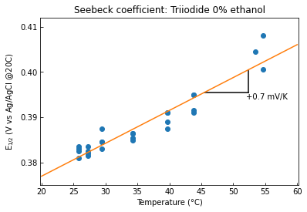
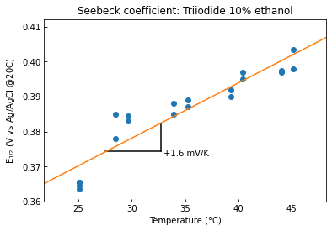
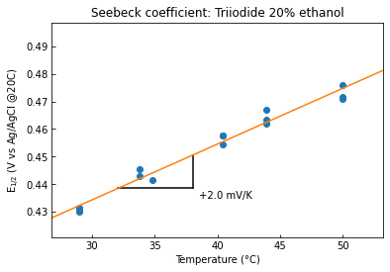
Figure S-10. Effect of adding a volume fraction of ethanol to the Seebeck coefficient of the I⁻/I₃⁻ redox couple. The used electrolytes were:
Top. 1M KI, 0.1 M I₂, 0% EtOH
Middle. 1M KI, 0.1 M I₂, 10% EtOH
Bottom. 1M KI, 0.1 M I₂, 20% EtOH

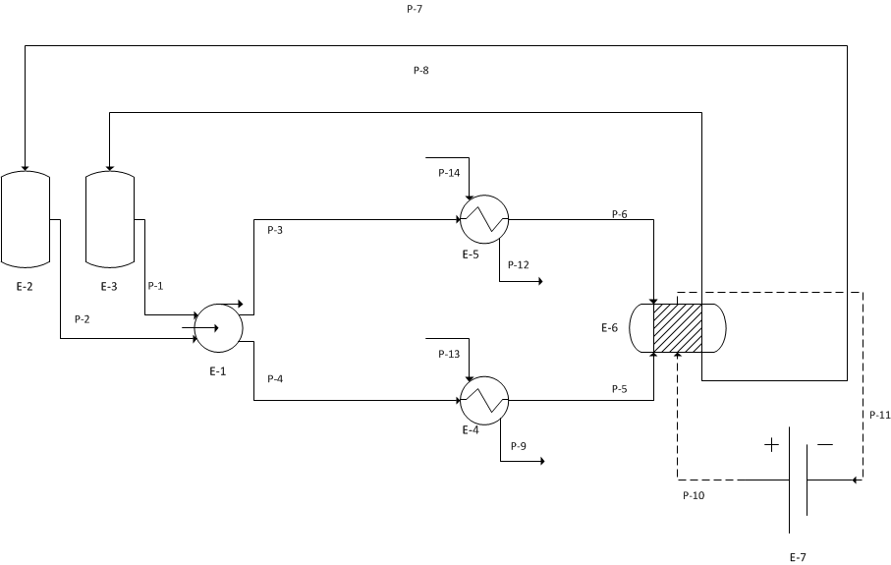
Figure S-11. Process flow diagram of the single cell experimental setup.
Equipment number (E-x) | Equipment
1 | Peristaltic pump
2 | Electrolyte container (0.5 L)
3 | Electrolyte container (0.5 L)
4 | Heating bath
5 | Heating bath
6 | Flow cell
7 | Potentiostat

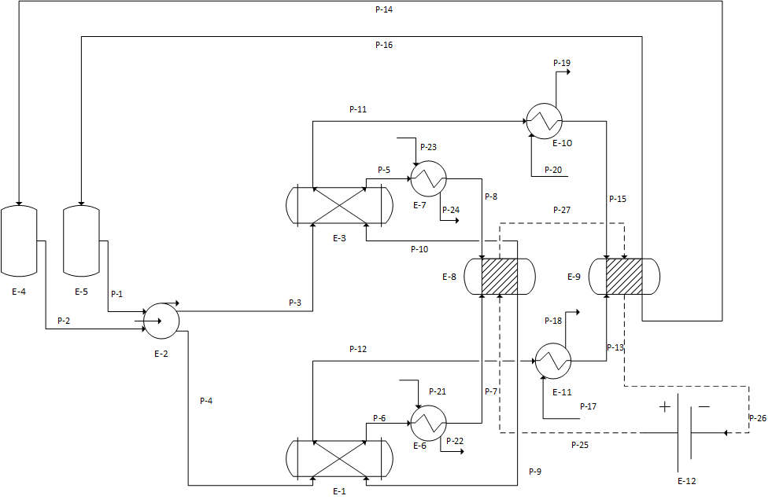
Figure S-12. Process flow diagram of the two cell experimental setup.
Equipment number (E-x) | Equipment
1 | Heat exchanger
2 | Peristaltic pump
3 | Heat exchanger
4 | Electrolyte container (2 L)
5 | Electrolyte container (2 L)
6 | Heating bath
7 | Heating bath
8 | Hot flow cell
9 | Cold flow cell
10 | Cooling bath
11 | Cooling bath
12 | Potentiostat

Supplementary Note 1. Seebeck coefficient derivation
To derive the equation for the Seebeck coefficient, we start at the relation between Gibbs energy and the electrochemical potential:
$$E= -\frac{∆G}{nF}$$
Here E is the electrochemical potential in V, ΔG is the change in Gibbs energy during the reaction in J/mol, n is the amount of electrons transferred in the reaction and F is Faradays constant.
We then substitute the Gibbs energy with the enthalpy and the entropy:
$$E=T∆S-∆H$$
Here T is the temperature in K, ΔS is the change in entropy during the reaction in J/(mol K) and ΔH is the change in enthalpy during the reaction in J/mol. The Seebeck coefficient is the temperature derivative of the electrochemical potential:
$$α=\left(\frac{dE}{dT}\right)=\frac{∆S}{nF}+\left(\frac{T\left(\frac{d∆S}{dT}\right)-\left(\frac{d∆H}{dT}\right)}{nF}\right)$$
Here α is the Seebeck coefficient of the redox reaction in V/K. Note that Δ represents the change due to reaction and d is used for a derivative, e.g. (dΔS/dT) is the first derivative of the reaction entropy to the temperature.
When assuming a constant pressure (dP = 0), the following relations can be used:
$${\left(\frac{∂∆S}{∂T}\right)}_{P}=\frac{∆C_{P}}{T}$$
$$\left(\frac{d∆H}{dT}\right)=d∆S={\left(\frac{∂∆S}{∂T}\right)}_{P}dT+{\left(\frac{∂∆S}{∂P}\right)}_{T}dP=\int{\frac{{∆C}_{P}}{T}}dT$$
Here, ΔC_{P} is the reaction heat capacity in J/(mol K). This results in:
$$α=\frac{∆S}{nF}+\frac{∆C_{P}-\int{\frac{{∆C}_{P}}{T}}dT}{nF}$$
As noted by Hammond and Risen, the ΔC_{P} terms in the equation are of similar magnitude and of opposite signs, and tend to have a small effect on the Seebeck coefficient (up to 8% of ΔS)¹. Similarly Salvi and deBethune reported a small effect of the reaction heat capacity on the electrode temperature coefficient², which allows us to approximate the Seebeck coefficient to be independent of temperature and mostly dependent on the reaction entropy:
$$α≈\frac{∆S}{nF}$$
To find the concentration dependence of the Seebeck coefficient we use the Nerst equation, where E₀ is the potential at standard conditions, α₀ the Seebeck coefficient at standard concentrations and Q the reaction quotient of the redox reactions:
$$E=E_{0}-\frac{RT}{nF}\ln\left(Q\right)$$
$$α=\frac{dE}{dT}=α_{0}-\frac{R}{nF}\ln\left(Q\right)$$
When using a calibration value for α₀ we can predict the values for non-standard concentrations. E.g. for the Iodide/Tri-iodide redox couple we can use 0.72 mV/K as α₀, the Seebeck coefficient for I⁻/I₃⁻ reported in Bratsch (-0.186 mV/K) corrected with the absolute temperature coefficient of the SHE (+0.906 mV/K). ³ The above equation can be used to predict the Seebeck coefficients at non-standard concentrations from our work and two literature sources:
Table S-1. Comparision of reported Seebeck coefficients of the I⁻/I₃⁻ redox couple
Source | [I-] (mol/L) | [I3-] (mol/L) | ln(Q) | α – reported (mV/K) | α – calculated* (mV/K)
Ding et al⁴ | 1.9 | 0.1 | 4.23 | 0.53 | 0.54
Qian et al⁵ | 0.9 | 0.1 | 1.99 | 0.63** | 0.63
This work | 0.009 | 0.001 | -7.22 | 1.04 | 1.03
* α is calculated according to α = α₀ – R/nF·ln([I⁻]^3/[I₃⁻]), where α₀ is 0.72 mV/K and R/nF = 4.31·10⁻² mV/K
** This value is predicted, based on the 0.1 mV/K larger cell Seebeck coefficient of Qian et al

Supplementary Note 2. Carnot efficiency from TS-diagram
The TS-diagram (Figure 1B of main article) illustrates the work via the area enclosed by the cycle. Step 1 and 3 of this cycle represent the heating and cooling, respectively, in the heat exchanger. A complete heat exchange is assumed (i.e., 100% heat recuperation). As the heat capacity of the cold and hot fluids can be assumed the same (see previous section), this implies that the $ΔT$ for step 1 and 3 are equal. When the external waste heat is added to the hot battery itself, and removed from the cold battery, the discharging at step 2 and charging at step 4 are being performed isothermal. Hence, this cycle corresponds to a trapezium, depicted in Fig. 2B of the main paper.
The area of this trapezium can be calculated via $area=T_{H}ΔS_{H}-T_{L}ΔS_{L}$, where the subscripts H and L indicate High and Low temperature, respectively. As the reaction enthalpy is assumed to be independent of temperature (i.e., $ΔH_{H}=ΔH_{L}$), which is again justified from the small effect of heat capacity compared to reaction entropy, this area corresponds to the change in Gibbs energy during discharging and charging, i.e., the maximum obtainable work.
Similarly, the heat input, required for step 2, is equal to $T_{H}ΔS_{H}$. Combining these two values yields the heat to power energy efficiency:
$η=\frac{T_{H}ΔS_{H}-T_{L}ΔS_{L}}{T_{H}ΔS_{H}}$
Because the reaction entropy during discharging and charging can also be assumed the same (i.e., ), this simplifies to
$η=\frac{T_{H}-T_{L}}{T_{H}}=1-\frac{T_{L}}{T_{H}}$
Which is equal to the Carnot efficiency. Because this derivation has assumed a 100% heat recuperation and assumed that the work is equal to the Gibbs energy change, this corresponds to an idealized case without Ohmic losses and heat losses.

Supplementary Note 3. Seebeck coefficients for simple redox reactions
We collected Seebeck coefficient data from literature, to investigate our theory shown in Figure 2C, which says:
- Simple redox couples consisting of cations have a positive Seebeck coefficient
- Simple redox couples consisting of anions have a negative Seebeck coefficient
As of now, we did not find any exceptions to the theory, and it seems that for most simple redox reactions the entropy change is mainly caused by a change in hydration shell. See figure S-13and table S-2:

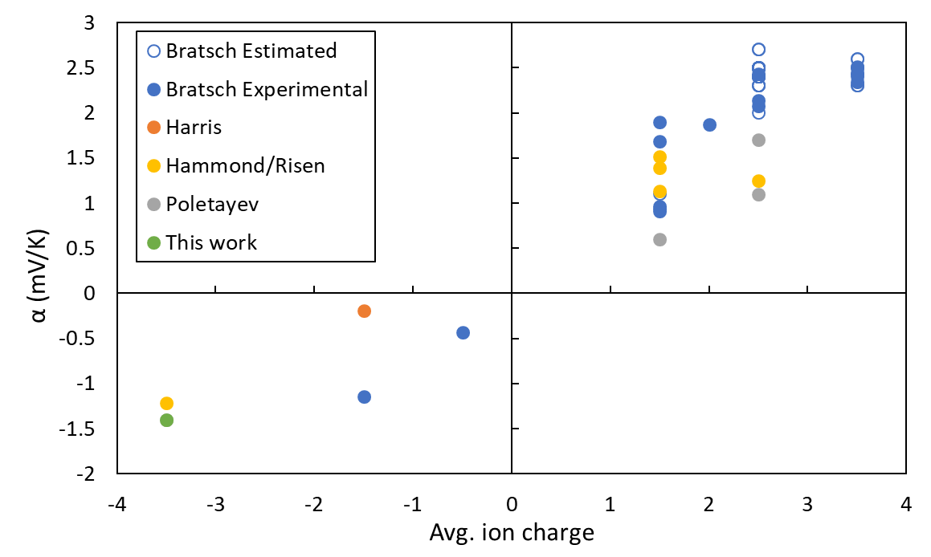
Figure S-13. Comparision of Seebeck coefficient with the average charge of the redox-active species of a redox reaction (e.g. average charge is +2.5 for Fe³⁺+ e⁻ Fe²⁺). The data this figure contains estimated and experimental Seebeck coefficients from Bratsch ³, and experimental values from Harris⁶, Hammond & Risen¹ and this work.
Table S-2. Tabulated Seebeck coefficients from Bratsch³, Harris⁶, Hammond/Risen¹, Poletayev⁷ and this work.
Redox couple | (dV/dT)_{isothermal}*  mV / K | α  mV / K | Avg Charge | Source | Seebeck Data
Pr4+ / Pr3+ | +1.4 | +2.3 | +3.5 | Bratsch | Estimated
Tb4+ / Tb3+ | +1.5 | +2.4 | +3.5 | Bratsch | Estimated
Pa4+ / Pa3+ | +1.7 | +2.6 | +3.5 | Bratsch | Estimated
Am4+ / Am3+ | +1.4 | +2.3 | +3.5 | Bratsch | Estimated
Cm4+ / Cm3+ | +1.7 | +2.6 | +3.5 | Bratsch | Estimated
Bk4+ / Bk3+ | +1.6 | +2.5 | +3.5 | Bratsch | Estimated
Cf4+ / Cf3+ | +1.6 | +2.5 | +3.5 | Bratsch | Estimated
Sc3+ / Sc2+ | +1.6 | +2.5 | +2.5 | Bratsch | Estimated
Pr3+ / Pr2+ | +1.6 | +2.5 | +2.5 | Bratsch | Estimated
Nd3+ / Nd2+ | +1.6 | +2.5 | +2.5 | Bratsch | Estimated
Pm3+ / Pm2+ | +1.5 | +2.4 | +2.5 | Bratsch | Estimated
Sm3+ / Sm2+ | +1.4 | +2.3 | +2.5 | Bratsch | Estimated
Dy3+ / Dy2+ | +1.6 | +2.5 | +2.5 | Bratsch | Estimated
Ho3+ / Ho2+ | +1.6 | +2.5 | +2.5 | Bratsch | Estimated
Er3+ / Er2+ | +1.6 | +2.5 | +2.5 | Bratsch | Estimated
Tm3+ / Tm2+ | +1.6 | +2.5 | +2.5 | Bratsch | Estimated
Yb3+ / Yb2+ | +1.4 | +2.3 | +2.5 | Bratsch | Estimated
Pu3+ / Pu2+ | +1.5 | +2.4 | +2.5 | Bratsch | Estimated
Am3+ / Am2+ | +1.8 | +2.7 | +2.5 | Bratsch | Estimated
Bk3+ / Bk2+ | +1.6 | +2.5 | +2.5 | Bratsch | Estimated
Cf3+ / Cf2+ | +1.6 | +2.5 | +2.5 | Bratsch | Estimated
Es3+ / Es2+ | +1.6 | +2.5 | +2.5 | Bratsch | Estimated
Fm3+ / Fm2+ | +1.6 | +2.5 | +2.5 | Bratsch | Estimated
Md3+ / Md2+ | +1.6 | +2.5 | +2.5 | Bratsch | Estimated
No3+ / No2+ | +1.5 | +2.4 | +2.5 | Bratsch | Estimated
Ti3+ / Ti2+ | +1.5 | +2.4 | +2.5 | Bratsch | Estimated
V3+ / V2+ | +1.5 | +2.4 | +2.5 | Bratsch | Estimated
Cr3+ / Cr2+ | +1.4 | +2.3 | +2.5 | Bratsch | Estimated
Mn3+ / Mn2+ | +1.8 | +2.7 | +2.5 | Bratsch | Estimated
Ni3+ / Ni2+ | +1.1 | +2.0 | +2.5 | Bratsch | Estimated
Cu3+ / Cu2+ | +1.5 | +2.4 | +2.5 | Bratsch | Estimated
(UO2)2+ / (UO2)+ | +0.2 | +1.1 | +1.5 | Bratsch | Estimated
Ce4+ / Ce3+ | +1.54 | +2.45 | +3.5 | Bratsch | Experimental
U4+ / U3+ | +1.61 | +2.52 | +3.5 | Bratsch | Experimental
Np4+ / Np3+ | +1.53 | +2.44 | +3.5 | Bratsch | Experimental
Pu4+ / Pu3+ | +1.441 | +2.347 | +3.5 | Bratsch | Experimental
Eu3+ / Eu2+ | +1.53 | +2.44 | +2.5 | Bratsch | Experimental
Fe3+ / Fe2+ | +1.175 | +2.081 | +2.5 | Bratsch | Experimental
Co3+ / Co2+ | +1.23 | +2.14 | +2.5 | Bratsch | Experimental
Tl3+ / Tl+ | +0.97 | +1.90 | +2 | Bratsch | Experimental
(NpO2)2+ / (NpO2)+ | +0.058 | +0.964 | +1.5 | Bratsch | Experimental
(PuO2)2+ / (PuO2)+ | +0.03 | +0.94 | +1.5 | Bratsch | Experimental
(AmO2)2+ / (AmO2)+ | +0.01 | +0.92 | +1.5 | Bratsch | Experimental
Cu2+ / Cu+ | +0.776 | +1.682 | +1.5 | Bratsch | Experimental
Ag2+ / Ag+ | ⁺0.99 | +1.90 | +1.5 | Bratsch | Experimental
(ClO2) / (ClO2)- | -1.335 | -0.429 | -0.5 | Bratsch | Experimental
(MnO4)- / (MnO4)2- | -2.05 | -1.14 | -1.5 | Bratsch | Experimental
Fe3+ / Fe2+ (Salicylamide) | N/A | +1.25** | +2.5 | Hammond/Risen | Experimental
Cu2+ / Cu+ (Acetate) | N/A | +1.13** | +1.5 | Hammond/Risen | Experimental
Cu2+ / Cu+ (Pyridine) | N/A | +1.51** | +1.5 | Hammond/Risen | Experimental
Cu2+ / Cu+ (NH3) | N/A | +1.39** | +1.5 | Hammond/Risen | Experimental
[Fe(CN)6]3- / [Fe(CN)6]4- | N/A | -1.21** | -3.5 | Hammond/Risen | Experimental
Mn(EDTA)- / Mn(EDTA)2- | -1.1 | -0.19 | -1.5 | Harris | Experimental
V3+/V2+ | N/A | +1.7 | +2.5 | Poletayev | Experimental
Fe3+/Fe2+ | N/A | +1.1 | +2.5 | Poletayev | Experimental
Methyl Viologen (2+/1+) | N/A | +0.6 | +1.5 | Poletayev | Experimental
[Fe(CN)6]3- / [Fe(CN)6]4- | N/A | -1.4 | -3.5 | Poletayev | Experimental
[Fe(CN)6]3- / [Fe(CN)6]4- | N/A | -1.4 | -3.5 | This work | Experimental
*Bratsch and Harris reported isothermal temperature coefficients, they have been converted into the Seebeck coefficient by adding the Seebeck coefficient of the SHE (0.906 mV/K³)
**Hammond & Risen reported ΔS values of the redox reactions, these have been converted into the Seebeck coefficient with equation 2.

Supplementary Note 4. Figure of merit calculation:
The figure of merit is a dimensionless constant to indicate the relative energy gain to the total heating of the system. Figure of merit (Y) calculations were done as per methods of Lee et al ⁸:
$$Y=\frac{αq_{c}}{c_{P}}$$
Here Y is the figure of merit, α is the total Seebeck coefficient, q_{c} is the charge capacity and heat capacity per unit volume. For solid electrodes, it is more convenient to do this calculation per unit of mass.
Figure of merit calculation for our system
α = |α_{cell}| = 2.88 mV K⁻¹
Specific charge capacity is calculated for various ΔSOC, as the battery in continuous mode requires a ΔSOC of less than 0.75 to have a positive energy gain. Specific charge capacity is then defined as:
$$q_{c}=\frac{ΔSOC⋅total charge}{total volume}$$
As ferro/ferri-cyanide is the limiting reactant in our system, it will be used in total charge. For ease of calculation, 1L of both electrolytes is assumed.
1 L of 0.3M K₃Fe(CN)₆, 0.3M K₄Fe(CN)₆, 0.35M KCl and 1L of 0.3M I₂, 0.9M KI, 1.1M KCl.
q_{c} = ΔSOC · ([Fe(CN)₆³⁻] + [Fe(CN)₆⁴⁻])·n·F/V_{total} = ΔSOC · (0.3M + 0.3M)·1·96485 C mol⁻¹/2 L = ΔSOC·28945 C L⁻¹
The heat capacity of our electrolytes was calculated using standard heat capacities reported by Hepler and Hovey⁹:
- K₃Fe(CN)₆ = -215 J mol⁻¹ K⁻¹ ⁹
- K₄Fe(CN)₆ = -475 J mol⁻¹ K⁻¹ ⁹
- KCl = -114 J mol⁻¹ K⁻¹ ⁹
- KI = -109 J mol⁻¹ K⁻¹ ⁹
- KI₃ = +170 J mol⁻¹ K⁻¹ ¹⁰ - assumed all I₂ reacted with KI
The total heat capacity is:
c_{P} = (c_{P}(2 L water) + c_{P}(0.3 mol K₃Fe(CN)₆) + c_{P}(0.3 mol K₄Fe(CN)₆) + c_{P}(1.45 mol KCl) + c_{P}(0.6 mol KI) + c_{P}(0.3 mol KI₃)/total volume (2L) = (2·4184 - 0.3·215 - 0.3·475 - 1.45·114 - 0.6·109 + 0.3·170)/2 = 3991 J L⁻¹ K⁻¹
Y = 2.88 ·10⁻³ V K⁻¹ · ΔSOC · 28945 C L⁻¹ / 3991 J L⁻¹ K⁻¹
ΔSOC | Y
0.25 | 0.005
0.5 | 0.010
1 | 0.021

Similar to the system of for Hammond and Risen ¹, the concentration of Fe(CN)6 could be increased to 0.5 M each. Assuming that the Seebeck coefficient and heat capacity are not affected by that change, this would increase the Y to 0.033 for ΔSOC = 1.
Figure of merit calculation for Fe(CN)₆^{3-/4-}& Cu(NH₃)₄²⁺/Cu(NH₃)₂⁺ ¹
The volume based Figure of Merit calculation for the system for Hammond and Risen ¹ was done similar to our system:
α = 2.9 mV K⁻¹
Hammond and Risen used 0.5 M of Cu^{1+/2+} and 0.5 M of Fe(CN)₆^{3-/4-}, so neither compound is limiting reactant, No information was given on the heat capacity, so assumed to be similar to water
- q_{c} = ([Fe(CN)₆³⁻] + [Fe(CN)₆⁴⁻])·n·F/V_{total} = (0.5 M + 0.5 M)·1·96485 C mol⁻¹ / 2 L = 48243 C L⁻¹
- c_{P} = 4184 J K⁻¹ L⁻¹
Y = 2.9 · 10⁻³ V K⁻¹ · 48243 C L⁻¹ / 4184 J K⁻¹ L⁻¹ = 0.033
Figure of merit calculation for Fe(CN)₆^{3-/4-}, FeHCF ¹¹
Parameters are taken from the article of Yang et al ¹¹. The heat capacity values were calculated using the supplementary information, assuming a liquid/solid ratio of 1 mL g⁻¹ (i.e. 1 g Prussian blue & 1 mL Fe(CN)₆ solution). The heat capacity of the solution and Prussian blue are 1.1 J g⁻¹ K⁻¹ and 4.18 J cm⁻³ K⁻¹ respectively. Assuming an electrolyte density of 1 g cm⁻³, the average heat capacity per gram is (1.1 + 4.18)/2 = 2.64 J g⁻¹ K⁻¹
- α = 1.45 mV K⁻¹
- q_{c} = 30.0 mAh g⁻¹ = 108 C g⁻¹
- c_{P} = 2.64 J g⁻¹ K⁻¹
Y = 1.45 · 10⁻³ V K⁻¹ · 108 C g⁻¹ / 2.64 J K⁻¹ g⁻¹ = 0.059
Figure of merit calculation for NiHCF, Ag/AgCl system ¹²
Parameters are taken from the article of Yang et al ¹²:
- α = 0.74 mV K⁻¹
- q_{c} = 36.0 mAh g⁻¹ = 129.6 C g⁻¹
- c_{P} = 2.84 J g⁻¹ K⁻¹
Y = 0.74 · 10⁻³ V K⁻¹ · 129.6 C g⁻¹ / 2.84 J g⁻¹ K⁻¹ = 0.034
Figure of merit calculation for Fe(CN)₆^{3-/4-}, V³⁺/V²⁺ system⁷
Parameters are taken from the SI of Poletayev et al⁷
- α = 3.00 mV K⁻¹
- q_{c} = ([Fe(CN)₆³⁻] + [Fe(CN)₆⁴⁻])·n·F/V_{total} = 0.8 mol L⁻¹·1·96485 C mol⁻¹/2 L = 38594 C L⁻¹
- c_{P} = 3.0 J g⁻¹ K⁻¹
- ρ_{avg} = (1160 + 1290 g L⁻¹)/2 = 1225 g L⁻¹
Y = 3.00 · 10⁻³ V K⁻¹ · 38594 C L⁻¹ / 1225 g L⁻¹ / 3.0 J g⁻¹ K⁻¹ = 0.032

Figure of merit calculation for VO₂⁺/VO²⁺, V³⁺/V²⁺ system ¹³
Parameters are taken from the paper of Reynard et al¹³:
- α = 1.16 mV K⁻¹
- c_{P} = 4200 J L⁻¹ K⁻¹
- q_{c} = 1 M total Vanadium·n·F/V_{total} = 1 mol L⁻¹·1·96485 C mol⁻¹/2 L = 48243 C L⁻¹
Y = 1.16 · 10⁻³ V K⁻¹ · 48242 C L⁻¹ / 4200 J L⁻¹ K⁻¹ = 0.013
Figure of merit calculation for the Fe(CN)₆^{3-/4-} & I⁻/I₃⁻ system of Qian et al⁵
Parameters are taken from Qian et al⁵
No heat capacity was reported, assumed similar to water:
- c_{P} = 4184 J K⁻¹ L⁻¹
- α = 1.9 mV K⁻¹
- q_{c} = ([Fe(CN)₆³⁻] + [Fe(CN)₆⁴⁻])·n·F/V_{total} = 0.75 mol L⁻¹·1·96485 C mol⁻¹/2 L = 36182 C L⁻¹
Y = 1.9 · 10⁻³ V K⁻¹ · 36182 C L⁻¹ / 4184 J L⁻¹ K⁻¹ = 0.016

Supplementary Note 5. Derivation of maximum Power and energy losses
To derive the maximum power we define the cell voltage in three parts:
- The open cell voltage , E_{OC}, which is the cell voltage at zero current
  - For our cell E_{OC} = αΔT
- The current dependent losses:
  - The Ohmic losses, IR, which is the current times the Ohmic resistance
  - The charge transfer losses, η_{CT}(I) , in the form of a reaction overpotential
- The current independent losses:
  - The concentration overpotential, RT/nF ln(Q).
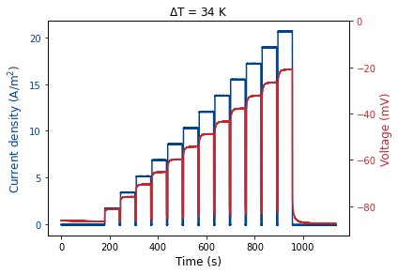
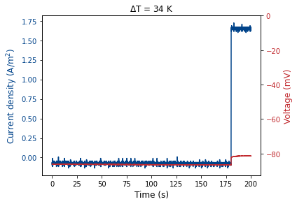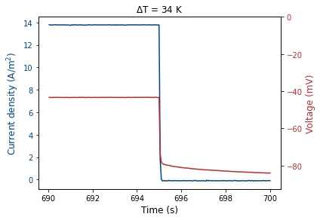
Figure S-13. Current/Voltage time curves for the system. Cold and hot cell operate at 20 and 54 °C respectively

For a discharging battery, the voltage then becomes:
 | $$U=E_{OC}-IR-η_{CT}\left(I\right)+\frac{RT}{nF}\ln\left(Q\right)$$ | (1)
We can measure E_{OC} at the start of the measurements where the concentrations are still unchanged. When interrupting the current, the IR and η_{CT}(I) terms become 0, and what is left is the E_{OC} and the RT/nF lnQ term.
At the maximum power density the temperature and current density are equal to ΔT = 34 K and j = 13.8 A/m².
The OCV at 0 A/m² is 86.6 mV, U at 13.8 A/m² is 43.4 mV, and U after the current interrupt is 78.2 mV.
The current dependent voltage change is 35 mV and the current independent change is 8.4 mV. This means that 10% of energy is lost due to concentration overpotential, and 40% due to Ohmic and activation overpotential losses. At maximum power density, the temperature of the hot and cold cell are 20 °C and 54 °C respectively, which results in a Carnot efficiency of 10.4%. As half of the energy is lost, the maximum heat to power efficiency at this power density is 5.2%.
Supplementary Note 6. Explanation of the Python model:
The calculations for Figure 4 a & b were done in two steps:
- The calculation of the cell potential at 20 and 80 °C for all state of charge, for a certain starting concentration of redox active species.
- Calculation of the heat to power efficiency for the full range of Δstate of charge and heat exchanger efficiencies

- Calculation of the cell potential
The cell potential was calculated with Nernst equation modified with a Seebeck coefficient. For a general half reaction, a·A(aq) + n·e⁻ b·B(aq) where unity activity coefficients are assumed, this equals:
$$E_{\frac{1}{2}}\left(T\right)=E_{\frac{1}{2}}^{0}+\left(T-T^{0}\right)∙α+\frac{RT}{nF}\ln\left(\frac{{\left[A\right]}^{a}}{{\left[B\right]}^{b}}\right)$$
- E_{1/2}(T) is the half-reaction potential at temperature T and concentrations [A] & [B]
- E_{1/2}⁰ is the standard half-reaction potential at 25 °C (298.15 K) and 1 M concentrations
- R, Ideal gas constant (8.314 J mol⁻¹K⁻¹)
- T, Temperature in degrees Kelvin (T₀ = 298.15 K)
- α, Seebeck coefficient of half reaction in V K⁻¹
- n, number of electrons that are transferred in the half reaction
- F, Faraday constant – 96485 C mol⁻¹
- [A]&[B], concentration of A and B in mol L⁻¹
- a & b, stoichiometry of A & B in the half reaction
The E_{1/2}⁰ of the ferrocyanide and triiodide reactions are as follows:
- I₃⁻ + 2e⁻ 3 I⁻ E⁰ = 0.54 V vs NHE
- Fe(CN)₆³⁻ + e⁻ Fe(CN)₆⁴⁻ E⁰ = 0.36 V vs NHE
When writing down the cell reaction for a spontaneous (galvanic) reaction, for n = 1, you get:
$$0.5I_{3}^{-}+Fe{\left(CN\right)}_{6}^{4-}→1.5I^{-}+Fe{\left(CN\right)}_{6}^{3-}$$
The cell potential then becomes:
$$E_{cell}\left(T\right)={E_{I_{3}}-E}_{Fe{\left(CN\right)}_{6}}=E_{cell}^{0}+\left(T-T^{0}\right)∙α_{cell}+\frac{RT}{nF}\ln\left(\frac{{\left[I_{3}^{-}\right]}^{0.5}\left[Fe{\left(CN\right)}_{6}^{4-}\right]}{{\left[I^{-}\right]}^{1.5}\left[Fe{\left(CN\right)}_{6}^{3-}\right] }\right)$$
- n = 1
- E_{cell}⁰, cell potential (0.54 – 0.36 V = 0.18 V)
- α_{cell}, +2.88 mV/K, as measured in figure 2B for the below concentrations
  - K₄Fe(CN)₆ 0.3 M
  - K₃Fe(CN)₆ 0.3 M
  - I₂ 0.3 M
  - KI 0.9 M (results in 0.6 M I⁻ + 0.3 M I₃⁻)
Using the E_{cell}(T) formula, we created the following V-dQ graph:
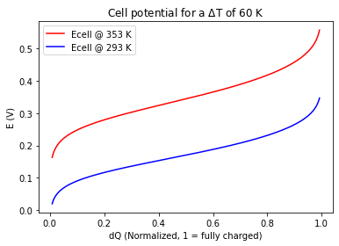
dQ | [Fe(CN)₆⁴⁻] | [Fe(CN)₆³⁻] | [I₃⁻] | [I⁻]
0 | 0 | 0.6 | 0.15 | 1.05
0.25 | 0.15 | 0.45 | 0.225 | 0.825
0.50 | 0.3 | 0.3 | 0.3 | 0.6
0.75 | 0.45 | 0.15 | 0.375 | 0.425
1 | 0.6 | 0 | 0.45 | 0.15
Here dQ is the normalized state of charge, which can be converted into the concentrations (mol L⁻¹) using the table below:

- Calculation of the heat to power efficiency
For a continuous system, without segmented electrodes, the entire flow cell will operate at the voltage of the flow cell outlet. This can be illustrated with the below graph, where E₁ and E₂ indicate operating voltages of the hot and cold flow cell respectively:
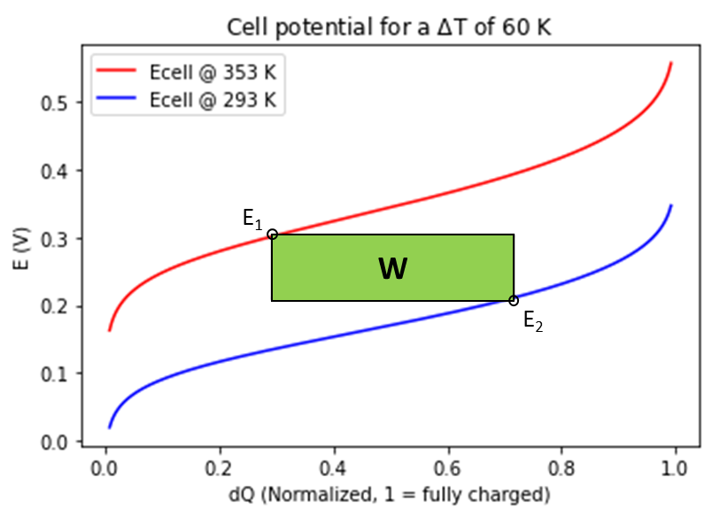
In a batch system, the full surface of the V-dQ can be harvested, which will result in a figure like Figure 1c.
ΔSOC | dQ-charged | dQ-discharged
0 | 0.5 | 0.5
0.2 | 0.6 | 0.4
0.5 | 0.75 | 0.25
0.8 | 0.90 | 0.10
1 | 1 | 0
The energy costs of heating and cooling have a set value, and the energy gain per cycle is strongly dependent on the extend of (dis)charge (ΔSOC). For the sake of the model we chose that the ΔSOC would be around a normalized dQ of 0.5, which results in the following table:

The efficiency is calculated as:
$$η=\frac{W}{Q_{in HX}+Q_{in reaction}}$$
For a system operating in continuous mode, Q_{in} and W are as follows:
$$W=\left(E_{1}-E_{2}\right)∙Δn∙n∙F$$
$$Q_{in HX }= ρ∙C_{p}∙V∙ΔT∙(1-η_{HX})$$
$$Q_{in reaction}=ΔS∙T_{H}∙Δn$$
For a system operating in batch mode, W changes to:
$$W=ΔS∙ΔT∙Δn$$
We chose a total volume of 2 L electrolyte (1 L of each electrolyte), so the concentrations are equal to the amount of moles. The symbols in the above equations:
- W Generated energy by the TREC in Joules
- Q_{in HX} Extra energy required to heat up system to operating temperature after imperfect heat exchanger, in Joules
- Q_{in reaction} Required energy for endothermic reaction in hot flow cell, in J
- E₁&E₂ Operating voltage of the hot & cold flow cell as per the figure above, in Volts
- Δn Amount of moles that react at this ΔSOC, in mol
- n Number of electrons that are transferred in the half reaction
- F Faraday constant, 96485 C mol⁻¹
- ρ Density, 1 kg L⁻¹
- C_{P} Heat capacity, 4184 J kg⁻¹ K⁻¹
- V Electrolyte volume, 2 L
- ΔT Temperature difference between hot and cold flow cells, in degrees Kelvin
- η_{HX} Efficiency of the heat exchanger
- ΔS Entropy change of the reaction, in J mol⁻¹ K⁻¹
- T_{H} Temperature of the hot cell
All these calculations where implemented into a python script, which resulted in the figures in the paper and supplementary information.

References
1. Hammond RH, Risen WM. An electrochemical heat engine for direct solar energy conversion. Solar Energy 1979, 23(5): 443-449.

2. Salvi GR, deBethune AJ. The Temperature Coefficients of Electrode Potentials. Journal of The Electrochemical Society 1961, 108(7): 672.

3. Bratsch S. Standard Electrode Potentials and Temperature Coefficients in Water at 298.15 K. Journal of Physical and Chemical Reference Data 1989, 18: 1-21.

4. Ding Y, Guo X, Ramirez-Meyers K, Zhou Y, Zhang L, Zhao F, et al. Simultaneous energy harvesting and storage via solar-driven regenerative electrochemical cycles. Energy & Environmental Science 2019, 12(11): 3370-3379.

5. Qian X, Shin J, Tu Y, Zhang JH, Chen G. Thermally Regenerative Electrochemically Cycled Flow Batteries with pH Neutral Electrolytes as for Harvesting Low-Grade Heat. Physical Chemistry Chemical Physics 2021.

6. Harris DC. Quantitative chemical analysis. Freeman: New York, 2003.

7. Poletayev AD, McKay IS, Chueh WC, Majumdar A. Continuous electrochemical heat engines. Energy & Environmental Science 2018, 11(10): 2964-2971.

8. Lee SW, Yang Y, Lee H-W, Ghasemi H, Kraemer D, Chen G, et al. An electrochemical system for efficiently harvesting low-grade heat energy. Nature Communications 2014, 5(1): 3942.

9. Hepler L, Hovey J. Standard state heat capacities of aqueous electrolytes and some related undissociated species. Canadian Journal of Chemistry 2011, 74: 639-649.

10. Lemire RJ, Campbell AB, Saluja PPS, LeBlanc JC. Heat capacities and densities of electrolyte mixtures in aqueous solution — Application to the determination of apparent molar heat capacities and volumes for potassium triiodide and dioxoneptunium(V) perchlorate. Journal of Nuclear Materials 1993, 201: 165-175.

11. Yang Y, Lee SW, Ghasemi H, Loomis J, Li X, Kraemer D, et al. Charging-free electrochemical system for harvesting low-grade thermal energy. Proc Natl Acad Sci U S A 2014, 111(48): 17011-17016.

12. Yang Y, Loomis J, Ghasemi H, Lee SW, Wang YJ, Cui Y, et al. Membrane-Free Battery for Harvesting Low-Grade Thermal Energy. Nano Letters 2014, 14(11): 6578-6583.

13. Reynard D, Dennison CR, Battistel A, Girault HH. Efficiency improvement of an all-vanadium redox flow battery by harvesting low-grade heat. Journal of Power Sources 2018, 390: 30-37.

