Supplemental data

Title:
Effects of carbon ion beam-induced mutagenesis for the screening of RED production-deficient mutants of Streptomyces coelicolor JCM4020

Authors:
Masaomi Yanagisawa^{†a}, Shumpei Asamizu^{†*a,b}, Katsuya Satoh^{c}, Yutaka Oono^{c}, Hiroyasu Onaka^{*a,b}

Affiliations:
ªGraduate School of Agricultural and Life Sciences, The University of Tokyo, 1-1-1
Yayoi, Bunkyo, Tokyo, Japan
^{b}Collaborative Research Institute for Innovative Microbiology (CRIIM), The University of Tokyo, 1-1-1 Yayoi, Bunkyo, Tokyo 113-8657, Japan
^{c}Department of Radiation-Applied Biology Research, Takasaki Advanced Radiation Research Institute, Quantum Beam Science Research Directorate, National Institutes for Quantum Science and Technology, Takasaki, Gunma, Japan

†These authors contributed equally to this work.

*Corresponding authors:
Shumpei Asamizu: asamizu@g.ecc.u-tokyo.ac.jp
Hiroyasu Onaka: aonaka@g.ecc.u-tokyo.ac.jp

Contents of supplemental data

Supplemental Table 1. Result of antiSMASH (ver. 6.0.1) for prediction of secondary metabolite biosynthetic gene cluster in the Streptomyces coelicolor JCM4020.

Supplemental figure 1.
Summary of method to screen RED deficient mutants of S. coelicolor JSM4020 (First screening method).

Supplemental figure 2.
Summary of method to screen RED deficient mutants of S. coelicolor JSM4020 (Second screening method).

Supplemental figure 3_1-5.
Phenotype of the mutants.

Supplemental figure 4.
Mutation caused frameshift in GltB and indicated to inactivate the function.

Supplemental figure 5.
Mutation caused frameshift in FusA and indicated to inactivate the function.

Supplemental figure 6.
Complementation of gltB (sco2026) gene in the Mt 108013 restore the production of RED.

Supplemental figure 7.
Complementation of fusA (sco4661) gene in the Mt 203010 restore the production of RED.

Supplemental Table 2. Primer sequences used in this study.

Supplemental Table 1. Result of antiSMASH (ver. 6.0.1) for prediction of secondary metabolite biosynthetic gene cluster in the Streptomyces coelicolor JCM4020.
Region | Type | From | To | Most similar known cluster |  | Similarity
Region 1 | hglE-KS,T1PKS | 71,407 | 124,413 | leinamycin | NRP + Polyketide:Modular type I + Polyketide:Trans-AT type I | 2%
Region 2 | terpene | 161,627 | 186,108 | isorenieratene | Terpene | 100%
Region 3 | lanthipeptide-class-i | 246,919 | 270,450
Region 4 | NRPS | 477,557 | 527,471 | coelichelin | NRP | 100%
Region 5 | RiPP-like | 774,865 | 783,131 | informatipeptin | RiPP:Lanthipeptide | 42%
Region 6 | lanthipeptide-class-i | 1,044,545 | 1,069,733
Region 7 | T3PKS | 1,382,895 | 1,421,712 | herboxidiene | Polyketide | 8%
Region 8 | ectoine | 2,121,065 | 2,131,463 | ectoine | Other | 100%
Region 9 | melanin | 3,096,622 | 3,107,191 | istamycin | Saccharide | 4%
Region 10 | siderophore | 3,191,637 | 3,202,807 | desferrioxamin B / desferrioxamine E | Other | 83%
Region 11 | NRPS | 3,691,637 | 3,770,751 | CDA1b / CDA2a / CDA2b / CDA3a / CDA3b / CDA4a / CDA4b | NRP:Ca+-dependent lipopeptide | 87%
Region 12 | T2PKS | 5,572,997 | 5,643,749 | actinorhodin | Polyketide:Type II | 100%
Region 13 | terpene | 5,747,286 | 5,767,846 | albaflavenone | Terpene | 100%
Region 14 | T2PKS | 5,827,242 | 5,899,784 | spore pigment | Polyketide | 66%
Region 15 | siderophore | 6,386,090 | 6,396,425
Region 16 | T1PKS,NRPS-like,prodigiosin | 6,479,428 | 6,526,198 | undecylprodigiosin | NRP + Polyketide | 100%
Region 17 | RiPP-like | 6,769,891 | 6,781,207
Region 18 | terpene | 6,793,711 | 6,813,180 | geosmin | Terpene | 100%
Region 19 | siderophore | 6,979,324 | 6,992,543 | enduracidin | NRP | 6%
Region 20 | T1PKS,butyrolactone | 7,017,911 | 7,088,990 | coelimycin P1 | Polyketide:Modular type I | 100%
Region 21 | thioamide-NRP,NRPS | 7,220,287 | 7,274,470 | nogalamycin | Polyketide | 40%
Region 22 | lanthipeptide-class-iii | 7,532,377 | 7,555,091 | SapB | RiPP:Lanthipeptide | 100%
Region 23 | terpene | 7,628,374 | 7,654,201 | hopene | Terpene | 100%
Region 24 | other,T3PKS | 7,947,407 | 8,022,409 | germicidin | Other | 100%
Region 25 | indole | 8,244,084 | 8,265,211 | 5-isoprenylindole-3-carboxylate β-D-glycosyl ester | Other | 28%
Region 26 | T3PKS,NRPS,terpene | 8,451,394 | 8,524,513 | coelibactin | NRP | 100%

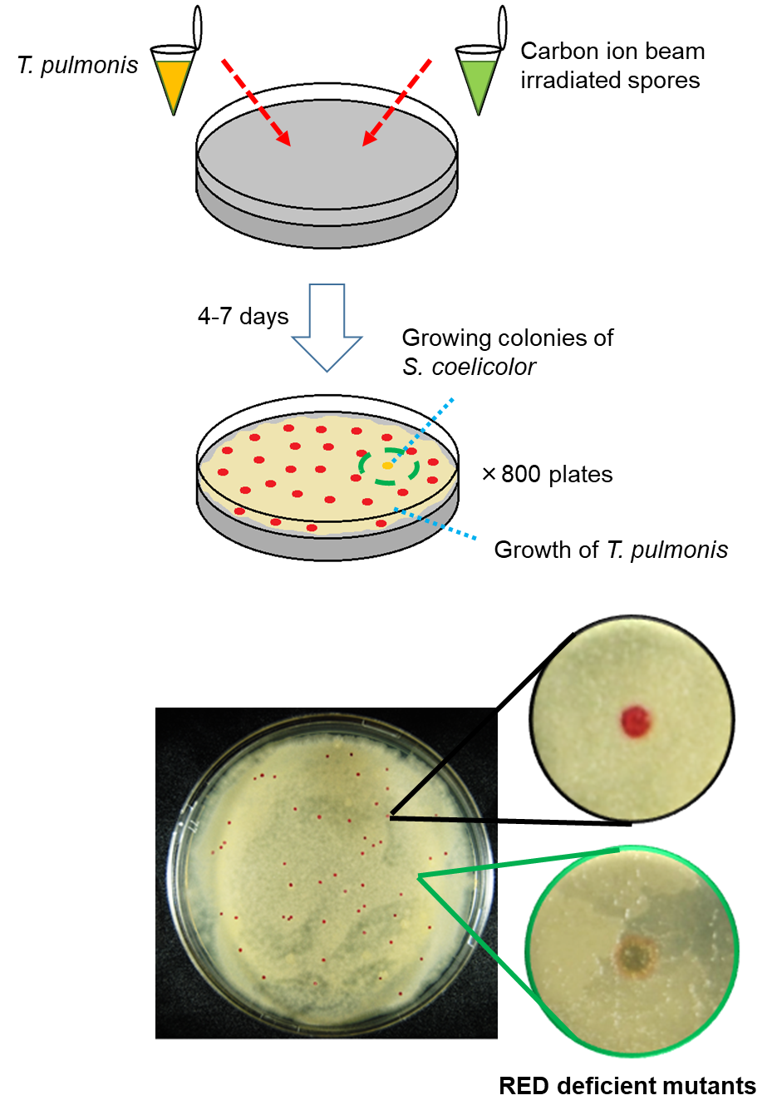
Supplemental figure 1.
Summary of method to screen RED deficient mutants of S. coelicolor JSM4020 (First screening method). Details are described in Material and methods.

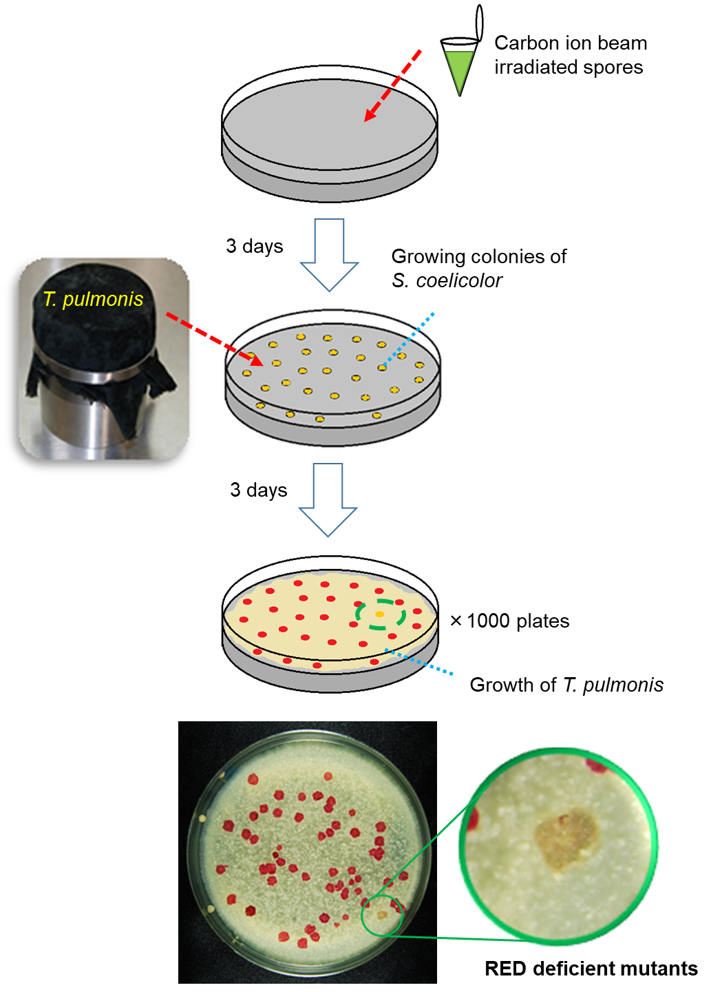
Supplemental figure 2.
Summary of method to screen RED deficient mutants of S. coelicolor JSM4020 (Second screening method). Details are described in Material and methods.

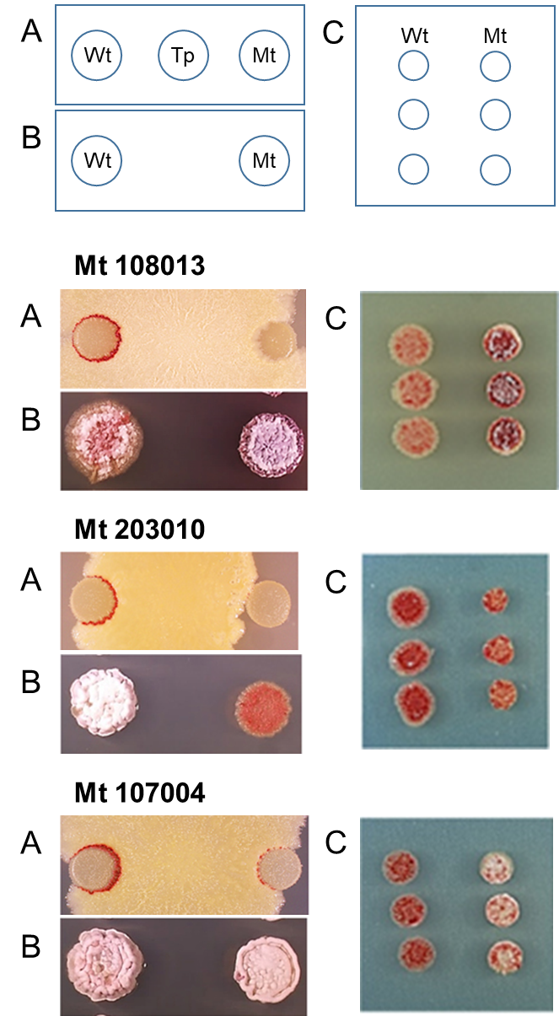
Supplemental figure 3_1.
Phenotype of the mutants. A: dual culture of strain JCM4020 wild type (Wt) or respective Mutant (Mt) with Tsukamurella pulmonis (Tp) grown on YGGS medium, day 5th. B: Wt and Mt grown on Bennett’s maltose, day 11th. C: Wt and Mt grown on Bennett’s maltose+1% NaCl, day 6th.

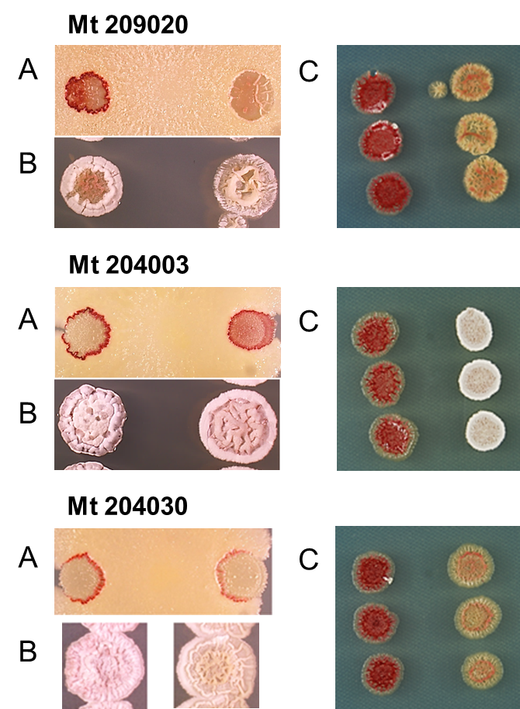
Supplemental figure 3_2.
Phenotype of the mutants. A: dual culture of strain JCM4020 wild type (Wt) or respective Mutant (Mt) with Tsukamurella pulmonis (Tp) grown on YGGS medium, day 5th. B: Wt and Mt grown on Bennett’s maltose, day 11th. C: Wt and Mt grown on Bennett’s maltose+1% NaCl, day 6th.

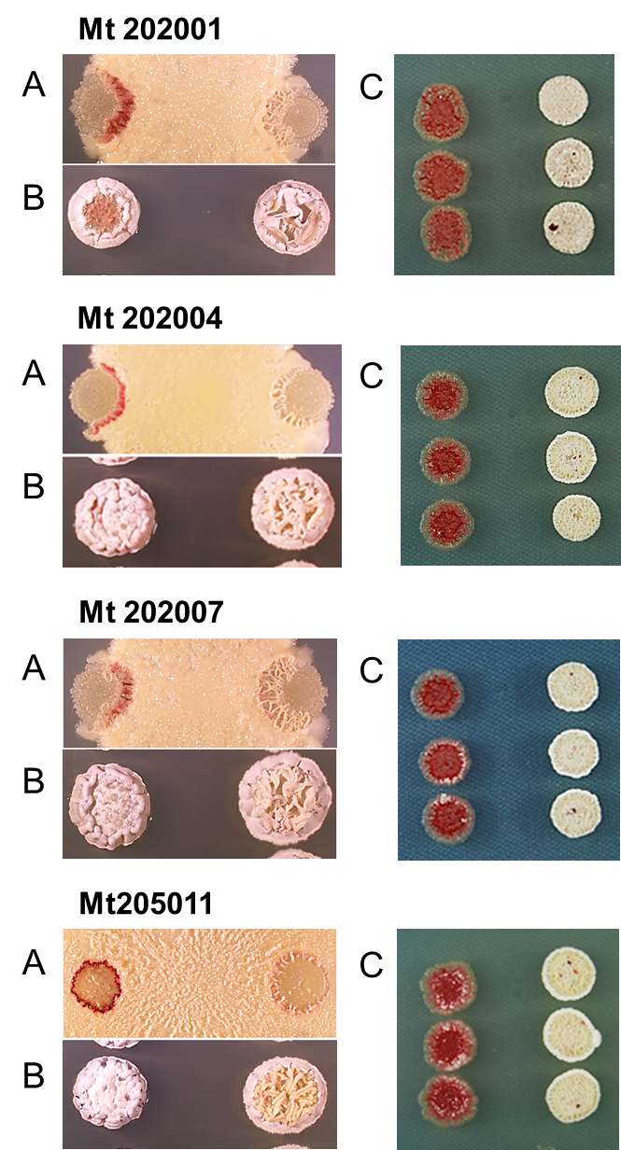
Supplemental figure 3_3.
Phenotype of the mutants. A: dual culture of strain JCM4020 wild type (Wt) or respective Mutant (Mt) with Tsukamurella pulmonis (Tp) grown on YGGS medium, day 5th. B: Wt and Mt grown on Bennett’s maltose, day 11th. C: Wt and Mt grown on Bennett’s maltose+1% NaCl, day 6th.

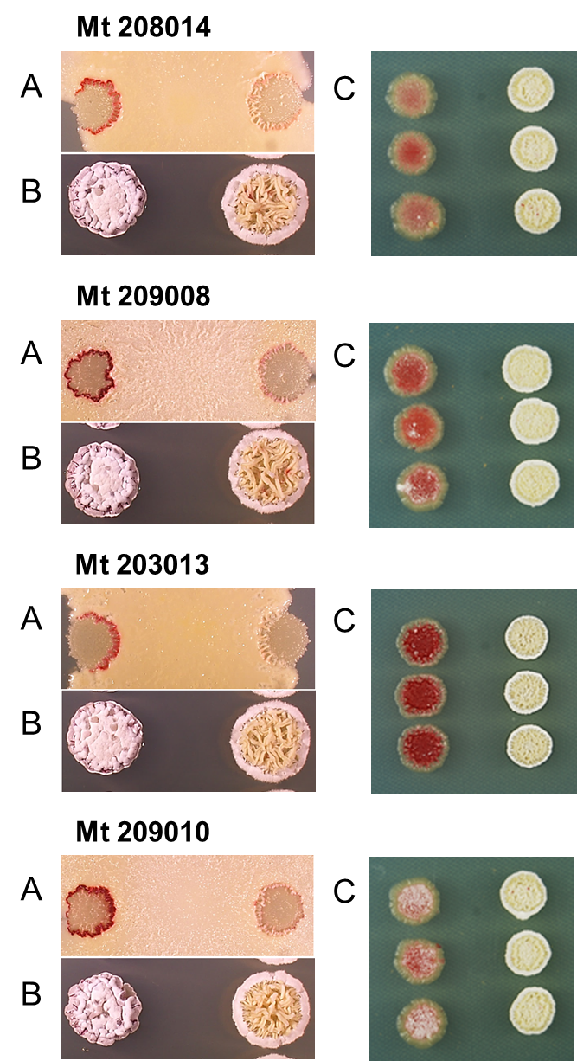
Supplemental figure 3_4.
Phenotype of the mutants. A: dual culture of strain JCM4020 wild type (Wt) or respective Mutant (Mt) with Tsukamurella pulmonis (Tp) grown on YGGS medium, day 5th. B: Wt and Mt grown on Bennett’s maltose, day 11th. C: Wt and Mt grown on Bennett’s maltose+1% NaCl, day 6th.

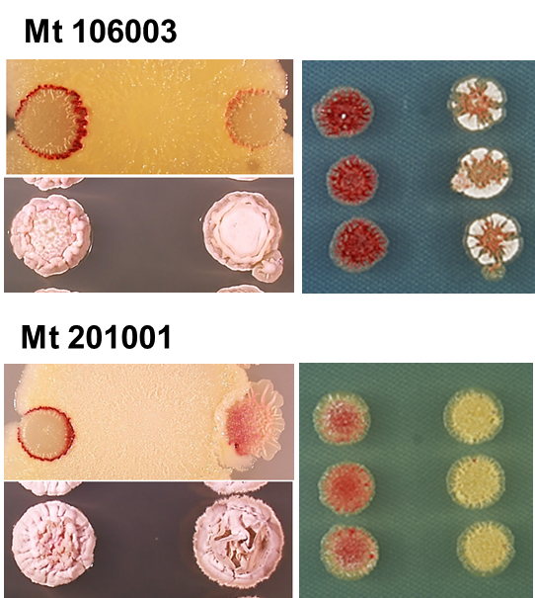
Supplemental figure 3_5.
Phenotype of the mutants. A: dual culture of strain JCM4020 wild type (Wt) or respective Mutant (Mt) with Tsukamurella pulmonis (Tp) grown on YGGS medium, day 5th. B: Wt and Mt grown on Bennett’s maltose, day 11th. C: Wt and Mt grown on Bennett’s maltose+1% NaCl, day 6th.

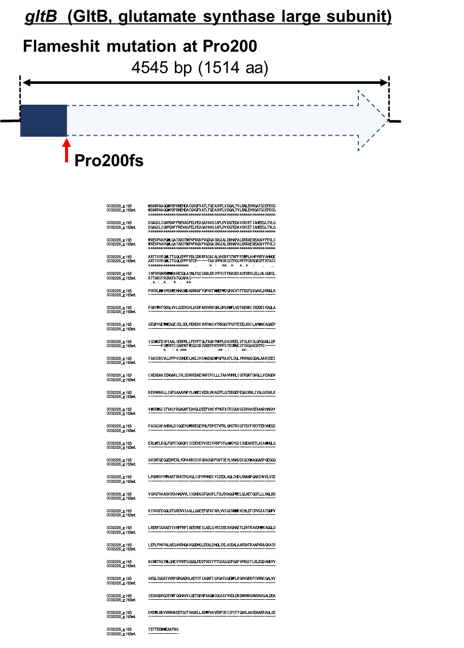
Supplemental figure 4.
Mutation caused frameshift in GltB and indicated to inactivate the function

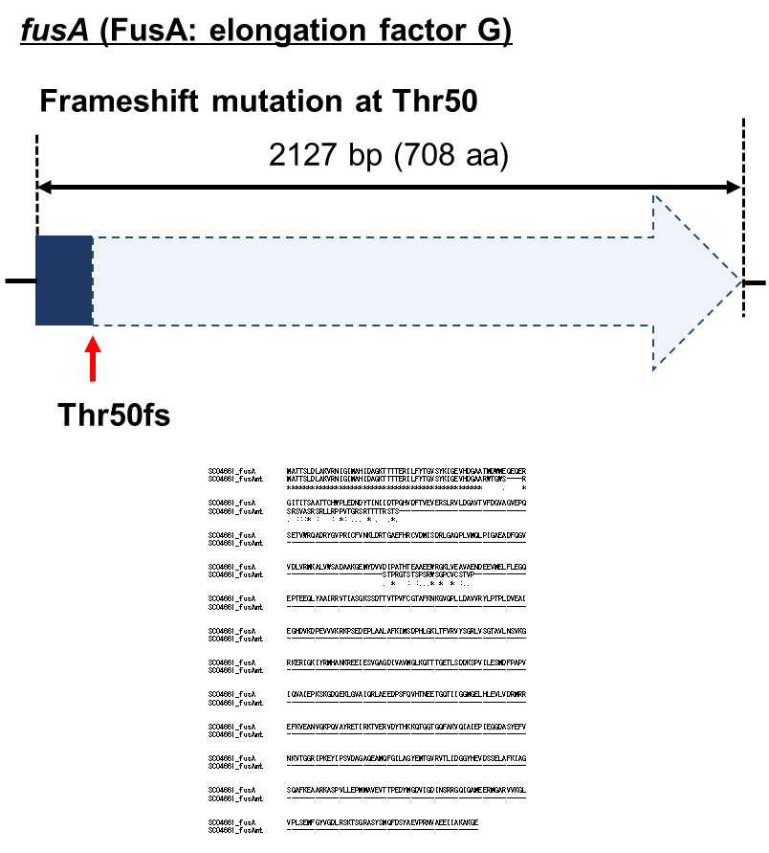
Supplemental figure 5.
Mutation caused frameshift in FusA and indicated to inactivate the function.

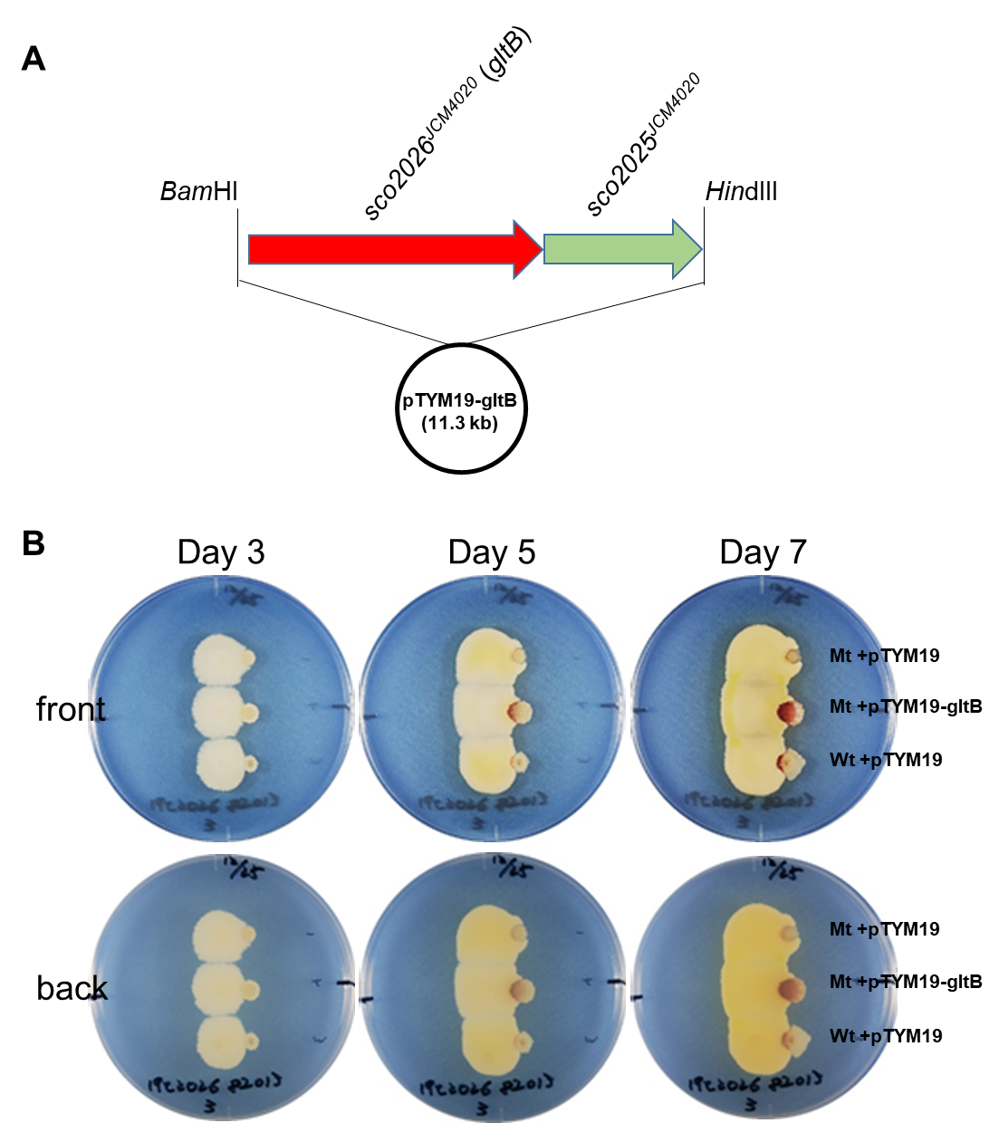
Supplemental figure 6.
Complementation of gltB (sco2026) gene in the Mt 108013 restore the production of RED.

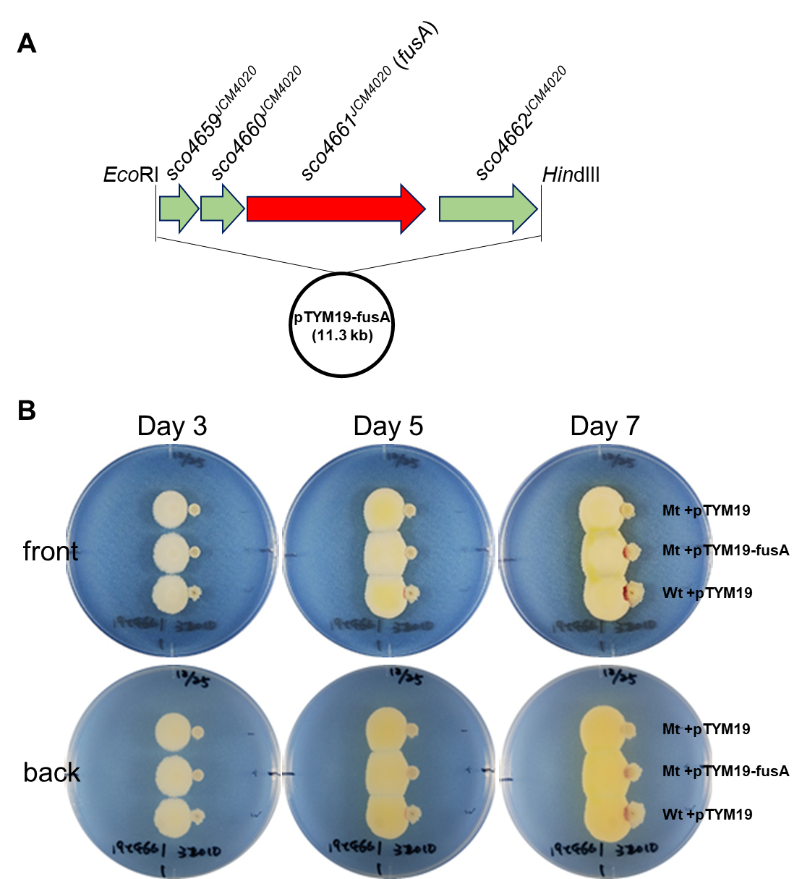
Supplemental figure 7.
Complementation of fusA (sco4661) gene in the Mt 203010 restore the production of RED.

Supplemental Table 2. Primer sequences used in this study.
primer name | sequence
gltB (sco2026-25)-for | ccgtggatccgtccggctcgaacttatgcg
gltB (sco2026-25)-rev | gtccaagctttcagaccgcgagggcgc
fusA (sco4659-62)-for | agtgaattcgagcgggcggcgatg
fusA (sco4659-62)-rev | aagaagcttttacttgttgatcttggtgacctggc
Note: underline indicate the restriction enzyme recognition site.

