Additional file 3

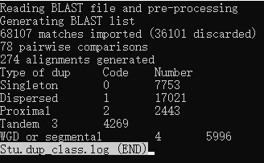

Figure S1 Gene duplication analysis of potato genome. Singleton: single copy genes; Proximal: adjacent but discontinuous repetitive genes on the same chromosome; Tandem: tandem duplications; WGD or segmental: whole genome duplications or segmental duplications; Dispersed: dispersed genes.

Figure S2 Sequence logos of conserved motifs in StKFB proteins.

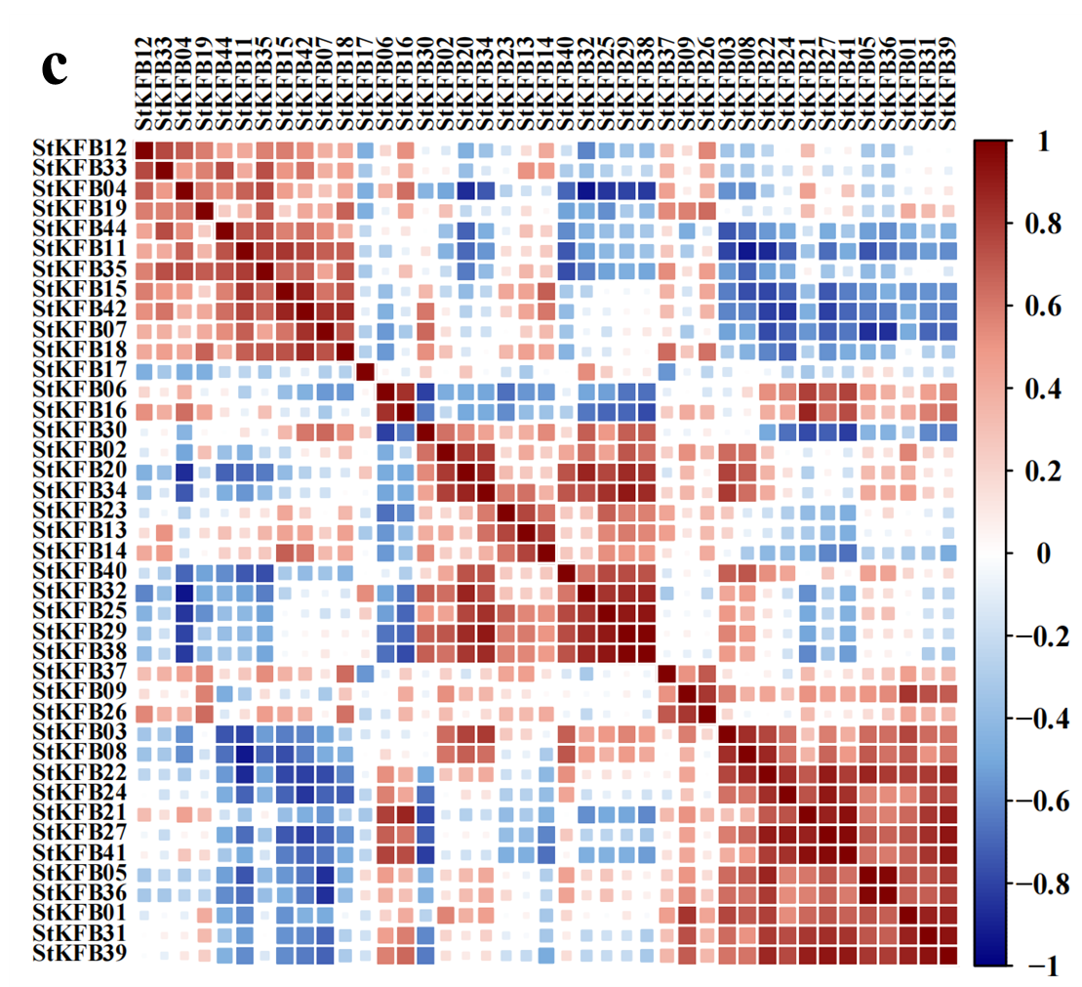

Figure S3 The correlation analysis between the expression patterns of StKFBs in diverse potato tissues (a), in potato plants with different treatments (b) and in three colored potato tubers (c).

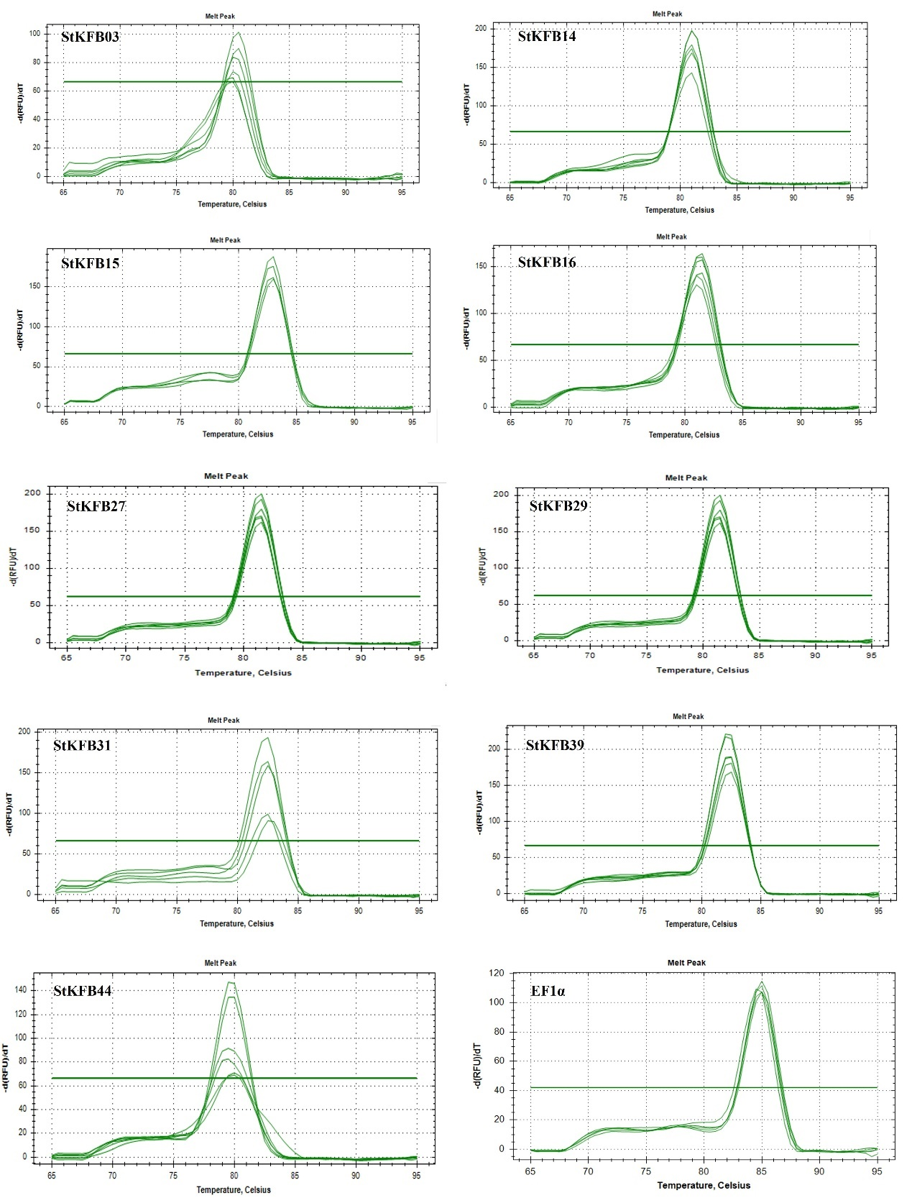

Figure S4 Melting curves of primers for qRT-PCR.

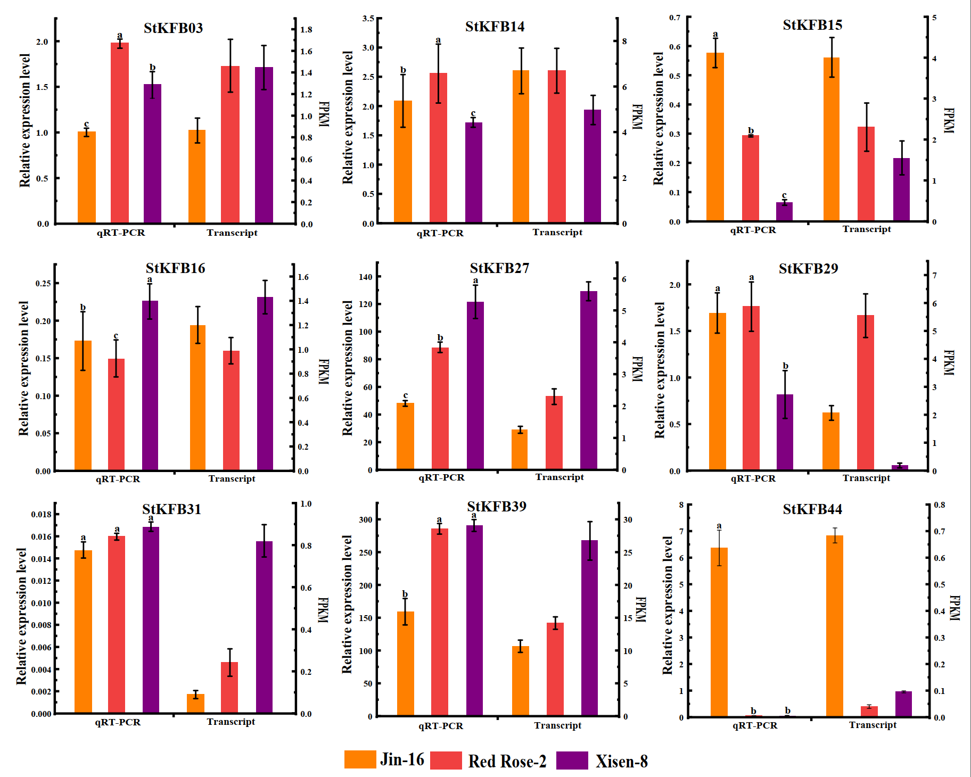

Figure S5 Comparison of the expression levels of the 9 selected StKFB genes determined by qRT-PCR and transcriptome sequencing.

Figure S6 Conserved domain analysis of StKFB01, AtFKF1, OsFKF1 and StKFB27.

