Supporting Information
Multiple Resonance Deep-red Emitters with Hybridized π-bonding/ non-bonding Orbitals to Surpass the Energy Gap Law
Yuewei Zhang^{1,2}, Dongdong Zhang^{1,2}*, Tianyu Huang^{1,2}, Alexander J. Gillett³, Yang Liu⁴, Linsong Cui³, Zhengyang Bin⁴, Guomeng Li^{1,2}, Chen Zhang^{1,2}, Yang Lu^{1,2}, Ziyang Liu^{1,2}, Jinbei Wei⁵ and Lian Duan^{1,2}*
¹Key Lab of Organic Optoelectronics and Molecular Engineering of Ministry of Education, Department of Chemistry, Tsinghua University, Beijing 100084, China. ²Center for Flexible Electronics Technology, Tsinghua University, Beijing 100084, China. ³Cavendish Laboratory, University of Cambridge, JJ Thomson Avenue, Cambridge CB3 0HE, UK. ⁴Key Lab of Green Chemistry and Technology of Ministry of Education, College of Chemistry, Sichuan University, 29 Wangjiang Road, Chengdu 610064, China. ⁵Beijing National Larboratory for molecular Sciences, Insititute of Chemeistry, Chinese Academy of Sciences, Beijing 100084, China. *e-mail: ddzhang@mail.tsinghua.edu.cn; duanl@tsinghua.edu.cn.
*E-mail: ddzhang@mail.tsinghua.edu.cn; duanl@mail.tsinghua.edu.cn

Table of Contents
- Experimental Section
  - General Information
  - Synthesis
- Supplementary figures and tables
- References

1. Experimental Section
1.1 General Information. All commercially available reagents were used as received unless otherwise stated. All reactions were carried out using Schlenk techniques under a nitrogen atmosphere. 600/400 MHz ¹H-NMR and 150 MHz ¹³C-NMR spectra were measured by a JEOL JNM-ECS600 spectrometer at room temperature in deuterated dichloromethane and chloroform respectively with tetramethyl silane as the internal standard. MALDI-TOF-MS data was performed on a Shimadzu AXIMA Performance MALDI-TOF instrument in positive detection modes. Elemental analysis was obtained with a CE-440 Elemental Analyzer.
1.2 Synthesis.
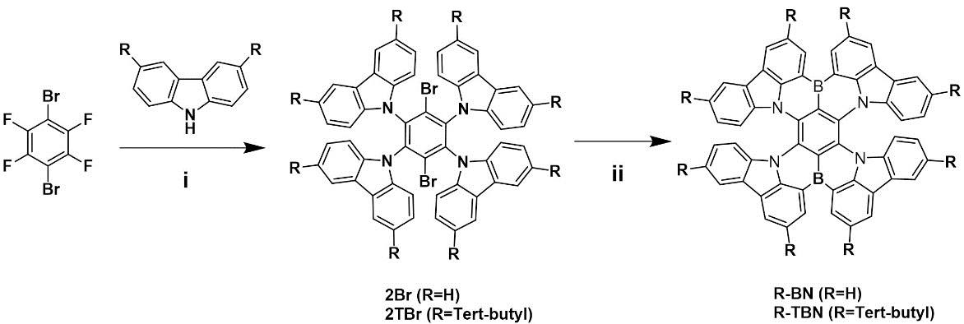
Scheme S1. Synthetic procedures: i) Cs₂CO₃, DMF, 150℃, 12 h; ii) n-BuLi, t-BuPh, 0℃, 30 min, then 60℃, 24 h; 2. BBr₃, -40℃, 0.5 h, then RT, 0.5 h; 3. NEt(i-Pr)₂, 0℃, then 120℃,5 h.
Synthesis of 2Br: 9,9',9'',9'''-(3,6-dibromobenzene-1,2,4,5-tetrayl)tetrakis(9H-carbazole): Under argon atmosphere carbazole (9.78g, 58.47 mmol) was added to a two necked round bottom flask equipped with a reflux condenser. Addition of cesium carbonate (38.10 g, 116.93mmol) followed by DMF (50 ml) resulted in a suspension, which was stirred for 30 min at room temperature. Afterwards, 5-bromo-2-chloro-1,3-difluorobenzene (3.00g, 9.74 mmol) was poured in all in once and reaction mixture was stirred at 155°C for 12 hours. The mixture was diluted with water and the crude product was recrystallized from hot ethanol. 2Br (7.52g, 8.39mmol, 86%) was obtained as white solid. ¹H NMR (400 MHz, Chloroform-d) δ: 7.80-7.77 (d, 8H), 7.26-7.24 (d, 8H),7.13-7.09 (t, 16H). MALDI-TOF: Calculated: 896.69, Found: 897.06. Anal. Calcd (%) for C₅₄H₃₂Br₂N₄: C, 72.33; H, 3.60; Br, 17.82; N, 6.25; Found: C, 72.22; H, 3.81; Br, 17.77; N, 6.20.
Synthesis of 2TBr: 9,9',9'',9'''-(3,6-dibromobenzene-1,2,4,5-tetrayl)tetrakis(3,6-di-tert-butyl-9H-carbazole): 2TBr was synthesized according to the same procedure as for 2Br by using 3,6-Di-tert-butylcarbazole (10.89 g, 38.98 mmol) instead carbazole. After recrystallization from hot ethanol, 2TBr (8.02 g, 5.96 mmol, 94%) was obtained as white solid. ¹H NMR (400 MHz, Chloroform-d) δ: 7.60 (d, J = 1.8 Hz, 8H), 7.09 (s, 8H), 6.95 (s, 8H), 1.37 (s, 72H). MALDI-TOF: Calculated: 1345.55, Found: 1345.63. Anal. Calcd (%) C₈₆H₉₆Br₂N₄: C, 76.77; H, 7.19; Br, 11.88; N, 4.16; Found: C, 76.61; H, 7.32; Br, 11.78; N, 4.29.
Synthesis of R-BN: A solution of n-butyllithium in pentane (7.9 mL, 1.70 M, 13.38 mmol) was added slowly to a solution of 2Br (2.0 g, 2.2 mmol) in tert-butylbenzene (20 mL) at 0 ºC under a nitrogen atmosphere. After stirring at 60 ºC for 24 h, pentane was removed in vacuo. After addition of boron tribromide (2.5 mL, 26.8 mmol) at –40 ºC, the reaction mixture was stirred at room temperature for 0.5 h. N,N-Diisopropylethylamine (7.0 mL, 40.2 mmol) was added at 0 ºC and then the reaction mixture was allowed to warm to room temperature. After stirring at 120 ºC for 5 h, the reaction mixture was cooled to room temperature. An aqueous solution of sodium acetate (5.0 g in 50 mL) and dichloromethane (100 mL) was added to the reaction mixture. The aqueous layer was separated and extracted with dichloromethane (100 mL). The combined organic layers were dried with magnesium sulphate, filtered, and evaporated under reduced pressure. The crude product was purified by column chromatography (silica, CH₂Cl₂ / petroleum ether = 50:1) and recrystallized from CH₂Cl₂ and methanol as a grey powder (0.64 g, yield: 38%).¹H NMR (600 MHz, Chloroform-d) δ 9.26 (d, J = 7.5 Hz, 1H), 8.50 (d, J = 7.3 Hz, 1H), 7.96 – 7.87 (m, 2H), 6.97 (t, J = 7.3 Hz, 1H), 6.68 (t, J = 7.7 Hz, 1H), 6.47 (d, J = 8.4 Hz, 1H). ¹³C NMR (151 MHz, Chloroform-d) δ: 141.93, 139.19, 133.20, 126.08, 125.07, 124.77, 122.85, 122.17, 121.88, 120.25, 111.53. MALDI-TOF: Calculated: 754.47, Found: 754.33. Anal. Calcd (%) for C₅₄H₂₈B₂N₄: C, 85.97; H, 3.74; B, 2.87; N, 7.43; Found: C, 85.84; H, 3.85; B, 2.66; N, 7.65.
Synthesis of R-TBN: R-TBN was synthesized according to the same procedure as for R-BN by using 2TBr (2.0 g, 1.5 mmol) instead 2Br (2.0 g, 2.2 mmol). R-TBN (0.72 g, yield: 40%) was obtained as a grey solid. ¹H NMR (600 MHz, Chloroform-d) δ: 9.05 (s, 2H), 8.43 (s, 2H), 8.38 (s, 2H), 8.35 (d, J = 8.7 Hz, 2H), 8.24 (s, 2H), 7.69 – 7.63 (m, 3H), 7.58 – 7.52 (m, 2H), 7.23 – 7.18 (m, 1H), 1.66 (s, 18H), 1.54 (s, 18H). ¹³C NMR (600 MHz, CDCl₃) ¹³C NMR (151 MHz, Chloroform-d) δ: 145.01, 144.33, 138.03, 129.39, 127.76, 125.15, 124.63, 123.45, 122.23, 121.80, 115.90, 111.60, 35.50, 34.59, 32.47, 31.74. MALDI-TOF: Calculated: 1203.33, Found: 1203.63. Anal. Calcd (%) C₈₆H₉₂B₂N₄: C, 85.84; H, 7.71; B, 1.80; N, 4.66; Found: C, 85.95; H, 7.67; B, 1.60; N, 4.78.
- Supplementary figures and tables
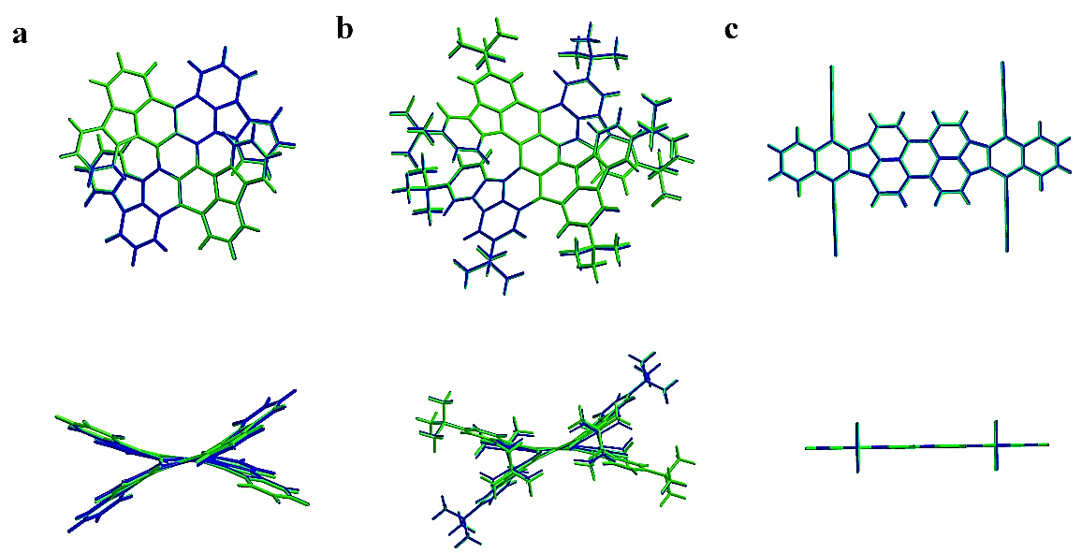
Figure S1. Comparison of the optimized structures of R-BN (a), R-TBN (b) and DBP (c) in the S₀ (blue) and S₁ (green) states.

Table S1. Summary of Franck-Condon analysis on the S₀–S₁ transition of R-BN, R-TBN and DBP at the (TD)B3LYP/6-31G(d) level.
compound | transition  (S₀ → S₁) | frequency  (cm^{–1}) | Relative frequency  (cm^{–1}) | line  density | dipole strength  (a.u.)
R-BN | 0 → 0 | 14956.9714 | 0 | 13480 | 0.8182
 | 0 → 7¹ | 15032.4336 | 75.4622 | 4687 | 0.2832
 | 0 → 13¹ | 15077.5726 | 120.6012 | 4369 | 0.2632
 | 0 → 13¹7¹ | 15153.0348 | 196.0634 | 1498 | 0.090
 | 0 → 25¹ | 15188.3327 | 231.3613 | 3996 | 0.2390
 | 0 → 29¹ | 15234.8884 | 277.9170 | 2747 | 0.1638
 | 0 → 25¹7¹ | 15263.7948 | 306.8234 | 1308 | 0.0788
 | 0 → 35¹ | 15298.6372 | 341.6658 | 2384 | 0.1415
 | 0 → 25¹13¹ | 15308.9339 | 351.9625 | 1269 | 0.0753
 | 0 → 39¹ | 15338.8585 | 381.8871 | 2183 | 0.1293
R-TBN | 0 → 0 | 14566.8524 | 0 | 11350 | 0.7078
 | 0 → 5¹ | 14587.8708 | 21.0184 | 1699 | 0.1058
 | 0 → 8¹ | 14598.2666 | 31.4142 | 2559 | 0.1593
 | 0 → 16¹ | 14605.9974 | 39.1450 | 1834 | 0.1141
 | 0 → 20¹ | 14630.8225 | 63.9701 | 1967 | 0.1221
 | 0 → 23¹ | 14645.6301 | 78.7777 | 1686 | 0.1046
 | 0 → 31¹ | 14681.261 | 114.4086 | 1524 | 0.09429
 | 0 → 84¹ | 14887.6385 | 320.7861 | 2259 | 0.1378
DBP | 0 → 0 | 15023.5961 | 0 | 146200 | 8.839
 | 0 →2² | 15037.1235 | 13.5274 | 15590 | 0.9416
 | 0 →3² | 15043.9355 | 20.3394 | 9765 | 0.5896
 | 0 → 22¹ | 15177.641 | 154.0449 | 30890 | 1.848
 | 0 → 53¹ | 15461.1973 | 437.6012 | 6338 | 0.3723
 | 0 → 61¹ | 15523.3474 | 499.7513 | 6316 | 0.3695
 | 0 →195¹ | 16327.7259 | 1304.1298 | 29590 | 1.646
 | 0 →195¹22¹ | 16481.7708 | 1458.1747 | 6412 | 0.3533
 | 0 → 223¹ | 16498.7421 | 1475.1460 | 7756 | 0.4270
 | 0 →231¹ | 16528.5489 | 1504.9528 | 21520 | 1.182
 | 0 →251¹ | 16667.3484 | 1643.7523 | 20020 | 1.091
Table S2. Summary of Franck-Condon analysis on the S₁–S₀ transition of R-BN, R-TBN and DBP at the (TD)B3LYP/6-31G(d) level.
compound | transition  (S₁ → S₀) | frequency  (cm^{–1}) | Relative frequency  (cm^{–1}) | line  density | dipole strength  (a.u.)
R-BN | 0 → 0 | 13710.5293 | 0 | 74.62 | 0.8276
 | 0 → 8¹ | 13630.9448 | -79.5845 | 22.91 | 0.2601
 | 0 →14¹ | 13586.9042 | -123.6251 | 18.65 | 0.2145
 | 0 → 26¹ | 13476.5627 | -233.9666 | 17.40 | 0.2068
 | 0 → 30¹ | 13422.6493 | -287.8800 | 9.990 | 0.1206
 | 0 → 37¹ | 13365.728 | -344.8013 | 13.14 | 0.1614
 | 0 → 40¹ | 13333.2926 | -377.2367 | 13.26 | 0.1645
 | 0 → 46¹ | 13256.1938 | -454.3355 | 5.917 | 0.0751
R-TBN | 0 → 0 | 13256.0205 | 0 | 51.95 | 0.6593
 | 0 → 1¹ | 13250.1384 | -5.8821 | 7.627 | 0.09697
 | 0 → 8¹ | 13223.1886 | -32.8319 | 12.01 | 0.1540
 | 0 → 16¹ | 13216.6104 | -39.4101 | 8.911 | 0.1145
 | 0 → 23¹ | 13175.6878 | -80.3327 | 7.610 | 0.09901
 | 0 → 91¹ | 12924.0378 | -331.9827 | 9.978 | 0.1402
DBP | 0 → 0 | 13714 | 0 | 755.9 | 8.374
 | 0 → 3² | 13673.3388 | -40.6612 | 31.15 | 0.3494
 | 0 →4² | 13669.2258 | -44.7742 | 47.94 | 0.5381
 | 0 →5² | 13668.8963 | -45.1037 | 58.99 | 0.6622
 | 0 → 22¹ | 13560.3158 | -153.6842 | 152.3 | 1.765
 | 0 → 52¹ | 13275.6291 | -438.3709 | 32.03 | 0.4041
 | 0 → 202¹ | 12386.3699 | -1327.6301 | 91.22 | 1.519
 | 0 →217¹ | 12294.9559 | -1419.0441 | 35.58 | 0.6103
 | 0 → 220¹ | 12252.0906 | -1461.9094 | 21.80 | 0.3797
 | 0 → 224¹ | 12227.7905 | -1486.2095 | 60.14 | 1.054
 | 0 → 250¹ | 12070.1554 | -1643.8446 | 27.37 | 0.5055

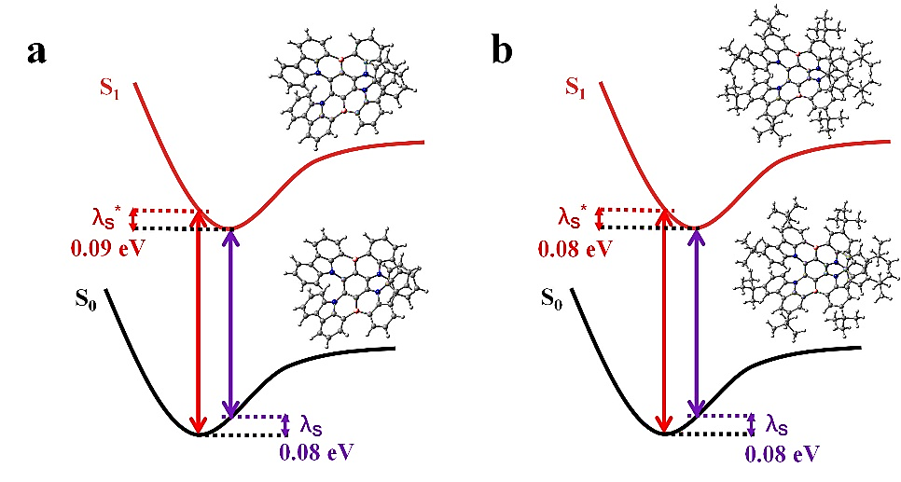
Figure S2. The optimized S₀ and S₁ structures, reorganization (λ_{S}) and structural relaxation (λ_{S}*) energies of (a) R-BN and (b) R-TBN.

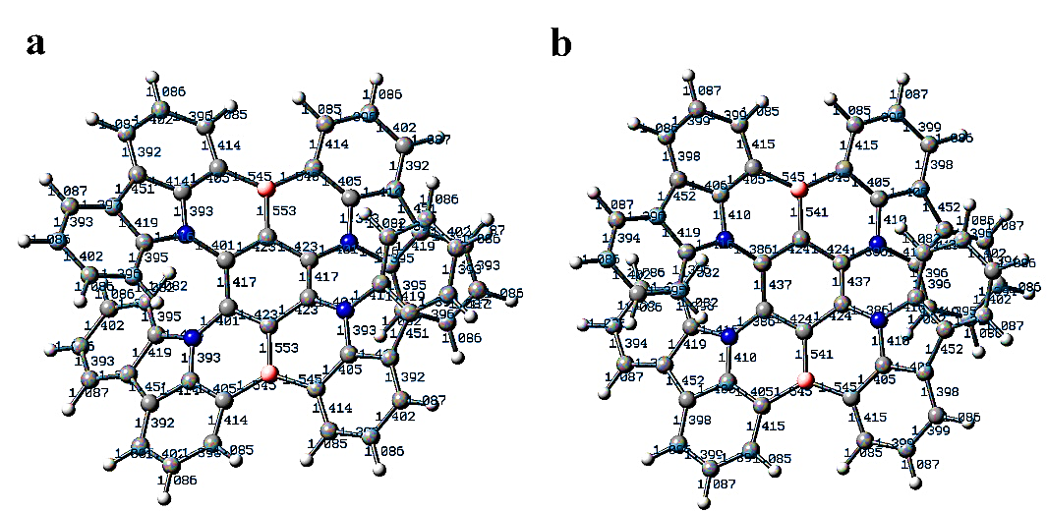
Figure S3. Bond lengths of the optimized structures of R-BN in the (a) S₀ and (b) S₁ states.

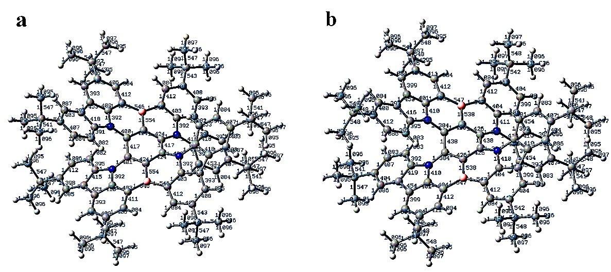
Figure S4. Bond lengths of the optimized structures of R-TBN in the (a) S₀ and (b) S₁ states.

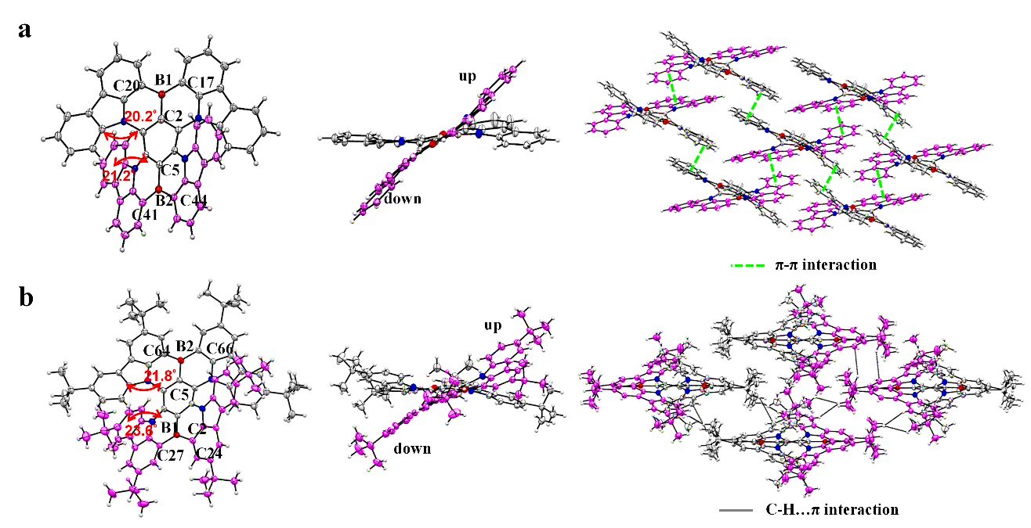
Figure S5. Crystal structures and molecular packing patterns of R-BN (a) and R-TBN (b).

Table S3. Summary of TD-DFT calculation for R-BN, R-TBN, BCz-BN and DBP at the S₀, S₁, and T₁ structures at the B3LYP/6-31G(d) level.
compound | Optimized structure | transition | Wavelength  (nm) | Energy  (eV) | Oscillator  strength | coefficient of HOMO-LUMO
R-BN | S₀ | S₀-S₁ | 600.08 | 2.0661 | 0.2544 | 0.70423
 |  | S₀-T₁ | 751.25 | 1.6504 | 0.0000 | 0.69848
 | S₁ | S₁-S₀ | 673.43 | 1.8411 | 0.2227 | 0.70526
 | T₁ | T₁-S₀ | 930.49 | 1.3325 | 0.0000 | 0.69992
R-TBN | S₀ | S₀-S₁ | 616.54 | 2.0110 | 0.3099 | 0.70448
 |  | S₀-T₁ | 770.21 | 1.6098 | 0.0000 | 0.69827
 | S₁ | S₁-S₀ | 688.05 | 1.8020 | 0.2759 | 0.70539
 | T₁ | T₁-S₀ | 943.98 | 1.3134 | 0.0000 | 0.69968
BCz-BN | S₀ | S₀-S₁ | 433.92 | 2.8573 | 0.4125 | 0.70146
 |  | S₀-T₁ | 505.55 | 2.4525 | 0.0000 | 0.68612
 | S₁ | S₁-S₀ | 453.96 | 2.7312 | 0.3558 | 0.70194
 | T₁ | T₁-S₀ | 530.09 | 2.3389 | 0.0000 | 0.68082
DBP | S₀ | S₀-S₁ | 572.91 | 2.1641 | 1.2005 | 0.70306
 |  | S₀-T₁ | 1011.99 | 1.2251 | 0.0000 | 0.69114
 | S₁ | S₁-S₀ | 640.46 | 1.9359 | 1.1841 | 0.70522
 | T₁ | S₀-T₁ | 1396.04 | 0.8881 | 0.0000 | 0.70696

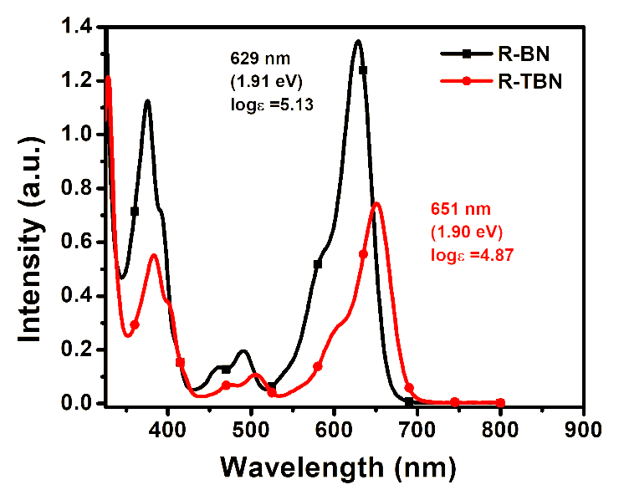
Figure S6. Absorption spectra of R-BN (black) and R-TBN (red) in toluene (0.01 mM solution at 298 K) with absorption maxima (nm, eV) and absorption coefficient at absorption maxima.

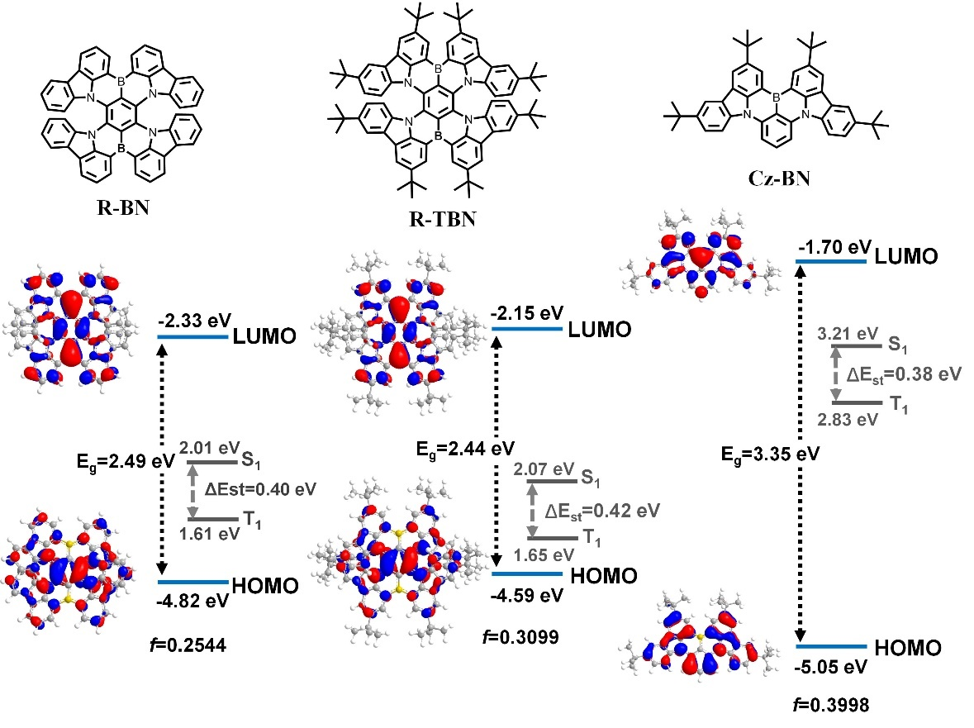
Figure S7. HOMO–LUMO distributions and the state levels of R-BN, R-TBN and BCz-BN.

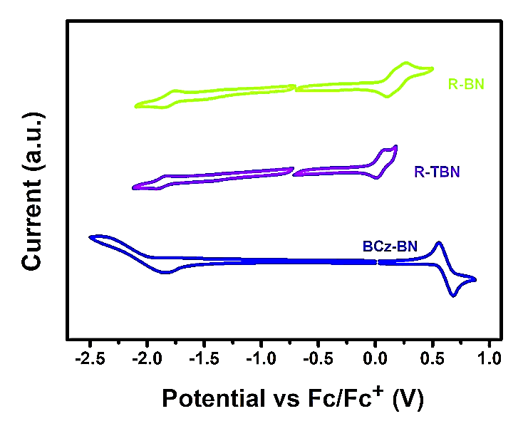
Figure S8. Cyclic Voltammograms of R-BN (green line), T-TBN (purple line) and BCz-BN (blue line).

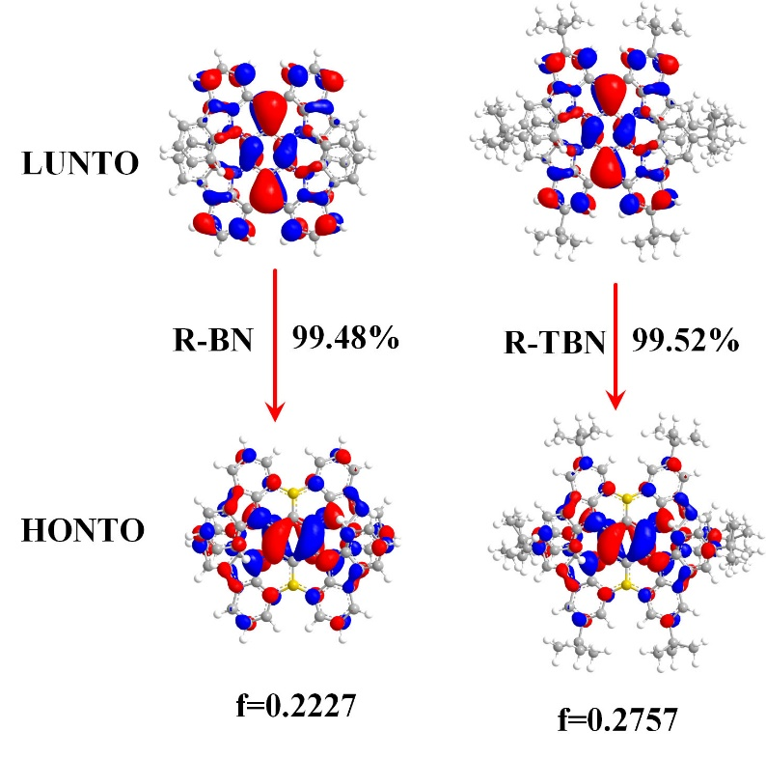
Figure S9. Highest occupied and lowest unoccupied natural transition orbitals (HONTOs and LUNTOs) of R-BNs for the S₁ state.

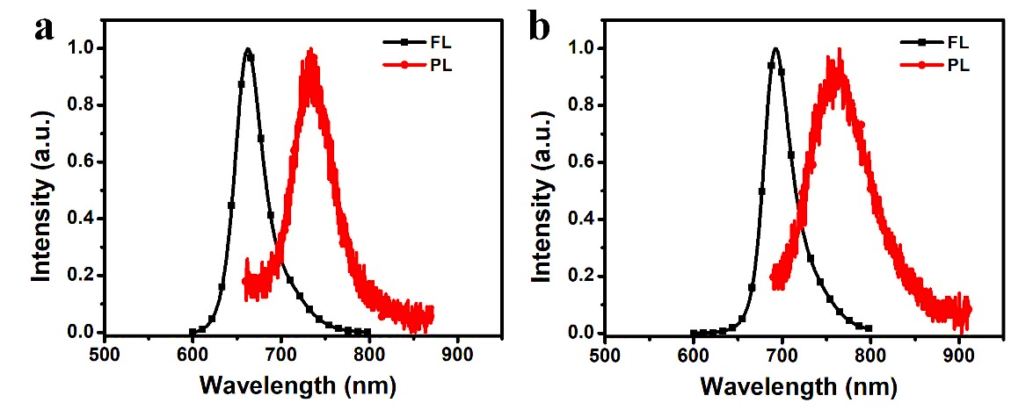
Figure S10. Fluorescence and Phosphorescence spectra of the R-BN (a) and R-TBN (b) in toluene.

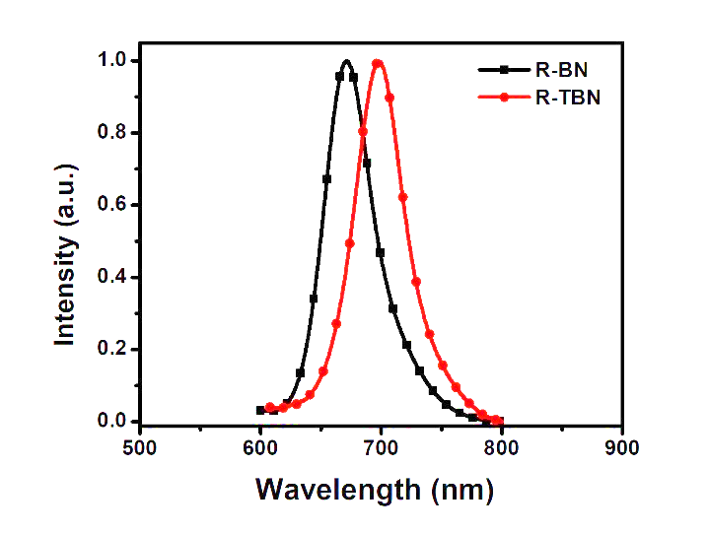
Figure S11. The normalized PL spectrum of 3 wt%-doped films of R-BN (black) and R-TBN (red) in CBP.
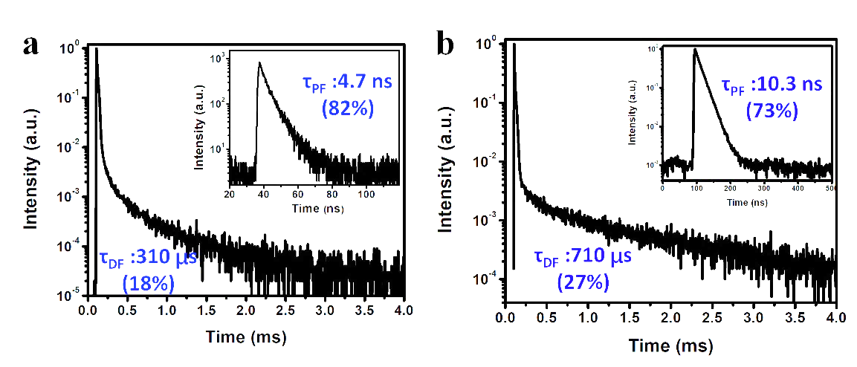
Figure S12. Transient decay spectra of a CBP film (3 wt%, dispersed) of R-BN (a) and R-TBN (b) at 300 K.

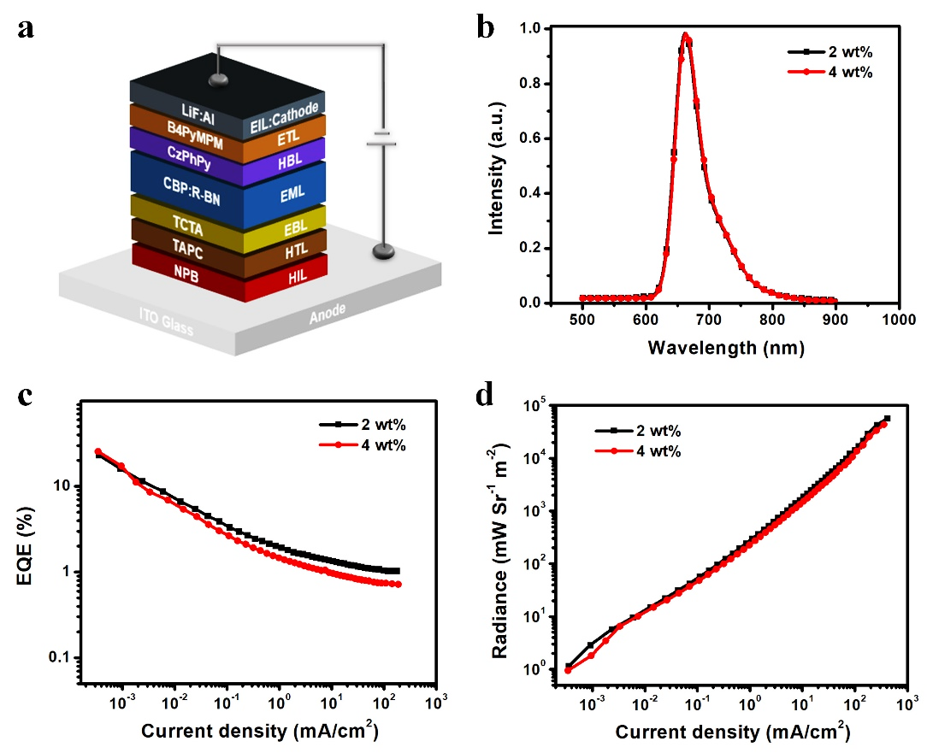
Figure S13. a) The energy level diagrams of the R-BN doped in CBP devices. b) The EL spectra of the devices. c) EQE versus current density characteristics. d) Radiance versus current density characteristics.
Table S4. Summary of the EL data of DR/NIR OLEDs based on R-BN doped in CBP with different doping concentrations.
Device | λ_{EL}^{a)}[nm] | FWHM^{b)}[nm] | EQE_{max}^{c)}[%] | Radiance^{d)}[mW Sr⁻¹ m⁻²] | CIE (x,y)^{e)}
2 wt% R-BN | 662 | 49 | 23.1 | 0.6 × 10⁵ | 0.718,0.280
4 wt% R-BN | 663 | 48 | 25.6 | 0.4 × 10⁵ | 0.720,0.279
^{a)}Maximum electroluminescence wavelength. ^{b)}Full width at half maximum of electroluminescence. ^{c)}Maximum external quantum efficiencies. ^{d)}Maximum radiance. ^{e)}Recorded at 10 mA cm⁻².

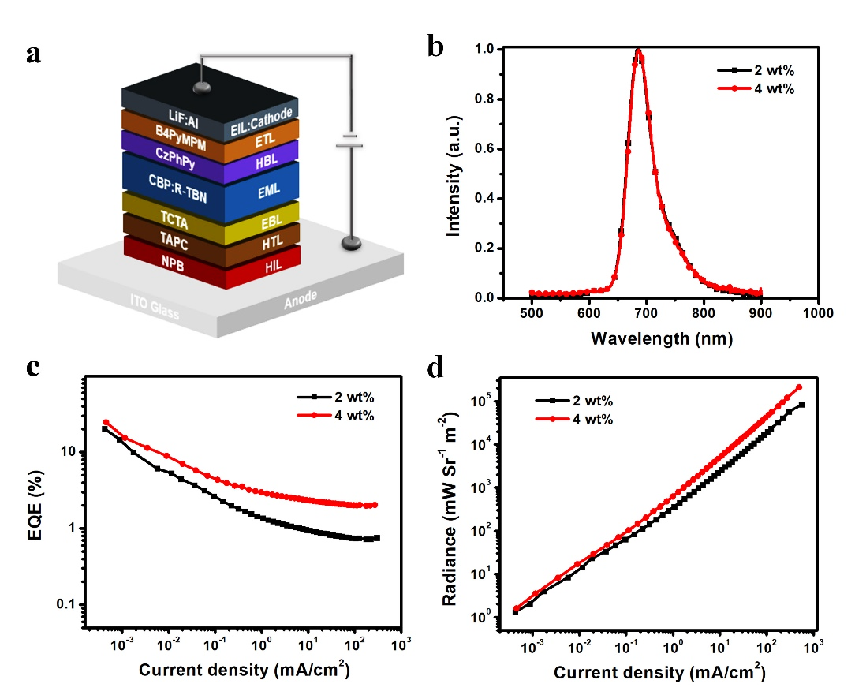
Figure S14. a) The energy level diagrams of the R-TBN doped in CBP devices. b) The EL spectra of the devices. c) EQE versus current density characteristics. d) Radiance versus current density characteristics.

Table S5. Summary of the EL data of DR/NIR OLEDs based on R-TBN doped in CBP with different doping concentrations.
Device | λ_{EL}^{a)}[nm] | FWHM^{b)}[nm] | EQE_{max}^{c)}[%] | Radiance^{d)}[mW Sr⁻¹ m⁻²] | CIE (x,y)^{e)}
2 wt% R-TBN | 686 | 49 | 20.3 | 0.8 × 10⁵ | 0.721,0.278
4 wt% R-TBN | 686 | 48 | 24.7 | 2.1 × 10⁵ | 0.722,0.278
^{a)}Maximum electroluminescence wavelength. ^{b)}Full width at half maximum of electroluminescence. ^{c)}Maximum external quantum efficiencies. ^{d)}Maximum radiance. ^{e)}Recorded at 10 mA cm⁻².

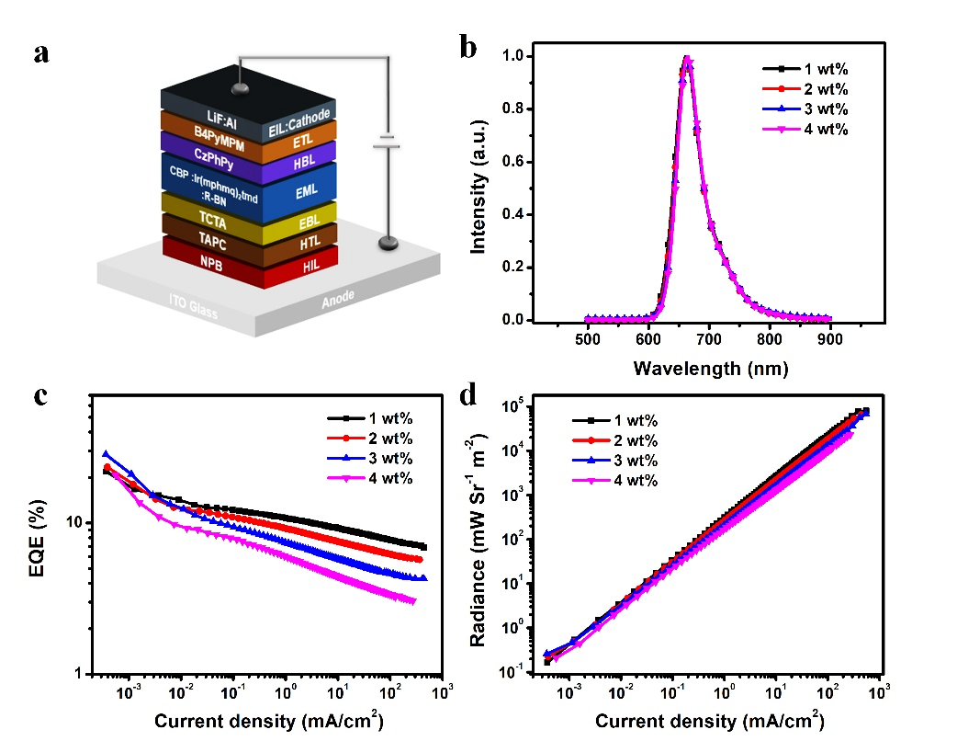
Figure S15. a) The energy level diagrams of the R-BN doped in CBP and Ir(mphmq)₂tmd devices. b) The EL spectra of the devices. c) EQE versus current density characteristics. d) Radiance versus current density characteristics.
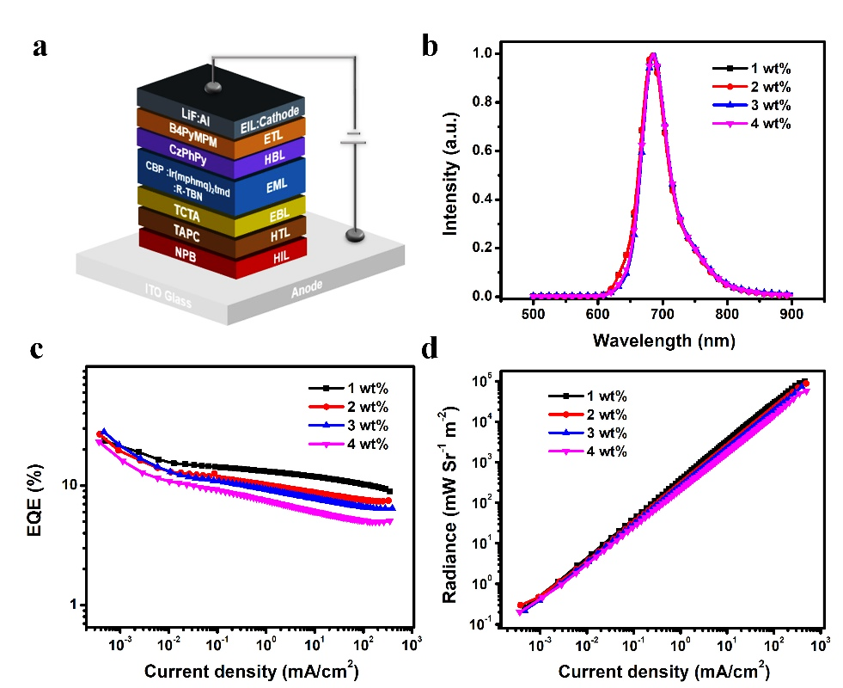
Figure S16. a) The energy level diagrams of the R-TBN doped in CBP and Ir(mphmq)₂tmd devices. b) The EL spectra of the devices. c) EQE versus current density characteristics. d) Radiance versus current density characteristics.
Table S6. Summary of the EL data of DR/NIR OLEDs based on R-BNs doped in CBP and Ir(mphmq)₂tmd with different doping concentrations.
Device | λ_{EL}^{a)}[nm] | FWHM^{b)}[nm] | EQE_{max}^{c)}[%] | Radiance^{d)}[mW Sr⁻¹ m⁻²] | CIE (x,y)^{e)}
1 wt% R-BN | 661 | 50 | 21.9 | 7.5 × 10⁵ | 0.716,0.282
2 wt% R-BN | 662 | 49 | 23.4 | 6.1 × 10⁵ | 0.718,0.282
3 wt% R-BN | 664 | 48 | 28.4 | 6.5 × 10⁵ | 0.719,0.280
4 wt% R-BN | 664 | 48 | 20.8 | 2.1 × 10⁵ | 0.720,0.280
1 wt% R-TBN | 684 | 49 | 23.7 | 10.3 × 10⁵ | 0.718,0.280
2 wt% R-TBN | 684 | 49 | 26.8 | 9.0 × 10⁵ | 0.718,0.280
3 wt% R-TBN | 686 | 49 | 28.1 | 7.3 × 10⁵ | 0.721,0.278
4 wt% R-TBN | 686 | 48 | 23.2 | 5.8 × 10⁵ | 0.722,0.278
^{a)}Maximum electroluminescence wavelength. ^{b)}Full width at half maximum of electroluminescence. ^{c)}Maximum external quantum efficiencies. ^{d)}Maximum radiance. ^{e)}Recorded at 10 mA cm⁻².

Table S7. The DR/NIR OLEDs devices published to date with the emission maxima > 650 nm and the corresponding citations.
EL λem (nm) | EQEmax (nm) | CIE (x,y) | Reference
656 | 12.8 | 0.66,0.34 | 1
670 | 15 | 0.64,0.36 | 1
693 | 10.19 | - | 2
696 | 9.7 | - | 2
700 | 9.4 | 0.68,0.31 | 3
728 | 3.9 | 0.69,0.31 | 3
668 | 9.8 | 0.68,0.32 | 4
710 | 2.1 | 0.70,0.29 | 4
728 | 0.064 | 0.70,0.29 | 5
715 | 0.254 | 0.69,0.30 | 5
721 | 9.69 | - | 6
700 | 14.1 | - | 7
711 | 3.5 | - | 7
680 | 5.2 | 0.68,0.32 | 8
652 | 12.3 | 0.67,0.33 | 9
670 | 3.18 | 0.64,0.36 | 10
691 | 2.22 | 0.65,0.36 | 10
693 | 2.1 | 0.68,0.35 | 10
696 | 1.43 | 0.68,0.35 | 10
664 | 4.7 | 0.68,0.32 | 11
676 | 3.7 | 0.68,0.31 | 11
692 | 4.3 | 0.70,0.30 | 11
712 | 6.57 | 0.68,0.29 | 12
664 | 28.4 | 0.719,0.280 | This work
686 | 28.1 | 0.721,0.278 | This work

Table S8. Crystal Data and Structure Refinements of R-BNs Crystals.
 | R-BN | R-TBN
empirical formula | C54 H28 B2 N4 | C86 H92 B2 N4
formula wt | 754.42 | 1203.25
crystal system | Triclinic | Triclinic
T (K) | 99.99(10) | 99.99(10)
space group | P -1 | P -1
a/Å | 8.0866(4) | 10.18637(18)
b/Å | 14.5879(5) | 17.8059(3)
c/Å | 15.5387(3) | 22.3062(3)
α/ ° | 91.985(2) | 106.4002(13)
β/ ° | 93.541(3) | 92.1304(13)
γ/ ° | 90.822(3) | 100.0691(15)
V/Å3 | 1828.23(12) | 3805.37(11)
Z | 2 | 2
density, mg/m3 | 1.370 | 1.050
absorption coefficient, mm⁻¹ | 0.618 | 0.450
F (000) | 780.0 | 1292.0
θ range/Å | 4.090-66.573 | 3.773-75.274
no. of reflcns collected | 6460 | 13444
no. of unique reflns | 5129 | 15298
R(int) | 0.0716 | 0.0459
GOF | 1.049 | 1.042
R1 [I > 2σ(I)] | 0.0469 | 0.0739
wR2 [I > 2σ(I)] | 0.1176 | 0.1918
R1 (all data) | 0.1384 | 0.0812
wR2 (all data) | 0.1239 | 0.1969

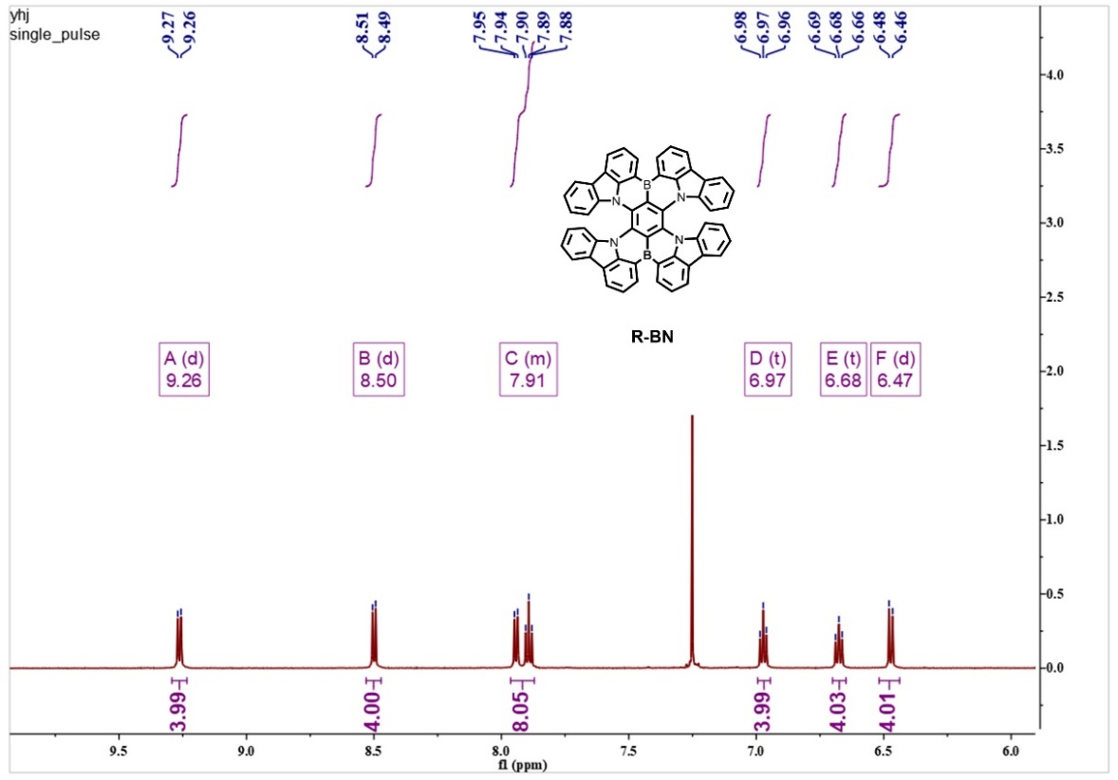
Figure S17. ¹H NMR spectrum of R-BN in CDCl₃.
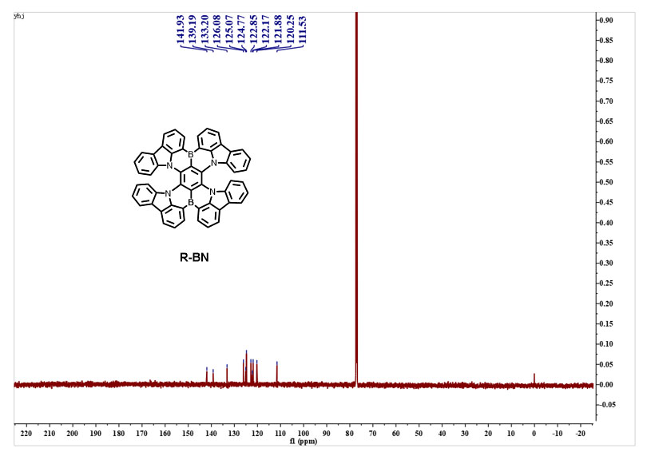

Figure S18. ¹³C NMR spectrum of R-BN in CDCl₃.

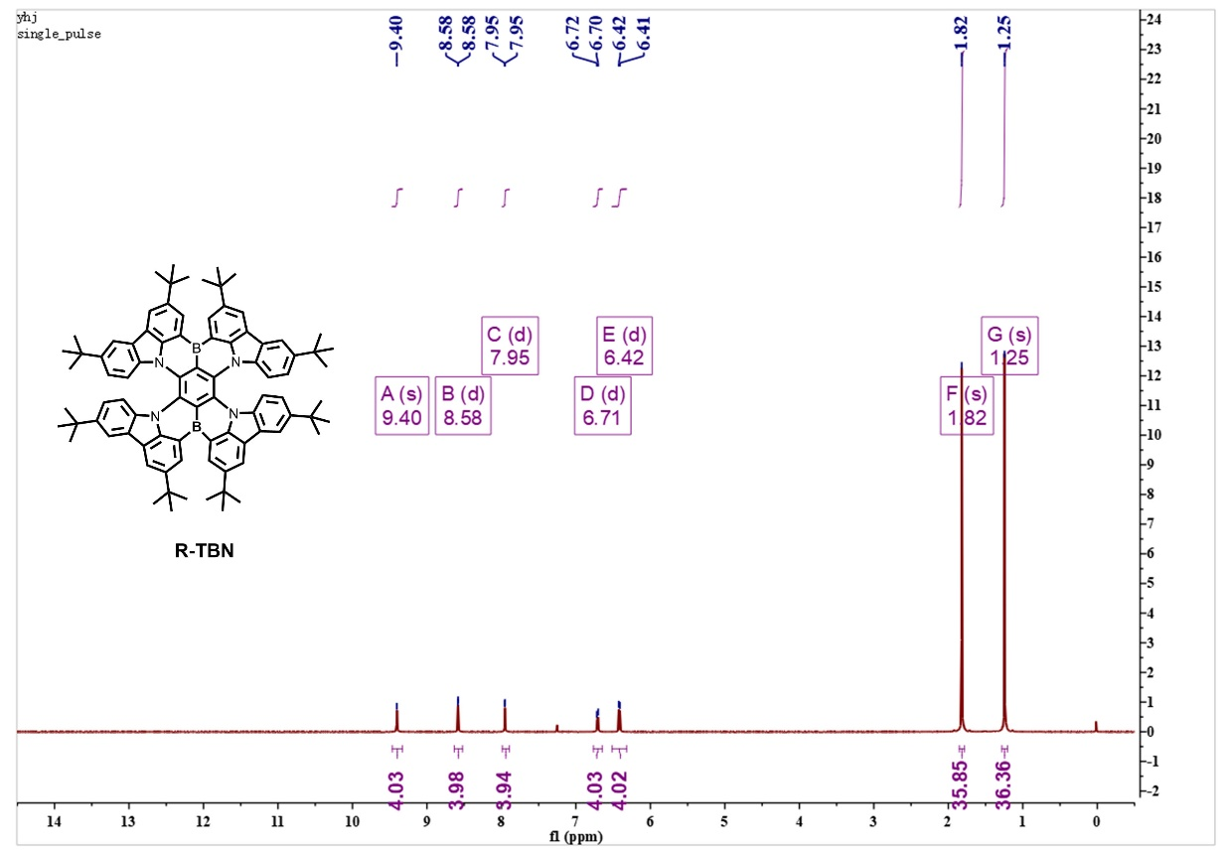
Figure S19. ¹H NMR spectrum of R-TBN in CDCl₃.

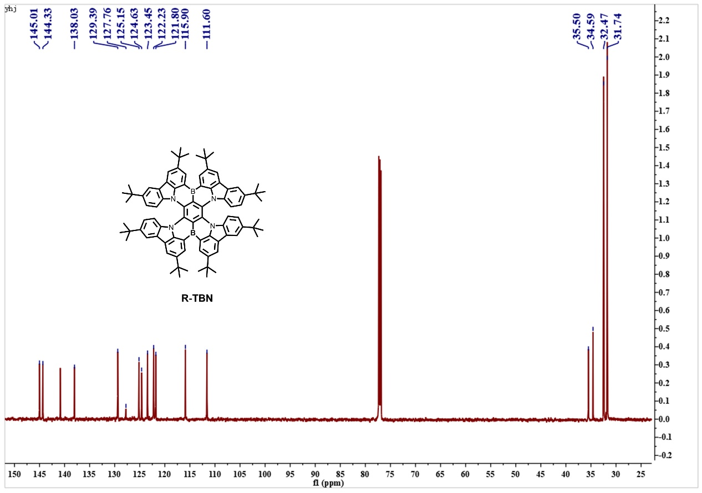

Figure S20. ¹³C NMR spectrum of R-TBN in CDCl₃.

- References
- Furue, R. et al. Highly Efficient Red–Orange Delayed Fluorescence Emitters Based on Strong π‐Accepting Dibenzophenazine and Dibenzoquinoxaline Cores: toward a Rational Pure‐Red OLED Design. Adv. Opt. Mater. 6, 1701147 (2018).
- Yuan, Y. et al. Over 10% EQE near-infrared electroluminescence based on a thermally activated delayed fluorescence emitter. Adv. Funct. Mater. 1700986 (2017).
- Li, C. et al. Deep‐red to near‐infrared thermally activated delayed fluorescence in organic solid films and electroluminescent devices. Angew. Chem. Int. Ed. 56, 11525-11529 (2017).
- Wang, S. et al. Highly efficient near‐infrared delayed fluorescence organic light emitting diodes using a phenanthrene‐based charge‐transfer compound. Angew. Chem. Int. Ed. 54, 13068–13072 (2015).
- Sun, K. et al. Near-infrared thermally activated delayed fluorescent dendrimers for the efficient non-doped solution-processed organic light-emitting diodes. Org. Electron. 48, 389-396 (2017).
- Kim, D. et al. High-efficiency electroluminescence and amplified spontaneous emission from a thermally activated delayed fluorescent near-infrared emitter. Nat. Photon. 12, 98-104 (2018).
- Xue, J. et al. Highly Efficient Thermally Activated Delayed Fluorescence via J‐Aggregates with Strong Intermolecular Charge Transfer. Adv. Mater. 31, 1808242 (2019).
- Chen, J. X. et al. Red/Near‐Infrared Thermally Activated Delayed Fluorescence OLEDs with Near 100% Internal Quantum Efficiency. Angew. Chem. Int. Ed. 58,14660-14665 (2019).
- Zhao. B. et al. Highly Efficient Deep‐Red Non‐Doped Diodes Based on a T‐Shape Thermally Activated Delayed Fluorescence Emitter. Angew. Chem. Int. Ed. 59, 19042-19047 (2020).
- Zhang, Y. et al. Achieving High‐Performance Solution‐Processed Deep‐Red/Near‐Infrared Organic Light‐Emitting Diodes with a Phenanthroline‐Based and Wedge‐Shaped Fluorophore. Adv. Electron. Mater. 5, 1800677 (2019).
- Yang, T. et al. Construction of Efficient Deep-Red/Near-Infrared Emitter Based on a Large π-Conjugated Acceptor and Delayed Fluorescence OLEDs with External Quantum Efficiency of over 20%. J. Phys. Chem. C 123, 18585-18592 (2019).
- Kumsampao, J. et al. A Simple and Strong Electron‐Deficient 5, 6‐Dicyano [2, 1, 3] benzothiadiazole‐Cored Donor‐Acceptor‐Donor Compound for Efficient Near Infrared Thermally Activated Delayed Fluorescence. Chem. - Asian J. 15, 3029-3036 (2020).

Cartesian coordinates
R-TBN (S₀)
C -0.0306 -1.3143 -0.1366  C 1.1675 -0.7481 0.1402  C 1.1876 0.6001 0.3183  C -0.0086 1.2282 0.4052  C -1.1909 0.6633 0.0705  C -1.2208 -0.6889 0.0081  C 1.3683 3.2827 1.3449  C 1.6696 4.4687 1.8957  C -1.3749 3.4483 0.7527  C -1.6589 4.7354 1.0072  C -2.8085 5.3186 0.6085  C -3.6818 4.5498 -0.0727  C -3.3854 3.2693 -0.3216  C -2.2455 2.696 0.0763  C 2.3202 2.5448 0.7747  C 3.5484 3.0663 0.7022  C 3.859 4.2631 1.2132  C 2.9154 4.9858 1.8513  N -2.1693 1.4535 -0.2257  N 2.2374 1.3549 0.3094  C -3.2265 1.2336 -0.9311  C 3.3974 1.1513 -0.2167  C 3.8657 0.209 -1.0533  C 5.1458 0.2103 -1.4604  C 6.0288 1.1583 -1.0914  C 5.5382 2.169 -0.3494  C 4.2572 2.1518 0.0408  C -4.0359 2.3056 -0.9732  C -5.224 2.3345 -1.5904  C -5.6621 1.2505 -2.2578  C -4.8051 0.2141 -2.3313  C -3.6167 0.206 -1.7052  B -0.0682 2.6369 1.1478  C -3.1393 6.7887 0.8987  C 3.2702 6.3497 2.4578  C 7.4773 1.1142 -1.591  C -7.0111 1.2041 -2.9838  C -2.0311 7.5471 1.6663  C -3.3626 7.5373 -0.4342  C -4.4224 6.8589 1.7559  C 2.0827 7.063 3.1454  C 4.3729 6.1619 3.523  C -7.4747 -0.9202 2.0902  C -2.1399 -7.5339 -1.7098  C -3.8002 -7.4396 0.1387  C -4.4436 -6.7227 -2.1963  C -8.08 0.4421 1.6773  C -8.4102 -2.0129 1.5242  C -7.4723 -1.0358 3.6285  B -0.0431 -2.7216 -0.8838  H 0.8634 5.0201 2.3881  H -0.9244 5.3222 1.5627  H -4.6368 4.959 -0.4324  H 4.89 4.6332 1.1183  H 3.215 -0.5674 -1.4801  H 5.4546 -0.5931 -2.1481  H 6.1597 3.0302 -0.0699  H -5.8158 3.2585 -1.5463  H -5.0568 -0.6664 -2.9438  H -2.9708 -0.6616 -1.8973  H -2.3185 8.6075 1.8484  H -1.8374 7.103 2.669  H -1.0756 7.5774 1.0951  H -3.5757 8.6167 -0.2628  H -4.2226 7.1374 -1.0149  H -2.4592 7.4716 -1.0827  H -4.2917 6.304 2.713  H -4.6839 7.911 2.01  H -5.3084 6.4299 1.2382  H 2.3923 8.044 3.572  H 1.2572 7.2828 2.4308  H 1.6753 6.4691 3.9947  H 4.6399 7.1292 4.0056  H 5.3154 5.7517 3.0982  H 4.0358 5.4668 4.3255  H 3.0094 7.4134 0.5458  H 4.0196 8.2998 1.7392  H 4.7069 6.9144 0.8541  H 9.156 -0.3237 -1.6708  H 8.009 -0.6084 -0.3202  H 7.5861 -1.0791 -1.9985  H 8.5216 1.4503 -3.5058  H 7.0596 2.4714 -3.2763  H 6.8916 0.733 -3.6936  H 8.4021 1.9458 0.238  H 9.4625 2.0039 -1.2021  H -4.1261 -6.1836 -3.1179  H -4.715 -7.7617 -2.4908  H -5.379 -6.2429 -1.8329  H -9.1527 0.5154 1.9662  H -7.5799 1.3097 2.1595  H -8.0197 0.5896 0.5757 | C 3.7794 7.288 1.341  C 8.0804 -0.2949 -1.3852  C 7.4866 1.4587 -3.095  C 8.4073 2.1116 -0.8632  C -7.9684 2.3452 -2.5701  C -6.7569 1.3134 -4.5014  C -7.743 -0.1241 -2.6788  C 3.6135 -0.4886 1.9161  C 4.8112 -0.5541 2.5206  C 3.2347 -1.4094 1.0128  C 4.0709 -2.4547 0.8916  C 5.2701 -2.5378 1.482  C 5.69 -1.5496 2.2944  N 2.1626 -1.5558 0.3108  C 2.2581 -2.7488 -0.1445  C 1.3713 -3.4413 -0.859  C 1.6841 -4.6571 -1.3327  C 2.8619 -5.2555 -1.0577  C 3.7383 -4.5662 -0.2986  C 3.4262 -3.3374 0.129  C 7.0406 -1.5798 3.0188  C 3.2264 -6.6514 -1.5795  C 6.7916 -1.9191 4.5033  C 8.0212 -2.6271 2.4436  C 7.7421 -0.2052 2.9192  C 2.1107 -7.3237 -2.413  C 4.4776 -6.548 -2.4788  C 3.5208 -7.5832 -0.3826  C -1.435 -3.4646 -0.7039  C -1.7381 -4.7376 -1.0033  C -2.3629 -2.6656 -0.1732  C -3.5793 -3.1786 0.0355  C -3.8961 -4.4439 -0.2615  C -2.9647 -5.2599 -0.795  N -2.273 -1.427 0.1412  C -3.4169 -1.1506 0.6692  C -3.8734 -0.1012 1.3747  C -5.1454 -0.0462 1.8025  C -6.0311 -1.0382 1.5891  C -5.5474 -2.146 0.9966  C -4.276 -2.1801 0.5776  C -3.3192 -6.7132 -1.1373  H 8.1351 3.1715 -1.0659  H -8.9611 2.2409 -3.0636  H -8.1508 2.3454 -1.4712  H -7.5894 3.3475 -2.8704  H -7.7116 1.2938 -5.0741  H -6.1303 0.4755 -4.8813  H -6.2324 2.2637 -4.7515  H -7.2169 -1.0179 -3.0783  H -7.8673 -0.27 -1.5824  H -8.7581 -0.1439 -3.1358  H 2.9447 0.3223 2.2378  H 5.0488 0.2356 3.2511  H 5.8808 -3.4332 1.305  H 0.9612 -5.1422 -1.996  H 4.715 -4.9938 -0.0298  H 7.7467 -1.9636 5.0741  H 6.1473 -1.1612 5.0026  H 6.2888 -2.9074 4.609  H 9.0132 -2.5733 2.9465  H 8.1997 -2.4656 1.3563  H 7.6656 -3.6706 2.5957  H 7.8584 0.1082 1.8581  H 7.1984 0.606 3.4499  H 8.7584 -0.2323 3.3729  H 2.4164 -8.3388 -2.7539  H 1.1765 -7.4604 -1.8225  H 1.8724 -6.7473 -3.3353  H 4.7591 -7.5407 -2.8975  H 5.3694 -6.1717 -1.9309  H 4.2952 -5.8604 -3.336  H 4.3895 -7.2456 0.2241  H 2.6404 -7.647 0.297  H 3.7594 -8.6167 -0.7216  H -0.9537 -5.3632 -1.4348  H -4.916 -4.8023 -0.0609  H -3.2233 0.7334 1.671  H -5.4469 0.8487 2.3702  H -6.1706 -3.039 0.8553  H -2.4476 -8.5797 -1.9373  H -1.7589 -7.1093 -2.6661  H -1.2963 -7.6078 -0.9866  H -4.0364 -8.5082 -0.0673  H -4.7239 -6.9932 0.5678  H -3.0159 -7.4149 0.9293  H -9.4625 -1.8562 1.8528  H -8.1357 -3.0319 1.8774  H -8.4141 -2.0086 0.4102  H -7.0436 -2.0104 3.9556  H -6.8729 -0.2292 4.1069  H -8.5042 -0.9653 4.0413
R-TBN (S₀)
C 1E-5 1.41975 -0.10265  C 1.22419 0.69491 -0.12941  C 1.22418 -0.69493 0.12925  C -1E-5 -1.41976 0.10254  C -1.22418 -0.69491 0.12931  C -1.22418 0.69493 -0.12938  C 1.39972 -3.61734 -0.23524  C 1.75884 -4.96939 -0.45594  C -1.39976 -3.61733 -0.23514  C -1.7589 -4.96939 -0.45578  C -3.04109 -5.48408 -0.21754  C -4.01976 -4.62381 0.32688  C -3.72943 -3.28559 0.55807  C -2.45293 -2.80056 0.1959  C 2.4529 -2.80059 0.19581  C 3.7294 -3.28564 0.55797  C 4.01972 -4.62385 0.3267  C 3.04105 -5.48409 -0.21775  N -2.38107 -1.43339 0.43999  N 2.38105 -1.43343 0.43994  C -3.5512 -1.06481 1.14677  C 3.55118 -1.06488 1.14673  C 3.87553 0.1076 1.82839  C 5.1069 0.16865 2.47598  C 6.03047 -0.89917 2.48299  C 5.65977 -2.08144 1.83534  C 4.42586 -2.17643 1.18573  C -4.42589 -2.17636 1.18578  C -5.65983 -2.08134 1.83535  C -6.03055 -0.89903 2.48294  C 4.01983 4.62376 -0.32664  C 3.72947 3.28557 -0.558  C 7.37937 0.73277 -3.20731  C 3.40891 6.95735 0.48621  C 7.13429 0.42751 -4.70425  C 8.25256 1.99854 -3.11537  C 8.16396 -0.438 -2.56838  C 2.23675 7.76121 1.08028  C 4.58417 7.01728 1.49137  C 3.8329 7.63872 -0.83689  C -1.3997 3.61735 0.23504  C -1.75879 4.96943 0.45566  C -2.4529 2.80059 -0.19594  C -3.72941 3.28564 -0.55807  C -4.0197 4.62388 -0.3269  C -3.04099 5.48414 0.21746  N -2.38107 1.43342 -0.44002  C -3.55123 1.06486 -1.14677  C -3.87563 -0.10764 -1.82839  C -5.10705 -0.16869 -2.4759  C -6.03062 0.89913 -2.48287  C -5.65986 2.08142 -1.83528  C -4.4259 2.17642 -1.18575  C -3.40864 6.95756 0.48561  C -7.37946 0.73278 -3.20708  C -2.23642 7.76144 1.07952  C -3.8326 7.63874 -0.8376  C -4.58388 7.01771 1.49077  C -8.16409 -0.4379 -2.56803  C -8.25261 1.99859 -3.11521  C -7.13445 0.42739 -4.70401  B 3E-5 2.96004 0.1652  H 0.99199 -5.64599 -0.80716  H -0.99206 -5.646 -0.80701  H -5.00321 -5.01009 0.5809  H 5.00318 -5.01014 0.58069  H 3.19785 0.95044 1.87384  H 5.35232 1.08767 3.00015  H 6.31275 -2.94732 1.84611  H -6.31281 -2.9472 1.84612  H -5.35239 1.08781 3.00007  H -3.19789 0.95053 1.87383  H -2.55625 -8.79219 -1.27008  H -1.89359 -7.34031 -2.03156  H 7.7688 2.86301 -3.58442  H 8.35967 -0.24392 -1.50737  H 7.61397 -1.38232 -2.63712  H 9.12805 -0.5747 -3.07401  H 2.55641 8.79199 1.2708  H 1.3816 7.80421 0.39607  H 1.89371 7.34002 2.03208  H 4.86777 8.05873 1.6876  H 5.47106 6.49697 1.11432  H 4.30682 6.55484 2.44559  H 4.69947 7.14717 -1.29162  H 3.01607 7.61672 -1.56723  H 4.10226 8.68711 -0.65832  H -0.99192 5.64603 0.80682  H -5.00315 5.01017 -0.58089  H -3.19797 -0.95048 -1.87386  H -5.3525 -1.08772 -3.00003  H -6.31283 2.9473 -1.84602 | C -5.10696 0.16878 2.47594  C -3.87557 0.1077 1.82839  B -2E-5 -2.96004 -0.16533  C -3.40879 -6.95748 -0.48572  C 3.40874 -6.95747 -0.48602  C 7.37926 -0.73284 3.20732  C -7.37937 -0.73266 3.2072  C -2.23661 -7.76138 -1.0797  C -3.83273 -7.63869 0.83748  C -4.58407 -7.01758 -1.49085  C 2.23658 -7.76132 -1.08009  C 4.58405 -7.01752 -1.49111  C 3.83263 -7.63878 0.83715  C 8.16393 0.43786 2.56837  C 7.13413 -0.42749 4.70424  C 8.2524 -1.99865 3.1155  C -8.25253 -1.99846 3.11537  C -7.1343 -0.42726 4.70411  C -8.164 0.43802 2.56817  C 3.87555 -0.10762 -1.82858  C 5.10694 -0.16868 -2.47611  C 3.55121 1.06484 -1.14687  C 4.42592 2.17637 -1.18578  C 5.65986 2.08137 -1.83534  C 6.03055 0.89911 -2.48303  N 2.38105 1.4334 -0.44013  C 2.45294 2.80055 -0.19592  C 1.39978 3.6173 0.23515  C 1.75894 4.96933 0.45595  C 3.04117 5.484 0.21783  H -1.38145 -7.80426 -0.39549  H -4.10206 -8.6871 0.65904  H -4.6993 -7.14711 1.29217  H -3.01588 -7.61657 1.5678  H -4.30675 -6.55524 -2.44513  H -4.86763 -8.05906 -1.68694  H -5.47096 -6.49725 -1.11384  H 2.55621 -8.79213 -1.27054  H 1.38139 -7.80425 -0.39592  H 1.8936 -7.34018 -2.03194  H 4.86762 -8.05899 -1.68725  H 5.47094 -6.49722 -1.11405  H 4.30677 -6.55513 -2.44538  H 3.01576 -7.61669 1.56745  H 4.10196 -8.68718 0.65866  H 4.6992 -7.14723 1.2919  H 9.128 0.57455 3.07404  H 8.35967 0.24371 1.50738  H 7.61397 1.38221 2.63703  H 8.08853 -0.30039 5.23022  H 6.58655 -1.24575 5.1857  H 6.55311 0.48998 4.84429  H 8.48561 -2.25811 2.07645  H 9.20244 -1.83071 3.63537  H 7.76859 -2.86308 3.58458  H -9.2026 -1.83047 3.63514  H -8.48564 -2.25797 2.07631  H -7.76878 -2.86287 3.58453  H -8.08872 -0.30011 5.23005  H -6.55326 0.4902 4.84414  H -6.58677 -1.24551 5.18563  H -7.61404 1.38238 2.63682  H -8.35969 0.24384 1.50717  H -9.12809 0.57474 3.07377  H 3.19784 -0.95042 -1.8741  H 5.35236 -1.08768 -3.00031  H 6.31286 2.94723 -1.84606  H 0.99211 5.64592 0.80722  H 5.00331 5.01003 -0.58057  H 8.08872 0.3004 -5.23019  H 6.55324 -0.48993 -4.84438  H 6.58677 1.24581 -5.18569  H 9.20261 1.83058 -3.6352  H 8.48572 2.25793 -2.0763  H -2.55602 8.79228 1.26988  H -1.89338 7.3404 2.03139  H -1.38128 7.80428 0.39528  H -4.1019 8.68717 -0.65918  H -4.69921 7.14717 -1.29225  H -3.01578 7.61658 -1.56794  H -4.30654 6.55539 2.44506  H -4.86741 8.0592 1.68684  H -5.4708 6.49739 1.11381  H -9.1282 -0.57459 -3.07361  H -7.61415 -1.38226 -2.63671  H -8.35974 -0.24373 -1.50703  H -9.2027 1.83062 -3.63496  H -7.76886 2.863 -3.58439  H -8.48568 2.25809 -2.07615  H -6.58692 1.24563 -5.18553  H -6.55342 -0.49008 -4.84406  H -8.08889 0.30025 -5.22991
DBP (S₀)
C 6.4632 1.3525 -2.8751  C 6.7897 0.0577 -2.6277  C 5.8848 -0.8007 -2.0922  C 4.6464 -0.3273 -1.8485  C 4.2943 0.9294 -2.1924  C 5.1989 1.8043 -2.6753  C 2.9638 1.042 -2.0017  C 3.3621 -2.0053 -0.5262  C 2.1233 -2.2615 -0.0678  C 1.0721 -1.4376 -0.2735  C 1.3049 -0.2915 -0.9458  C 0.3631 0.6349 -1.2188  C 0.7499 1.7276 -1.9135  C 2.0188 1.9407 -2.3069  C -0.8975 0.3966 -0.7959  C -1.1289 -0.7462 -0.1176  C -0.1859 -1.6698 0.1607  C -2.3765 -0.9789 0.3078  C -2.7655 -2.0292 1.0317  C -1.8362 -2.9636 1.271  C -0.5763 -2.7709 0.84  C -1.945 1.2292 -0.9856  C -3.1921 0.9542 -0.5619  C -3.4327 -0.1981 0.0768  C -4.514 -0.8091 0.6029  C -4.0725 -1.8633 1.3208  C -5.8246 -0.4994 0.5445  C -6.6779 -1.2408 1.296  C -6.2183 -2.2341 2.0999  C -4.9037 -2.572 2.1107  C -4.4137 -3.5481 2.909  C -6.2528 0.4884 -0.2747  C 6.1761 -2.0986 -1.8456  C 4.8459 3.0907 -2.9008  C 5.1115 3.7213 -4.0626  C 4.7657 5.003 -4.2619  C 4.1482 5.6922 -3.2919  C 3.8796 5.0873 -2.1262  C 4.2241 3.8034 -1.9391  C -7.0706 1.4743 0.1461  C -7.4962 2.4379 -0.6859  C -7.117 2.4329 -1.9718  C -6.3091 1.4587 -2.4139  C -5.8841 0.5032 -1.5721  C -3.3673 -3.2991 3.7229  C -2.872 -4.2414 4.5408  C -3.4146 -5.467 4.5604  C -4.4556 -5.7367 3.7598  C -4.9473 -4.7856 2.9501  C 5.382 -3.0768 -2.3272  R-TBN (S₁) | C 7.455 2.1869 -3.2595  C 8.6949 1.77 -3.5464  C 8.9712 0.4674 -3.4515  C 8.0215 -0.36 -2.9966  C 3.5875 -0.8874 -1.2286  C 2.5528 -0.058 -1.3697  C 5.6562 -4.3739 -2.1161  C 6.739 -4.7253 -1.4082  C 7.5425 -3.7696 -0.9201  C 7.2627 -2.4755 -1.1421  C -8.0161 -1.0642 1.2197  C -8.8878 -1.7149 2.0009  C -8.4187 -2.5807 2.9022  C -7.1022 -2.8242 2.9355  H 7.3175 3.2742 -3.3601  H 9.4713 2.4801 -3.8776  H 9.9718 0.0905 -3.7222  H 8.3336 -1.4146 -2.9551  H 4.165 -2.7151 -0.2816  H 2.0264 -3.1984 0.5017  H 0.0371 2.513 -2.208  H 2.2365 2.8414 -2.8983  H -2.0721 -3.9056 1.7861  H 0.1225 -3.5879 1.0759  H -1.8342 2.1973 -1.4974  H -3.9765 1.7059 -0.7292  H 5.586 3.1825 -4.9013  H 4.9809 5.4894 -5.2282  H 3.8644 6.7457 -3.4511  H 3.3821 5.6494 -1.318  H 4.0139 3.3563 -0.9515  H -7.3791 1.5383 1.2043  H -8.1519 3.2418 -0.311  H -7.4659 3.2216 -2.6587  H -6.0007 1.4396 -3.4727  H -5.2477 -0.2979 -1.9875  H -2.9109 -2.2945 3.7648  H -2.0225 -4.0064 5.2041  H -3.0092 -6.245 5.2282  H -4.9014 -6.7457 3.7614  H -5.7819 -5.0626 2.2826  H 4.4986 -2.8348 -2.944  H 4.9953 -5.1532 -2.5315  H 6.9663 -5.7893 -1.2294  H 8.4295 -4.0493 -0.3272  H 7.9321 -1.7222 -0.691  H -8.4893 -0.3745 0.5044  H -9.9718 -1.5269 1.9227  H -9.1104 -3.099 3.5874  H -6.8034 -3.5463 3.7105
C 1E-5 1.41975 -0.10265  C 1.22419 0.69491 -0.12941  C 1.22418 -0.69493 0.12925  C -1E-5 -1.41976 0.10254  C -1.22418 -0.69491 0.12931  C -1.22418 0.69493 -0.12938  C 1.39972 -3.61734 -0.23524  C 1.75884 -4.96939 -0.45594  C -1.39976 -3.61733 -0.23514  C -1.7589 -4.96939 -0.45578  C -3.04109 -5.48408 -0.21754  C -4.01976 -4.62381 0.32688  C -3.72943 -3.28559 0.55807  C -2.45293 -2.80056 0.1959  C 2.4529 -2.80059 0.19581  C 3.7294 -3.28564 0.55797  C 4.01972 -4.62385 0.3267  C 3.04105 -5.48409 -0.21775  N -2.38107 -1.43339 0.43999  N 2.38105 -1.43343 0.43994  C -3.5512 -1.06481 1.14677  C 3.55118 -1.06488 1.14673  C 3.87553 0.1076 1.82839  C 5.1069 0.16865 2.47598  C 6.03047 -0.89917 2.48299  C 5.65977 -2.08144 1.83534  C 4.42586 -2.17643 1.18573  C -4.42589 -2.17636 1.18578  C -5.65983 -2.08134 1.83535  C -6.03055 -0.89903 2.48294  C -5.10696 0.16878 2.47594  C -3.87557 0.1077 1.82839  B -2E-5 -2.96004 -0.16533  C -3.40879 -6.95748 -0.48572  C 3.40874 -6.95747 -0.48602  C 7.37926 -0.73284 3.20732  C -7.37937 -0.73266 3.2072  C -2.23661 -7.76138 -1.0797  C -3.83273 -7.63869 0.83748  C -4.58407 -7.01758 -1.49085  C 2.23658 -7.76132 -1.08009  C 4.58405 -7.01752 -1.49111  C 3.83263 -7.63878 0.83715  C -3.8326 7.63874 -0.8376  C -4.58388 7.01771 1.49077  C -8.16409 -0.4379 -2.56803  C -8.25261 1.99859 -3.11521  C -7.13445 0.42739 -4.70401  B 3E-5 2.96004 0.1652  H 0.99199 -5.64599 -0.80716  H -0.99206 -5.646 -0.80701  H -5.00321 -5.01009 0.5809  H 5.00318 -5.01014 0.58069  H 3.19785 0.95044 1.87384  H 5.35232 1.08767 3.00015  H 6.31275 -2.94732 1.84611  H -6.31281 -2.9472 1.84612  H -5.35239 1.08781 3.00007  H -3.19789 0.95053 1.87383  H -2.55625 -8.79219 -1.27008  H -1.89359 -7.34031 -2.03156  H -1.38145 -7.80426 -0.39549  H -4.10206 -8.6871 0.65904  H -4.6993 -7.14711 1.29217  H -3.01588 -7.61657 1.5678  H -4.30675 -6.55524 -2.44513  H -4.86763 -8.05906 -1.68694  H -5.47096 -6.49725 -1.11384  H 2.55621 -8.79213 -1.27054  H 1.38139 -7.80425 -0.39592  H 1.8936 -7.34018 -2.03194  H 4.86762 -8.05899 -1.68725  H 5.47094 -6.49722 -1.11405  H 4.30677 -6.55513 -2.44538  H 3.01576 -7.61669 1.56745  H 4.10196 -8.68718 0.65866  H 4.6992 -7.14723 1.2919  H 9.128 0.57455 3.07404  H 8.35967 0.24371 1.50738  H 7.61397 1.38221 2.63703  H 8.08853 -0.30039 5.23022  H 6.58655 -1.24575 5.1857  H 6.55311 0.48998 4.84429  H 8.48561 -2.25811 2.07645  H 9.20244 -1.83071 3.63537  H 7.76859 -2.86308 3.58458  H -9.2026 -1.83047 3.63514  H -5.4708 6.49739 1.11381  H -9.1282 -0.57459 -3.07361  H -7.61415 -1.38226 -2.63671  H -8.35974 -0.24373 -1.50703  H -9.2027 1.83062 -3.63496 | C 8.16393 0.43786 2.56837  C 7.13413 -0.42749 4.70424  C 8.2524 -1.99865 3.1155  C -8.25253 -1.99846 3.11537  C -7.1343 -0.42726 4.70411  C -8.164 0.43802 2.56817  C 3.87555 -0.10762 -1.82858  C 5.10694 -0.16868 -2.47611  C 3.55121 1.06484 -1.14687  C 4.42592 2.17637 -1.18578  C 5.65986 2.08137 -1.83534  C 6.03055 0.89911 -2.48303  N 2.38105 1.4334 -0.44013  C 2.45294 2.80055 -0.19592  C 1.39978 3.6173 0.23515  C 1.75894 4.96933 0.45595  C 3.04117 5.484 0.21783  C 4.01983 4.62376 -0.32664  C 3.72947 3.28557 -0.558  C 7.37937 0.73277 -3.20731  C 3.40891 6.95735 0.48621  C 7.13429 0.42751 -4.70425  C 8.25256 1.99854 -3.11537  C 8.16396 -0.438 -2.56838  C 2.23675 7.76121 1.08028  C 4.58417 7.01728 1.49137  C 3.8329 7.63872 -0.83689  C -1.3997 3.61735 0.23504  C -1.75879 4.96943 0.45566  C -2.4529 2.80059 -0.19594  C -3.72941 3.28564 -0.55807  C -4.0197 4.62388 -0.3269  C -3.04099 5.48414 0.21746  N -2.38107 1.43342 -0.44002  C -3.55123 1.06486 -1.14677  C -3.87563 -0.10764 -1.82839  C -5.10705 -0.16869 -2.4759  C -6.03062 0.89913 -2.48287  C -5.65986 2.08142 -1.83528  C -4.4259 2.17642 -1.18575  C -3.40864 6.95756 0.48561  C -7.37946 0.73278 -3.20708  C -2.23642 7.76144 1.07952  H -8.48564 -2.25797 2.07631  H -7.76878 -2.86287 3.58453  H -8.08872 -0.30011 5.23005  H -6.55326 0.4902 4.84414  H -6.58677 -1.24551 5.18563  H -7.61404 1.38238 2.63682  H -8.35969 0.24384 1.50717  H -9.12809 0.57474 3.07377  H 3.19784 -0.95042 -1.8741  H 5.35236 -1.08768 -3.00031  H 6.31286 2.94723 -1.84606  H 0.99211 5.64592 0.80722  H 5.00331 5.01003 -0.58057  H 8.08872 0.3004 -5.23019  H 6.55324 -0.48993 -4.84438  H 6.58677 1.24581 -5.18569  H 9.20261 1.83058 -3.6352  H 8.48572 2.25793 -2.0763  H 7.7688 2.86301 -3.58442  H 8.35967 -0.24392 -1.50737  H 7.61397 -1.38232 -2.63712  H 9.12805 -0.5747 -3.07401  H 2.55641 8.79199 1.2708  H 1.3816 7.80421 0.39607  H 1.89371 7.34002 2.03208  H 4.86777 8.05873 1.6876  H 5.47106 6.49697 1.11432  H 4.30682 6.55484 2.44559  H 4.69947 7.14717 -1.29162  H 3.01607 7.61672 -1.56723  H 4.10226 8.68711 -0.65832  H -0.99192 5.64603 0.80682  H -5.00315 5.01017 -0.58089  H -3.19797 -0.95048 -1.87386  H -5.3525 -1.08772 -3.00003  H -6.31283 2.9473 -1.84602  H -2.55602 8.79228 1.26988  H -1.89338 7.3404 2.03139  H -1.38128 7.80428 0.39528  H -4.1019 8.68717 -0.65918  H -4.69921 7.14717 -1.29225  H -3.01578 7.61658 -1.56794  H -4.30654 6.55539 2.44506  H -4.86741 8.0592 1.68684  H -7.76886 2.863 -3.58439  H -8.48568 2.25809 -2.07615  H -6.58692 1.24563 -5.18553  H -6.55342 -0.49008 -4.84406  H -8.08889 0.30025 -5.22991
R-BN (S₁)
C 5E-5 1.42046 -9.4E-4  C 1.22525 0.70235 -0.07965  C 1.2252 -0.70241 0.07961  C -6E-5 -1.42043 9.6E-4  C -1.22523 -0.70234 0.07967  C -1.22518 0.70246 -0.07955  C 1.39795 -3.5831 -0.51384  C 1.75614 -4.91097 -0.84275  C -1.39829 -3.58293 -0.51393  C -1.75655 -4.91078 -0.84287  C -3.04378 -5.4108 -0.63532  C -4.03781 -4.62765 -0.03143  C -3.74013 -3.31079 0.3075  C -2.45851 -2.80723 -0.01564  C 2.45829 -2.80742 -0.01571  C 3.7399 -3.31105 0.3074  C 4.03749 -4.62793 -0.03152  C 3.04337 -5.41104 -0.6353  N -2.38139 -1.46328 0.33654  N 2.38126 -1.46345 0.33648  C -3.54718 -1.14264 1.07347  C 3.54712 -1.14286 1.07331  C 3.84742 -0.01991 1.84459  C 5.07589 0.00766 2.50578  C 5.98246 -1.05806 2.41578  C 5.65823 -2.19796 1.68378  C 4.42934 -2.25329 1.02211  C -4.42947 -2.25302 1.02229  C -5.65841 -2.19759 1.68385  C -5.98262 -1.05765 2.41581  C -5.07596 0.00799 2.50586  C -3.84746 -0.01967 1.84474  H 5.01624 -5.05071 0.18007  H 3.26745 -6.43905 -0.90625  H 3.15331 0.8039 1.94857  H 5.3265 0.87599 3.10862  H 6.93237 -1.00326 2.93971  H 6.33936 -3.04404 1.64715  H -6.33958 -3.04362 1.64718  H -6.93255 -1.00277 2.93968  H -5.32654 0.87635 3.10867  H -3.15329 0.80408 1.9488  H 3.15318 -0.80395 -1.94889  H 5.32637 -0.87614 -3.10893 | B -1.4E-4 -2.93247 -0.38845  C 3.84738 0.01978 -1.84482  C 5.07585 -0.00786 -2.50599  C 3.54719 1.14267 -1.0734  C 4.42954 2.25299 -1.02207  C 5.65844 2.1976 -1.68371  C 5.98256 1.05774 -2.41584  N 2.38136 1.46331 -0.33656  C 2.45852 2.80725 0.01574  C 1.39826 3.58299 0.51393  C 1.75658 4.9108 0.84296  C 3.04386 5.41075 0.63557  C 4.03791 4.62759 0.03174  C 3.7402 3.31076 -0.30727  C -1.39799 3.58314 0.51373  C -1.75612 4.91108 0.84245  C -2.45828 2.80747 0.01555  C -3.73985 3.3111 -0.30767  C -4.0374 4.62804 0.03104  C -3.0433 5.41119 0.63481  N -2.38128 1.46346 -0.33645  C -3.54712 1.14281 -1.07329  C -3.8475 0.01971 -1.84433  C -5.07601 -0.00795 -2.50544  C -5.98256 1.0578 -2.41558  C -5.65824 2.19784 -1.68383  C -4.42929 2.25328 -1.02229  B 1.1E-4 2.93252 0.38843  H 1.00716 -5.58209 -1.24838  H -1.00761 -5.58191 -1.24855  H -3.26795 -6.43878 -0.90627  H -5.01657 -5.05039 0.18021  H 6.33968 3.04358 -1.64695  H 6.93246 1.00289 -2.93976  H 1.00766 5.58196 1.24862  H 3.26803 6.43873 0.90657  H 5.01671 5.05028 -0.17979  H -1.00712 5.58222 1.24801  H -5.01613 5.05083 -0.18066  H -3.26737 6.43924 0.90559  H -3.15341 -0.80413 -1.94823  H -5.32668 -0.8764 -3.10808  H -6.93251 1.00291 -2.93943  H -6.33934 3.04394 -1.64731
DBP (S₁)
C -7.42112 0.71909 -1.1E-4  C -7.42112 -0.71909 1E-4  C -6.178 -1.44102 2.2E-4  C -4.9976 -0.72626 1.1E-4  C -4.9976 0.72626 -1E-4  C -6.178 1.44102 -2.2E-4  C -8.66978 1.39663 -1.9E-4  C -9.86265 0.70546 -1E-4  C -9.86265 -0.70546 8E-5  C -8.66978 -1.39663 1.8E-4  C -3.59288 -1.17385 1.9E-4  C -2.79807 0 1E-5  C -3.59288 1.17385 -1.8E-4  C -2.93709 -2.39635 3.8E-4  C -1.5257 -2.4225 3.4E-4  C 4.9976 0.72626 1E-4  C 4.9976 -0.72626 -1.1E-4  C 6.178 1.44102 2.2E-4  C 7.42112 0.71909 1E-4  C 7.42112 -0.71909 -1.1E-4  C 6.178 -1.44102 -2.2E-4  C 6.17417 -2.93729 -4.1E-4  C 6.17417 2.93729 4.1E-4  C -6.17417 -2.93729 4.1E-4  C -6.17417 2.93729 -4.1E-4  C -6.16761 3.65254 1.20638  C -6.14741 5.04831 1.20652  C -6.13599 5.74976 -7.6E-4  C -6.14791 5.04801 -1.20787  C -6.16812 3.65225 -1.20738  C 6.16765 3.65254 -1.20638  C 6.14745 5.04831 -1.20652  C 6.13599 5.74976 7.7E-4  C 6.14788 5.04801 1.20787  C 6.16808 3.65224 1.20738  C 6.16808 -3.65224 -1.20738  C 6.14787 -5.04801 -1.20787  C 6.13599 -5.74976 -7.7E-4  C 6.14745 -5.04831 1.20651  C 6.16765 -3.65254 1.20637  C -6.16807 -3.65224 1.20738  C -6.14787 -5.04801 1.20788  C -6.13599 -5.74976 7.7E-4  C -6.14745 -5.04831 -1.20651  C -6.16766 -3.65254 -1.20637  C 8.66978 1.39663 1.8E-4  C 9.86265 0.70546 9E-5  C 9.86265 -0.70546 -1E-4  C 8.66978 -1.39663 -1.9E-4  H -8.67382 2.4814 -3.3E-4  H -10.80386 1.24871 -1.7E-4 | C -0.73291 -1.26946 9E-5  C -1.39677 0 0  C -0.73291 1.26946 -9E-5  C -1.5257 2.4225 -3.3E-4  C -2.93709 2.39635 -3.8E-4  C 0.73291 1.26946 9E-5  C 1.39677 0 0  C 0.73291 -1.26946 -8E-5  C 2.79807 0 0  C 3.59288 -1.17385 -1.8E-4  C 2.93709 -2.39635 -3.7E-4  C 1.5257 -2.4225 -3.3E-4  C 1.5257 2.4225 3.3E-4  C 2.93709 2.39635 3.8E-4  C 3.59288 1.17385 1.8E-4  H -10.80386 -1.24871 1.4E-4  H -8.67382 -2.4814 3.2E-4  H -3.47965 -3.33486 5.8E-4  H -1.04547 -3.39607 5.1E-4  H -1.04547 3.39607 -5.1E-4  H -3.47965 3.33486 -5.8E-4  H 3.47965 -3.33486 -5.7E-4  H 1.04547 -3.39607 -5E-4  H 1.04547 3.39607 5E-4  H 3.47965 3.33486 5.7E-4  H -6.17307 3.10768 2.14657  H -6.13985 5.58716 2.15043  H -6.11963 6.83641 -9E-4  H -6.14074 5.58664 -2.15191  H -6.17396 3.10716 -2.14744  H 6.17314 3.10769 -2.14657  H 6.13992 5.58716 -2.15043  H 6.11963 6.83641 9.1E-4  H 6.14067 5.58663 2.15191  H 6.1739 3.10715 2.14744  H 6.17389 -3.10716 -2.14744  H 6.14067 -5.58663 -2.15192  H 6.11963 -6.83641 -9.1E-4  H 6.13992 -5.58716 2.15042  H 6.17314 -3.10769 2.14657  H -6.17389 -3.10715 2.14744  H -6.14067 -5.58663 2.15192  H -6.11963 -6.83641 9.1E-4  H -6.13993 -5.58716 -2.15042  H -6.17315 -3.10769 -2.14657  H 8.67382 2.4814 3.2E-4  H 10.80386 1.24871 1.5E-4  H 10.80386 -1.24871 -1.6E-4  H 8.67382 -2.4814 -3.3E-4

