A
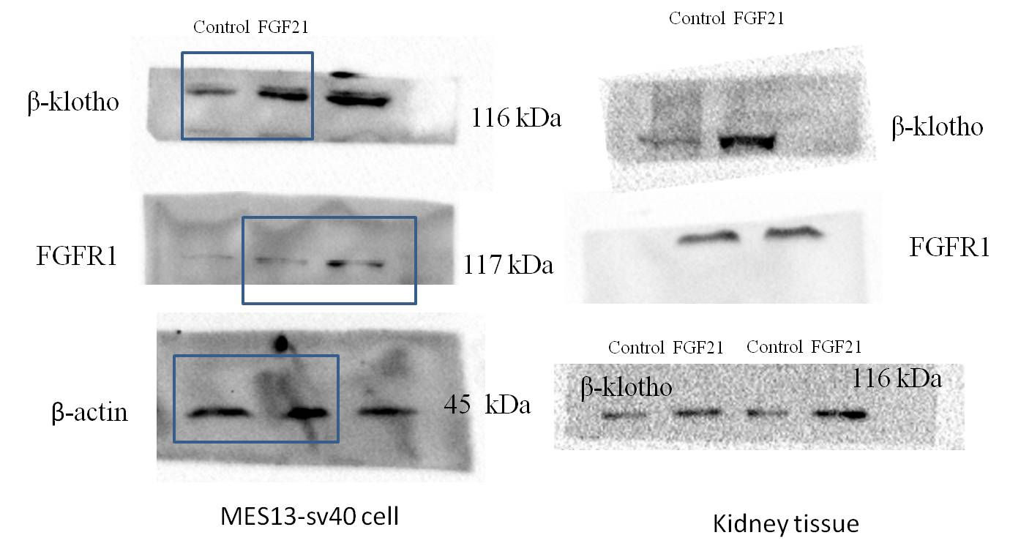
Panel A represents Western blot analysis shown in Fig1. The box panes were target lanes. Every lane in every protein image was a same group of the kidney mice or cell. The first lane was normal control. The second lane was FGF21 treatment. The data of manuscript was cropped from these original data
B
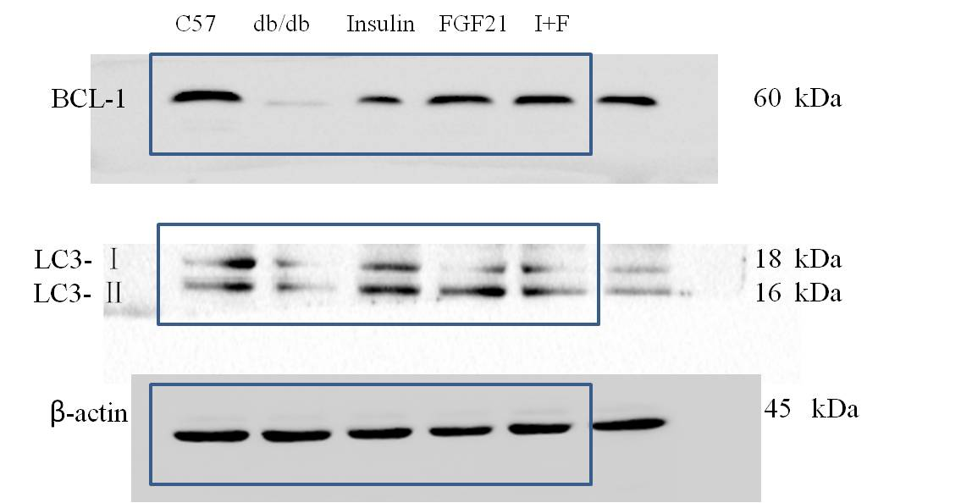
Panel B represents Western blot analysis shown in Fig. 4C. The box panes were target lanes. Every lane in every protein image was a same group of the kidney mice. The first lane was normal control. The sencond lane was model control. The third lane was insulin treatment. The fourth lane was FGF21treatment. The fifth lane was FGF21 treatment combination with insulin. The data of manuscript was cropped from these original data

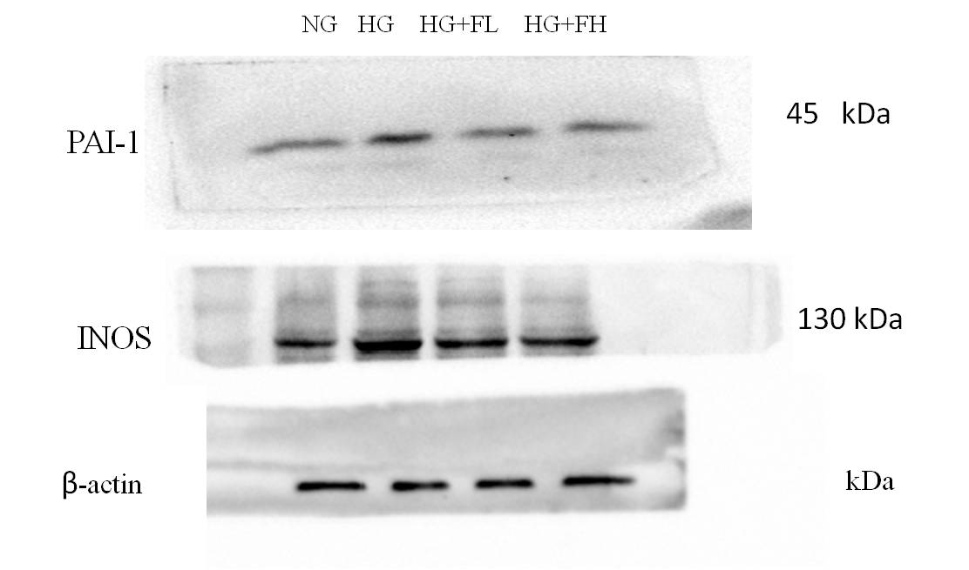
C
Panel C represents Western blot analysis shown in Fig. 5E. Every lane in every protein image was a same group of cells. The first lane was normal control. The sencond lane was model control. The third lane was low dose FGF21 treatment. The fourth lane was high dose FGF21treatment. The data of manuscript was cropped from these original data.
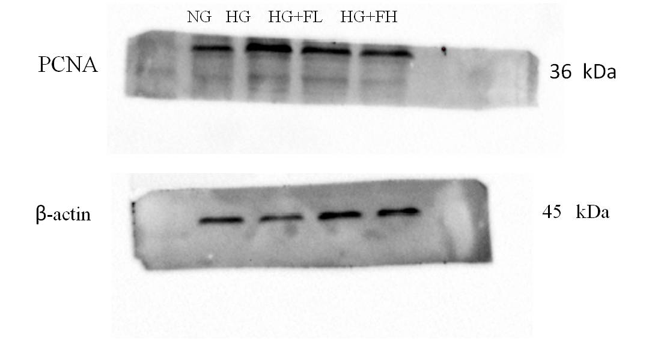
D
Panel D represents Western blot analysis shown in Fig. 6C. Every lane in every protein image was a same group of cells. The first lane was normal control. The sencond lane was model control. The third lane was low dose FGF21 treatment. The fourth lane was high dose FGF21treatment. The data of manuscript was cropped from these original data.

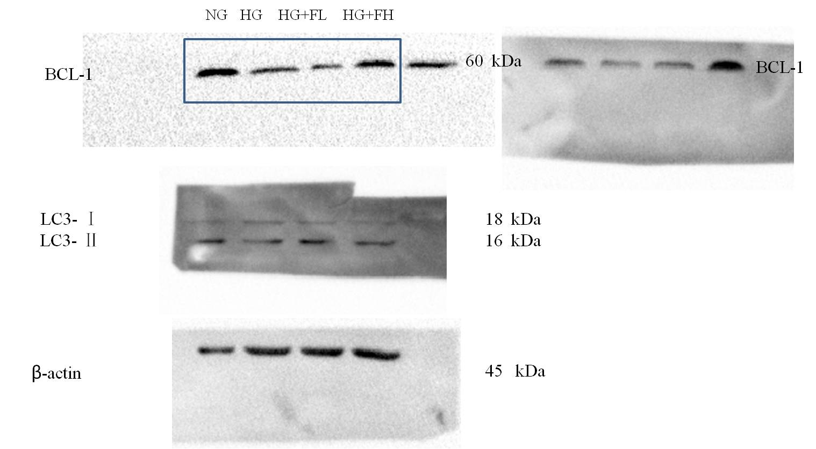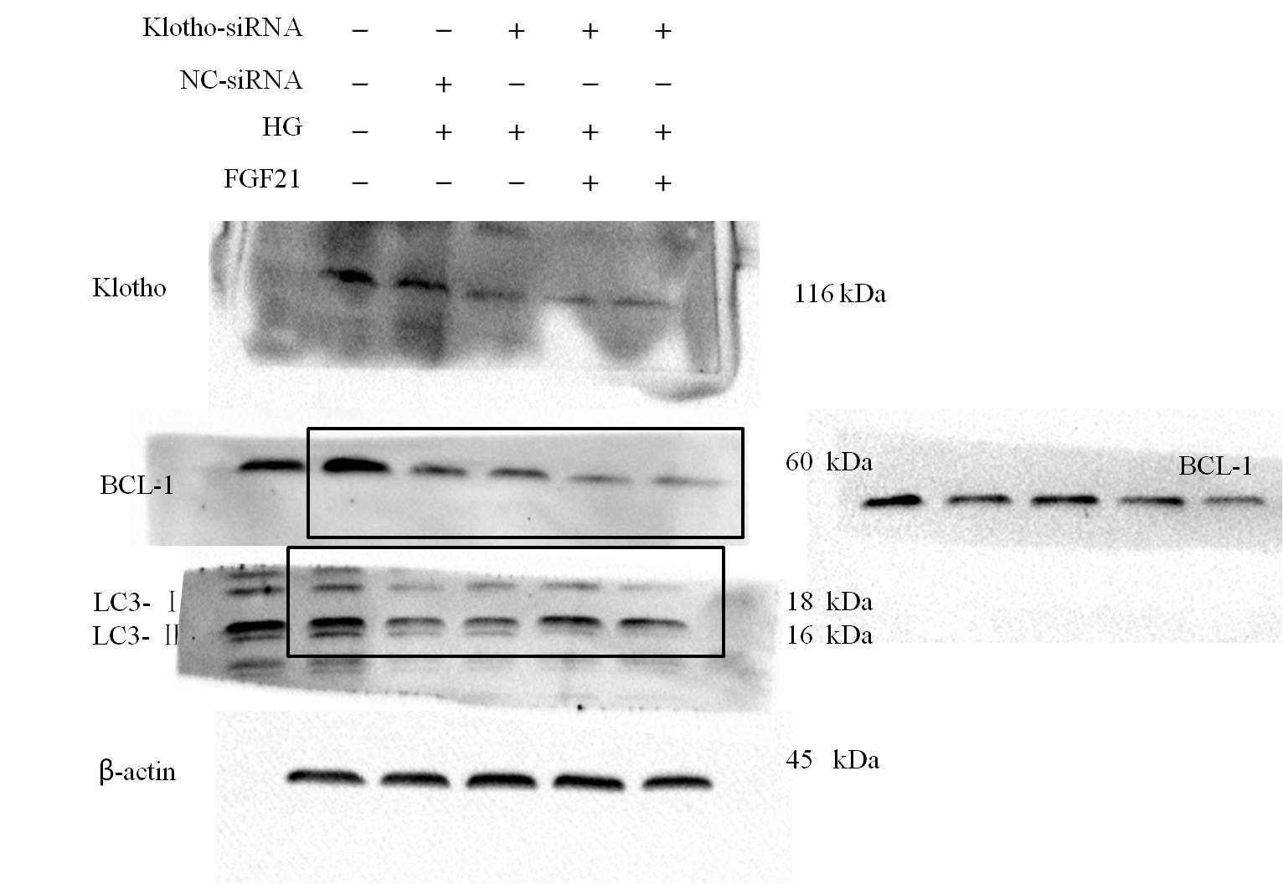
F
E
Panel E, F represents Western blot analysis shown in Fig. 7C, F. The box panes were target lanes. Every lane in every protein image was a same group of cells. The data of manuscript was cropped from these original data.

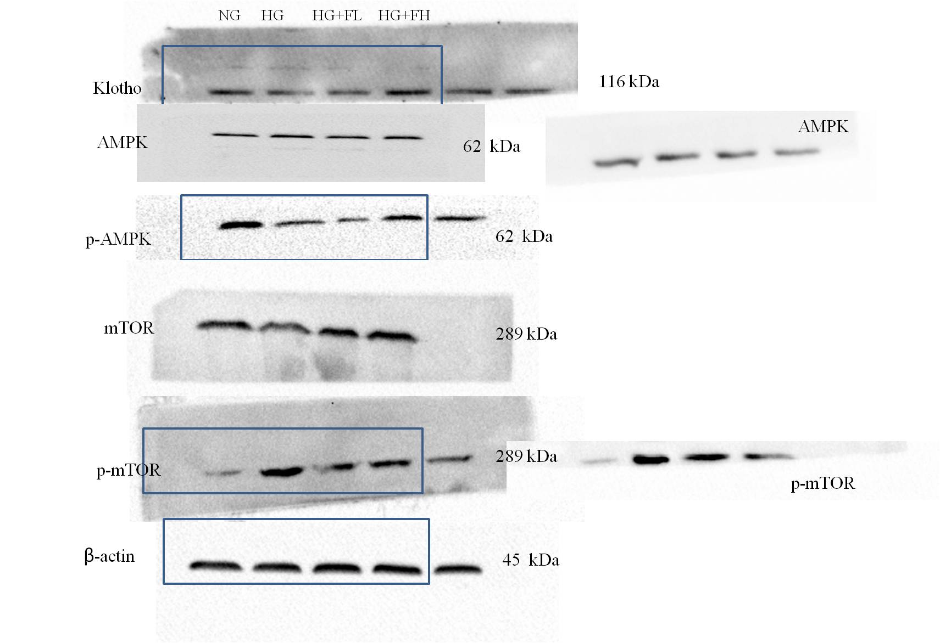
G
Panel G represents Western blot analysis shown in Fig. 8A. The box panes were target lanes. Every lane in every protein image was a same group of cells. The first lane was normal control. The sencond lane was model control. The third lane was low dose FGF21 treatment. The fourth lane was high dose FGF21treatment. The data of manuscript was cropped from these original data.

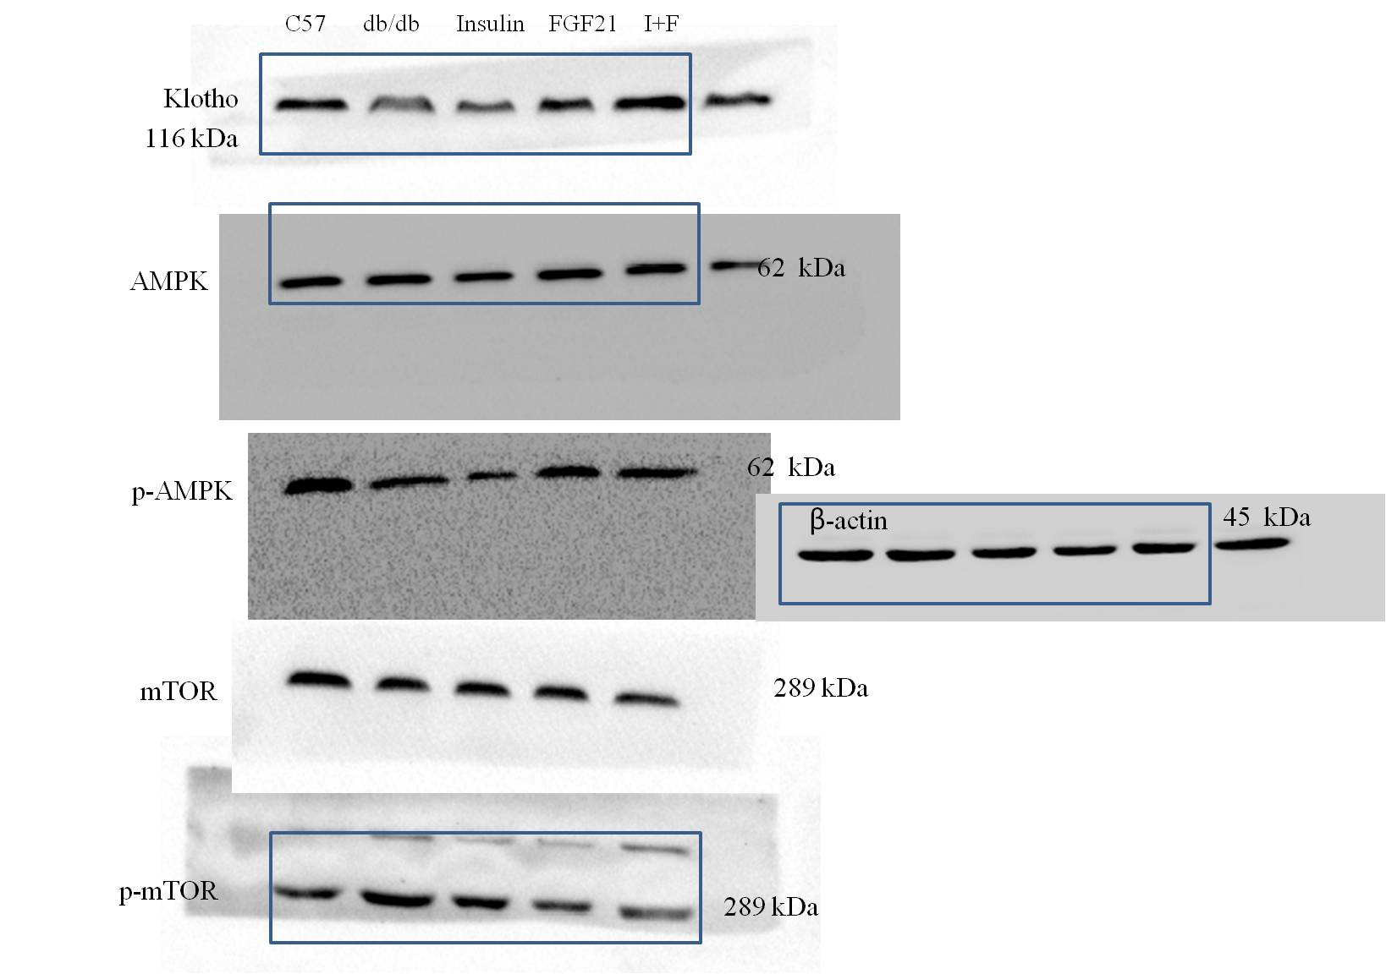
H
Panel H represents Western blot analysis shown in Fig. 8B. The box panes were target lanes. Every lane in every protein image was a same group of the kidney mice. The first lane was normal control. The sencond lane was model control. The third lane was insulin treatment. The fourth lane was FGF21treatment. The fifth lane was FGF21 treatment combination with insulin. The data of manuscript was cropped from these original data
I
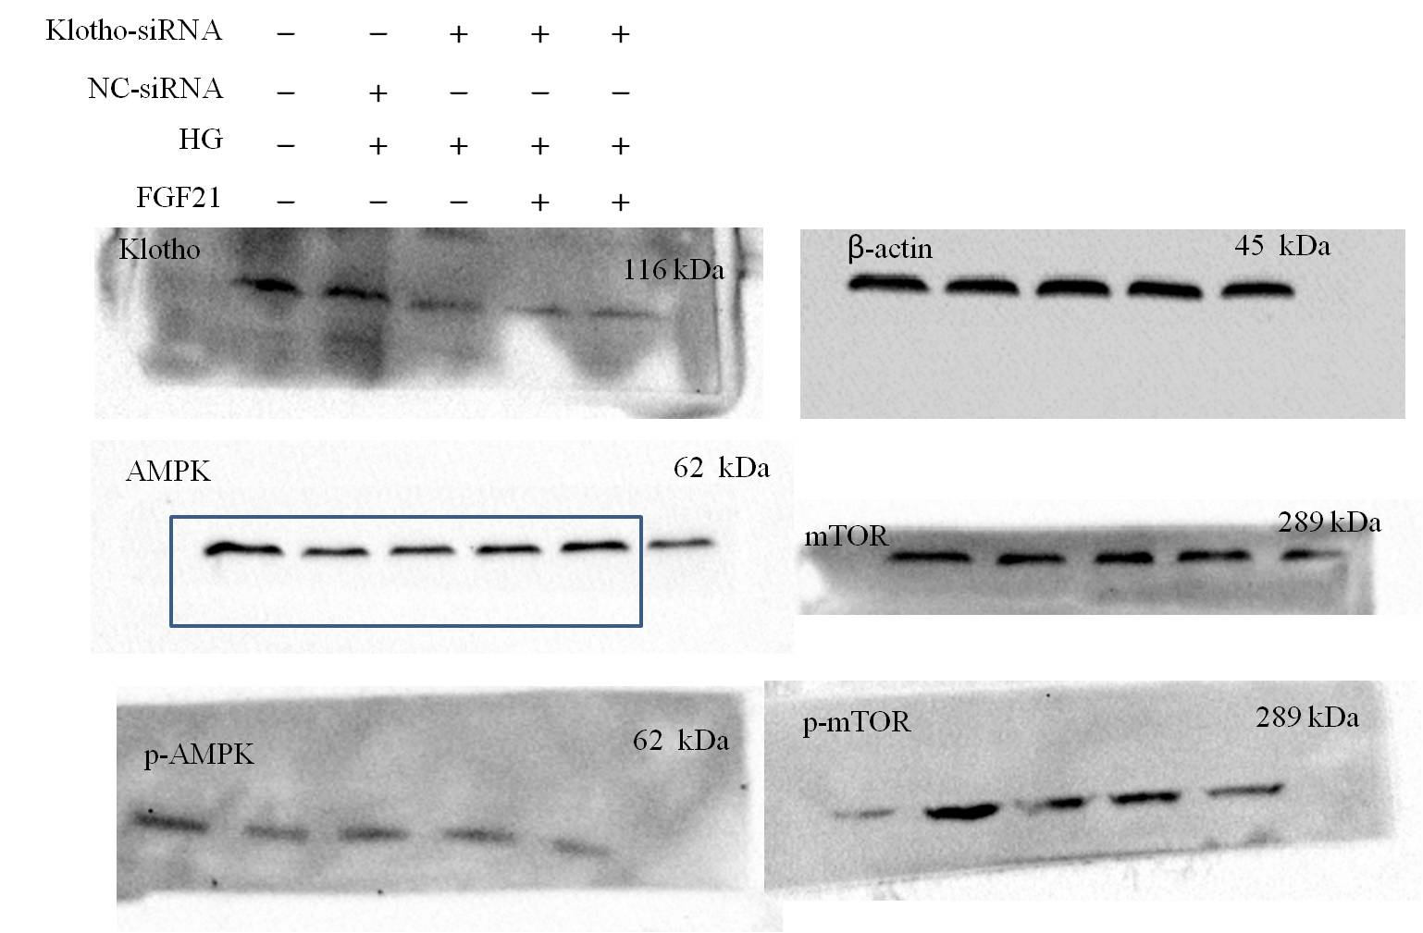
Panel I represents Western blot analysis shown in Fig. 8C, F. The box panes were target lanes. Every lane in every protein image was a same group of cells. The data of manuscript was cropped from these original data.

