Supplementary Information

Journal of Physiology and Biochemistry
Effect of Exercise Training on Autophagic Process in White Adipose Tissue of High Fat Diet-Induced Obese Mice

Saeed Daneshyar
Department of Exercise Physiology, Faculty of Physical Education and Sport Sciences, Tehran University, Tehran, Iran; Department of Physical Education, Faculty of Humanities, Ayatollah Alozma Boroujerdi University, Lorestan, Iran; 0000-0002-8806-9736; s.daneshyar@ut.ac.ir

Gholamreza Tavoosidana
Department of Molecular Medicine, School of Advanced Technologies in Medicine, Tehran University of Medical Sciences, Tehran, Iran; 0000-0002-1079-7434; g-tavoosi@tums.ac.ir

Fatemeh Jalali-Moghim
Department of Physiology, Faculty of Basic Sciences, Bu-Ali Sina University, Hamedan, Iran; 0000-0003-4917-2017; Fjalali82@yahoo.com

Sadegh Amani- Shalamzari
Department of exercise physiology, Faculty of Physical Education and Sport Sciences, Kharazmi University, Karaj, Iran; 0000-0002-3021-8970; amani_sadegh@khu.ac.ir

*Corresponding author: https://orcid.org/0000-0002-8806-9736; e-mail: s.daneshyar@abru.ac.ir

Supplemental Table 1. The information of target-gene primers
Ref. | product length | Reverse primer  5′→3′ | Forward primer  5′→3′ | Accession | Name
[1] | 150 | GGAGGGATGGTGTATGGTAAG  Tm: 57.23; GC%: 52.38 | AGACCTGCTTACTTGCTGTG  Tm: 57.82; GC%: 50 | NM_007798.3 | CTSB
[2] | 184 | TATCCACGAACCCTGTGTCA  Tm: 58.37; GC%: 50 | GTGGACTGTTCTCACGCTCA  Tm: 59.97; GC%: 55 | NM_009984.4 | CTSL
[3] | 120 | GTCAAATAGCTGACTCTTGGCAA  Tm: 59.25; GC%: 43.48 | TGTGCTTCGAGATGTGTGGTT  Tm: 60.20; GC%: 47.62 | NM_053069.6 | ATG5
[3] | 101 | CACCTGACTTTATGGCTTCCC  Tm: 58.63; GC%: 52.38 | CCTGCACAACACCAACACAC  Tm: 60.18; GC%: 55.00 | NM_001253717.2 | ATG7
[4] | 141 | CCTGCGAGGCATAAACCATGT  Tm: 61.02; GC5: 52.38 | GCTTGCAGCTCAATGCTAAC  Tm: 58.09; GC%: 50.00 | NM_026160.5 | LC3b (Map1lc3b)
[4] | 150 | CAGCGGCTATGAGAGAAGCTAT-  Tm: 47.62; GC%: 50.00 | TGTGGTGGGAACTCGCTATAA  Tm: 58.82; GC%; 59.77 | NM_011018.3 | SQSTM1  (p62)
[5] | 70 | TGTCATCATCCAGCGAACAC  Tm: 58.27; GC%: 50 | AAGGTGCAACCTTTTAATGTGAC  Tm: 58.06; Gc%: 39 | NM_010685.4 | LAMP2
 | 138 | TGCTGGAAGGTGGACAGTGAGG  Tm: 64.17; GC%: 59.09 | CATTGCTGACAGGATGCAGAAGG  Tm: 62.04; GC%: 52.17 | NM_007393.5 | ꞵ-Actin
CTSB, cathepsin B; CTSL, cathepsin L; ATG5, autophagy-related genes5; ATG7, autophagy-related genes7; LC3b, microtubule-associated protein 1-light chain 3; SQSTM, sequestosome 1; LAMP2, lysosome-associated membrane protein 2; Ref., Reference

Supplemental Table 2. The information of the antibodies used in the western blot
dilution | Inc. |  | Cat. No. |  | Name
1:1000 |  | Cell Signaling Technology, Danvers, Massachusetts, USA |  | Cathepsin B (D1C7Y), 31718 | CTSB
1:500 |  | Santa Cruz Biotechnology  Dallas, Texas , USA |  | cathepsin L Antibody (B-8): sc-393770 | CTSL
1:1000 |  | Cell Signaling Technology, Danvers, Massachusetts, USA |  | Atg5 (D5F5U), 12994 | ATG5
1:1000 |  | Cell Signaling Technology, Danvers, Massachusetts, USA |  | Atg7 Antibody , 2631 | ATG7
1:1000 |  | Cell Signaling Technology, Danvers, Massachusetts, USA |  | LC3A/B Antibody, 4108 | LC3A/B
1:1000 |  | Cell Signaling Technology, Danvers, Massachusetts, USA |  | SQSTM1/p62 Antibody #5114 | SQSTM1  (p62)
1:500 |  | Santa Cruz Biotechnology  Dallas, Texas, USA |  | LAMP2 Antibody (M3/84): sc-19991 | LAMP2
1:1000 |  | Cell Signaling Technology, Danvers, Massachusetts, USA |  | β-Actin (8H10D10) Mouse mAb #3700 | ꞵ-Actin
1:1000 |  | Novus Biologicals  Centennial, Colorado |  | Goat anti-Rabbit IgG Secondary Antibody HRP (Horseradish Peroxidase) HAF-008 | Secondary Antibody
CTSB, cathepsin B; CTSL, cathepsin L; ATG5, autophagy-related genes5; ATG7, autophagy-related genes7; LC3A/B, microtubule-associated protein 1-light chain 3; SQSTM, sequestosome 1; LAMP2, lysosome-associated membrane protein 2; Cat. No., Catalogue number; Inc., Incorporated

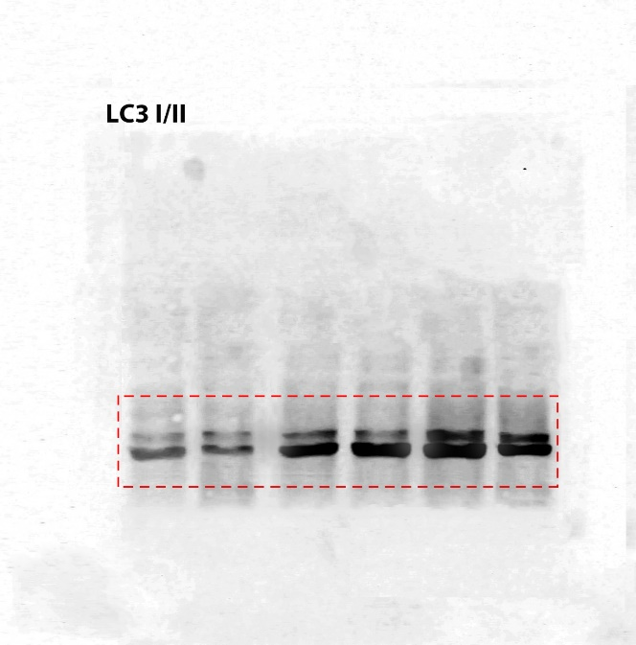
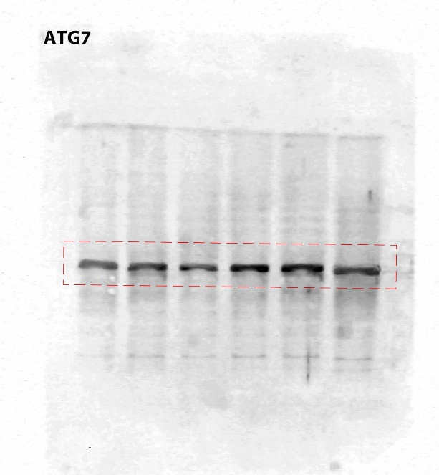
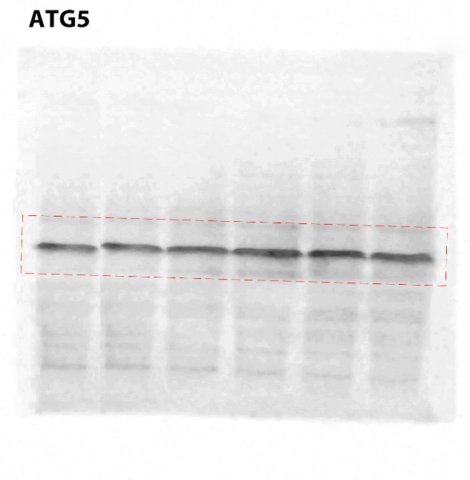
Supplemental Figure. Western-Blot image (without crop) of measured protein
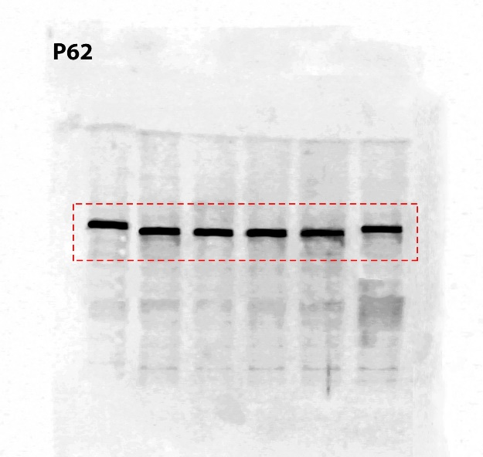

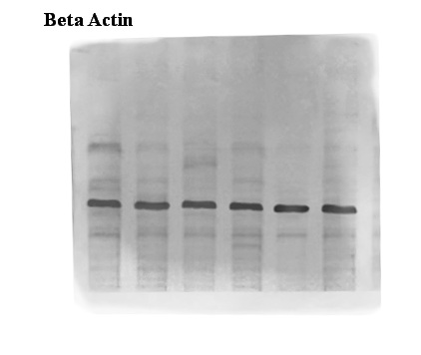
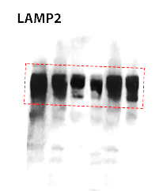
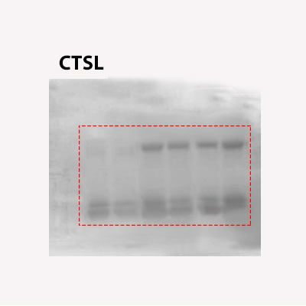
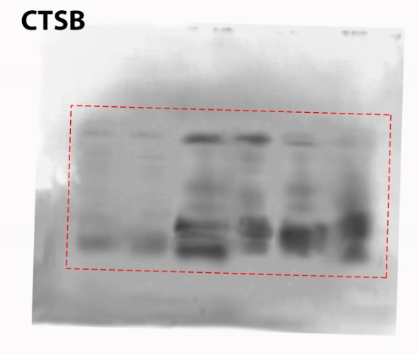

1. Moon, H.Y., et al., Running-induced systemic cathepsin B secretion is associated with memory function. Cell metabolism, 2016. 24(2): p. 332-340.
2. Yamada, A., et al., Cathepsin L Inhibition Prevents Murine Autoimmune Diabetes via Suppression of CD8+ T Cell Activity. PLOS ONE, 2010. 5(9): p. e12894.
3. Deng, Y., et al., Berberine attenuates autophagy in adipocytes by targeting BECN1. Autophagy, 2014. 10(10): p. 1776-86.
4. Parousis, A., et al., Contractile activity attenuates autophagy suppression and reverses mitochondrial defects in skeletal muscle cells. Autophagy, 2018. 14(11): p. 1886-1897.
5. Sakane, H. and K. Akasaki, The major lysosomal membrane proteins LAMP-1 and LAMP-2 participate in differentiation of C2C12 myoblasts. Biological and Pharmaceutical Bulletin, 2018. 41(8): p. 1186-1193.

