Supplement 1. GOS scores before and after successful eradication

 | Group N (n = 233) |  |  | Group E (n = 117)
 | Before | After | P | Before | After | P
GOS score | 1.84 ± 0.81 | 1.46 ± 0.58 | < 0.01 | 1.89 ± 0.86 | 1.52 ± 0.55 | < 0.01
Epigastric pain | 2.22 ± 1.45 | 1.64 ± 0.97 | < 0.01 | 2.21 ± 1.48 | 1.54 ± 0.86 | < 0.01
Heartburn | 2.05 ± 1.24 | 1.55 ± 0.93 | < 0.01 | 2.09 ± 1.31 | 1.70 ± 0.92 | < 0.01
Acid regurgitation | 1.81 ± 1.17 | 1.46 ± 0.83 | < 0.01 | 1.86 ± 1.10 | 1.60 ± 0.92 | < 0.05
Bloating | 2.28 ± 1.31 | 1.64 ± 0.88 | < 0.01 | 2.25 ± 1.32 | 1.77 ± 0.98 | < 0.01
Nausea | 1.59 ± 1.18 | 1.22 ± 0.60 | < 0.01 | 1.66 ± 1.08 | 1.25 ± 0.52 | < 0.01
Belching | 1.60 ± 0.96 | 1.39 ± 0.80 | < 0.01 | 1.62 ± 0.80 | 1.44 ± 0.81 | < 0.05
Early satiety | 1.51 ± 0.97 | 1.32 ± 0.64 | < 0.01 | 1.55 ± 0.93 | 1.35 ± 0.62 | < 0.05
Postprandial fullness | 1.67 ± 1.01 | 1.44 ± 0.81 | < 0.01 | 1.79 ± 1.21 | 1.54 ± 0.89 | < 0.05
Borborygmus | 1.67 ± 0.97 | 1.49 ± 0.86 | < 0.01 | 1.66 ± 1.11 | 1.46 ± 0.79 | 0.07
Hunger pain | 1.89 ± 1.19 | 1.47 ± 0.81 | < 0.01 | 1.74 ± 1.18 | 1.51 ± 0.90 | < 0.05
Supplement 2. Long-term follow-up of dyspepsia symptoms after successful eradication
 | Group N (n = 40) | Group E (n = 20)
Gender (male/ female), n | 17/ 23 | 9/ 11
Mean age at H. pylori eradication, years (range) | 52.4 (17-64) | 70.0 (65-76)
Mean period between eradication and  3rd questionnaires, months (range) | 61.3 (15-124) | 54.8 (12-116)
Eradication therapy  1st-line/2nd-line/3rd-line /4th-line, n | 22/ 7/ 8/ 3 | 11/ 3/ 5/ 1
H. pylori-associated dyspepsia, n (%) | 32 (80) | 12 (60)

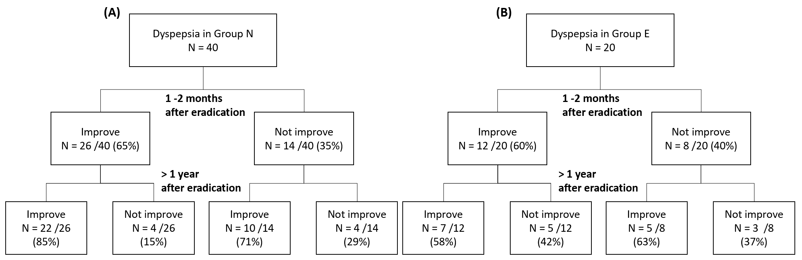
Supplement 3. Long-term effects of H. pylori eradication on dyspepsia.
(A) In the non-elderly patients, 26 patients with dyspepsia before eradication had decreases in scores to improvement of dyspepsia at 1-2 months after eradication and 22 patients (85%) had long-term improvement in symptoms. (B) In the elderly patients, 12 patients (60%) with dyspepsia before eradication had decreases in scores to improvement of dyspepsia at 1-2 months after eradication and 7 patients (58%) had long-term improvement in symptoms.

