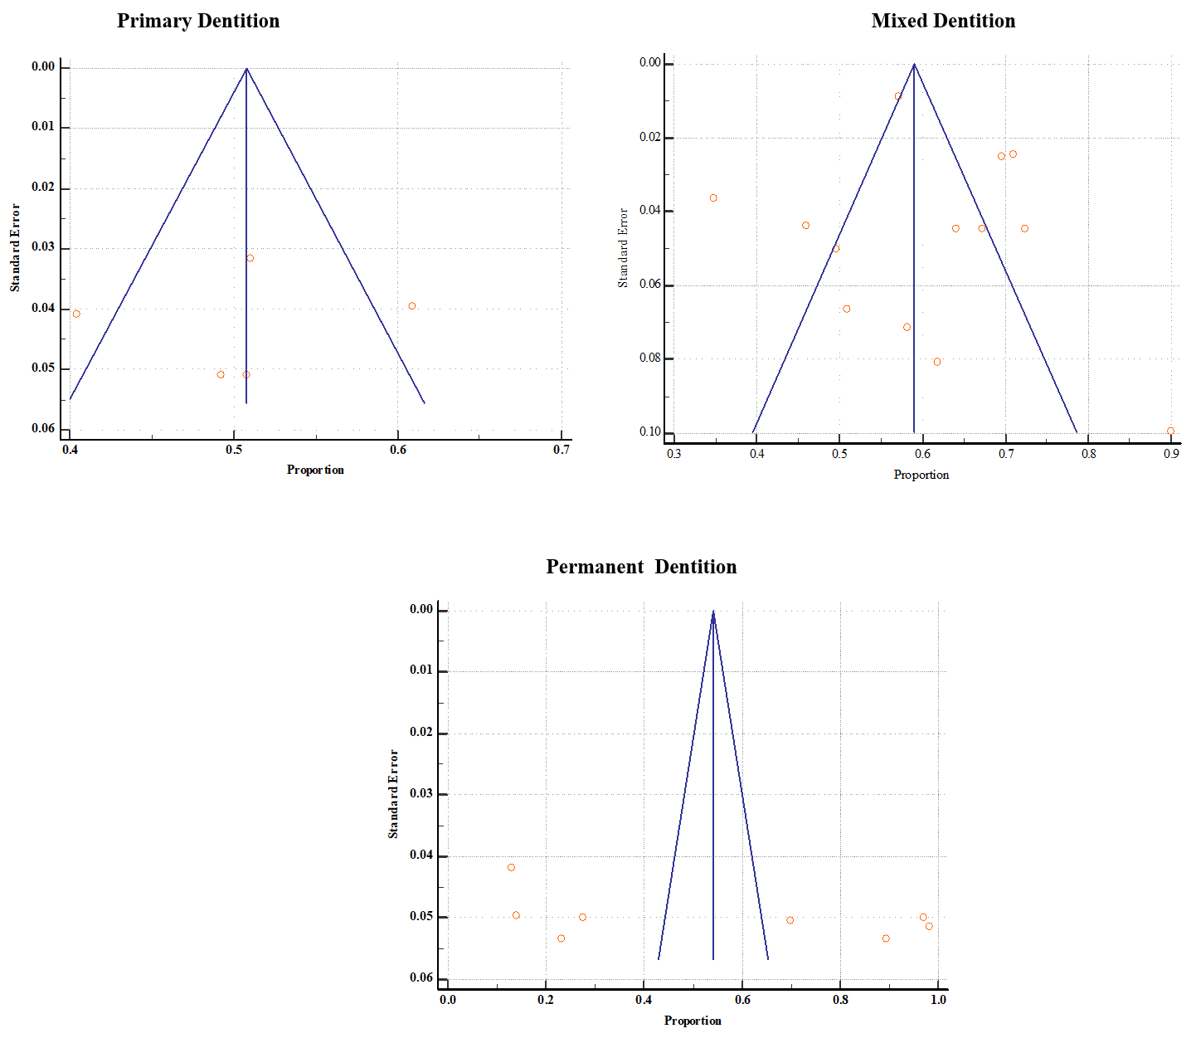
Figure S2. Funnel plot showing the prevalence of dental caries as the proportion for primary, mixed, and permeant dentitions

