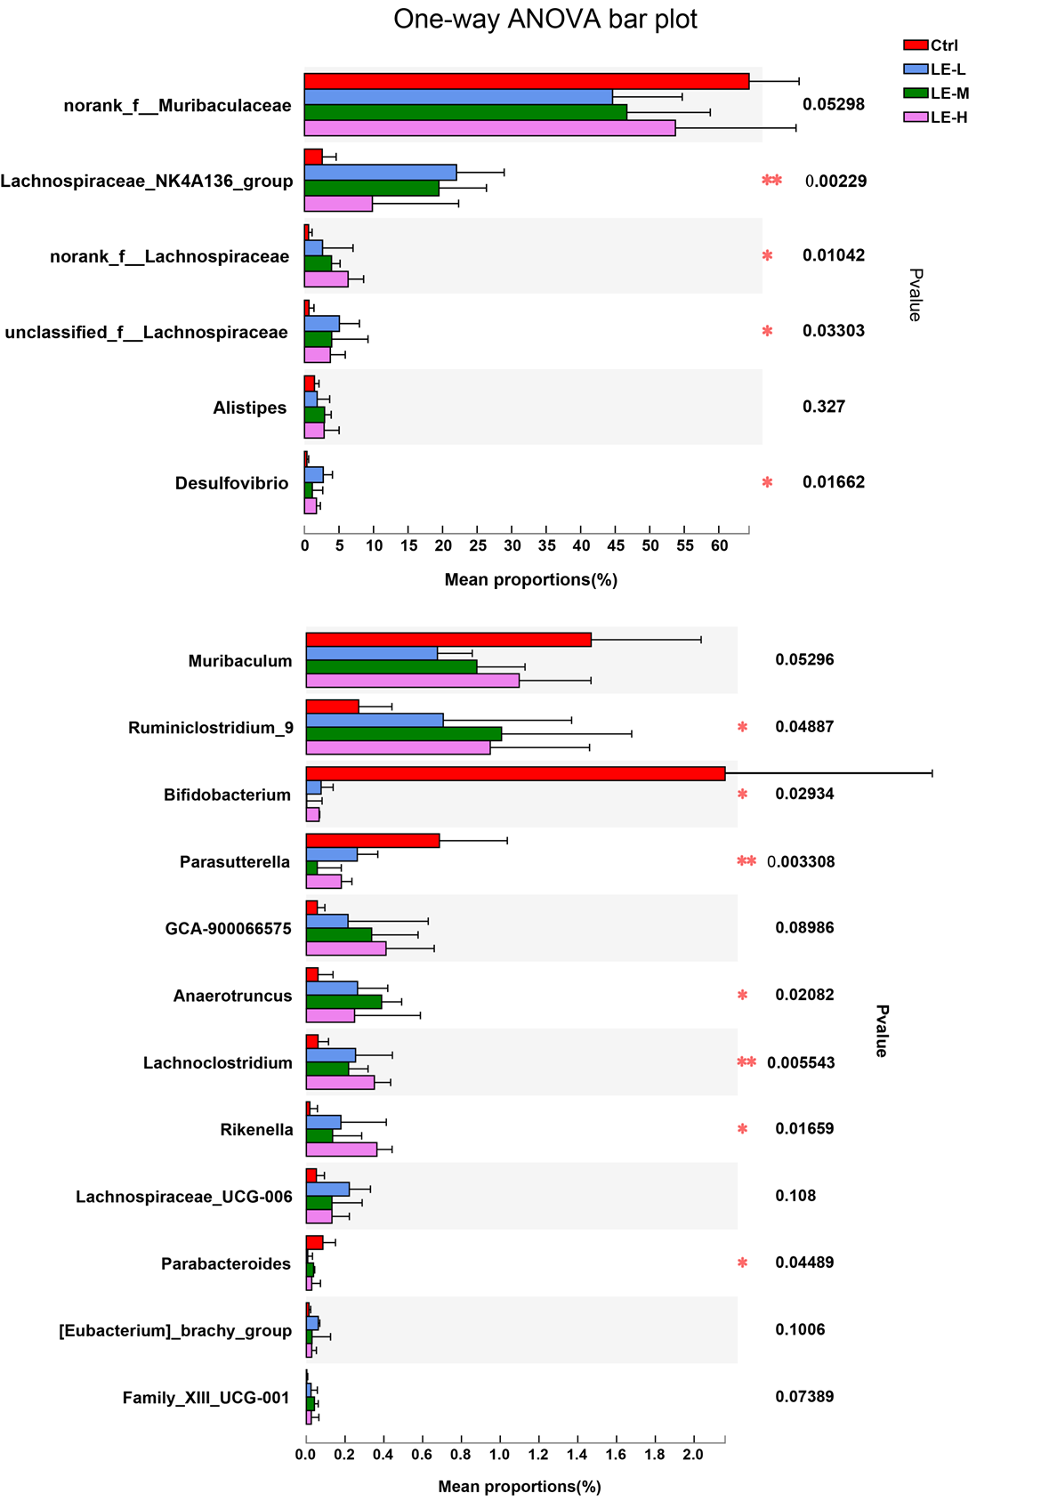
Additional Information Fig. S1. Generic difference among groups after 2 weeks of Longan extract treatment. *p < 0.05, **p < 0.01, by one-way ANOVA.

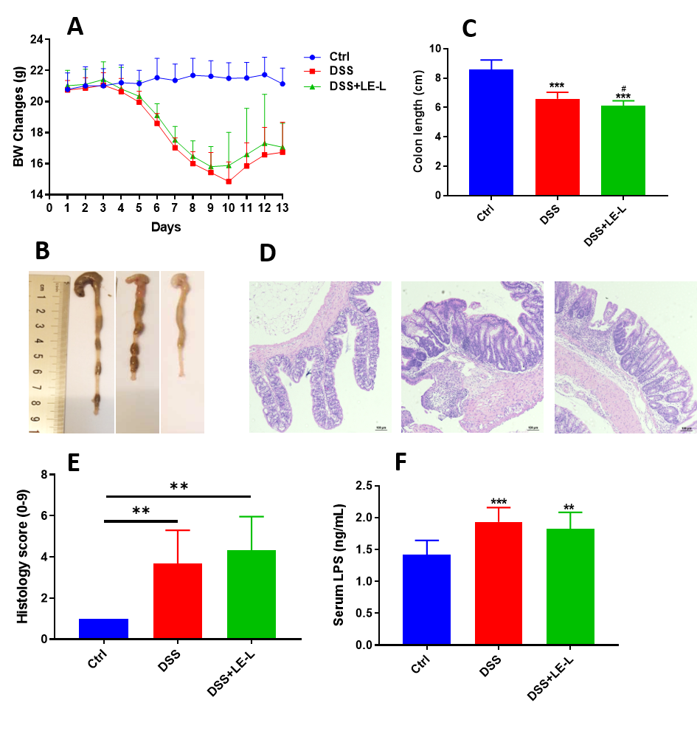 Additional Information Fig. S2. Intake of longan extract (LE) at 4 g/kg did not aggravate DSS-induced colitis in mice. (A) Body weight changes. (B) Colon length. (C) Statistics for colon length. (D) Histopathological changes of colon tissues after H&E staining. (E) Histological score based on H&E stained colon sections. (F) Serum level of LPS. Data are presented as mean ± SD. *p < 0.05, **p < 0.01, compared to Ctrl.

