·Supplementary Material for
Neighborhood-Level Public Facilities and COVID-19 Transmission:
A Nationwide Geo-spatial Study in China
This PDF file includes:
Tables S1 to S4
Figure S1 and S2

Table S1. Description of eight kinds of facilities

Facilities | Description
Restaurant | Chinese food restaurant, foreign food restaurant, fast food restaurant, leisure food restaurant, coffee House, tea house, ice cream shop, bakery, dessert house
Shopping | Convenience store, home electronics hypermarket, supermarket, plants and pet market, home building materials market, comprehensive market, stationary store, sports store, commercial street, clothing store, clothing store
Hotel | Hotel
Living | Daily life service place, travel agency, information center, information center, ticket office, post office, logistics service, telecom office, professional service firm, job center, water supply service office, electric supply service office, beauty and hairdressing store, repair store, photo finishing, bath and massage center, laundry agency, move service, lottery store, funeral facilities
Recreation | Sports stadium, golf related, recreation center, holiday and nursing resort, recreation place, theatre and cinema, park and square
Public transit | Airport related, railway station, port and marina, coach station, subway station, light rail station, bus station, commuter bus station, parking lot
Education | Museum, exhibition hall, convention and exhibition center, art gallery, library, science and technology museum, planetarium, cultural palace, archives hall, arts organization, media organization, school, research institution, training institution, driving school, transportation service related
Health services | Hospital, clinic, emergency center, disease prevention institution, pharmacy

Table S2 Correlation matrices* of the eight types of facilities
 | Restaurant | Shopping | Hotel | Living | Recreation | Traffic | Education | Health services
Restaurant | 1.00ª
Shopping | 0.91 | 1.00
Hotel | 0.75 | 0.74 | 1.00
Living | 0.92 | 0.91 | 0.76 | 1.00
Recreation | 0.78 | 0.75 | 0.83 | 0.75 | 1.00
Public transit | 0.70 | 0.67 | 0.65 | 0.75 | 0.62 | 1.00
Education | 0.85 | 0.82 | 0.73 | 0.88 | 0.73 | 0.76 | 1.00
Health services | 0.79 | 0.77 | 0.69 | 0.87 | 0.69 | 0.69 | 0.79 | 1.00

*: Pearson product-moment correlation coefficient

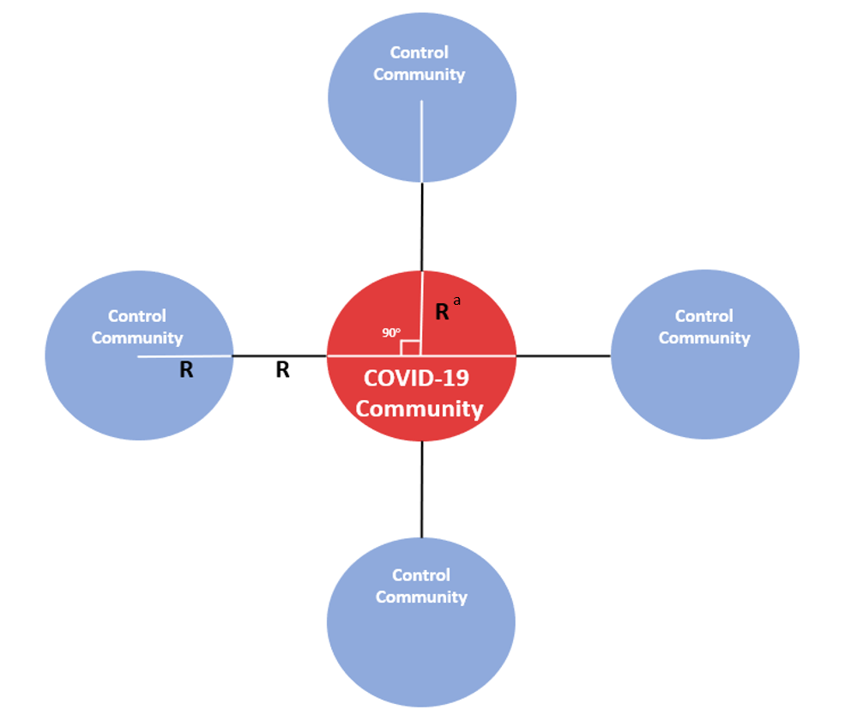
Figure S1.
Designing of the case and control selection
* R=1500 m
If the point was not located in a neighborhood, we use a K-nearest-neighbor algorithm to identify the nearest neighborhood to the point

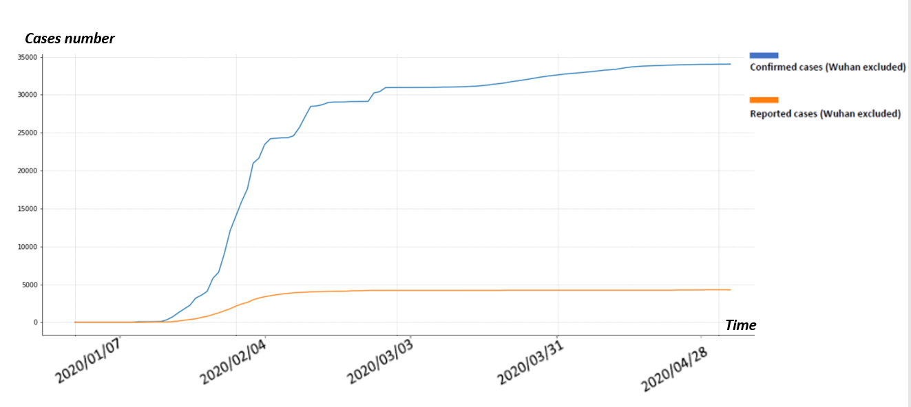
Figure S2. Distribution of Reported and Confirmed COVID-19 Cases in China from January 7th to April 30th, 2020

Table S3. Sensitivity analysis: Association of eight types of public facilities with having COVID cases in the communities using different buffer range
 | 800 m buffer | 1200 m buffer
 | Odds ratio (95% Confidence interval) ª
Restaurant ^{b} | 1.52 (1.42, 1.63) | 1.68 (1.58, 1.80)
Shopping | 1.64 (1.53, 1.75) | 1.88 (1.76, 2.01)
Hotel | 1.55 (1.45, 1.66) | 2.01 (1.88, 2.16)
Living | 1.47 (1.38, 1.57) | 1.50 (1.40, 1.60)
Recreation | 1.76 (1.65, 1.89) | 1.90 (1.78, 2.04)
Public transit | 1.56 (1.45, 1.67) | 1.31 (1.22, 1.40)
Education | 1.51 (1.41, 1.61) | 1.72 (1.60, 1.83)
Health service | 1.55 (1.45, 1.65) | 3.41 (3.17, 3.66)
ª Model adjusted for city-level variables including population size, Gross Domestic Product, unemployment rate, Government Budget Balance, and resident mobility. Odds ratios from logistic regressions are shown on the left-hand side.
^{b} The reference group was the “lower than the median” for each public facility

Table S4. Sensitivity analysis: Association of eight types of public facilities with having COVID cases in the communities by using different cut-off point to drop those neighborhoods with lower numbers of public facilities
Total facilities | ≥1 | ≥3 | ≥5
Number of communities | 8,139 | 6,379 | 5,913
 | Odds ratio (95% Confidence interval) ª
Restaurant ^{b} | 1.22 (1.16, 1.29) | 1.69 (1.59, 1.80) | 1.74 (1.63, 1.86)
Shopping | 1.27 (1.211, 1.34) | 1.70 (1.60, 1.81) | 1.89 (1.77, 2.02)
Hotel | 1.26 (1.19, 1.33) | 1.82 (1.71, 1.93) | 2.00 (1.88, 2.14)
Living | 1.14 (1.08, 1.21) | 1.47 (1.38, 1.56) | 1.50 (1.41, 1.60)
Recreation | 1.19 (1.13, 1.25) | 1.68 (1.58, 1.79) | 1.74 (1.63, 1.86)
Public transit | 1.00 (0.93, 1.06) | 1.30 (1.22, 1.38) | 1.35 (1.26, 1.44)
Education | 1.18 (1.12, 1.25) | 1.65 (1.55, 1.75) | 1.70 (1.59, 1.81)
Health service | 1.88 (1.78, 1.98) | 2.93 (2.75, 3.12) | 3.22 (3.01, 3.45)
ª Model adjusted for city-level variables including population size, Gross Domestic Product, unemployment rate, Government Budget Balance, and resident mobility. Odds ratios from logistic regressions are shown on the left-hand side.
^{b} The reference group was the “lower than the median” for each public facility

