Supplement

Supplement table 1 Change in metabolic health status and risk of CKD: sensitivity analyses
 | Stable MHNW | MHNW-MUNW | MUNW | Stable MHOW | MHOW-MUOW | MUOW | Stable MHO | MHO-MUO | MUO
Competing risk model | Reference | 1.17(1.03-1.33) | 1.36(1.21-1.51) | 1.07(0.98-1.17) | 1.25(1.12-1.40) | 1.52(1.40-1.65) | 1.16(1.01-1.32) | 1.36(1.17-1.57) | 1.90(1.73-2.09)
Excluding participants with CKD occurring within the first two years of follow-up | Reference | 1.15(1.00-1.32) | 1.35(1.20-1.52) | 1.07(0.97-1.17) | 1.24(1.10-1.39) | 1.53(1.39-1.67) | 1.13(0.98-1.30) | 1.32(1.12-1.55) | 1.91(1.72-2.11)
Excluding participants received medication | Reference | 1.18(1.03-1.35) | 1.44(1.26-1.63) | 1.08(0.98-1.18) | 1.26(1.13-1.42) | 1.56(1.41-1.72) | 1.13(0.98-1.30) | 1.35(1.15-1.58) | 1.94(1.73-2.17)
Using overweight and obesity defined as ≥ 25kg/ m2 and ≥ 30kg/ m2 | Reference | 1.22(1.10-1.37) | 1.36(1.24-1.49) | 1.09(1.00-1.19) | 1.21(1.08-1.34) | 1.67(1.54-1.81) | 1.10(0.90-1.35) | 1.47(1.19-1.83) | 1.94(1.71-2.19)
Interval-censored survival models | Reference | 1.18(1.04-1.34) | 1.37(1.22-1.53) | 1.06(0.97-1.16) | 1.24(1.11-1.39) | 1.54(1.41-1.68) | 1.16(1.01-1.32) | 1.35(1.16-1.58) | 1.91(1.74-2.10)
Cox proportional-hazards regression models used age as the time scale, all models were adjusted for sex, income, educational level, drinking, smoking, physical activity, ALT, LDL-C, Hs-CRP. MHNW, metabolically healthy normal-weight; MHOW, metabolically healthy overweight; MHO, metabolically healthy obesity; MUNW, metabolically unhealthy normal-weight; MUOW, metabolically unhealthy overweight; MUO, metabolically unhealthy obesity.

Supplement table 2 Baseline characteristics of participants across metabolic health status and waist circumstance categories.
 | MHNW | MUNW | MHO | MUO | P
N | 18324 | 5209 | 9341 | 6510 | -
Age, years | 49.22±11.17 | 53.33±10.09 | 53.18±10.91 | 55.41±10.25 | ＜0.001
Male, % | 13891(75.91) | 4519(86.75) | 6980(74.72) | 5269(80.94) | ＜0.001
BMI, kg/m² | 23.41±2.56 | 24.63±2.63 | 26.49±3.15 | 27.78±3.09 | ＜0.001
WC, cm | 79.72±6.10 | 82.49±5.12 | 95.13±6.97 | 96.32±6.95 | ＜0.001
LDL-C, mmol/L | 2.30(1.82-2.74) | 2.40(1.89-2.86) | 2.10(1.56-2.63) | 2.21(1.64-2.78) | ＜0.001
ATL, U/L | 17.00(12.00-23.00) | 19.00(14.00-26.00) | 19.00(13.00-27.00) | 22.00(16.00-31.70) | ＜0.001
Hs-CRP, mg/L | 0.50(0.20-1.37) | 0.70(0.28-1.63) | 0.90(0.32-2.72) | 1.22(0.50-3.34) | ＜0.001
Current smoker, % | 5976(32.61) | 1830(35.13) | 2611(27.95) | 2067(31.75) | ＜0.001
Current drinker, % | 3212(17.53) | 1196(22.96) | 1521(16.28) | 1316(20.22) | ＜0.001
Active physical exercise, % | 2169(11.84) | 755(14.49) | 999(10.69) | 939(14.42) | ＜0.001
High income, % | 1383(7.55) | 343(6.58) | 583(6.24) | 513(7.88) | ＜0.001
University or higher degree, % | 1851(10.10) | 304(5.84) | 601(6.43) | 404(6.21) | ＜0.001
BMI, body mass index; WC, waist circumstance; MHNW, metabolically healthy normal-weight; MHO, metabolically healthy obesity; MUNW, metabolically unhealthy normal-weight; MUO, metabolically unhealthy obesity.

Supplement table 3 Association of change in metabolic health status and risk of CKD by waist circumstance categories.
 | N | Events | Incidence, /1000 person-years | HR(95%CI)
Stable MHNW | 14501 | 1498 | 14.28 | Reference
MHNW-MUNW | 3747 | 447 | 17.05 | 1.16(1.05-1.29)
MUNW | 5209 | 824 | 23.56 | 1.47(1.34-1.60)
Stable MHO | 6178 | 790 | 17.86 | 1.07(0.98-1.16)
MHO-MUO | 3145 | 479 | 21.58 | 1.27(1.15-1.42)
MUO | 6510 | 1284 | 29.66 | 1.65(1.53-1.79)
Cox proportional-hazards regression models used age as the time scale, all models were adjusted for sex, income, educational level, drinking, smoking, physical activity, ALT, LDL-C, Hs-CRP. MHNW, metabolically healthy normal-weight; MHO, metabolically healthy obesity; MUNW, metabolically unhealthy normal-weight; MUO, metabolically unhealthy obesity.

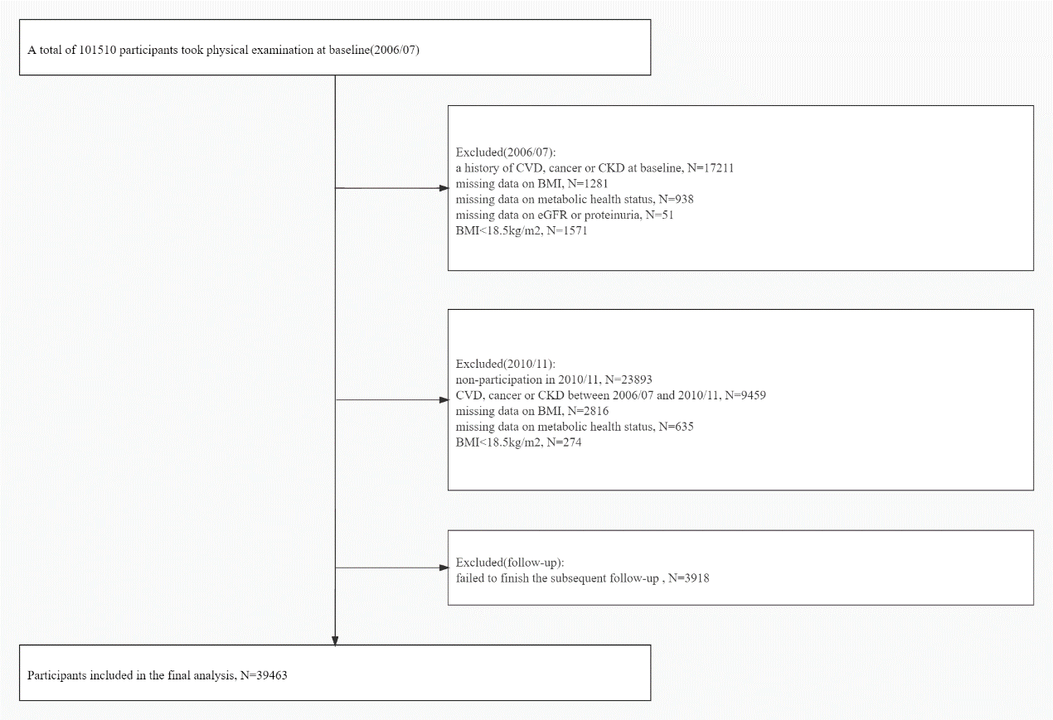
Supplement Figure 1. Flow chart of participants

Number at risk
Stable MHNW | 10891 | 10886 | 10588 | 9804 | 9512 | 8566 | 8252 | 7047 | 5399 | 2488
MHNW-MUNW | 2270 | 2267 | 2209 | 2006 | 1931 | 1678 | 1600 | 1309 | 1019 | 481
MUNW | 2703 | 2688 | 2601 | 2272 | 2196 | 1859 | 1778 | 1424 | 1136 | 485
Stable MHOW | 7751 | 7738 | 7564 | 6997 | 6798 | 6081 | 5835 | 4963 | 3972 | 1743
MHOW-MUOW | 3230 | 3222 | 3130 | 2876 | 2783 | 2460 | 2364 | 1976 | 1544 | 727
MUOW | 5698 | 5687 | 5484 | 4882 | 4702 | 4034 | 3851 | 3086 | 2362 | 1097
Stable MHO | 2155 | 2153 | 2085 | 1921 | 1874 | 1700 | 1649 | 1395 | 1138 | 488
MHO-MUO | 1415 | 1414 | 1368 | 1255 | 1205 | 1094 | 1060 | 875 | 682 | 293
MUO | 3346 | 3339 | 3220 | 2841 | 2755 | 2361 | 2248 | 1829 | 1398 | 581

Supplement Figure 2. Kaplan Meier curves showing change in metabolic health status over time and risk of chronic kidney disease
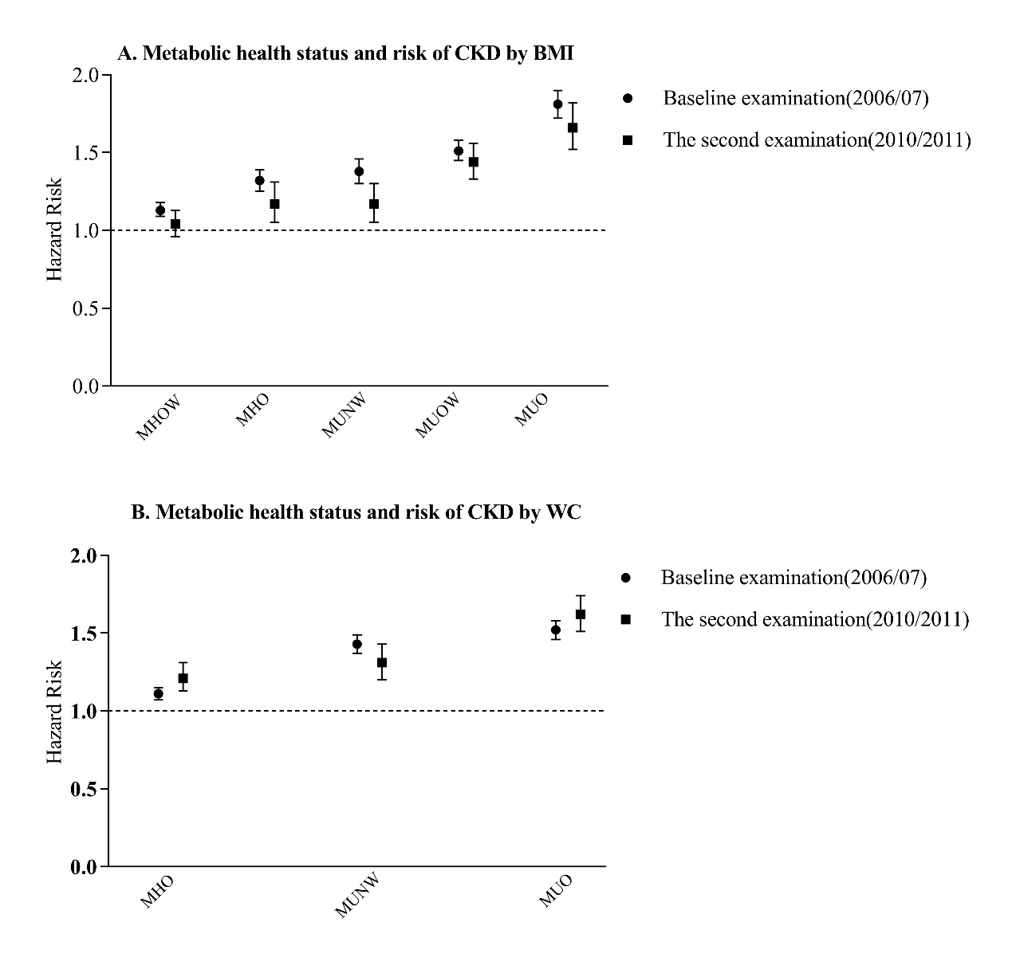
Supplement Figure 3. Association of metabolic health status and risk of CKD by BMI and WC categories. (MHNW, metabolically healthy normal-weight; MHOW, metabolically healthy overweight; MHO, metabolically healthy obesity; MUNW, metabolically unhealthy normal-weight; MUOW, metabolically unhealthy overweight; MUO, metabolically unhealthy obesity. Cox proportional-hazards regression models used age as the time scale, all models were adjusted for sex, income, educational level, drinking, smoking, physical activity, ALT, LDL-C, Hs-CRP.)

