Supplementary materials

Pediatric Primary Immune Regulation Disorder on IL-10 -IL-10R Axis: A systematic review of 284 patients

Sharifinejad et al.

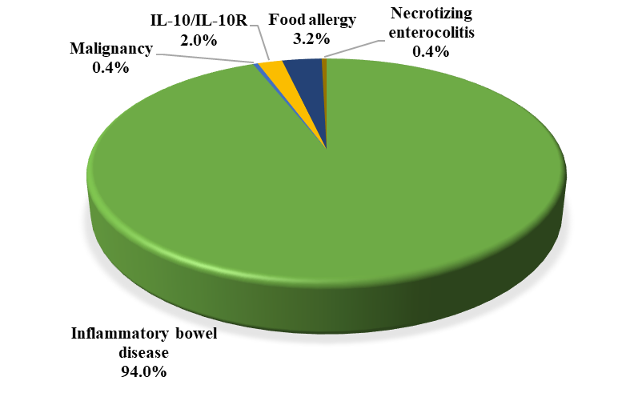
Figure S1- Initial diagnosis of patients with IL-10 and/or IL-10R deficiency.

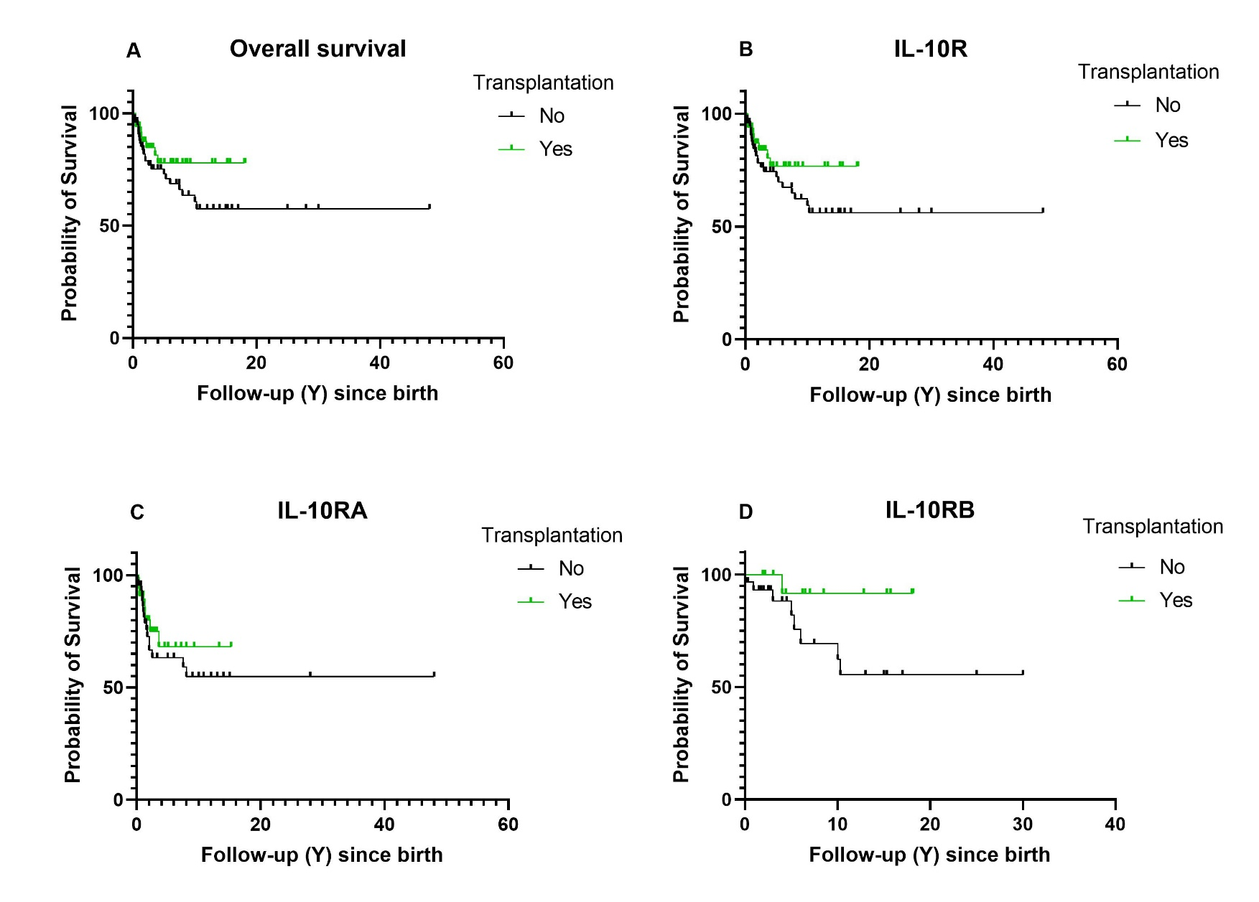
Figure S2- Kaplan-Meier survival curves of all HSCT transplanted and transplanted cases (A), patients with IL-10R deficiency (B), patients with IL-10RA deficiency (C), patients with IL-10RB deficiency (D). Transplantation was associated with a higher survival rate in all (A-D) curves.

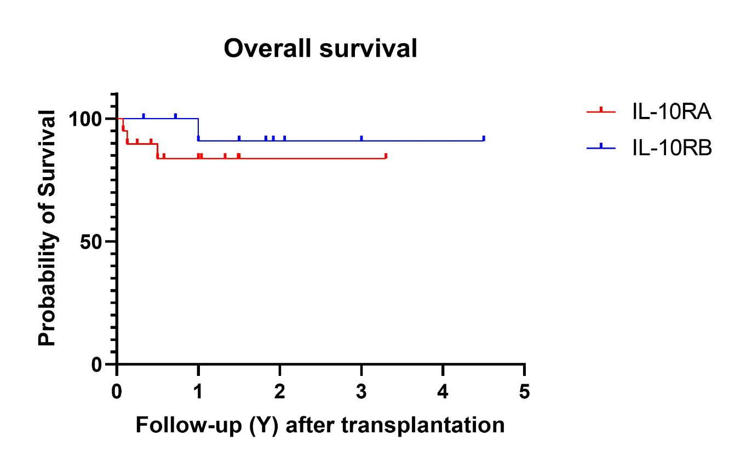
Figure S3- Kaplan-Meier survival curves of cases with available data who underwent HSCT.

Table S1– Therapeutic data of patients with IL-10/IL-10R deficiencies.
Parameters | Total | IL-10 | IL-10R | P- value | IL-10RA | IL-10RB | P- value
Transplantation, n, % (n=187) | 56 (29.9) | 2 (50) | 54 (29.5) | 0.638 | 37 (28.5) | 15 (30) | 0.838
Transplantation age, y, median (IQR), (n=157) | 2.0 (1.0-6.0) | 2.5 (1.2- ) | 2.0 (0.9-6.3) | 1.000 | 1.7 (0.8-5.8) | 3.0 (1.0-7.5) | 0.330
Follow up after transplantation, y, median (IQR), (n=157) | 1.0 (0.5-1.5) | - | 1.0 (0.5-1.5) | - | 0.5 (0.3-1.2) | 1.0 (1.0-2.0) | 0.015
Neutrophil engraftment, d, median (IQR), (n=157) | 21.0 (13.0-23.2) | 0 | 21.0 (13.0-23.2) | - | 21.5 (14.5-28.5) | 12.0 (11.0-18.5) | 0.058
Thrombocyte engraftment, d, median (IQR), (n=157) | 26.0 (19.0-29.0) | 0 | 26.0 (19.0-29.0) | - | 27.5 (25.2-30.7) | 14.0 (9.2-22.5) | 0.002
Immunosuppressive therapy, n, % (n=184) | 160 (87) | 8 (100) | 152 (86.4) | 0.097 | 104 (84.6) | 46 (90.2) | 0.326
Steroid therapy, n, % (n=163) | 107 (65.6) | 7 (100) | 100 (64.1) | 0.599 | 61 (55) | 37 (86) | <0.001
Surgery, n, % (n=174) | 107 (61.5) | 3 (42.9) | 106 (57.6) | 0.465 | 64 (49.6) | 38 (74.5) | 0.002
y; year, d; day, n; number
The median is shown [with 25th and 75th percentiles].
* p-value is statistically significant <0.05

