Supporting Information
Flexible, Sensitive, Multifunctional Rubber-based Sensor with Multiple Responses to Infrared, Temperature, Humidity and Strain
Zhongjie Zheng, Li Yang, Yunpeng Yang, Baofeng Lin, Lihua Fu and Chuanhui Xu*
School of Chemistry and Chemical Engineering, Guangxi University, Nanning 530004, China
Corresponding Author: Chuanhui Xu xuhuiyee@gxu.edu.cn

1. Experimental section
1.1 Materials
Carboxymethyl starch sodium (substitution degree: 3.5%), sodium periodate (NaIO₄) and polyvinyl pyrrolidone (PVP, molecular weight: 58000) were purchased from Shanghai Macklin Biochemical Co., Ltd. Silver nitrate (AgNO₃) and ammonia were purchased from Sinopharm Chemical Reagent Co., Ltd (China). These chemicals are all analytical reagents (AR). XSBR latex (solid content 50 wt%, average size of latex particle at ~ 200 nm) was purchased from Wuhan Fengyao-Tonghui Chemical Products Co., Ltd. (China). The XSBR was a random copolymer consisting of 3 wt% carboxyl functional monomer, 35 wt% butadiene and 62 wt% styrene. All the chemicals were used without further purification. Deionized water was used in all the experiments.

1.2 Preparation of XSBR/CMS films
The 3 wt% CMS suspension was prepared by dissolving the CMS in deionized water under magnetic stirring (300 rpm). The CMS suspension was added dropwise into XSBR latex (20.0g, containing 10.0 g of pure XSBR) under mechanical stirring (1000 rpm) for 1 hour. Then, the well-mixed mixtures were degassed by a planetary mixing/degassing apparatus [Marath Industrial (Hongkong) Co., Ltd.]. Finally, the mixtures were dried at 40 °C until constant weight. XSBR/CMS films were coded according to the CMS content, for example, XSBR/CMS-5 represented the 10.0 g XSBR with 0.5 g of CMS.

1.3 Synthesis of aldehyde-modified carboxymethyl starch sodium (ACMS)
ACMS was synthesized by an oxidization method according to Bouhadir’s report.¹ Briefly, 10.0 g CMS was dispersed in 375 mL deionized water to achieve a concentration of 3.75 wt%. 8.697 g sodium periodate was dissolved in 60 mL deionized water, and added dropwise into above CMS suspension under magnetic stirring (300 rpm) in the dark for 3 h. The reaction mechanism of synthesis of ACMS is illustrated in Figure S1 (Supporting Information). Then, 10 mL ethylene glycol was added into mixture to inactivate sodium periodate and stop the reaction, stirring for 1 h. The ACMS was dialyzed by deionized water for 3 days and then freeze-dried. 13.35 g product was obtained (yield 89%). The FTIR spectra (Figure S2, Supporting Information) provides a powerful information to prove the formation of aldehyde groups in the CMS molecules. After the reaction, a new peak appeared at 1737cm⁻¹ is belonged to >C=O of aldehyde groups.² The same results are obtained by the H-NMR spectra in Figure S3 (Supporting Information). As shown in Figure S3, both two peaks at the chemical shift between 9 and 10 (9.2 and 9.6, respectively) are belonged to the aldehyde groups.³ According to the integral of peak areas, the substitution degree of ACMS achieved 2.8%. Specially, the solubility of ACMS was significantly improved that it formed a transparent solution (Figure S4, Supporting Information). As for the CMS, it only dispersed in water as solid particles, forming a suspension rather than transparent solution (Figure S5, Supporting Information). The above significant difference suggested that the ACMS could achieve a good dispersion at molecular level in the aqueous phase of XSBR latex during the film-formation, which was critical to fabricate highly sensitive humidity-responsive rubber film.⁴

1.4 Preparation of Ag NFs solution
0.5 g ACMS was dissolved in 30 mL deionized water under magnetic stirring (300 rpm). AgNO₃ with different mass (0.125, 0.25, 0.5 and 0.75g) was dissolved in 20 mL deionized water. Then, the dilute ammonia (2 mL ammonia was diluted by 50 mL deionized water) was added dropwise into the AgNO₃ solution until the precipitation was just dissolved. The solution was added into foregoing ACMS solution under magnetic stirring (100 rpm) for 30 min.

1.5 Preparation of Ag NPs solution
The essential difference between foregoing Ag NFs solution and Ag NPs solution is whether PVP is used. 0.5 g ACMS was dissolved in 30 mL deionized water under magnetic stirring (300 rpm). After dissolution, the PVP was added into the ACMS solution under magnetic stirring (300 rpm). AgNO₃ with different mass (0.125, 0.25, 0.5 and 0.75g) was dissolved in 20 mL deionized water. Then the dilute ammonia (2 mL ammonia was diluted by 50 mL deionized water) was added dropwise into the AgNO₃ solution until the precipitation was just dissolved. The solution was added into foregoing ACMS solution under magnetic stirring (100 rpm) for 30 min.

1.6 Preparation of multifunctional rubber-based flexible sensor (MRFS)
The foregoing Ag NFs and Ag NPs solution (containing 0.5 g ACMS and different nanosilver contents) with the same content were mixed under magnetic stirring (300 rpm) for 5 min. Then it was added into 10.0 g XSBR latex (containing 5.0 g of pure XSBR) under mechanical stirring of 500 rpm for 10 min. After that, the mixture was degassed by a planetary mixing/degassing apparatus [Marath Industrial (Hongkong) Co., Ltd.]. Finally, the rubber composite film was dried at 40 °C until constant weight. According to the content of Ag in the matrix, the flexible composite films were named as MRFS-5, MRFS-10, MRFS-20 and MRFS-30. Taking MRFS-30 as example, there are 30 wt% Ag in the flexible composite film. For all samples, the films have ACMS content with 20 wt%.

1.7 Materials characterization
Fourier transform infrared (FTIR) spectra were recorded with an attenuated total reflectance (ATR) accessory from 4000-700 cm⁻¹ with a resolution of 4 cm⁻¹ and 32 scans (Nexus-470, Thermo Fisher Scientific, USA). Scanning electron microscope (SEM) was conducted with a voltage of 5 kV in high vacuum mode by FEI Quattro S SEM (Thermo Fisher Scientific, USA), and gold as a thin layer was sprayed on the cryo-fractured surfaces before observation. X-ray diffraction (XRD) pattern was obtained in D/max-Ultima IV X-ray diffractometer (30 mA and 40 kV) using Cu Kα (1.5418Å) X-rays, the angular range of 5 to 90° at a rate of 10° min⁻¹ in steps of 0.02°. Ultraviolet–visible spectroscopy (UV-Vis) was conducted with scanning range of 300 to 800 nm by UV1901 (Shanghai, China). Nuclear magnetic resonance hydrogen spectroscopy (H-NMR, 500 MHz) was recorded with D₂O as solvent (AVANCE III HD500, Bruker, Germany). The contact angles of deionized water were evaluated with a contact angle goniometer (DSA100E, KRüSS, Germany).
The water adsorption was conducted at 75% and 93% relative humidity by saturated sodium chloride solution and saturated potassium nitrate solution sealed in desiccator. The weighted samples (m₀) were placed in the desiccator, and then weighted (m₁) at the same interval. The water content was calculated by equation (1).
$water content=\frac{m_{1}-m_{0}}{m_{0}} ×100\%$ (1)
The mechanical properties of samples were tested by UT-2080 tensile machine (U-CAN UT-2080, Taiwan, China). Dumbbell-shaped samples (75 mm × 4 mm × 0.4 mm and a gauge length of 20 mm) were stretched at the rate of 500 mm/min at room temperature. Each sample was tested at least three times. The Young’s modulus was calculated from the initial slope of the stress-strain curves.
The conductive properties of sample were tested by 7-digit digital multimeter (DMM 7510, Keithley, America). Conductivity was tested at 33%, 57%, 75% and 93% relative humidity adjusted by saturated magnesium chloride solution, saturated sodium bromide solution, saturated sodium chloride solution and saturated potassium nitrate solution, respectively. The conductivity was calculated by equation (2).
$σ=L/\left(R∙b∙d\right)$ (2)
Where L is distance between electrodes (30 mm); R is the resistance; b is width (10 mm); d is thickness (~ 0.3 mm).
The equilibrium swelling experiments were conducted as follows. The constant weight samples (m₀) were soaked in toluene at room temperature for 3 days to reach swelling equilibrium. Then the samples were carefully taken away from the toluene and filter paper was used to adsorb the solvent on the samples’ surface and weighed (m₁) immediately. Finally, the samples were placed in oven at 60 ℃. The swelling ratios were calculated from equation (3).
$V_{r}=\frac{m_{1}-m_{0}}{m_{0}} ×100\%$ (3)
The method of photothermal conversion efficiency was shown as follows. Firstly, a beaker (m₁= 10.67 g) with weighted water (m₂) was illuminated by NIR with a power of 0.41 W/cm², and the temperature and time were recorded by infrared thermal imager (H16, Hikmicro, China), serving as a blank group. Then, the water was renewed, and MRFS-30 (2×2 cm) was soaked in the water. The systems were illuminated by NIR under the same condition, meanwhile, the temperature and time were recorded by infrared thermal imager. The calculation details of photothermal conversion efficiency (η) were calculated as following equation:
$η=\frac{hS(T_{Max}-T_{Surr})-Q_{0}}{I}$ (4)
Where h is the heat transfer coefficient (%); and S is the surface area (cm²) of beaker; and T_{Max} and T_{Surr} are the maximal temperature and surrounding temperature (room temperature: 25.1 ℃), respectively; Q₀ is the heat yielded from the solar absorbed by the beaker and the water; I is the effective NIR power (W/cm²). To obtain the hS, θ (dimensionless driving force temperature) and τ_{s} (a sample system time constant) were introduced.
$θ=\frac{T-T_{Surr}}{T_{Max}-T_{Surr}}$ (5)
$τ_{S}=\frac{-t}{\ln\left(1-θ\right)}$ (6)
The time constant τ_{s} can be obtained by the linear relationship between -t and ln(1-θ), showing in Figure S21. according to the equation (7), the hS can be obtained.
$τ_{S}=\frac{\sum_{i}^{ }{m_{i}C_{p,i}}}{hS}$ (7)
Where i terms m_{i}C_{p,i} are products of the mass and heat capacity of system components (beaker: m₁ and 1.2 J g^{–1} °C^{–1} for C_{p,1}; water: m₂ and 4.2 J g^{–1} °C^{–1} for C_{p,2}). The Q₀ was calculated by the same method.
2. Synthesis of ACMS
Figure S1. Reaction mechanism of synthesis of ACMS.

Figure S2. FTIR spectra of CMS and ACMS.

Figure S3. H-NMR spectra of ACMS.

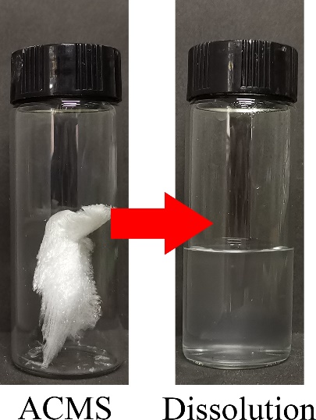
Figure S4. Solubility of ACMS.

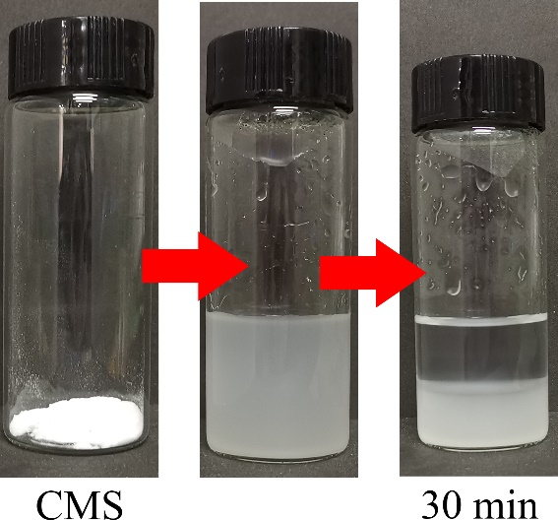
Figure S5. Solubility of CMS.

3. Study of XSBR/CMS films
Figure S6. FTIR spectra of XSBR and XSBR/CMS composites.
Before the preparation of highly sensitive humidity-responsive rubber film, we should discuss the structure of XSBR/CMS film without Ag NPs. A typical FTIR spectra of XSBR, XSBR/CMS films and CMS are exhibited in Figure S6. The broad absorption at 3400 to 3300 cm⁻¹ is attributable to the stretching vibration of -OH. As the CMS increases from 0 to 25 wt%, the absorption is shifted to lower wavenumbers from 3394 to 3298 cm⁻¹.⁵ In addition, the absorption at 1154 cm⁻¹ is corresponding to C−O, which is shifted from 1154 to 1151 cm⁻¹ with the increased content of CMS, presumably demonstrating that the hydrogen bonds are formed between CMS and XSBR.⁶
Figure S7. Mechanical properties of XSBR and XSBR/CMS composites. (a) Typical stress-strain curves of XSBR and XSBR/CMS composites. (b) Young's modulus of XSBR and XSBR/CMS composites. (c) Stress at 5% strain of XSBR and XSBR/CMS composites. (d) Fracture energy of XSBR and XSBR/CMS composites.
Typical stress-strain curves of XSBR/CMS films are plotted in Figure S7a. The reinforcing effect of CMS is clearly shown by the significant increase of Young’s modulus. For example, the Young’s modulus increases from 5.3 MPa (neat XSBR) to 63.6 MPa (XSBR/CMS-25) which is spectacularly increased by 1200% (Figure S7b), and the stress at 5% strain increases from 1.93 MPa (neat XSBR) to 6.30 MPa increased by 326% (Figure S7c). It is noteworthy that the stress-strain curves behave like plastics as the CMS content exceeds 15 wt% (XSBR/CMS-15, 20, 30), exhibiting obvious yield point. Before the yield point, the rigid bottom layer plays a major role for anti-deformation, showing stress-whitening due to light diffraction from lots of slight cracks generated by the tensile stress. After the yield point, rigid bottom layer is irreversibly destroyed.⁷ Meanwhile, the deformation of samples is attributed to the movement of the low-modulus top layer, leading to the stress decreasing. However, due to the rigid bottom layer and defect caused by crack, the slippage of XSBR chain during stretching is effectively hindered, and the elongation at break sharply decreases form 327% (neat XSBR) to 15% (XSBR/CMS-25). Figure S7d shows the fracture energy value for XSBR/CMS films, which first increases and then reduces. The fracture energy value is derived from the integration of the stress-strain curves, which is related with elongation at break and modulus. While the CMS content is lower than 15 wt% (XSBR, XSBR/CMS-5, 10), the modulus plays a dominating role, leading to an increase of fracture energy. When the CMS content exceeds 15 wt% (XSBR/CMS-15, 20, 30), the drop of elongation at break plays the dominating role, resulting in a decrease of fracture energy.

Figure S8. Equilibrium swelling experiments (a) and swelling ratio of XSBR and XSBR/CMS composites (b).
Equilibrium swelling experiments were conducted to illustrate the double-layer structure, shown in Figure S8. In XSBR/CMS-5 film, the slight flaws which lead to rough bottom surface can be seen after swelled for 3 days. Conversely, the top surface is smooth without flaws. When the CMS content increases to 10 wt%, more obvious flaws and less fragments are observed. Furthermore, the XSBR/CMS-15 gel is completely separated into fragments with similar size and regular shape as soon as it is taken out from toluene. These results indicate that the XSBR/CMS film has double-layer structure. During the film-forming process, because the CMS only disperses in water to form uniform suspension rather than dissolution (Figure S8a), the aqueous phase of bottom contains more CMS due to gravity, resulting in the double-layer structure. While the double-layer XSBR/CMS films are immersed in toluene, the top surface is subject to a greater driving force for swelling, and more CMS in bottom surface with (not swollen in toluene) restricts the movement of XSBR chain, causing that the XSBR/CMS gel bends and cracks. Although the suspended CMS sinks at the bottom, the dispersion of CMS is uniform because of the similar and regular fragments, indicating that uniform dispersion at the bottom. In addition, the swelling ratio of XSBR/CMS films is shown in Figure S8b. Due to the weak interactions, the XSBR film is broken easily by a tweezer. As expected, the swelling ratio decreases from 548% of XSBR/CMS-5 to 374% of XSBR/CMS-25, showing the significantly improved swollen resistance by the interaction of hydrogen bounding between XSBR and CMS.
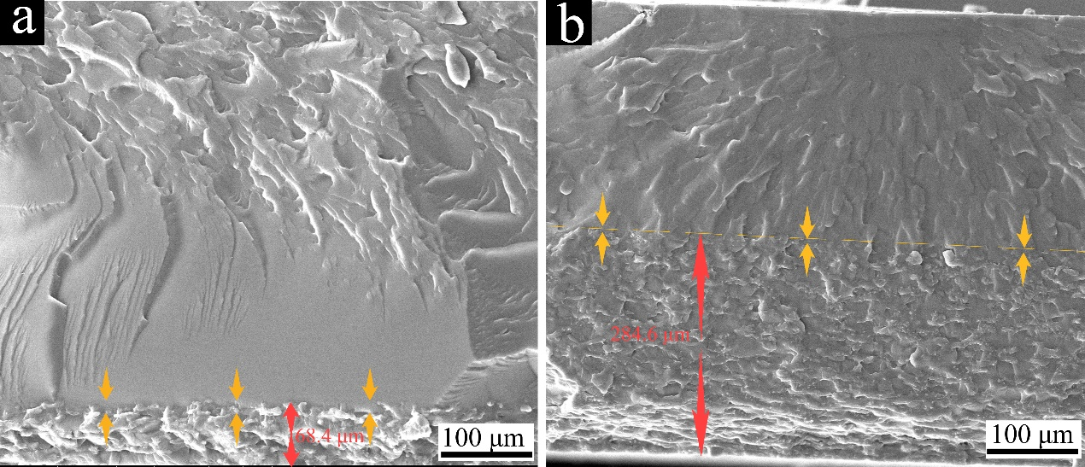
Figure S9. SEM images of XSBR/CMS-5 and XSBR/CMS-25 with double-layer morphology.
The double-layer morphology is shown clearly on the fractured XSBR/CMS-5 and XSBR/CMS-25 surface in Figure S9. In Figure S9a, uneven surface, containing more CMS, is seen at the bottom layer compared with the top layer. When the CMS content achieved 25 wt%, the interface between the double layer become blurry. The thickness of bottom layer increases from 68.4 μm to 284.6 μm (Figure S9b). Briefly, CMS is dispersed in water as solid particles due to its poor solubility, forming a suspension rather than transparent solution (Figure S5). As a result, a double-layer morphology of XSBR/CMS films was formed during the film-formation under the influence of gravity (Figure S9, Supporting Information). This demonstrated the inferior interaction between CMS and XSBR, which goes against the fabrication of MRFS.

4. Study of HSHFR
Figure S10. reaction mechanism of ACMS and [Ag(NH₃)₂]⁺ solution.

Figure S11. XRD pattern of nanosilver with 5 wt% content in the XSBR/ACMS.

Figure S12. FTIR spectra of MRFS and XSBR/CMS-20.

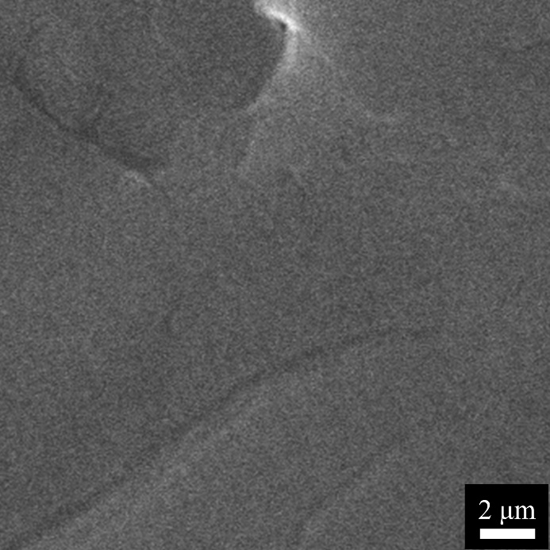
Figure S13. The cryo-fractured surface of XSBR/ACMS with 20 wt% ACMS without nanosilver. No particles are seen in the cryo-fractured surface, indicating that the particles are not ACMS in MRFS-30 (Figure 1g and 1h) MRFS-25 (Figure S16).

Figure S14. Energy dispersive spectrometer of MRFS-30 with a uniform dispersion of Ag element.

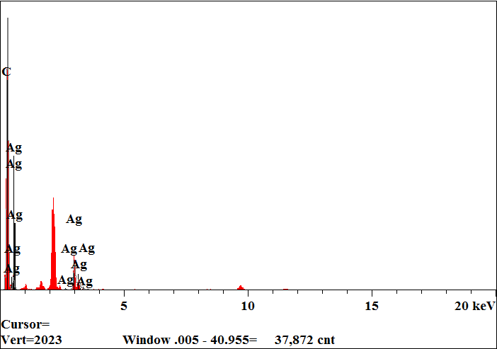
Figure S15. Line scan of EDS for MRFS-30.

Table S1. The element content of MRFS-30
Element | Intensity (c/s) | Atomic (%) | Content (wt%)
C | 602.46 | 86.982 | 64.064
O | 26.66 | 8.906 | 8.737
Ag | 74.52 | 4.112 | 27.199

To confirm that the particles are Ag NPs, SEM image of XSBR/ACMS (without nanosilver and ACMS content at 20 wt%) and energy dispersive spectrometer (EDS) of MRFS-30 were conducted as shown in Figure S13 and S14. In Figure S13, no particles are seen on the cryo-fractured surface, indicating that the particles are not ACMS in MRFS-30 (Figure 1g and 1h) and MRFS-25 (Figure S16). In Figure S14, EDS suggests that the particles contain Ag element. Additionally, the element contents (C, O and Ag) are shown in Figure S15 and Table S1 in which the Ag content is 27.199 wt% in accordance with the addition amount of 30 wt%.

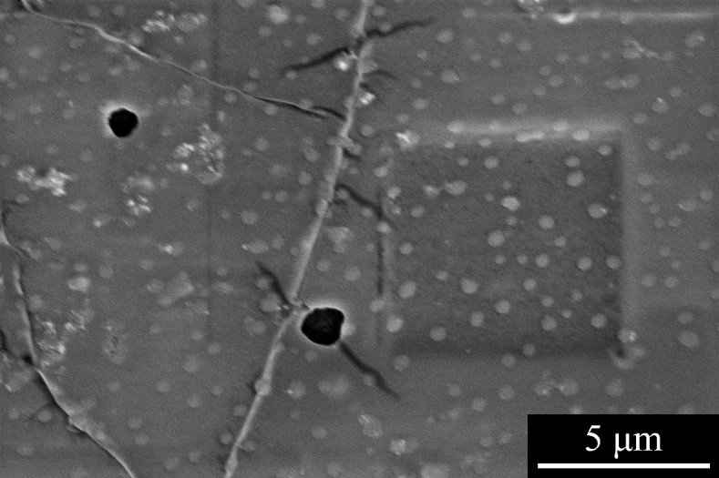
Figure S16. SEM image of MRFS-25. The semi-embedding Ag NPs have an average size of 250 nm, similar with that of HSHR-30. The leaf-vein-like structure has been formed under 25 wt% Ag content.

Figure S17. Swelling ratio of MRFS.

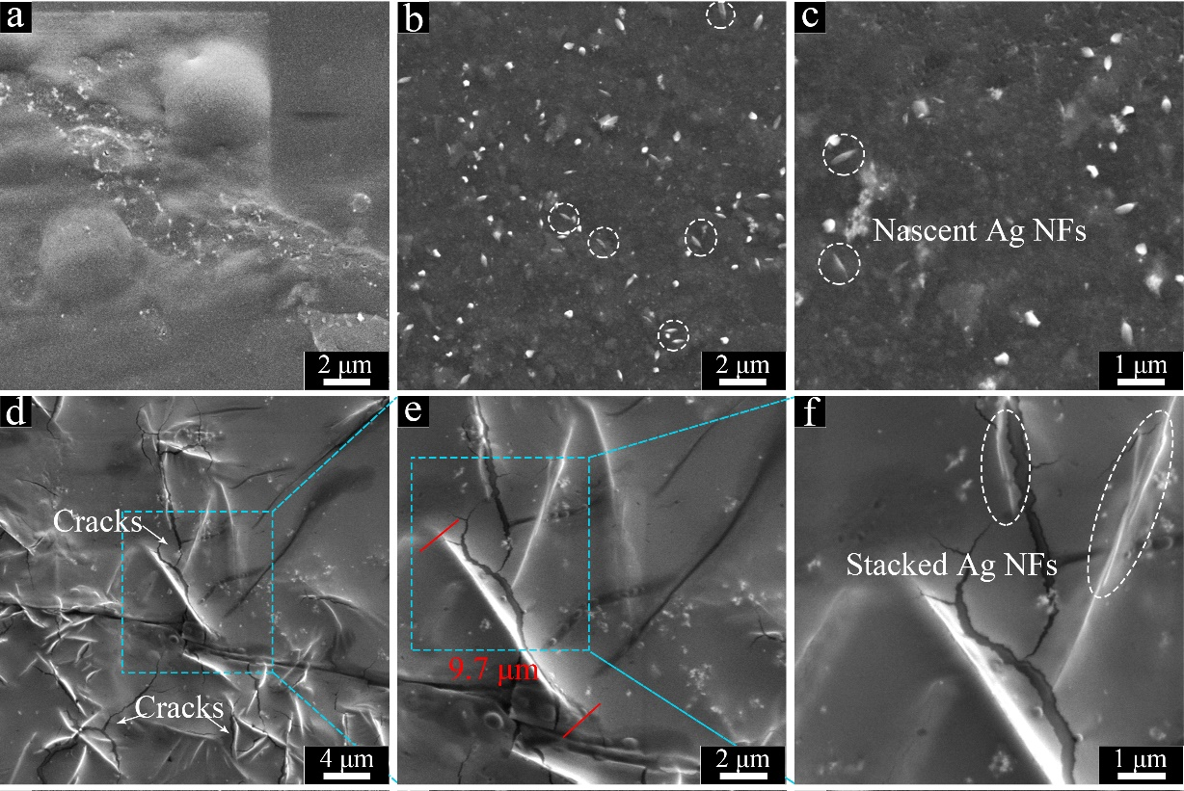
Figure S18. SEM images of MRFS. (a) Cryo-fractured surface of MRFS-5, only Ag NPs can be seen. (b) and (c) Cryo-fractured surface of MRFS-10 with nascent Ag NFs. (d), (e) and (f) Cryo-fractured surface of MRFS-20 with obvious Ag NFs.
The evolution of structure of the cryo-fractured surfaces of MRFS with various nanosilver concentration was investigated by SEM. At the Ag content of 5 wt%, Ag NFs are not observed in Figure S17a due to that such a content of 5 wt% is too low to form Ag NFs. When the Ag concentration increases to 10 wt%, nascent Ag NFs with a length of 400-700 nm (white dash) can be found in Figure S17b and S17c. These results suggest that the main morphology of reduced nanosilver is Ag NPs under a low content <10 wt% even without PVP. With the content achieving 20 wt%, Ag NFs with thickness of ~ 40 nm can be clearly seen in Figure S17d. Some cracks emerge in rubber matrix due to the stress concentration generated during drying the cryo-fractured surface of MRFS (Figure S17e). In Figure S17f, it is noteworthy that several Ag NFs are stacked (white dash) which imply the embryonic form of next evolution stage that the Ag NFs stack to form leaf-vein-like network at a 30 wt% content.

Figure S19. The Schematic illustration of the film-formation process for ACMS with a fine dispersion.
The CMS has a poor solubility in water (Figure S5), leading to a double-layer morphology after the film-formation of XSBR/CMS composites (Figure S9). However, after the synthesis of ACMS, the improved solubility endows ACMS with a good dispersion in water (Figure S4). Furthermore, after the reaction with [Ag(NH₃)₂]⁺, the aldehyde groups of ACMS turn into carboxyl groups which further improved its compatibility with the XSBR matrix by hydrogen bounding (Figure S18). Therefore, during the film-formation process, the ACMS is uniformly dispersed around XSBR particles, namely the aqueous phase. The solid ACMS is regenerated from solution state and dispersed in the interstitial space between the XSBR particles. Simultaneously, the deformation of XSBR particles occurs under the capillary force which is generated during the film-forming process. With the further drying, the XSBR particles fuse together because of their self-adhesive properties, which facilitates to increase the chances of hydrogen bonding formation between XSBR and ACMS.. Therefore, the regenerated ACMS is confined in the interstices of the coagulated XSBR particles. As a result, the layered morphology disappears in the MRFS. Benefiting from the good dispersion of ACMS in the aqueous phase of XSBR latex, the final prepared MRFS has a high sensitivity to the moisture in the air.

Figure S20. Typical stress-strain curves of MRFS-30 with time.

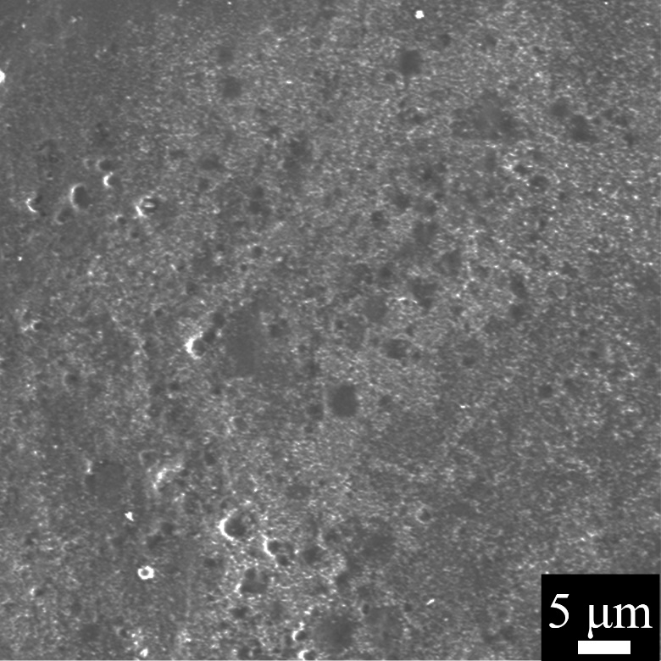
Figure S21. SEM images of MRFS-30 soaked by ammonia solution. The cubic Ag₂O disappears.

Figure S22. The paper was charred by the MRFS-30 upon NIR irradiation with a power of 0.82 W/cm².

Figure S23. The time constant for (a) blank group and (b) MRFS-30 heat transfer from the system.

Table S2. PCE of reported organic molecules, polymers, and inorganic materials.
Photothermal materials | Wavelength (nm) | PCE | Ref.
QDI-NPs | 808 | 64.7% | 8
2TPE-2NDTA | 808 | 54.9% | 9
PEG-PCB | 808 | 32% | 10
PPP-NDs | 635 | 54.2% | 11
ICG | 808 | 17.3% | 12
Mito-CCy | 730 | 9.5% | 13
PPy NPs | 808 | 45% | 14
MRFS | 808 | 78.6% | This work

Figure S24. The temperature changes of SMA under NIR irradiation with a power of 0.4 W/cm².

Table S3. Summary of TCR of temperature sensors
Sensing materials | TCR (%/℃) | Sensing ranges (℃) | Ref.
Polymine/AgNPs | 0.17 | 24-54 | 15
BP/LEG | 0.1736 | 25-50 | 16
PU/R-GO | 0.9 | 30-80 | 17
Ag nanocrystals | 0.0912 | <99.85 | 18
PEDOT:PSS | 0.03 | 30-45 | 19
Cr/Pt:Cr/Au polyimide | 0.333 | 20-100 | 20
Gr/PDMS | 0.8 | 25-75 | 21
PPy-Ag NW | 0.086 | 17-50 | 22
GO/PU | 0.80 | 30-80 | 23
Laser-engraved graphene | 0.06 | 25-50 | 24
Pt NFs/silk fibroin | 0.205 | 20-60 | 25
Polyaniline | 1.00 | 15-45 | 26
LC-GO/CMC | 0.289 | 20-80 | 27
Graphene/MPPU | 0.815 | 20-100 | 28
Ag NPs | 2.064 | 28.9-33.6 | This work
 | 0.3861 | 33.6-71.5
 | 1.616 | 92.2-107.0

Table S4. The conductivity of MRFS-10, 20 and 30.
 | MRFS-10 | MRFS-20 | MRFS-30
Conductivity at 33% RH (S/m) | 9.83×10⁻⁵ | 6.57×10⁻⁴ | 0.00556
Conductivity at 57% RH (S/m) | 1.02×10⁻⁴ | 0.00225 | 0.0114
Conductivity at 75% RH (S/m) | 8.02×10⁻⁴ | 0.0102 | 0.0550
Conductivity at 93% RH (S/m) | 0.00911 | 0.0631 | 0.148

Table S5. The conductivity of XSBR/ACMS/Ag conductive film with 30 wt% Ag NPs at different RH.
RH | 33% | 57% | 75% | 93%
Conductivity (S/m) | 0.00238 | 0.00677 | 0.0488 | 0.0756

Figure S25. The (R-R₀)/R₀ obviously decreased from -0.4404 to -0.4427 for t= 0.49 s under the RH change (from 57% to 75% RH).

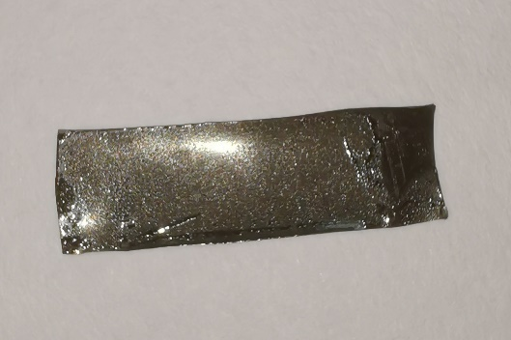
Figure S26. The sample of MRFS-30 was placed in 75% RH for a long time (3300 s) on which there are dewdrops due to the water saturation.

Figure S27. The (R-R₀)/R₀ obviously increased from 0 to 0.0148 during 1.23 s under the RH change (from 93% to 75% RH).

Figure S28. Comparison of the time of response to the humidity change and the elongation at break for humidity sensors. The detailed information is shown in Table S6.

Table S6 Comparison of the time of response to the humidity change and the elongation at break for humidity sensors.
Matrix | Time (s) | Elongation at break (%) | Ref.
coolmax fibers | 0.6 | 7 | 29
poly(acrylamide-co-sodium acrylate) | 0.5 | 170 | 30
polydimethylsiloxane | 0.063 | 30 | 31
cellulose | 0.5 | 13 | 32
polyurethane | 1.1 | 500 | 33
Corn starch hydrogels | 1 | 140 | 34
Polydimethylsiloxane | 10 | 90 | 35
polyvinyl alcohol | 10 | 250 | 36
cellulose | 6 | 43 | 37
cellulose paper | 25 | 3 | 38
Rubber | 0.5 | 367 | This work

Figure S29. The schematic diagram of the strain sensing experimental setup.

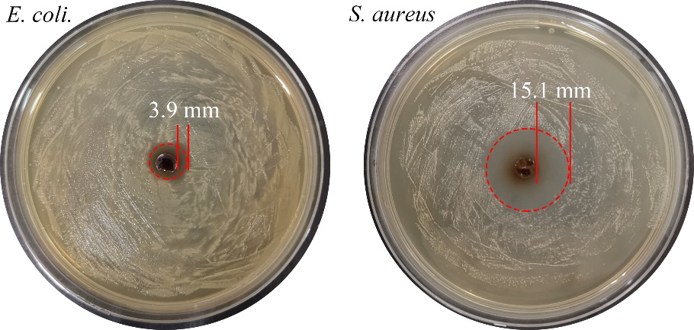
Figure S30. Antibacterial properties of MRFS-30 for E. coli. and S. aureus.

Reference
1. Bouhadir, K. Hausmana, D. Mooney D. Synthesis of cross-linked poly(aldehyde guluronate) hydrogels. Polymer 1999, 40, 3575.
2. Yi, Y. Jiang, Z. Yang, S. Ding, W. Wang, YN. Shi, B. Formaldehyde formation during the preparation of dialdehyde carboxymethyl cellulose tanning agent. Carbohyd. Polym. 239, 116217 (2020).
3. Blankenburg, J. Maciol, K. Hahn, C. Frey, H. Poly(ethylene glycol) with Multiple Aldehyde Functionalities Opens up a Rich and Versatile Post-Polymerization Chemistry. Macromolecules 52, 1785-1793 (2019).
4. Xu, C. et al. Fabrication of high-performance magnetic elastomers by using natural polymer as auxiliary dispersant of Fe3O4 nanoparticles. Compos. Part-A Appl. S. 140, 106158 (2021).
5. Nie, J. Fan, J. Gong, Z. Xu, C. Chen, Y. Frame-structured and self-healing ENR-based nanocomposites for strain sensors. Eur. Polym. J. 154, 110569 (2021).
6. Nie, J. Huang, J. Fan, J. Cao, L. Xu, C. Chen, Y. Strengthened, Self-Healing, and Conductive ENR-Based Composites Based on Multiple Hydrogen Bonding Interactions. ACS Sustain. Chem. Eng. 8, 13724-13733 (2020).
7. Yu, P. He, H. Luo, Y. Jia, D. Dufresne, A. Reinforcement of Natural Rubber: The Use of in Situ Regenerated Cellulose from Alkaline–Urea–Aqueous System. Macromolecules 50, 7211-7221 (2017).
8. Liu, C. Zhang, S. Li, J. Wei, J. Mullen, K. Yin, M. A Water-Soluble, NIR-Absorbing Quaterrylenediimide Chromophore for Photoacoustic Imaging and Efficient Photothermal Cancer Therapy. Angew. Chem. Int. Ed. Engl. 58, 1638-1642 (2019).
9. Zhao, Z. et al. Highly efficient photothermal nanoagent achieved by harvesting energy via excited-state intramolecular motion within nanoparticles. Nat. Commun. 10, 768 (2019).
10. Jiang, Y. et al. Amphiphilic semiconducting polymer as multifunctional nanocarrier for fluorescence/photoacoustic imaging guided chemo-photothermal therapy. Biomaterials 145, 168-177 (2017).
11. Zou, Q. Abbas, M. Zhao, L. Li, S. Shen, G. Yan, X. Biological Photothermal Nanodots Based on Self-Assembly of Peptide-Porphyrin Conjugates for Antitumor Therapy. J. Am. Chem. Soc. 139, 1921-1927 (2017).
12. Zheng, M. et al. Robust ICG theranostic nanoparticles for folate targeted cancer imaging and highly effective photothermal therapy. ACS Appl. Mater. Inter. 6, 6709-6716 (2014).
13. Jung, HS. et al. A Mitochondria-Targeted Cryptocyanine-Based Photothermogenic Photosensitizer. J. Am. Chem. Soc. 139, 9972-9978 (2017).
14. Chen, M. Fang, X. Tang, S. Zheng, N. Polypyrrole nanoparticles for high-performance in vivo near-infrared photothermal cancer therapy. Chem. Commun. 48, 8934-8936 (2012).
15. Zou, Z. Zhu, C. Li, Y. Lei, X. Zhang, W. Xiao, J. Rehealable, fully recyclable, and malleable electronic skin enabled by dynamic covalent thermoset nanocomposite. Sci. Adv. 2018, 4, eaaq0508.
16. Chhetry, A. et al. Black Phosphorus@Laser‐Engraved Graphene Heterostructure‐Based Temperature–Strain Hybridized Sensor for Electronic‐Skin Applications. Adv. Funct. Mater. 31, 2007661 (2020).
17. Trung, TQ. Ramasundaram, S. Hwang, BU. Lee, NE. An All-Elastomeric Transparent and Stretchable Temperature Sensor for Body-Attachable Wearable Electronics. Adv. Mater. 28, 502-509 (2016).
18. Joh, H. et al. Surface Design of Nanocrystals for High-Performance Multifunctional Sensors in Wearable and Attachable Electronics. Chem. Mater. 31, 436-444 (2018).
19. An, BW. Heo, S. Ji, S. Bien, F. Park, JU. Transparent and flexible fingerprint sensor array with multiplexed detection of tactile pressure and skin temperature. Nat. Commun. 9, 2458 (2018).
20. Kim, JJ. Stafford, GR. Beauchamp, C. Kim, SA. Development of a Dental Implantable Temperature Sensor for Real-Time Diagnosis of Infectious Disease. Sensors 20, 3953 (2020).
21. Wang, Z. et al. 3D-Printed Graphene/Polydimethylsiloxane Composites for Stretchable and Strain-Insensitive Temperature Sensors. ACS Appl. Mater. Inter. 11, 1344-1352 (2019).
22. He, W. Li, G. Zhang, S. Wei, Y. Wang, J. Li, Q. Zhang, X. Polypyrrole/Silver Coaxial Nanowire Aero-Sponges for TemperatureIndependent Stress Sensing and Stress-Triggered Joule Heating. ACS Nano 2015, 9, 4244–4251.
23. Trung, TQ. Dang, TML. Ramasundaram, S. Toi, PT. Park, SY. Lee, NE. A Stretchable Strain-Insensitive Temperature Sensor Based on Free-Standing Elastomeric Composite Fibers for On-Body Monitoring of Skin Temperature. ACS Appl. Mater. Inter. 11, 2317-2327 (2019).
24. Yang, Y. et al. A laser-engraved wearable sensor for sensitive detection of uric acid and tyrosine in sweat. Nat. Biotechnol. 38, 217-224 (2020).
25. Huang, J. et al. Stretchable and Heat‐Resistant Protein‐Based Electronic Skin for Human Thermoregulation. Adv. Funct. Mater. 30, 1910547 (2020).
26. Hong, SY. et al. Stretchable Active Matrix Temperature Sensor Array of Polyaniline Nanofibers for Electronic Skin. Adv. Mater. 28, 930-935 (2016).
27. Li, Q. et al. Laser Direct Writing of Flexible Sensor Arrays Based on Carbonized Carboxymethylcellulose and Its Composites for Simultaneous Mechanical and Thermal Stimuli Detection. ACS Appl. Mater. Inter. 13, 10171-10180 (2021).
28. Hu, X. et al. Multiscale Disordered Porous Fibers for Self-Sensing and Self-Cooling Integrated Smart Sportswear. ACS Nano 14, 559-567 (2020).
29. Xu, L. et al. Coolmax/graphene-oxide functionalized textile humidity sensor with ultrafast response for human activities monitoring. Chem. Eng. J. 412, 128639 (2021).
30. Ju, M. Wu, B. Sun, S. Wu, P. Redox‐Active Iron‐Citrate Complex Regulated Robust Coating‐Free Hydrogel Microfiber Net with High Environmental Tolerance and Sensitivity. Adv. Funct. Mater. 30, 128639 (2020).
31. Kim, SY. Park, S. Park, HW. Park, DH. Jeong, Y. Kim, DH. Highly Sensitive and Multimodal All-Carbon Skin Sensors Capable of Simultaneously Detecting Tactile and Biological Stimuli. Adv. Mater. 27, 4178-4185 (2015).
32. Ma, J. et al. Robust cellulose-carbon nanotube conductive fibers for electrical heating and humidity sensing. Cellulose 28, 7877-7891 (2021).
33. Li, M. Lyu, Q. Sun, L. Peng, B. Zhang, L. Zhu, J. Fluorescent Metallosupramolecular Elastomers for Fast and Ultrasensitive Humidity Sensing. ACS Appl. Mater. Inter. 12, 39665-39673 (2020).
34. Zeng, S. Zhang, J. Zu, G. Huang, J. Transparent, flexible, and multifunctional starch-based double-network hydrogels as high-performance wearable electronics. Carbohyd. Polym 267, 118198 (2021).
35. Tripathy, A. Sharma, P. Sahoo, N. Pramanik, S. Abu Osman, NA. Moisture sensitive inimitable Armalcolite/PDMS flexible sensor: A new entry. Sensors and Actuat. B-Chem. 262, 211-220 (2018).
36. Cheng, Y. Wang, H. Li, L. Han, T. Liang, X. Dong, L. Flexible photoluminescent humidity sensing material based on electrospun PVA nanofibers comprising surface-carboxylated QDs. Sensors and Actuat. B-Chem. 284, 258-264 (2019).
37. Wang, Y. Zhang, L. Zhou, J. Lu, A. Flexible and Transparent Cellulose-Based Ionic Film as a Humidity Sensor. ACS Appl. Mater. Inter. 12, 7631-7638 (2020).
38. Guan, X. et al. Flexible humidity sensor based on modified cellulose paper. Sensors and Actuat. B-Chem. 339, 129879 (2021).

