SUPPLEMENTARY MATERIAL

Sick leave and costs in active workers with chronic osteoarthritis pain in Spain: Outcomes of the OPIOIDS Real World study
Antoni Sicras-Mainar, Juan Carlos Tornero-Tornero, Francisco Vargas-Negrín, Isabel Lizarraga, Aram Sicras-Navarro, Javier Rejas-Gutierrez.

Table S1. Opioid administered and prescribing medical specialty.

Study groups | ATC code | Total
Number of patients, % |  | N | %
Weak opioids
Tramadol | N02AX02 | 2635 | 51.8%
Tramadol + Paracetamol | N02AJ13 | 1023 | 20.1%
Paracetamol + Codeine | N02AJ06 | 49 | 1.0%
Codeine + Ibuprofen | N02AJ08 | 22 | 0.4%
Caffeine + Codeine + Aspirin | N02AJ07 | 3 | 0.1%
Total, weak opioids |  | 3732 | 73.3%
Strong opioids
Fentanyl | N02AB03 | 356 | 7.0%
Tapentadol | N02AX06 | 347 | 6.8%
Oxycodone-naloxone | N02AA55 | 335 | 6.6%
Buprenorphine | N02AE01 | 162 | 3.2%
Morphine | N02AA01 | 81 | 1.6%
Oxycodone | N02AA05 | 38 | 0.7%
Hydromorphone | N02AA03 | 27 | 0.5%
Pethidine | N02AB02 | 10 | 0.2%
Naloxone | N07BC51 | 1 | 0.0%
Total, strong opioids |  | 1357 | 26.7%
Total, weak and strong opioids |  | 5089 | 100%
Prescribing medical specialty (total opioids)
Family medicine |  | 3693 | 72.6%
Traumatology |  | 578 | 11.4%
Anesthesia and resuscitation |  | 345 | 6.8%
Rheumatology |  | 105 | 2.1%
Rehabilitation |  | 92 | 1.8%
Other specialties |  | 276 | 5.4%
Prescribing medical specialty (weak opioids)
Family medicine |  | 2887 | 77.4%
Specialists |  | 845 | 22.6%
Prescribing medical specialty (strong opioids)
Family medicine |  | 806 | 59.4%
Specialists |  | 551 | 40.6%
Values expressed in absolute numbers (N) and percentage (%). ATC: Anatomical Therapeutic Chemical Classification System.

Table S2. Analgesic medication by pre- and post-opioid initiation periods in the total sample and according to type of opioid.
Study groups | Weak opioid | Strong opioid | Total | p-value
Number of patients, % | N = 3732 (73.3%) | N = 1357 (26.7%) | N = 5089 (100%)
12 months pre-opioid
NSAID | 47.3% | 54.5% | 49.2% | <0.001
Paracetamol | 74.5% | 68.9% | 73.0% | <0.001
Metamizole | 16.5% | 21.7% | 17.8% | <0.001
Mean medicaments (SD) | 1.4 (0.6) | 1.5 (0.7) | 1.4 (0.6) | 0.001
12 months post-opioid initiation
NSAID | 45.2% | 50.7%* | 46.6%* | <0.001
Paracetamol | 74.7% | 70.2% | 73.5% | 0.002
Metamizole | 15.0% | 17.2%† | 15.6%† | 0.060
Mean medicaments (SD) | 1.3 (0.6) † | 1.4 (0.6) † | 1.4 (0.6) | 0.091
24 months post-opioid initiation
NSAID | 50.7%† | 56.7%† | 52.3%† | <0.001
Paracetamol | 40.9%‡ | 43.8%‡ | 41.7%‡ | 0.053
Metamizole | 15.4% | 16.4%‡ | 13.0%‡ | 0.211
Mean medicaments (SD) | 1.2 (0.6) ‡ | 1.2 (0.6) ‡ | 1.2 (0.6) ‡ | 0.358
36 months post-opioid initiation
NSAID | 53.2%‡ | 59.6%‡ | 54.9%‡ | <0.001
Paracetamol | 38.2%‡ | 40.8%‡ | 38.9%‡ | 0.104
Metamizole | 25.5%‡ | 27.0%‡ | 25.9%‡ | 0.275
Mean medicaments (SD) | 1.2 (1.2) ‡ | 1.3 (1.1) ‡ | 1.2 (1.1) ‡ | 0.004
Values expressed as percentage or mean (SD: standard deviation) *p<0.05; †p<0.01; ‡p<0.001 vs. 12 months pre-opioid initiation; not significant when not indicated. NSAID: Nonsteroidal anti-inflammatory drug.

Table S3. Clinical effectiveness of opioid use expressed as effect on pain intensity

Study groups | Weak opioid | Strong opioid | Total | p-value
Number of patients, % | N = 3732 | N = 1357 | N = 5089
Pain intensity (NRS)
Initial | 7.3 (1.1) | 8.3 (1) | 7.6 (1.1) | <0.001
Final | 6.2 (1.1) | 7.2 (1) | 6.4 (1.1) | <0.001
Difference (absolute) | -1.2 (1.4) | -1.1 (1.4) | -1.2 (1.4) | 0.602
p | <0.001 | <0.001 | <0.001
Difference (relative) | -14.5% | -12.6% | -14.0% | <0.001
P-value | <0.001 | <0.001 | <0.001
Variation in pain intensity
Scale with score <5 (last record | 8.6% | 1.8% | 6.8% | <0.001
Relative reduction in baseline pain, <30% | 14.4% | 13.6% | 14.2% | 0.425
Relative reduction in baseline pain, <50% | 7.9% | 4.5% | 7.0% | <0.001
Values expressed as percentage or mean (SD)
NRS: numeric rating scale; NRS scored 0 (no pain) to 10 (worst imaginable pain).

Figure S1. Kaplan-Meier curves of persistence and cumulative probability of remaining on treatment at 36 months follow-up.

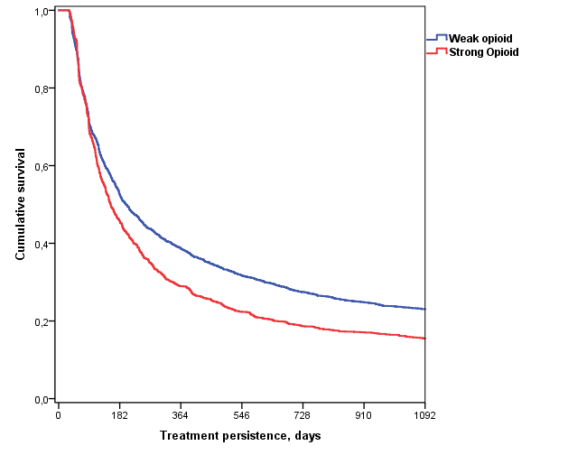
Kaplan-Meier curves. Weak opioid vs. Strong opioid: median time, 200 vs. 155 days, respectively.
Pairwise comparison: Chi-square = 35.467; p = 0.001. Hazard ratio; HR=1.27 (1.17 – 1.34).

Figure S2. Percentage of patients who received rehabilitation with/without sick leave and according to type of opioid and study period.

12 months pre-opioid
12 months post-opioid initiation
36 months post-opioid initiation

