A Soft Wearable and Full Textile Piezoresistive Sensor for Plantar Pressure Capturing
Yongsong Tan ^{1,2 #}, Kamen Ivanov^{1,3 #}, Zhanyong Mei⁴, Hui Li¹, Huihui Li¹, Ludwig Lubich⁵, Chaoxia Wang ² *, Lei Wang ¹ *
¹Shenzhen Institutes of Advanced Technology, Chinese Academy of Sciences, The Shenzhen Key Laboratory for Low-cost Healthcare, 1068 Xueyuan Avenue, Shenzhen University Town, Shenzhen, 518055 People's Republic of China
²Key Laboratory of Eco-Textile, Ministry of Education, College of textile science and Engineering, Jiangnan University, 1800 Lihu Road, Wuxi 214122, China
³ Shenzhen College of Advanced Technology, University of Chinese Academy of Sciences, 1068 Xueyuan Avenue, Shenzhen University Town, Shenzhen, 518055 People's Republic of China
⁴College of Cyber Security, Chengdu University of Technology, Chengdu 610059, China
⁵Faculty of Telecommunications, Technical University of Sofia, Sofia 1000, Bulgaria
#Tan Yongsong and Kamen Ivanov contributed to this work equally
*Correspondence: wangchaoxia@sohu.com; wang.lei@siat.ac.cn

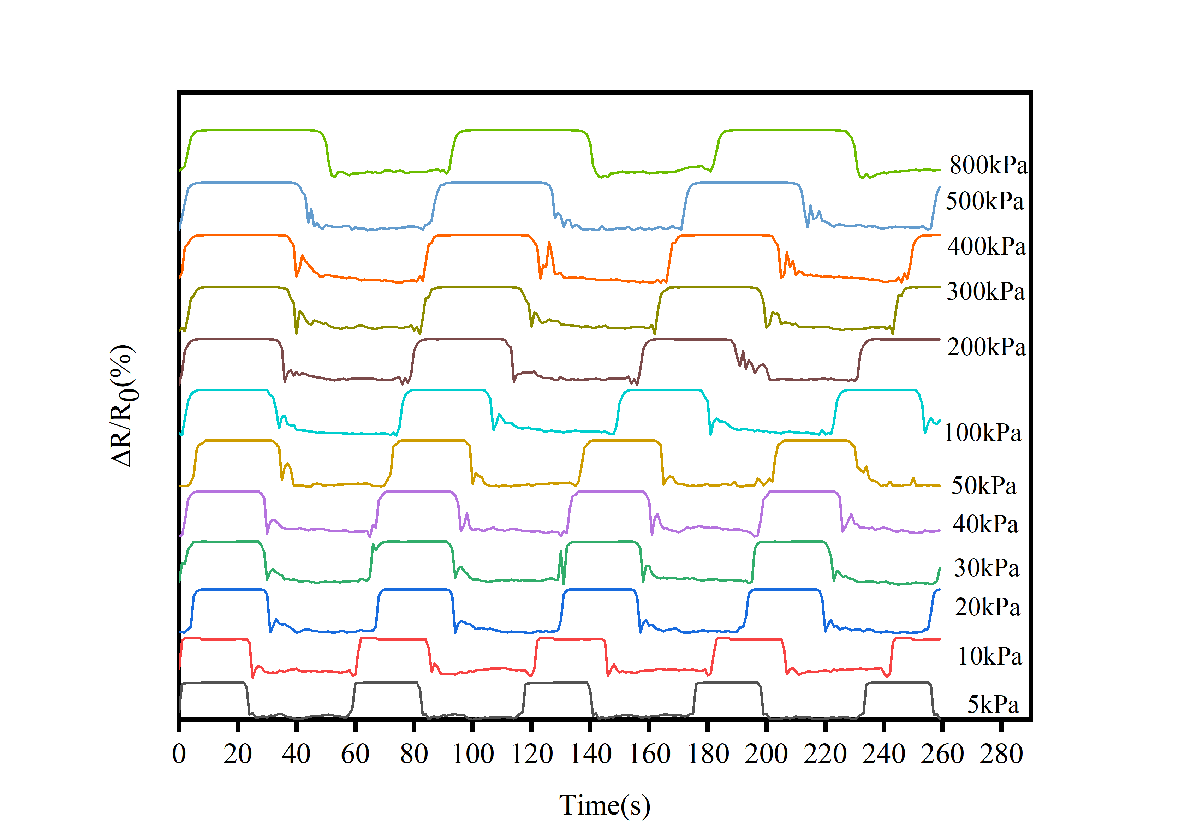
Fig. S1 The sensor performace of the TPRS on different pressure

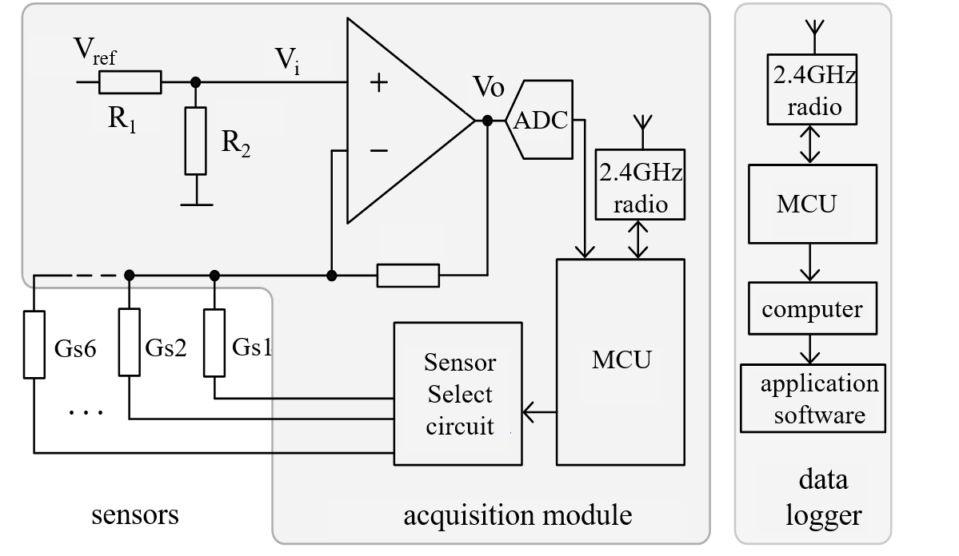
Fig S2. Block diagram of the full hardware configuration

To obtain the signals of all insole sensors in real time, it was appropriate to apply and adapt a previously developed acquisition module. The block diagram of the sensor is given in Fig. 2.The microprocessor at the sensor side is integrated into the system-on-chip nRF52832 and was responsible for serving all tasks, including controlling the sensor selection circuit, reading the analog-to-digital converter and transmitting the sensor data over a Bluetooth Low Energy interface to the host computer, where received data were visualized and recorded. During the experiment, error-free transmission of data was achieved thanks to maintaining a reasonably close distance between the insole and data logger and using continuous checks of received data, as well as an external antenna at the logger side that extends its range.
The microcontroller at the sensor side scans the sensors sequentially in time, where the individual sampling frequency of each sensor is 100 Hz, a rate that can reflect enough signal changes observed during walking. The currently read sensor is selected through control logic for sensor selection.
The interface circuit based on a transimpedance amplifier operates under the presumption that the current through the sensor changes linearly with the applied force. In that:
$V_{i}=V_{ref}\frac{R2}{R1+R2}=σV_{ref}$ (1)
Thanks to the fact that Vref acts as a reference of the analog-to-digital converter, the sensor conductance is derived directly as:
$Gs=\frac{\left(\frac{ADCreading}{ADClevels}-σ\right)}{σRf}$ (2)
In the interface circuit, we had to adjust the feedback resistor Rf to match the range of the proposed sensor.

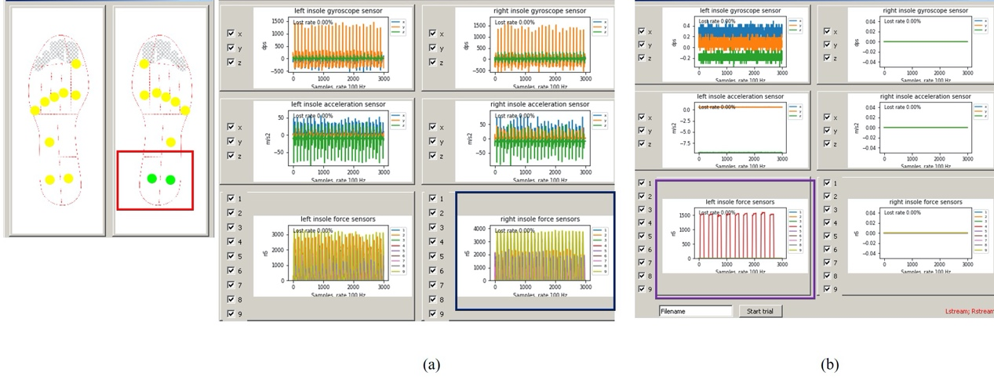
Fig.S 3 (a) The response of different parts of insole to the change of external pressure at a certain time during walking, (b) the response of a point on the insole to stable pressure.
The testing process has been conducted, as shown in Fig S 3a-b. When heel 1 and heel 2 received external pressure, the light at the left insole part of Fig S 3a will be on and the yellow part will show the change of sensor resistance. And the TPRS can also make a sensitive and stable response when a cyclic fixed-point force is applied to a certain part of the insole, as shown in the purple area of Fig 3b. After testing each part of the insole, the results show that the insole can respond sensitively to the external pressure changes. Through observing the reaction of insole sensor to external pressure, we can see that the insole can reflect the change of sole pressure accurately and quickly in real time.

