Supporting Information for
Growing pacific linkage with the interannual variability of North Atlantic explosive cyclogenesis

Jacob Stuivenvolt-Allen¹, Simon S.-Y. Wang^{1,2}, Yoshimitsu Chikamoto¹, Jonathan D.D. Meyer^{1,2}, Zachary F. Johnson³, Liping Deng⁴

¹Department of Plants, Soils, and Climate, Utah State University, Logan UT, United States
²Utah Climate Center, Utah State University, Logan UT, United States
³Department of Earth, Atmospheric, and Planetary Sciences, Purdue University, West Lafayette, IN, United States
⁴College of Ocean and Meteorology, Guangdong Ocean University, Zhanjiang 524088, Guangdong, China

Contents of this file

Figures S1-S3

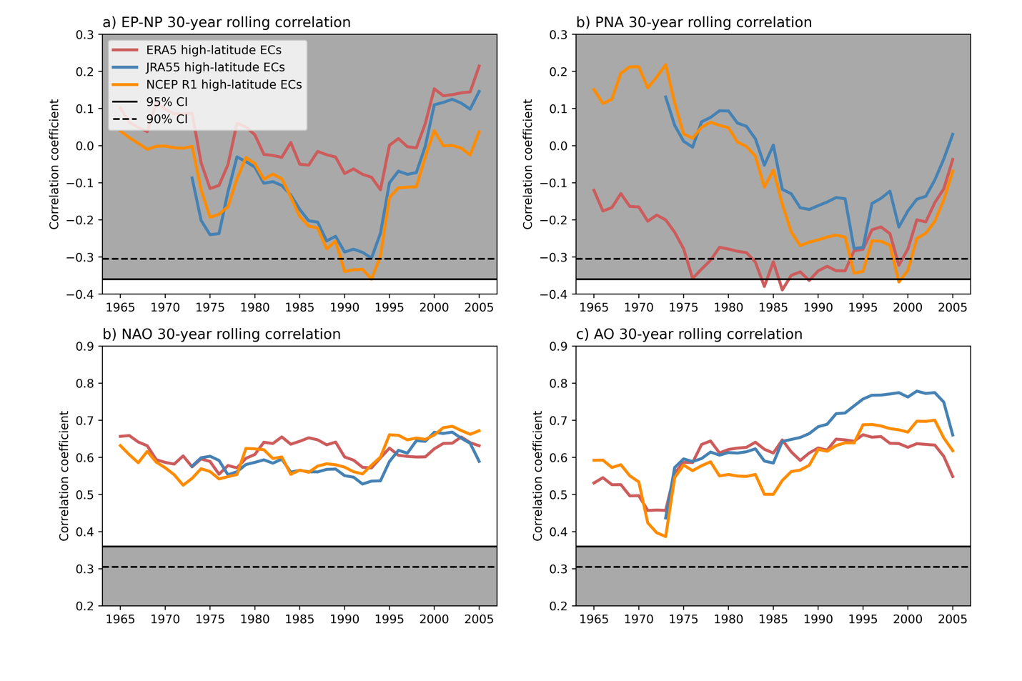

Figure S1. A 30-year rolling correlation between the November through March frequency of high-latitude ECs tracked in ERA5 (red line), JRA55 (blue line) and NCEP R1 (orange line) with the EP-NP (a), PNA (b), NAO (c), and AO teleconnection indices (d). The horizontal dotted line and solid line indicate the significance thresholds for 28 degrees of freedom for the 90% and 95% confidence interval respectively. Gray shading highlights the insignificant areas.

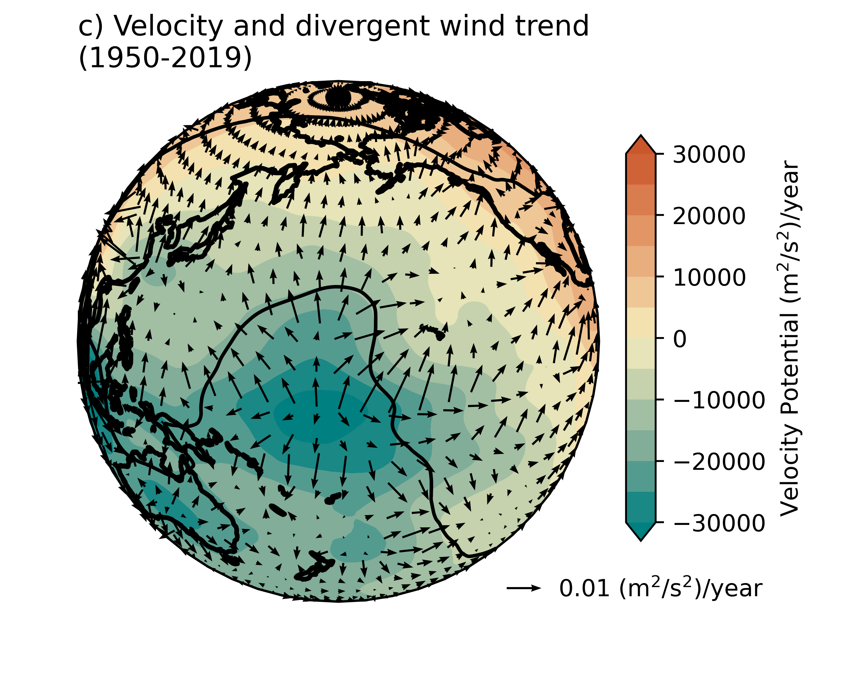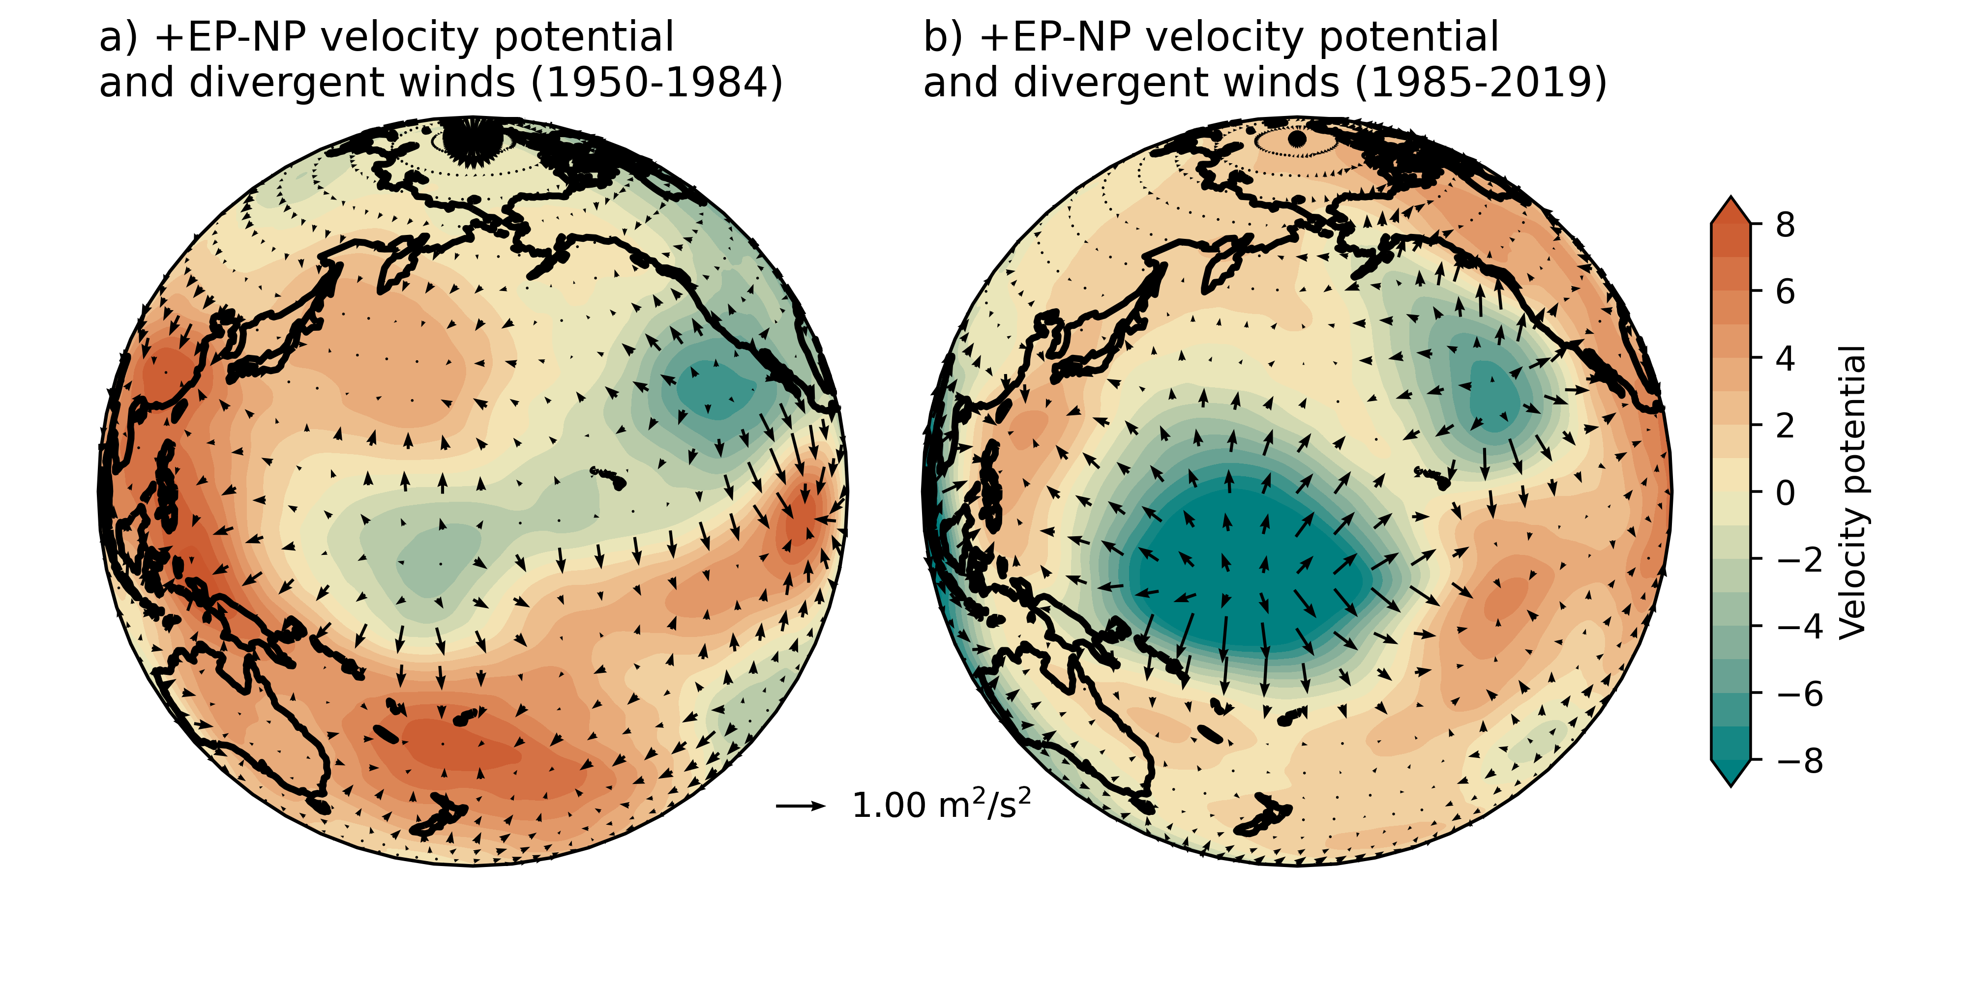
Figure S2. Velocity potential and irrotational winds at 250 hPa for the positive EP-NP from 1950 to 1985 (a) and 1985 to 2020 (b). Figure 8c shows the linear trend of velocity potential and irrotational winds. These plots are centered on 180° W, showing the north Pacific Ocean.

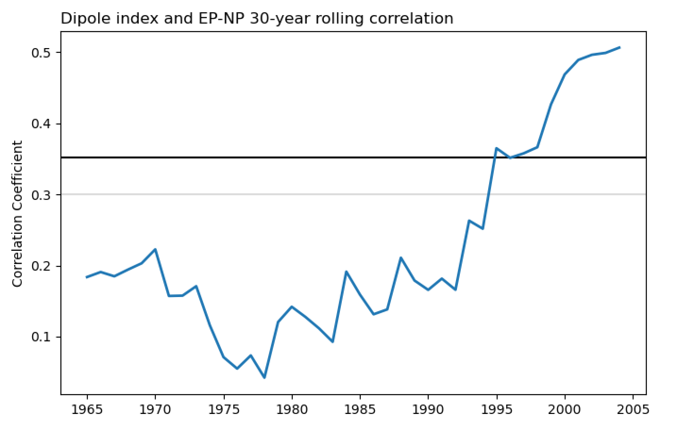
Figure S3. November through March “dipole-index” 30-year rolling correlation with the EP-NP index. The dipole index is calculated following Wang et al. (2015) by subtracting the monthly Z300 values between the ridge center (232.5-237.5°E & 47.5-52.5°N) from the trough center (282.5-287.5°E and 57.5-62.5°N) in NCEP R1. The horizontal black and gray lines indicate the 95% and 90% confidence intervals for 28 degrees of freedom.

