Extended Data
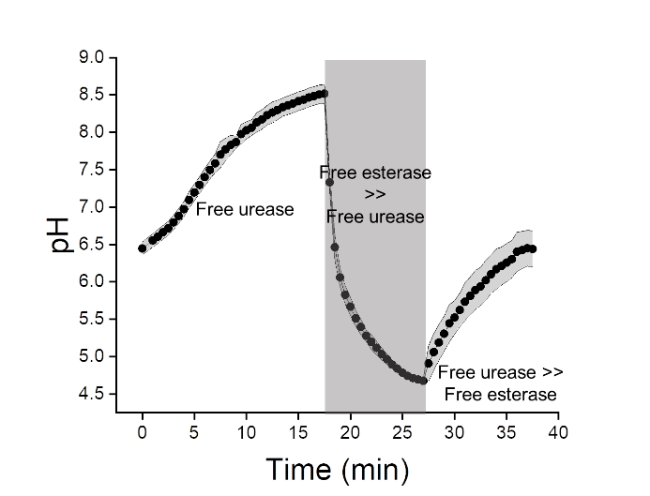
Extended Data Figure 1 │Evolution of pH by alternation of urease and esterase spiking in non-buffered conditions. The solutions were initially spiked with 3.6 pmol of urease, followed by 0.6 pmol esterase, and finally additional 18.3 pmol of urease (n = 3 technical replicates, mean ± SD).
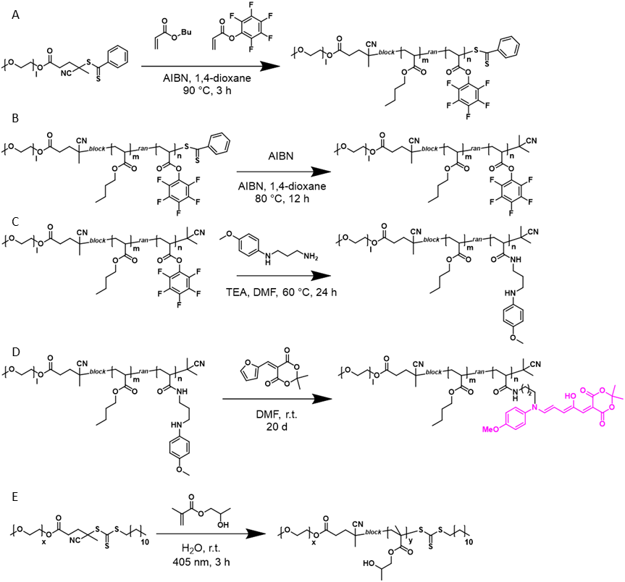
Extended Data Scheme 1 │ Synthesis of functional polymers. A. Chain extension of PEG macroCTA with PFPA and BA by RAFT polymerisation producing the activated ester diblock copolymer. B. Removal of the chain-transfer agent end-group from the activated ester diblock copolymer. C. Synthesis of the aromatic amine DASA precursor polymer by amidation with MPDP on the activated esters. D. Reaction of the aromatic amine DASA precursor polymer with the Meldrum’s acid activated furan adduct to yield the DASA diblock copolymer. E. Synthesis of PEG-b-PHPMA by PISA.
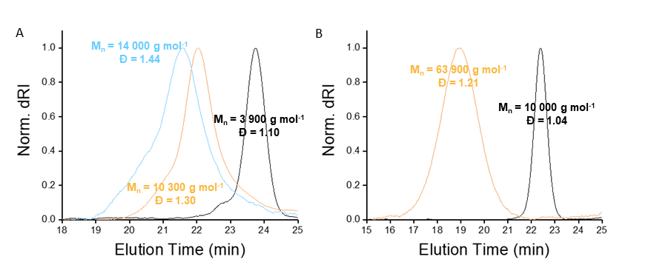
Extended Data Figure 2 │GPC elugrams of synthesised polymers. 0.075 w/w % LiBr in DMF-GPC elugrams of A. DASA polymer (blue), PEG-b-(PBA-co-PPFPA) (orange), PEG-CPADB (black) B. PEG-b-PHPMA (orange) and PEG-CDTPA (black).
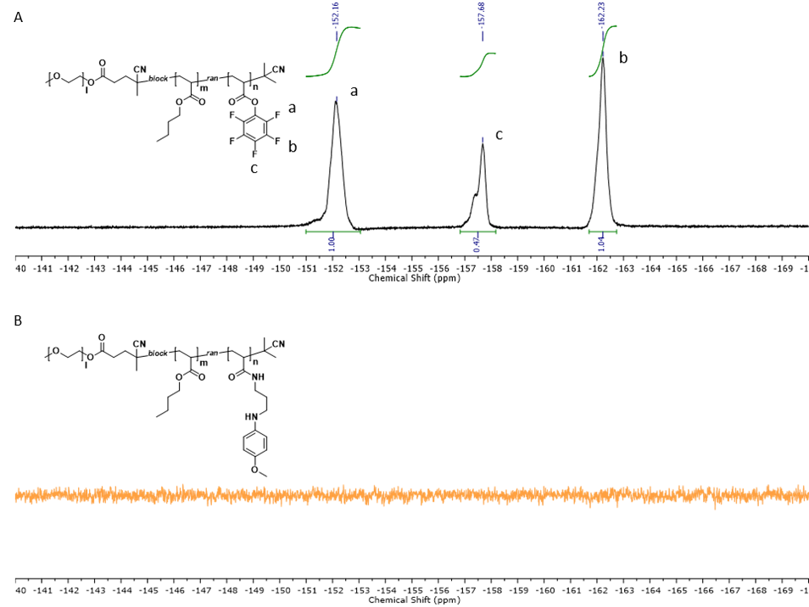 Extended Data Figure 3 │¹⁹F NMR of PEG-b-(PBA-co-PPFPA) before and after modification with the DASA aromatic amine precursor. A. PEG-b-(PBA-co-PPFPA) diblock copolymer. B. Aromatic amine DASA precursor polymer. The disappearance of the pentafluorophenyl ester fluorine peaks indicates the modification of the polymer with the aromatic amine DASA precursor, which was further confirmed by FT-IR (Extended Data Figure 4).
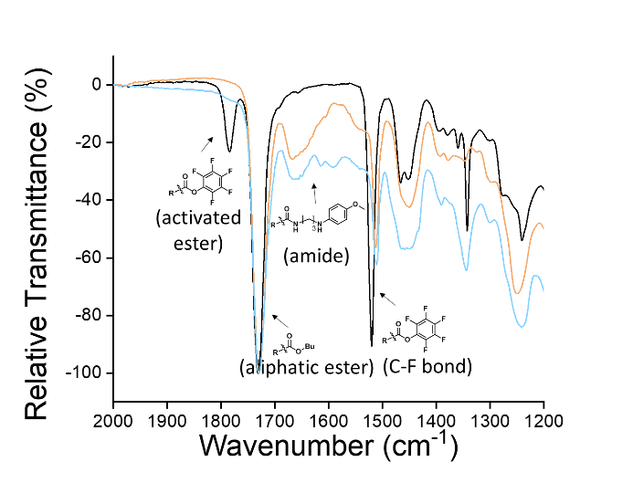
Extended Data Figure 4 │ ATR FT-IR of synthetic steps to achieve DASA polymers. The activated ester polymer PEG-b-(PBA-co-PPFPA) (black) was modified with the aromatic amine precursor MPDP (orange). The disappearance of the activated ester bond coincides with the formation of an amide bond. Reaction with the Meldrum’s acid-derived furan adduct (blue) generates the DASA polymer.
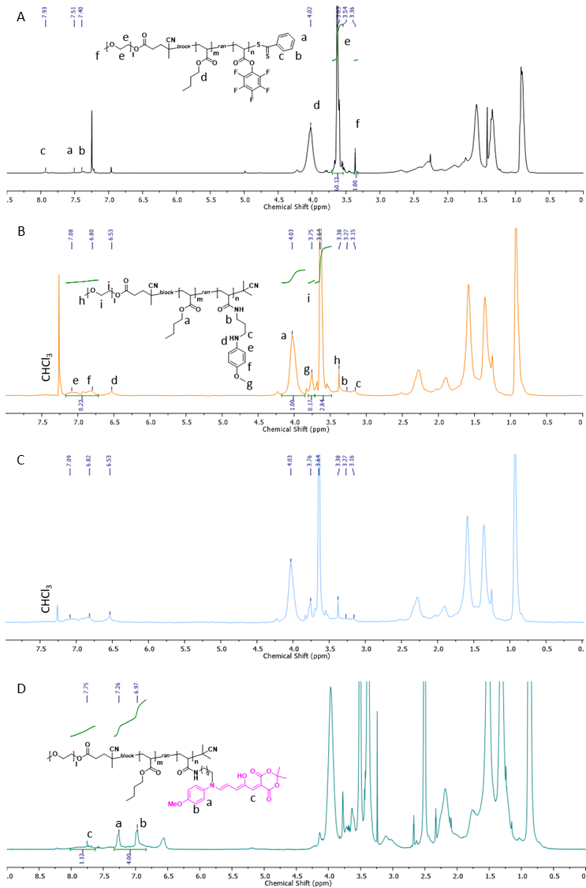
Extended Data Figure 5 │NMR spectroscopy of synthetic steps to achieve DASA polymers. A. ¹H NMR of PEG-b-(PBA-co-PPFPA). B. Aromatic amine-modified block copolymer. C. Diffusion-edited ¹H NMR of the aromatic amine-modified block copolymer. The presence of the highlighted peaks from panel B confirms the functionalisation of the polymer. D. ¹H NMR of the DASA block copolymer.
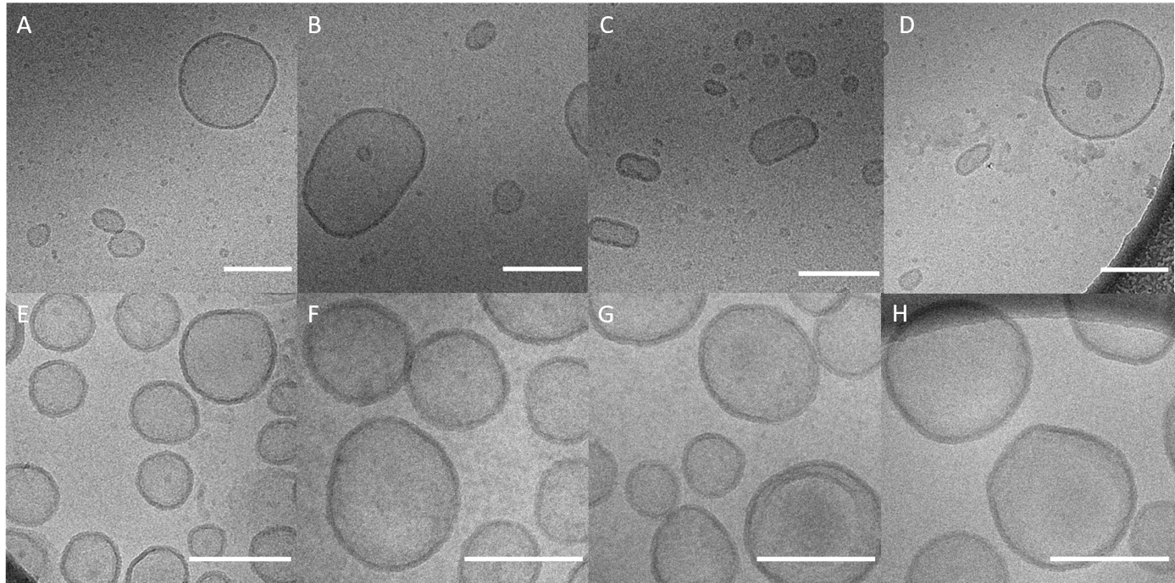
Extended Data Figure 6 │cryo-TEM micrographs of the synthesised nanoreactors. A-D. DASA-esterase. The scale bar corresponds to 200 nm. E-H. PISA-urease. The scale bar corresponds to 300 nm.
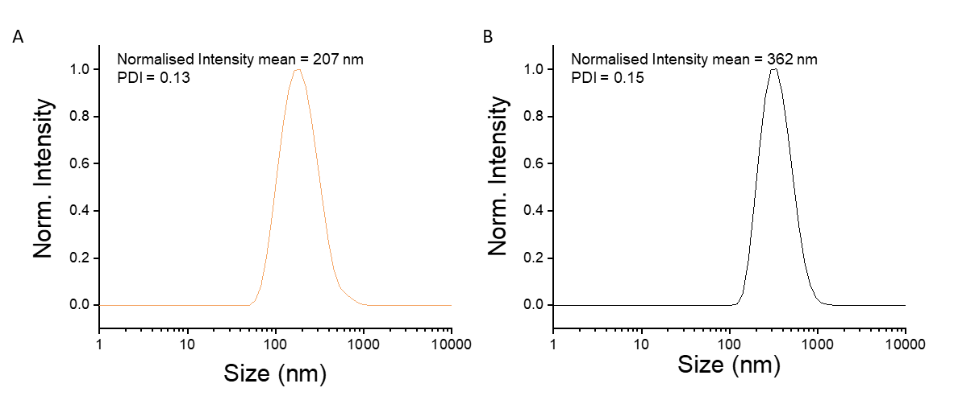
Extended Data Figure 7 │DLS of the synthesised nanoreactors. A. DASA-esterase. B. PISA-urease. Data shown as mean (n = 3).
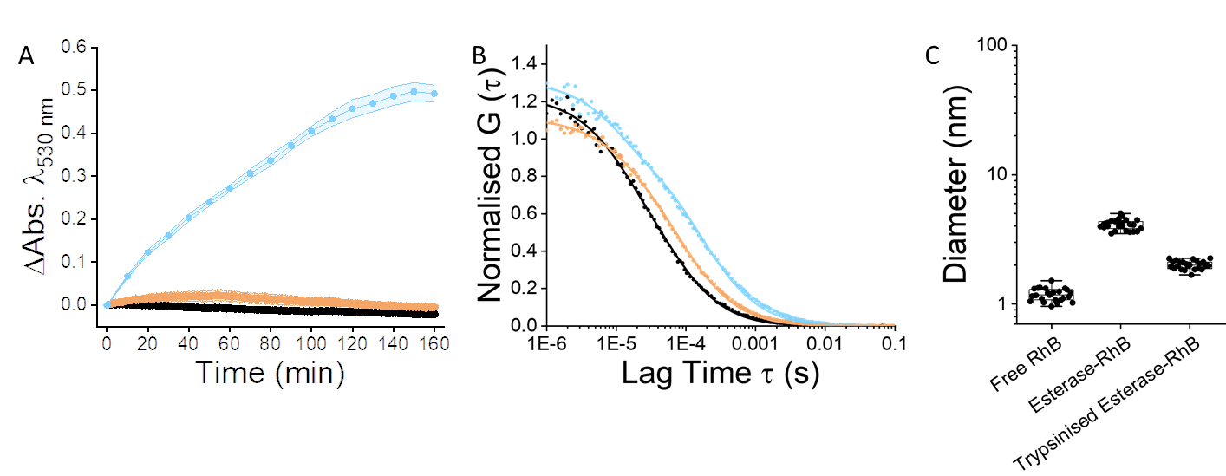
Extended Data Figure 8 │Digestion of non-encapsulated esterase with trypsin. A. UV-Vis kinetics of ethyl acetate hydrolysis reaction catalysed by free trypsinised esterase (orange), DASA-esterase nanoreactors with externally trypsinised esterase employing green light (λ = 530 nm) at 1.49 mW∙cm⁻² (blue) and in darkness (black) (n = 3 technical replicates, mean ± SD). The last two datasets were reproduced from Figure 2D for illustration purposes. B. Normalised FCS autocorrelation curves of RhB-esterase (blue), trypsinised RhB-esterase (orange), and sulforhodamine B (black) (average curves of n = 25 technical replicates, 5 s each, dots represent raw data, fitted curves are straight lines). C. Hydrodynamic diameters derived from Normalised FCS autocorrelation curves in panel B (displayed: centre line, the median; box limits, upper and lower quartiles; whiskers, minimum and maximum values, n = 25 technical replicates, 5 s each).
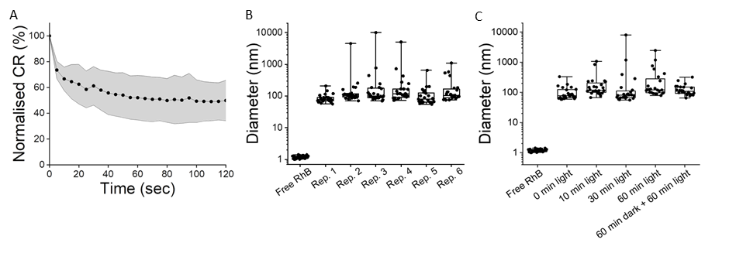Extended Data Figure 9 │Single particle characterisation of DASA photoswitching. DASAs isomerise from a colourful, fluorescent, and less polar isomer in darkness to a colourless, non-fluorescent, and more polar isomer in the presence of visible light. A. FCS normalised count rate (CR) of DASA polymersomes excited with a laser (λ_{ex} = 561 nm) over time (6 samples with n = 25 technical replicates, 5 s each, mean ± SD). B. Hydrodynamic diameters derived from FCS autocorrelation analysis of raw CR panel B. C. Hydrodynamic diameters derived from normalised FCS autocorrelation curves of samples externally irradiated with green light (λ_{ex} = 530 nm) (n = 25 technical replicates, 5 s each; displayed: centre line, the median; box limits, upper and lower quartiles; whiskers, minimum and maximum values).
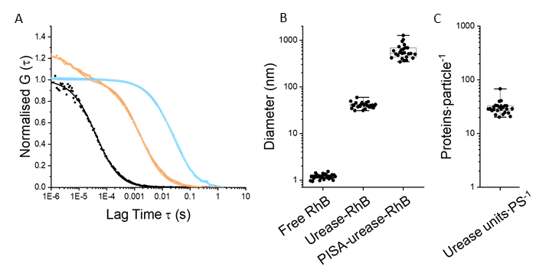

Extended Data Figure 10 │FCS measurements showing the encapsulation of urease in PISA-derived polymersomes. A. Normalised FCS autocorrelation curves of PISA-RhB-urease (blue), RhB-urease (orange), and sulforhodamine B (black) (average curves of n = 25 technical replicates, 5 s each, dots represent raw data, fitted curves are straight lines). B. Hydrodynamic diameters derived from Normalised FCS autocorrelation curves in panel A C. Quantification of urease proteins per PISA polymersome. (Displayed: centre line, the median; box limits, upper and lower quartiles; whiskers, minimum and maximum values, n = 25).
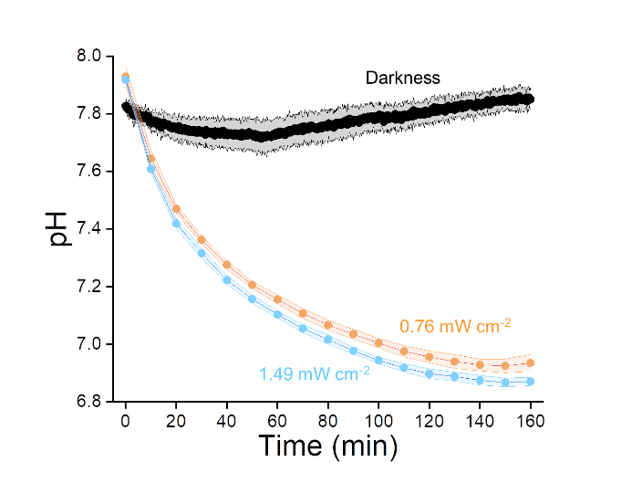
Extended Data Figure 11 │ DASA-esterase nanoreactor mediated biocatalytic hydrolysis of ethyl acetate in the presence of MR by continuous irradiation of green light (λ = 530 nm). Evolution of pH at 1.49 mW∙cm⁻² (blue), 0.76 mW∙cm⁻² (orange), and 0 mW∙cm⁻² (black). The formation of MRH was monitored by absorbance measurements at 530 nm (n = 3 technical replicates, mean ± SD) shown in Figure 2D in the main manuscript.
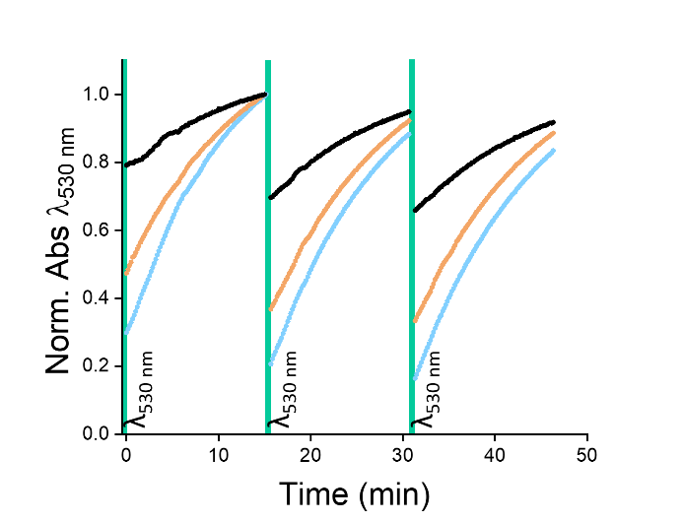
Extended Data Figure 12 │UV—Vis measurements of DASA polymer photoswitching in THF. In each photoswitching cycle, the solutions were irradiated for 30 sec and thermal recovery of the absorbance was monitored at 530 nm for 15 min. The samples were irradiated at green light (λ = 530 nm) intensities of 0.23 mW∙cm⁻² (black), 0.76 mW∙cm⁻² (orange), and 1.49 mW∙cm⁻² (blue).
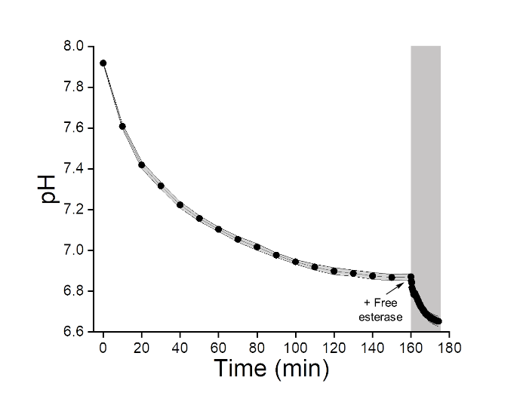
Extended Data Figure 13 │ Evolution of pH after addition of free esterase after formation of green light-mediated plateau. 60 pmol of free esterase was added after the formation of plateau by green light at 1.49 mW∙cm⁻² (n = 3 technical replicates, mean ± SD). The data was calculated from the absorbance values shown in Figure 2E in the main manuscript.
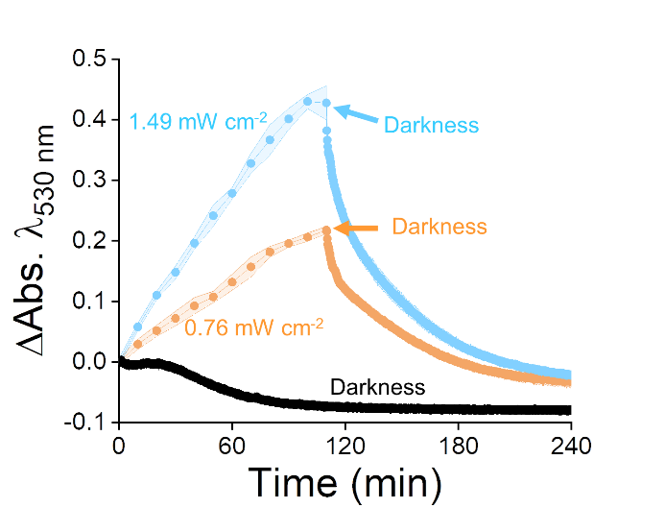
Extended Data Figure 14 │Light-fuelled modulation of pH by chemical communication between DASA-esterase and PISA-urease nanoreactors at different light intensities. Monitoring of absorbance evolution by continuous irradiation of green light at 0 mW∙cm⁻² (black), 0.76 mW∙cm⁻² for 110 min followed by 0 mW∙cm⁻² (orange), and 1.49 mW∙cm⁻² for 110 min followed by 0 mW∙cm⁻² (blue) (n = 3 technical replicates, mean ± SD). The corresponding calculated pH values are shown in Figure 4B.

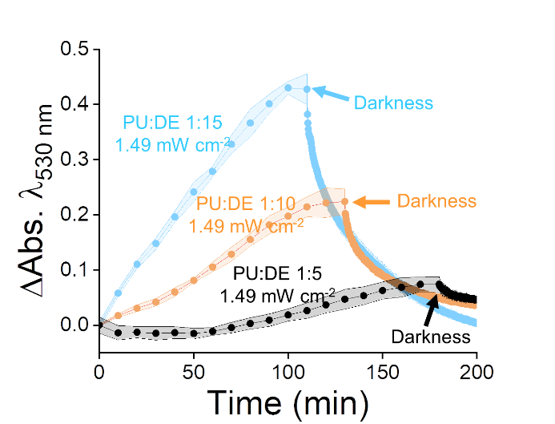
Extended Data Figure 15 │ Light-fuelled modulation of pH by chemical communication between DASA-esterase and PISA-urease nanoreactors at different ratios. Monitoring of absorbance evolution by continuous irradiation of green light at 1.49 mW∙cm⁻² with volume ratios of PISA-urease : DASA-esterase of 1:5 (irradiation for 180 min by irradiation at 0 mW∙cm⁻²) (black), 1:10 (irradiation for 130 min followed by 0 mW∙cm⁻²) (orange), and 1:15 (irradiation for 110 min followed by irradiation at 0 mW∙cm⁻²) (blue) (n = 3 technical replicates, mean ± SD). The latter was repeated from Extended Data Figure 15 for illustration purposes. The corresponding calculated pH values are shown in Figure 4C.

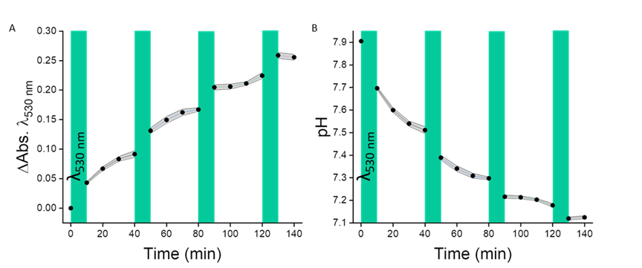
Extended Data Figure 16 │ DASA-esterase nanoreactor mediated biocatalytic hydrolysis of ethyl acetate in the presence of MR in alternating light and darkness cycles. A. UV-Vis measurements B. Calculation of pH from absorbance values. In each cycle, the samples were irradiated with green light at 1.49 mW∙cm⁻² for 10 min and production of MRH was monitored at 530 nm for 30 min (n = 3 technical replicates, mean ± SD).
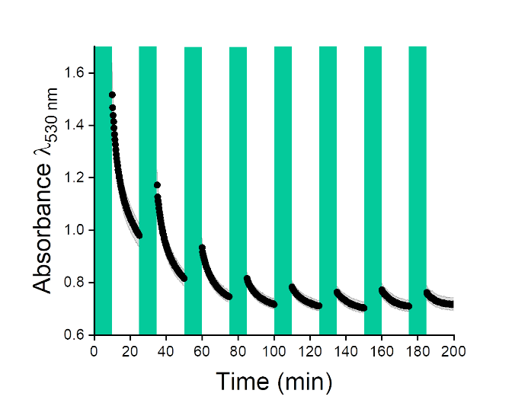
Extended Data Figure 17 │ Modulation of medium species by alternating light between DASA-esterase and PISA-urease nanoreactors. UV-Vis measurements monitoring the formation of MRH by alternation of green light at 4.31 mW∙cm⁻² and darkness. In each cycle, the samples were irradiated for 10 min and the absorbance at λ = 530 nm was probed for 15 min in darkness (n = 3, technical replicates, mean ± SD). The pH evolution in Figure 4B in the main manuscript was calculated from such absorbance values.
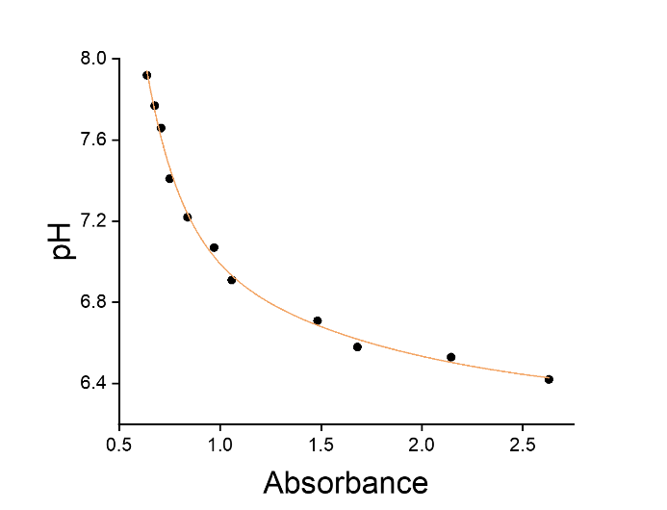
Extended Data Figure 18 │Calibration curve of absorbance vs pH. The aqueous solutions were composed of MR (7.4∙10⁻¹ μmol∙mL⁻¹), urea (8.3∙10⁻¹ mmol∙mL⁻¹), and saturated ethyl acetate at a range of pH and absorbance values. The data was fitted to an exponential decay function (r² = 0.99).

