Supplementary figures

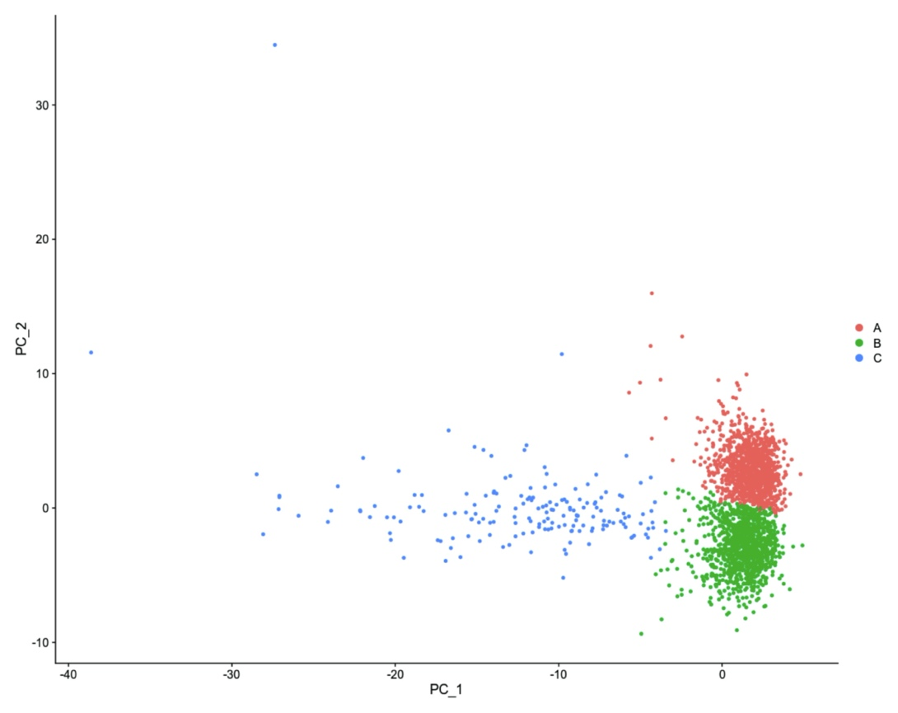
Supplementary figure 1. Principal Component Analysis (PCA) plot of gene exppression from human skeletal muscle snRNAseq colored by the cluster annotation, see Figure 1A, obtained from the Louvain clustering on the number of significant principal components (according to Seurat workflow).

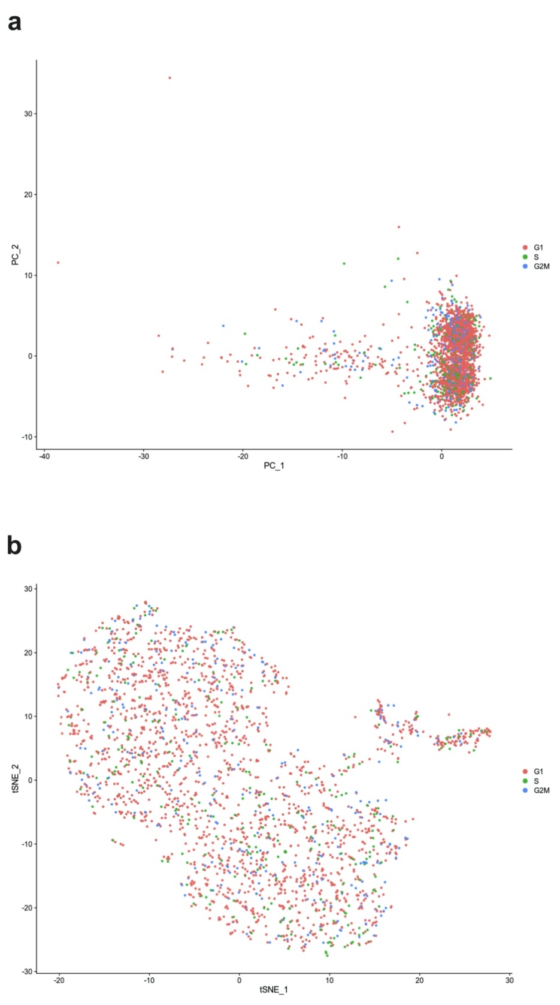
Supplementary figure 2. (a) Principal Component Analysis (PCA) plot, and (b) tSNE plot of gene expression from human skeletal muscle snRNAseq colored by the cell cycle annotation obtained from the CellCycleScoring function from Seurat workflow. No obvious cluster formation based on the cell cycle can be observed from neither the PCA nor the tSNE plot.

