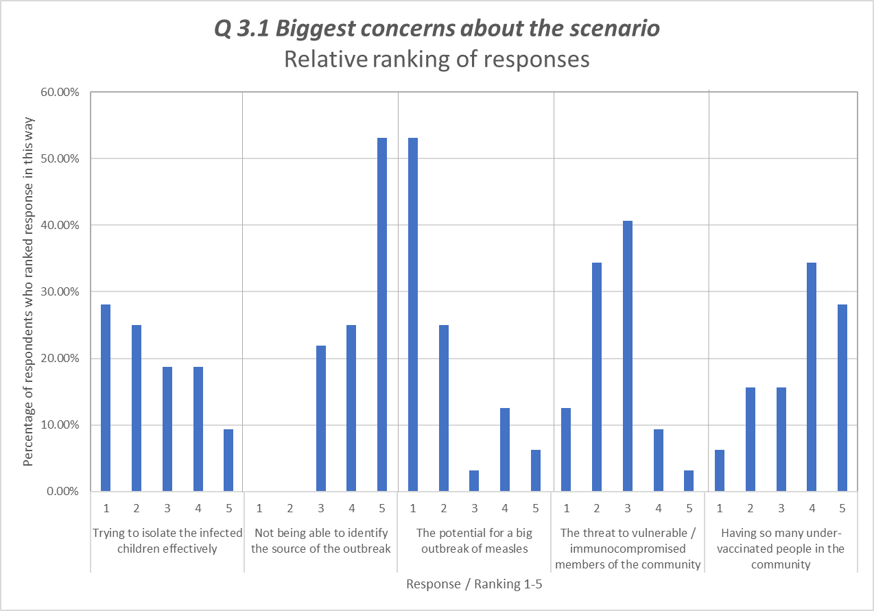

Additional File 2: Biggest concerns about the scenario, Relative rankings (Round 2)

