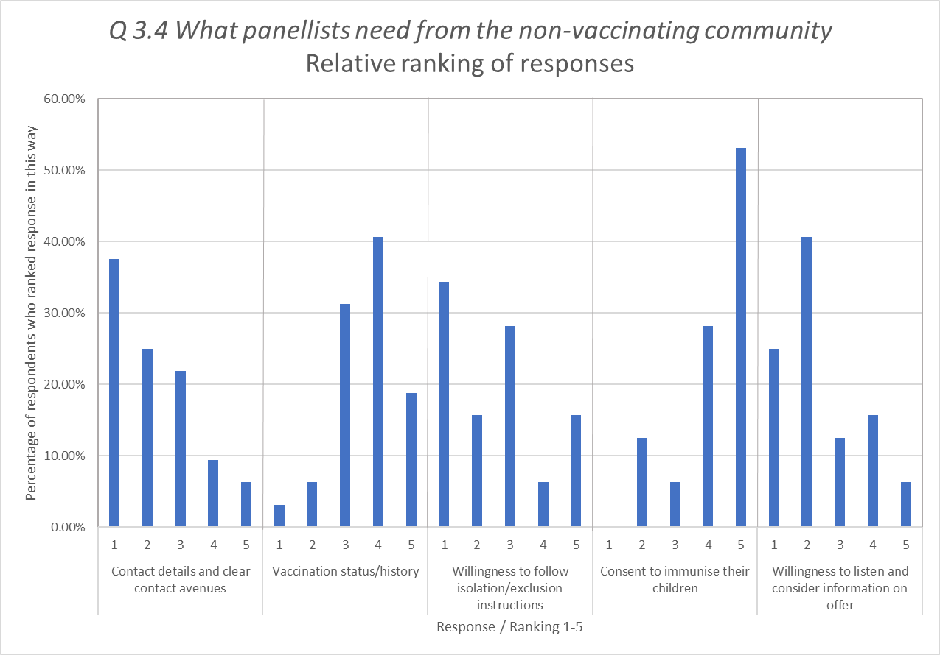
Additional File 5: What panellists need from the non-vaccinating community, Relative rankings (Round 2)

