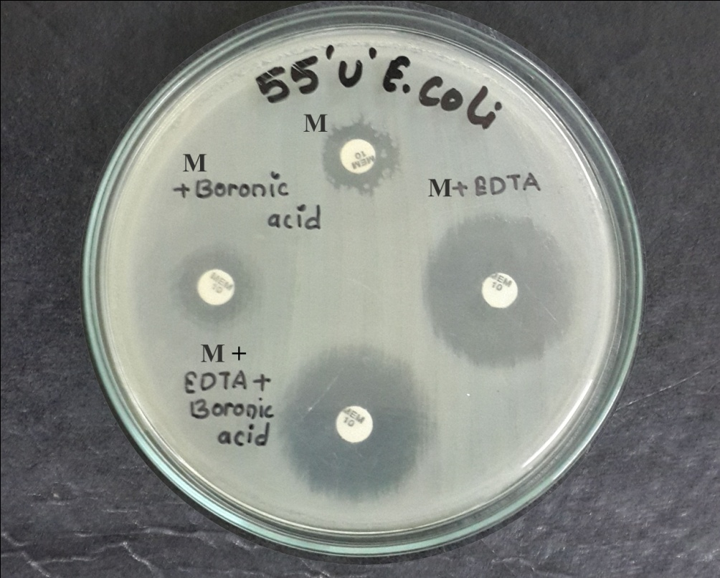

M-Meropenem
Photograph 3: MBL positive MDR E. coli isolate

