Abbreviations
LCD: lattice corneal dystrophy ;
IVCM: in vivo laser scanning confocal microscopy
Acknowledgements
The authors would like to thank all the staff and participants in the observation.
Funding
Science, Technology and Innovation Commission of Shenzhen Municipality (JCYJ20170306140020487; JCYJ20160428144605809). The funding organization had no role in the design or conduct of this research.
Availability of data and materials
The datasets used and/or analysed during the current study are available from the corresponding author on reasonable request.
Authors’ contributions
Ming Li and Fengjiao Zhu planned the study; Chun Zhang conducted the survey; Fangwei Ying performed the data processing; Danyao Nie collected the data of lattice corneal dystrophy. All authors have read and approved the final manuscript.
Ethical approval and consent to participate
This project was approved by the Internal Review Board (IRB) of Shenzhen Eye Hospital (Code #: 20190220), in accordance with the tenets of the Declaration of Helsinki. Written informed consent was obtained from each participant at the examination site.
Competing interests
The authors declare that they have no competing interest.
Author details
¹ Pudong New Area Eye and Dental Diseases Prevention & Treatment Center, Shanghai, 201399, P. R. China
² Shenzhen Eye Hospital, Joint College of Optometry of Shenzhen University (Shenzhen University Health Science Center), Affiliated Shenzhen Eye Hospital of Jinan University, Shenzhen, 518040, P. R. China
Corresponding Author: liming75@sina.com
Postal address: 18#, Zetian Road, Futian District, Shenzhen Eye Hospital, Shenzhen, 518040, P. R. China
Email address: liming75@sina.com;
Telephone #: 0086-13560780995

Figure legends：
Figure 1. Photograph of the anterior segment of LCD, the corneal stroma seen in lattice-like stripe turbidity

Figure 2A. The first type of LCD that the corneal stromal nerves not involved, the nerve fibers straight, and highly reflective, with smooth borders and a straight structure
Figure 2B. Some of amyloid encapsulating the nerve fibers of the corneal stroma; the affected nerve fibers becoming thickened and the unwrapped nerves growing thinner, taking the form of being beaded, defined as Grade I of neurotropic phenomenon
Figure 2C. A large number of amyloids in the nerve fibers enveloping the corneal stroma; the affected nerve fibers significantly thickened, defined as Grade II of neurotropic phenomenon of LCD

Figure 3A. The second type of LCD that the corneal stroma nerves not involved; the curved nerve fibers having a fine, highly reflective, slender, curved structure
Figure 3B. The curved nerve fibers partially thickened due to LCD lesions, showing uneven thicknesses; the curved nerve fibers not affected in the lower left, still defined as Grade I of neurotropic phenomenon of LCD
Figure 3C. The nerve fibers of the corneal stroma significantly thickened after being wrapped by LCD lesions, defined as Grade II of neurotropic phenomenon of LCD

Figure 4A. The third type of LCD that the corneal stroma not involved, showing branching nerve fibers in the corneal stroma
Figure 4B. Some of amyloid encapsulating the branching nerve fibers in the corneal stroma, with the nerve fibers becoming thickened and segmented, defined as Grade I of neurotropic phenomenon of LCD
Figure 4C. A large number of amyloids wrapping the nerve fibers in the corneal stroma, with the nerve fibers becoming all significantly thickened, without segmentation, defined as Grade II of neurotropic phenomenon of LCD

Figure 5A. The trend of 16 eyes of neurotropic phenomenon of LCD based on a 10-year observation
Figure 5B. The trend of the remaining patients of neurotropic phenomenon of LCD.

Figure: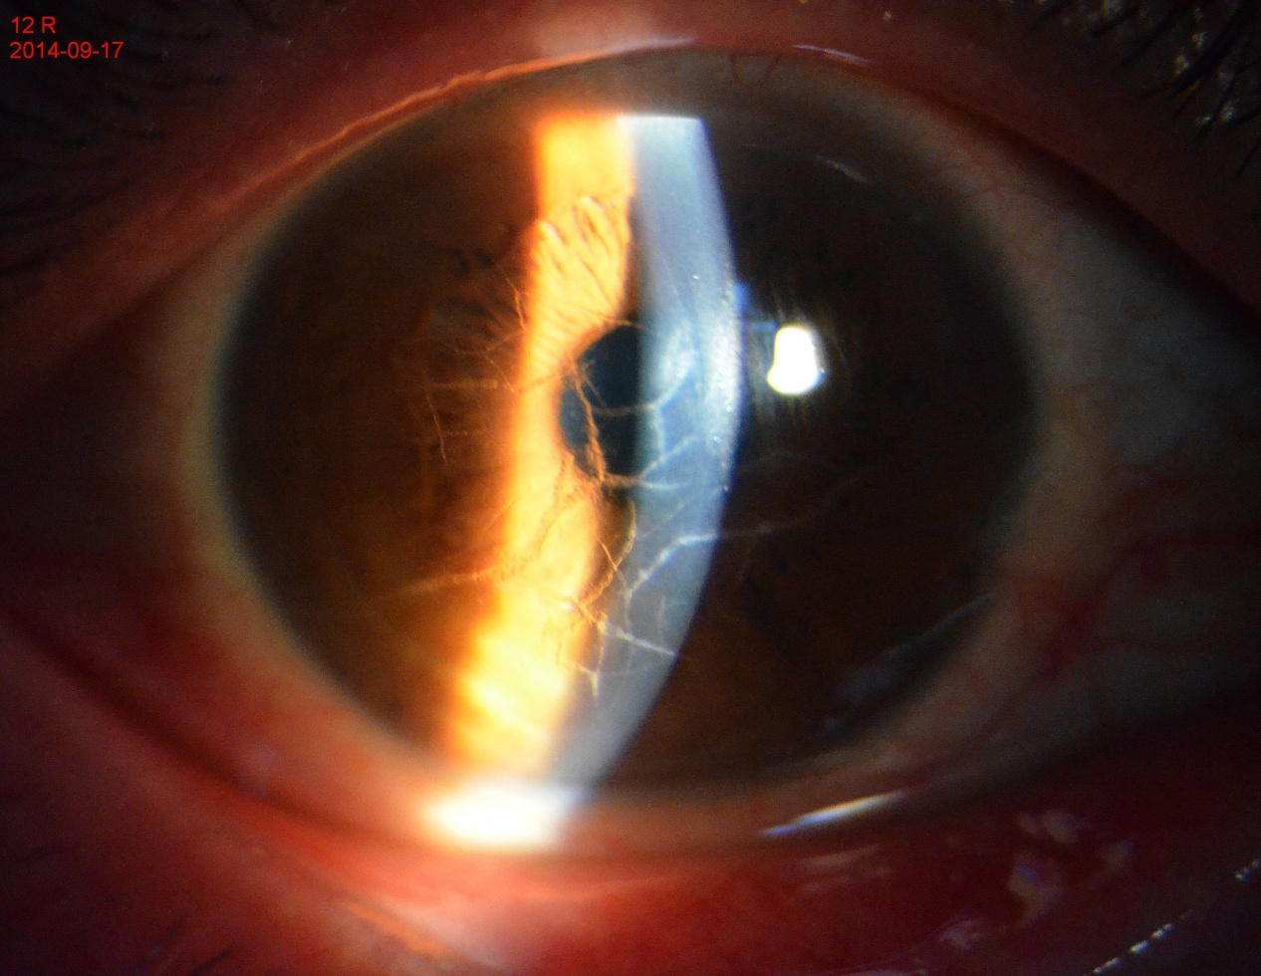
Figure 1. Photograph of the anterior segment of LCD, the corneal stroma seen in lattice-like stripe turbidity 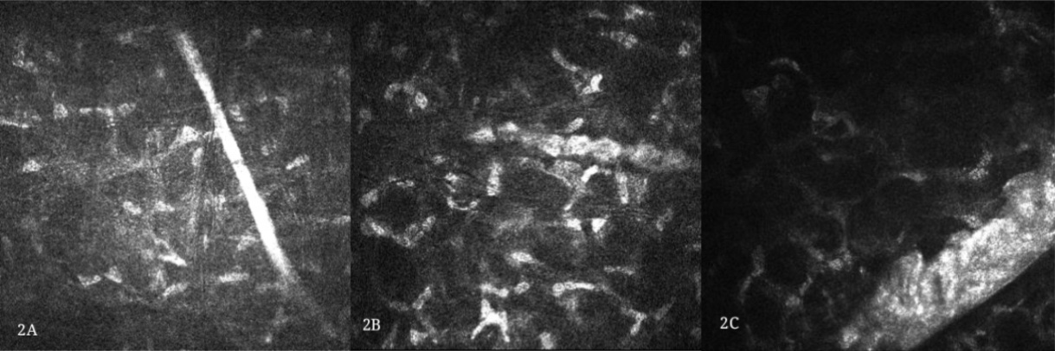
Figure 2A. The first type of LCD that the corneal stromal nerves not involved, the nerve fibers straight, and highly reflective, with smooth borders and a straight structure
Figure 2B. Some of amyloid encapsulating the nerve fibers of the corneal stroma; the affected nerve fibers becoming thickened and the unwrapped nerves growing thinner, taking the form of being beaded, defined as Grade I of neurotropic phenomenon
Figure 2C. A large number of amyloids in the nerve fibers enveloping the corneal stroma; the affected nerve fibers significantly thickened, defined as Grade II of neurotropic phenomenon of LCD

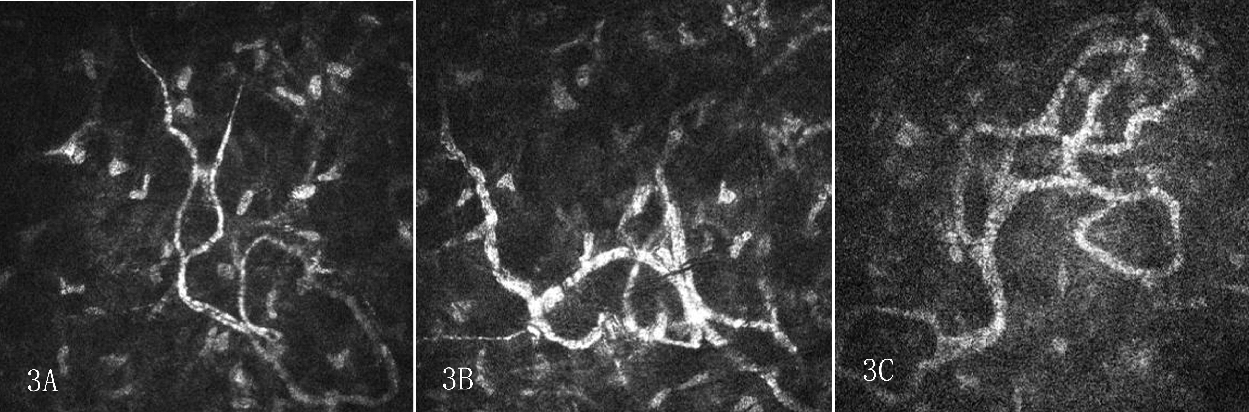
Figure 3A. The second type of LCD that the corneal stroma nerves not involved; the curved nerve fibers having a fine, highly reflective, slender, curved structure
Figure 3B. The curved nerve fibers partially thickened due to LCD lesions, showing uneven thicknesses; the curved nerve fibers not affected in the lower left, still defined as Grade I of neurotropic phenomenon of LCD
Figure 3C. The nerve fibers of the corneal stroma significantly thickened after being wrapped by LCD lesions, defined as Grade II of neurotropic phenomenon of LCD
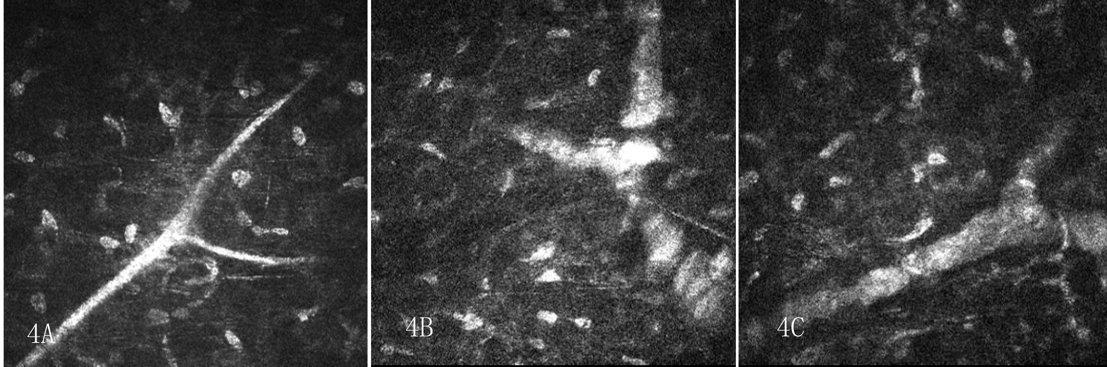
Figure 4A. The third type of LCD that the corneal stroma not involved, showing branching nerve fibers in the corneal stroma
Figure 4B. Some of amyloid encapsulating the branching nerve fibers in the corneal stroma, with the nerve fibers becoming thickened and segmented, defined as Grade I of neurotropic phenomenon of LCD
Figure 4C. A large number of amyloids wrapping the nerve fibers in the corneal stroma, with the nerve fibers becoming all significantly thickened, without segmentation, defined as Grade II of neurotropic phenomenon of LCD

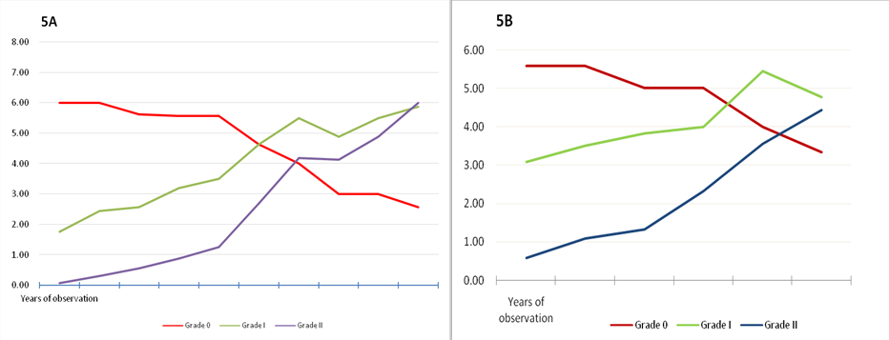
Figure 5A. The trend of 16 eyes of neurotropic phenomenon of LCD based on a 10-year observation .
Figure 5B. The trend of the remaining patients of neurotropic phenomenon of LCD

