Supplementary material

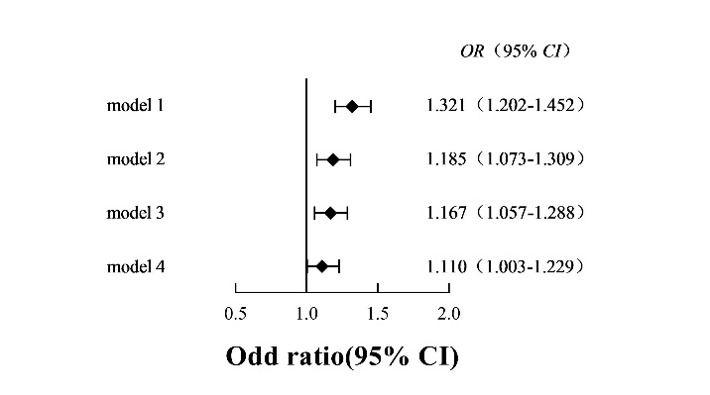
Figure S1 Logistic regression analysis of the relationship between remnant cholesterol and ischemic cardiovascular disease (RC was analyzed as a continuous variable)
Model 1: adjusted for gender+ age. Model 2: Model 1+current smoker+ obesity+ hypertension+ diabetes+ lipid-lowering therapy. Model 3: Model 2+ low-density lipoprotein cholesterol. Model 4: Model 2+ high-density lipoprotein cholesterol.

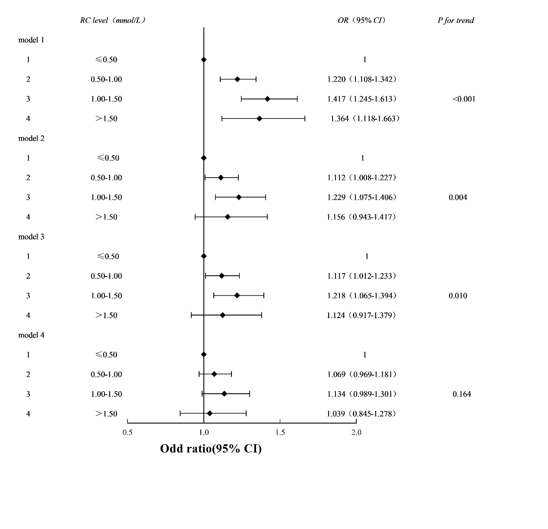
Figure S2 Logistic regression analysis of the relationship between remnant cholesterol and ischemic cardiovascular disease (RC was analyzed by grouping by clinical boundaries)
Model 1: adjusted for gender+ age. Model 2: Model 1+current smoker+ obesity+ hypertension+ diabetes+ lipid-lowering therapy. Model 3: Model 2+ low-density lipoprotein cholesterol. Model 4: Model 2+ high-density lipoprotein cholesterol.

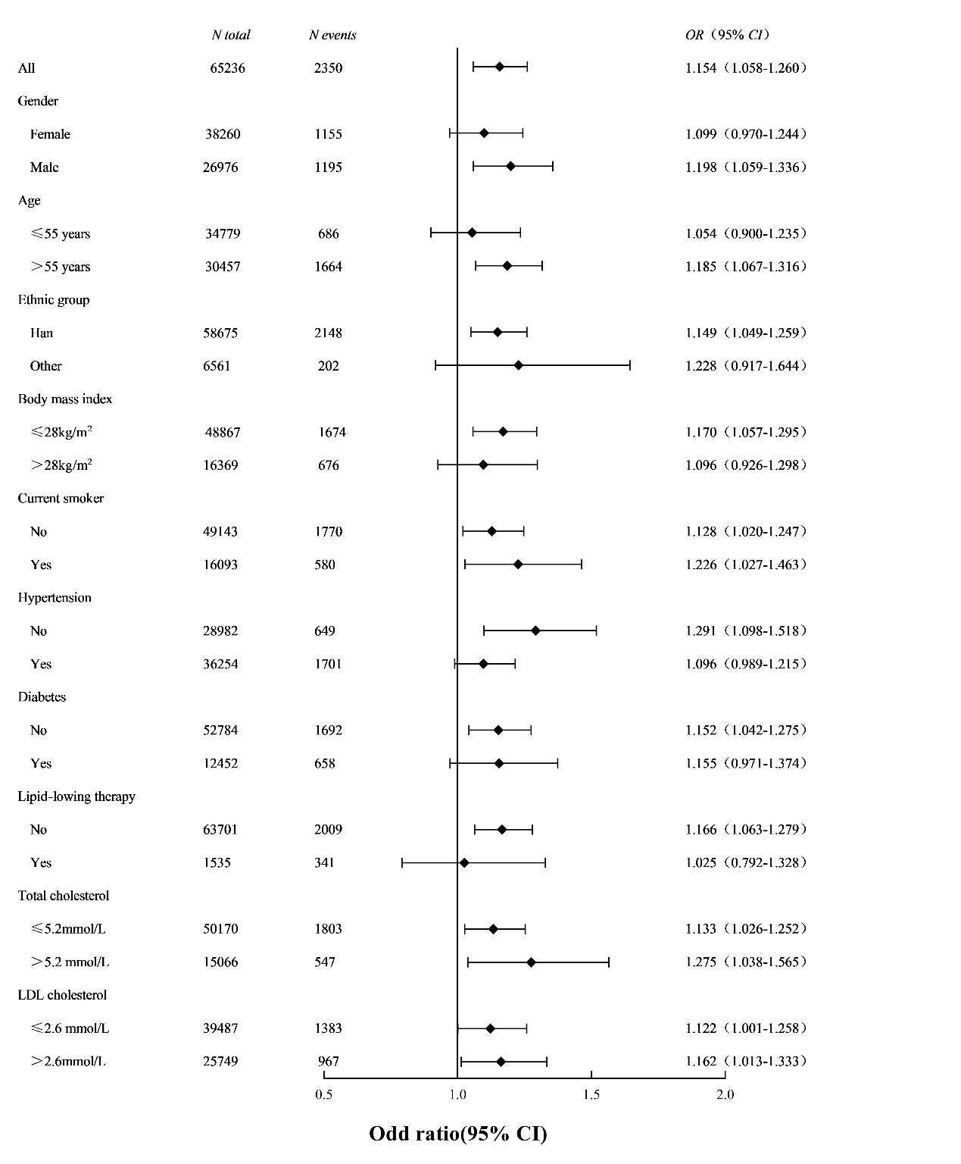
Figure S3 Risk of ischemic cardiovascular disease stratified by cardiovascular risk factors
The reference group is individuals with low concentrations of both (RC≤0.6mmol/L)

