Supporting Information
Fig. S1 Relative expression levels of selected S. cerevisiae cyclin genes in replicated experiments. A fold changes of CLN1, CLN2, CLB3, CLB1, and CLB2 during BR late-log phase. B fold changes of the same cycling genes during SCF short cycle 21. ACT1 and ALG9 were used as reference genes, and a sample collected at 16.2 h during BR was used as the reference sample. Error bars show one standard deviations (n = 3).

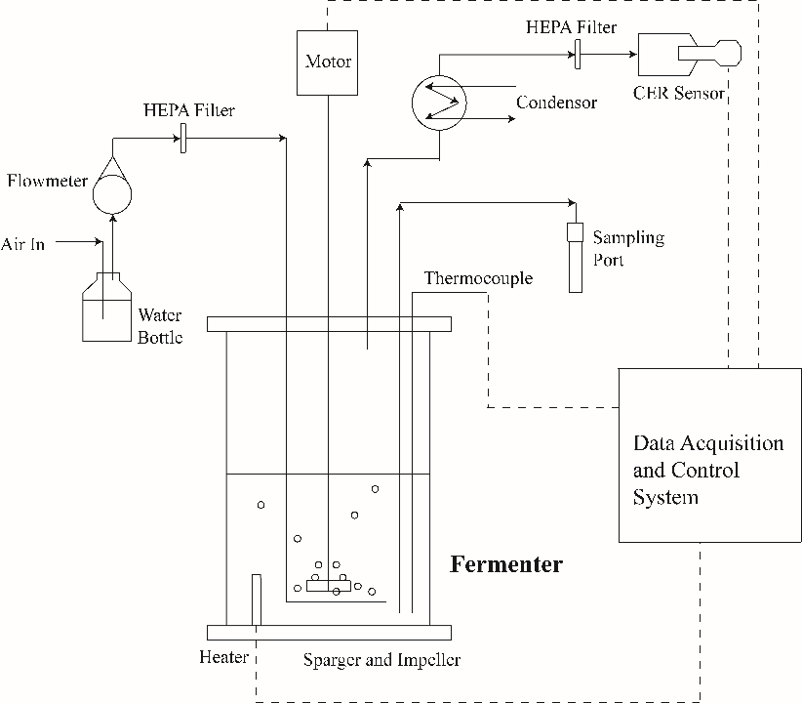
Fig. S2 Schematic of the batch reactor configuration used for this study.

