Supplementary Material. Stephanie M. Juice, Paul G. Schaberg, Alexandra M. Kosiba, Carl E. Waite, Gary J. Hawley, Deane Wang, Julia N. Perdrial, and E. Carol Adair. Soil type modifies the impacts of warming and snow exclusion on carbon and nutrient losses

1. Supplementary Methods

Seedling planting and establishment period
Prior to planting saplings, we tilled the top 5 cm of mesocosm soil and added 0.5 L Osmocote fertilizer (16-5-10; The Scotts Company, Marysville, OH, USA) to aid seedling establishment. For six months following planting, saplings were watered as necessary to encourage establishment before initiating experimental climate treatments. During this period, quaking aspen developed Shepherd’s crook fungus (Venturia tremulae), which was treated using copper sulfate fungicide at a rate of 35 mL L-1 every two weeks throughout the summer (June - August).

2. Supplementary Results

Nitrate and ammonium losses
Nitrate (${NO}_{3}^{-}$) loss dynamics were somewhat similar to TDN, but soil type and climate treatments interacted with biomass to affect nitrate losses (Table S4). Before accounting for biomass, ${NO}_{3}^{-}$ loss varied by soil type and climate treatment in both years (soil × treatment interaction). As observed in TDN, climate treatments had little impact on coarse soils relative to the controls. On fine soils, ${NO}_{3}^{-}$ loss from warmed and snow exclusion treatments were 150% and 440% greater than controls in 2014, and 40% and 270% greater than controls in 2015, respectively. Also like TDN, ${NO}_{3}^{-}$ loss from coarse soils in 2015 was ~17 times that from fine soils, averaged across climate treatments, but losses were similar across soil types in 2014. Accounting for differences in biomass revealed significant soil by treatment by biomass interactions in both years (Table S4). Increasing biomass decreased losses from coarse soils in control treatments in both years and warming treatments in 2015; increasing biomass had little or no impact on ${NO}_{3}^{-}$ losses from fine soils in either year, regardless of treatment.
Without accounting for biomass, there were no impacts of soil or treatment on ammonium (${NH}_{4}^{+}$) loss in either year (Table S4). Accounting for biomass revealed a significant soil by treatment by biomass effect in 2014, where biomass had little impact on losses, except in the snow exclusion treatment, where increasing biomass reduced ${NH}_{4}^{+}$ losses in fine soils but increased them very slightly in coarse soils. In 2015 there were no treatment or soil impacts on ${NH}_{4}^{+}$ losses, but increasing biomass reduced losses by a maximum of 70% (marginally significant linear regression, p = 0.08).

Magnesium and aluminum losses
Without accounting for biomass, there were no soil or treatment impacts on Mg losses in 2014. Accounting for biomass that year revealed that Mg losses generally declined with increasing biomass, except in fine soils in controls and in coarse soils in heated treatments. In 2015, Mg losses were 60% higher from coarse soils (7.4 g ± 0.1) than fine soils (4.7 g ± 0.1) and soil and treatment interacted to alter Mg loss dynamics as follows: on coarse soils, warming (6.7 g ± 0.1) and snow exclusion (7.1 g ± 0.1) reduced Mg loss as compared to controls (8.4 g ± 0.2). However, on fine soils warming (5.4 g ± 0.1) increased Mg losses, and snow exclusion (3.7 g ± 0.2) decreased them, as compared to controls (4.9 g ± 0.1). That year, biomass had no significant effect on Mg losses.
Aluminum loss in 2014 was 30% greater from coarse (541 mg ± 7) than fine (409 mg ± 8) soils and had no relationship to climate treatment. In 2015, Al loss varied in the different soil-treatment groups (soil × treatment interaction), such that its loss from coarse soils was consistent across climate treatments (control: 518 mg ± 21; warmed: 510 mg ± 6; snow exclusion: 541 mg ± 22), but fine soil Al loss was reduced by snow exclusion (390 mg ± 10) as compared to control (510 mg ± 30) and warming (512 mg ± 15). Biomass had no significant impacts on Al losses.

3. Supplementary Tables

Table S1 Physical and chemical properties of the two soils used in the mesocosms. Data marked with * are from Beard et al. (2005) and were measured when the site was established in 1995. pH measurements were made in 2015. Water holding capacity (WHC) and cation exchange capacity (CEC) were measured on unsieved, archived samples (collected in 2015) in 2019. All other data were measured in 2013 before initiation of climate treatments. Data are means with standard errors in parentheses where available.

Soil Property | Coarse | Fine
Bulk density (g cm⁻³) | 1.724 | 1.498
WHC (%) | 9.6 | 14.1
CEC (meq 100 g⁻¹)* | 11.08 | 0.98
Clay (%)* | 1.15 | 0.95
Silt (%)* | 0.56 | 0.66
Sand (%)* | 63.92 | 81.17
Fine gravel >2 mm (%)* | 34.26 | 17.30
pH | 7.639 (0.173) | 6.156 (0.193)
Ca (mg kg⁻¹) | 1773.75 (68.74) | 70.00 (4.68)
P (mg kg⁻¹) | 4.50 (0.80) | 1.55 (0.22)
K (mg kg⁻¹) | 42.83 (4.36) | 48.79 (3.89)
Mg (mg kg⁻¹) | 35.36 (1.22) | 10.69 (0.90)
Na (mg kg⁻¹) | 5.83 (0.31) | 4.93 (0.33)
Al (mg kg⁻¹) | 7.74 (0.15) | 11.16 (0.44)
Fe (mg kg⁻¹) | 9.07 (0.57) | 4.27 (0.45)
Mn (mg kg⁻¹) | 20.26 (0.73) | 12.91 (0.94)
S (mg kg⁻¹) | 32.16 (1.31) | 6.91 (1.07)
% C | 0.698 (0.039) | 0.325 (0.033)
% N | 0.045 (0.004) | 0.031 (0.003)
C:N | 15.891 (0.851) | 10.520 (0.350)
Table S2 Physical and chemical properties of the soils in the mesocosms used in each treatment prior to treatment establishment (2013). Means (standard deviations) are shown. No significant differences were found among treatments prior to treatment establishment (p < 0.05).

Soil Property | Snow Exclusion | Heated | Control
Bulk density (g cm⁻³) | 1.51 (0.28) | 1.73 (0.13) | 1.59 (0.21)
Ca (mg kg⁻¹) | 914.4 (911.4) | 881.6 (891.4) | 969.6 (973.6)
P (mg kg⁻¹) | 3.2 (2.6) | 3.2 (3.4) | 2.7 (1.4)
K (mg kg⁻¹) | 46.9 (13.6) | 46.8 (18) | 43.8 (12.6)
Mg (mg kg⁻¹) | 24.7 (13.2) | 21.9 (14.1) | 22.5 (13.7)
Na (mg kg⁻¹) | 5.1 (1.3) | 5.2 (1.5) | 5.8 (0.7)
Al (mg kg⁻¹) | 9.8 (2.7) | 9 (1.5) | 9.5 (2.1)
Fe (mg kg⁻¹) | 7.8 (3.3) | 5.4 (2.9) | 6.9 (2.6)
Mn (mg kg⁻¹) | 17.8 (4.4) | 14.7 (5.7) | 17.2 (3.8)
S (mg kg⁻¹) | 19.4 (15.7) | 19 (13.3) | 20.2 (13.3)
% C | 0.59 (0.25) | 0.44 (0.24) | 0.54 (0.21)
% N | 0.04 (0.01) | 0.03 (0.02) | 0.04 (0.01)
C:N | 13.82 (3.7) | 12.52 (3.63) | 13.54 (3.87)

Table S3 Rooting depth characteristics and relative location of the South Burlington, VT planting site in relation to tree species ranges for saplings planted in the mesocosms.

Location | Shallow rooted | Deep rooted
At south of range | paper birch  (Betula papyrifera Marshall) | quaking aspen  (Populus tremuloides Michx.)
At north of range | black cherry  (Prunus seronita Ehrh) | American chestnut  (Castanea dentate (Marshall) Borkh.)

Table S4 Analysis of deviance results for 2014 and 2015 models of soil water leachate ammonium (${NH}_{4}^{+}$), nitrate (${NO}_{3}^{-}$), magnesium (Mg), and Aluminum (Al) as a function of soil × treatment (ANOVA) and as a function of soil × treatment × total plant biomass (ANCOVA). Bold values indicate p < 0.05.

Var | Year | R² | Chi Square Values
 |  |  | Soil | Trt | Soil x Trt | Bio | Bio x Soil | Bio x Trt | Bio x Soil x Trt
$${NO}_{3}^{-}$$ | 2014 | 0.6396 | 1.0 | 13.3 | 24.9
 |  | 0.7857 | 2.0 | 1.5 | 9.7 | 4.0 | 3.1 | 2.7 | 7.1
 | 2015 | 0.6751 | 32.7 | 1.7 | 6.8
 |  | 0.9394 | 33.9 | 39.2 | 56.5 | 36.5 | 18.1 | 48.9 | 61.9
$${NH}_{4}^{+}$$ | 2014 | 0.1378 | 0.0 | 1.3 | 1.6
 |  | 0.5091 | 0.8 | 6.4 | 14.3 | 0.0 | 0.8 | 4.4 | 12.0
 | 2015 | 0.1116 | 0.0 | 0.7 | 1.6
 |  | 0.4601 | 0.0 | 0.4 | 3.2 | 4.1 | 0.0 | 0.1 | 2.6
Mg | 2014 | 0.3441 | 3.8 | 4.1 | 4.9
 |  | 0.6977 | 0.2 | 1.5 | 9.0 | 10.2 | 0.1 | 0.5 | 6.4
 | 2015 | 0.9141 | 150.8 | 18.0 | 23.8
 |  | 0.9491 | 0.01 | 3.3 | 1.1 | 0.0 | 1.7 | 5.1 | 2.8
Al | 2014 | 0.4306 | 12.6 | 0.2 | 0.8
 |  | 0.6164 | 5.1 | 1.0 | 3.0 | 0.0 | 3.2 | 0.9 | 2.4
 | 2015 | 0.3477 | 2.8 | 2.5 | 6.9
 |  | 0.5581 | 0.3 | 1.6 | 3.6 | 2.1 | 0.2 | 2.8 | 1.9
Trt- treatment, Bio- biomass.

Table S5 Climate treatments significantly altered mean soil temperatures* ($Χ_{2}^{2}$ = 39.8, p < 0.0001, R² = 0.77), soil moisture (2015: $Χ_{2}^{2}$ = 7.1, p = 0.03, R² = 0.32), annual water leachate volume (2014: $Χ_{2}^{2}$ = 10.5, p = 0.005, R² = 0.52; 2015: $Χ_{2}^{2}$ = 11.1 p = 0.003, R² = 0.35), snow depth area under the curve (AUC; 2014: $Χ_{2}^{2}$ = 399.1, p < 0.0001, R² = 0.95; 2015: $Χ_{2}^{2}$ = 294.7, p < 0.0001, R² = 0.95), and soil freezing AUC (2014: $Χ_{2}^{2}$ = 187.6, p < 0.0001, R² = 0.80; 2015: $Χ_{2}^{2}$ = 9.2, p = 0.01, R² = 0.36) throughout the replicated climate change mesocosm experiment. Values are means with standard errors of the mean in parentheses.

 | Coarse |  |  |  | Fine
Variable | Control | Warmed | Snow  Exclusion |  | Control | Warmed | Snow  Exclusion
Mean soil temp, 5 cm depth (°C)*
2014 | 9.4  (0.02) | 10.0  (0.02) | 8.9  (0.02) |  | 9.1  (0.02) | 10.1  (0.02) | 8.8  (0.02)
2015 | 8.3  (0.03) | 8.6  (0.02) | 7.9  (0.03) |  | 8.2  (0.02) | 9.1  (0.02) | 7.9  (0.02)
Mean annual soil moisture (0-12 cm, %)
2014 | 2.98 (0.27) | 2.67 (0.27) | 2.76 (0.26) |  | 5.94 (0.52) | 5.03  (0.50) | 6.00  (0.53)
2015 | 3.30 (0.28) | 3.02 (0.28) | 3.28 (0.35) |  | 8.73 (0.81) | 6.84 (0.60) | 6.04 (0.47)
Annual water leachate volume (L)
2014 | 2705 (129) | 2372 (49) | 2532  (48) |  | 2451 (26) | 2058 (175) | 2338 (120)
2015 | 2296 (225) | 1812 (58) | 2129 (166) |  | 2569 (255) | 2102 (278) | 1755  (96)
Snow AUC (cm days)
2014 | 1466 (86) | 581  (30) | 1211  (31) |  | 1594 (38) | 555  (44) | 1242  (78)
2015 | 1166 (19) | 705  (16) | 957  (10) |  | 1149 (15) | 735  (48) | 980  (20)
Soil freezing AUC (cm days)
2014 | 2357 (208) | 2814 (467) | 5443 (244) |  | 2320 (203) | 2719 (239) | 5423 (164)
2015 | 4343  (131) | 4040  (263) | 4742  (214) |  | 4147  (617) | 4140  (162) | 4565  (88)
* Statistics shown for 5 cm depth. Climate treatments significantly altered mean soil temperatures at 0, 5, 10, 30, and 60 cm depths (p < 0.05).

4. Supplementary Figures

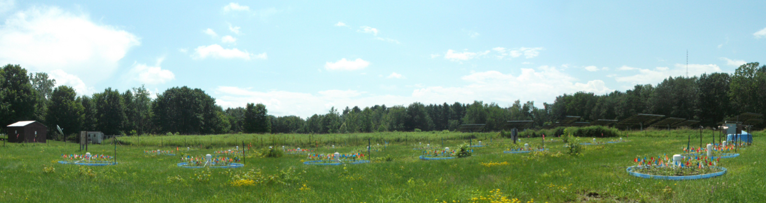
Fig. S1 Mesocosms after planting in 2013.

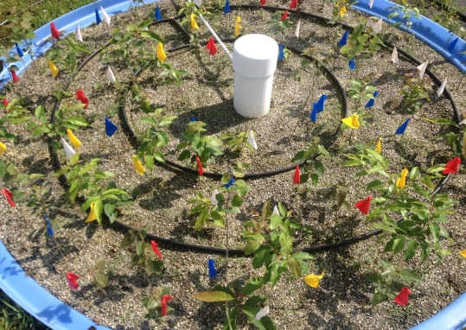
b)
a)
Fig. S2 Photos of installed mesocosms with experimental infrastructure. (a) Inter-planted deciduous mix of saplings with irrigation system during site establishment/pre-treatment phase in summer 2013. The capped white tube in the center was uncapped to measure the water level in the leachate drainage area, and the white tube extending from the center tube to the top of the photo is the vacuum extraction tube for leachate collection. (b) Tarp installed over a mesocosm receiving the snow exclusion treatment, with translucent plastic sheeting (0.6 m tall) around the perimeter to moderate the effects of wind. Tarps were hung only during snow events for six weeks following the first snowstorm of the year.

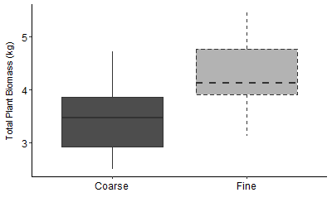
Fig. S3 Total plant biomass by soil type, measured at the end of the experiment in August 2015. Fine soils supported 24% more total plant biomass than coarse soils (p = 0.007, R² = 0.29).

