Drought tolerant wheat varieties enrich seed microbiomes for beneficial microbes under drought conditions

Holly Hone*¹, Ross Mann¹, Guodong Yang^{1,3}, Jatinder Kaur¹, Ian Tannenbaum^{1,2}, Tongda Li^{1,2}, German Spangenberg^{1,2} and Timothy Sawbridge^{1,2}
¹Agriculture Victoria, AgriBio, Centre for AgriBioscience, Bundoora, VIC, Australia.
²School of Applied Systems Biology, La Trobe University, Bundoora, VIC, Australia.
³College of Animal Science and Technology, Henan University of Science and Technology, Luoyang, Henan, People's Republic of China

Supplementary Figure 1 – Curtobacterium MALDI tree
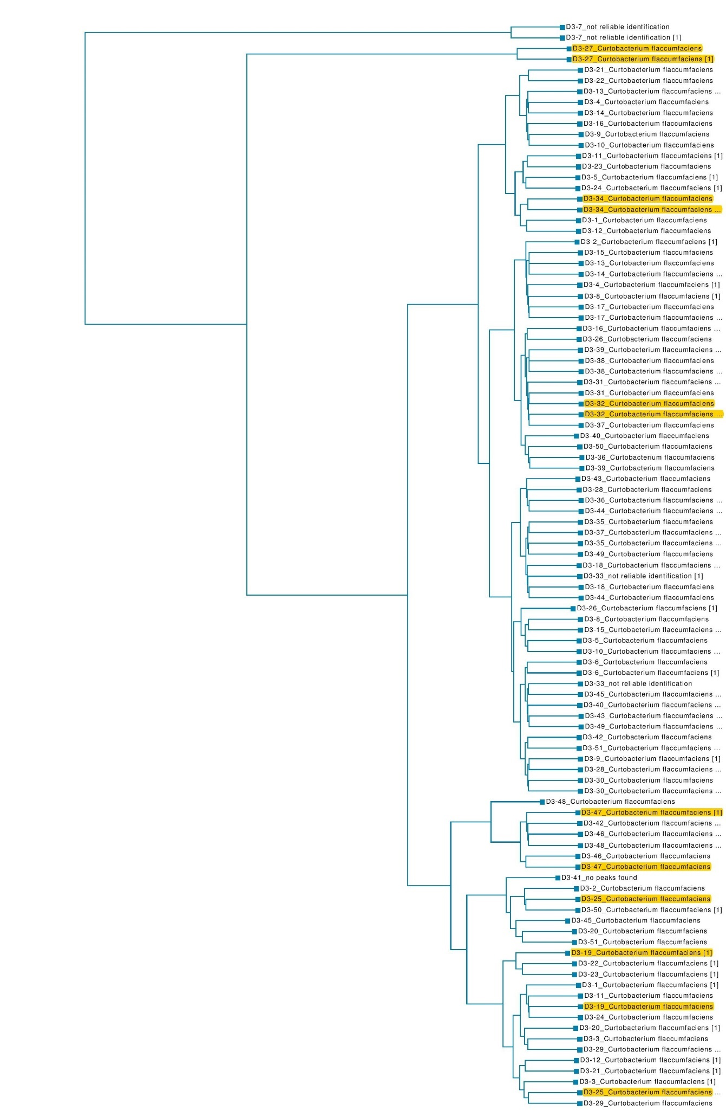
Supplementary Figure 2 – Arthrobacter MALDI tree
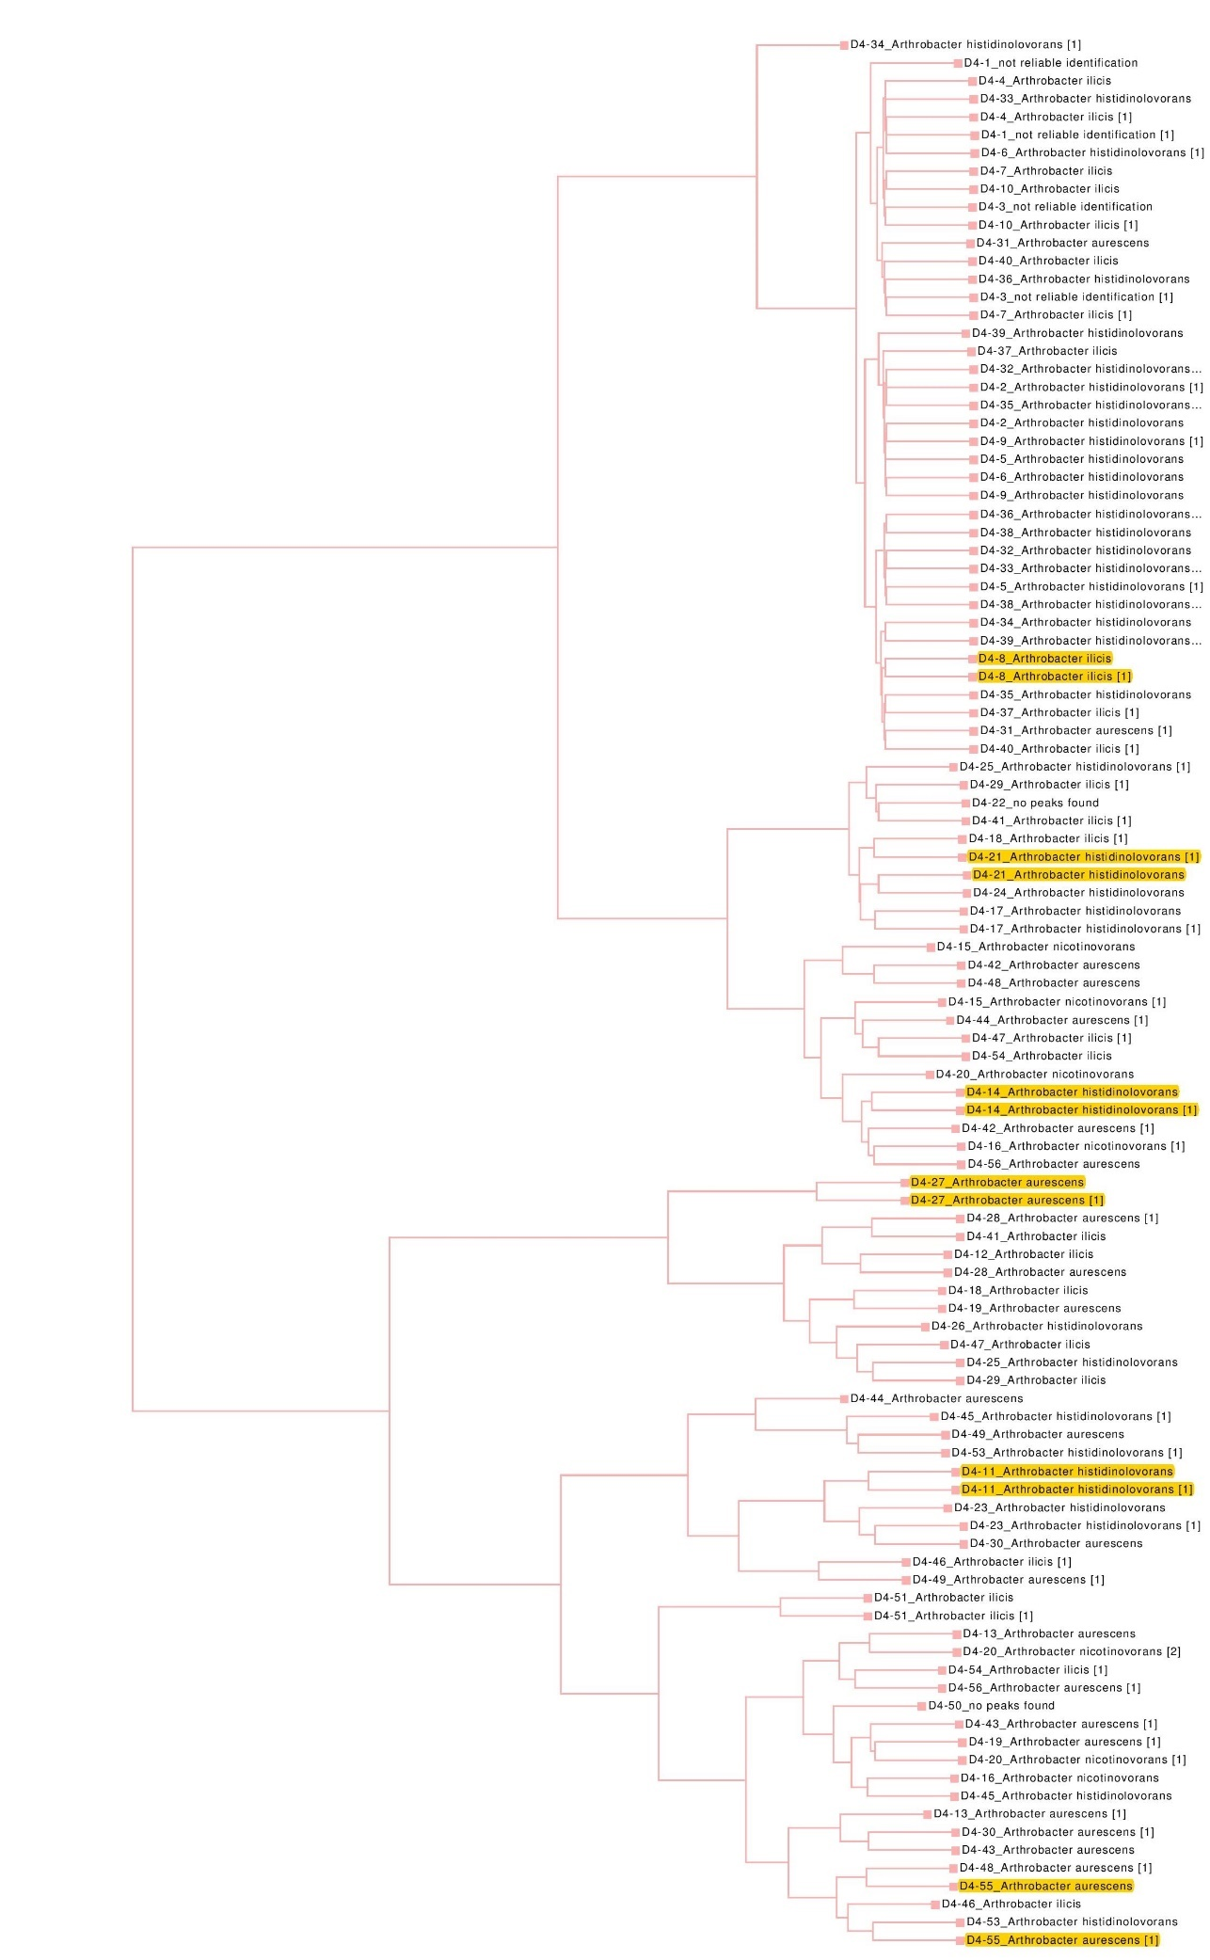
Supplementary Table 1. Microbial isolates from Line 3 and Line 4
 | Line 3 | Line 4
Arthrobacter | 0 | 49
Clavibacter | 0 | 0
Curtobacterium | 49 | 0
Erwinia | 0 | 0
Rathayibacter | 0 | 0
Paenibacillus | 0 | 0
Pantoea | 0 | 0
Pseudomonas | 0 | 0
No identification | 2 | 7
Total | 51 | 56

Supplementary Table 2. ANOVA analysis identified the 60 most significant OTUs when comparing microbiomes under drought conditions and microbiomes under rainfed conditions.
OTU number. | OTU ID | Genera | P-value | BH Q-value
1 | 9af3467db68cf6063627304cecd46a65 | Pseudomonas* | 9.04E-18 | 2.30E-13
2 | 7ff346973a282aa55de296afdb5d74af | Unknown | 2.11E-15 | 2.69E-11
3 | 945f562bda86790338922e12f9854407 | Flavobacterium | 7.74E-13 | 6.57E-09
4 | 8735f92a7f18db944bc86277fbd3222 | Unknown | 1.72E-12 | 1.10E-08
5 | fcd80f0cf279eff3c50b66a78d98beeb | Amycolatopsis | 2.99E-12 | 1.52E-08
6 | 8599524cec26e00cc7df72e7ecc01220 | Unknown | 1.57E-11 | 6.64E-08
7 | d829bee4984f82ffc2453212157caf96 | Bradyrhizobium | 3.68E-11 | 1.68E-07
8 | cc761daf51f27c453da57f3f1f0ff5cc | Pantoea* | 5.80E-11 | 1.68E-07
9 | 0a023b056a85b92a1ca8214e78a9c45a | Skermanella | 5.96E-11 | 1.89E-07
10 | 8154c989085dcab535c58fd5a7a18220 | Rubrobacter | 7.45E-11 | 1.89E-07
11 | a869b422007c6d75482b0e9e0338b95c | Unknown | 1.64E-10 | 3.79E-07
12 | 5f8db894a571d35c9d2fa4f8df8581f9 | Massilia | 2.16E-10 | 4.59E-07
13 | 5afec052157f7768bf459883f118a638 | Flavobacterium | 4.25E-10 | 8.32E-07
14 | 6abc517aa40e9e7b9c652902fe04bb1a | Unknown | 4.84E-10 | 8.80E-07
15 | 20425d99034cf4044217704b16934e27 | Noviherbaspirillum | 5.63E-10 | 9.54E-07
16 | 889f1bc31887efea2354ba099342a203 | Streptomyces | 6.36E-10 | 1.01E-06
17 | d40c63c872b5cfe4bb4caa9738d10c1f | Uncultured | 3.81E-09 | 5.49E-06
18 | 35d20da789dde8d76e4389fd6d30cc9d | Dactylosporangium | 3.10E-09 | 5.49E-06
19 | 09f944acc15518b31e5803e1e4cb4e43 | Duganella | 4.35E-09 | 5.49E-06
20 | 432b565bc288a18487cfa84b311b7469 | Unknown | 4.47E-09 | 5.49E-06
21 | 205e9006842d47d1a2d1caf6a96e0c88 | Microvirga | 4.53E-09 | 5.49E-06
22 | f6c528c217081be9871de0fc58b89408 | Variovorax | 5.66E-09 | 6.54E-06
23 | 6e4b50a611f333bfb12f3b9a4a9e8b61 | Uncultured | 1.09E-08 | 1.20E-05
24 | f37fc1dccfeba0004cbeb4f1ad6083c6 | Duganella | 1.68E-08 | 1.78E-05
25 | 120eba657e42a11a5c29f97b90f02035 | Streptomyces | 2.13E-08 | 2.17E-05
26 | 3a66a38841ba6877568198b9dac3a1dc | Lysobacter | 2.34E-08 | 2.29E-05
27 | ef0c7928901deab56b8d8abef337ac5c | Rubrobacter | 2.95E-08 | 2.78E-05
28 | cc34ab07649c94630cbc697762ac4b32 | Candidatus | 4.14E-08 | 3.76E-05
29 | 79029fa983ec4eda60117a273a52cfc0 | Caulobacter | 4.47E-08 | 3.92E-05
30 | 0f8ac0d81dd6449a43b34fcb184efd8f | Candidatus | 4.86E-08 | 4.12E-05
31 | cb5b9907447a49154182dee3ea78d16e | Acidibacter | 5.96E-08 | 4.89E-05
32 | 0f18144d308ada95632ab5193d92073f | Pseudomonas* | 6.77E-08 | 5.38E-05
33 | bf321c05d79f766c0099afb9ecc42f52 | Streptomyces | 1.21E-07 | 9.32E-05
34 | b712f6d712748de96eb148834a623ba1 | Geodermatophilus | 1.91E-07 | 1.43E-04
35 | a285136eb52ed887013aaa7917ce5051 | RB41 | 3.79E-07 | 2.75E-04
36 | bc3676c17839094c4fa8e33268905268 | Candidatus | 4.40E-07 | 3.11E-04
37 | e08272633711f2ea424a3232ed337e8 | Unknown | 1.38E-06 | 9.45E-04
38 | 1d145835e7f0188562322f4eefb02657 | Uncultured | 1.72E-06 | 1.15E-03
39 | bc23d6db3bfb2c79f5eb1cec8f01f841 | Uncultured | 1.86E-06 | 1.21E-03
40 | 6e1575cfc367c39ec52c4d1e699a1fb2 | Cellvibrio | 2.14E-06 | 1.21E-03
41 | 132ffe9a542685a423a59236950b46b0 | Unknown | 2.27E-06 | 1.36E-03
42 | bb740c10ad31d5779e628bccffdb5015 | Skermanella | 2.30E-06 | 1.40E-03
43 | e8246466fe381d8a8d5c10cb90640eb3 | Sorangium | 2.49E-06 | 1.48E-03
44 | 9b4be26e7bb3a23d25e080a3bba619f6 | Arthrobacter* | 2.72E-06 | 1.57E-03
45 | d5620170bb86a5572c5c1b92cd915f05 | Uncultured | 2.93E-06 | 1.66E-03
46 | 00337a2c0aa8af2c100ebca3424b94a1 | Uncultured | 4.37E-06 | 2.42E-03
47 | a08ee4a8aa1ece798d78fae2b9ad0401 | Uncultured | 5.24E-06 | 2.83E-03
48 | 278a455d0edc27f3fcfb16ad5243ce26 | Unknown | 5.62E-06 | 2.98E-03
49 | b8c4ed03d7d91546b9fad80b80135a3 | Blastococcus | 6.64E-06 | 3.45E-03
50 | 44e2ab81e5e7cff6d965651c707b9479 | Uncultured | 7.92E-06 | 4.03E-03
51 | caa68010e3e574c4f1069b0ea4e6437e | Blyi10 | 8.72E-06 | 4.31E-03
52 | fbcfe878584c87b171eafb171b8a0fef | Rubrobacter | 8.83E-06 | 4.31E-03
53 | 1c2b8892a0d7f828d72808cd01cfd199 | Devosia | 8.98E-06 | 4.31E-03
54 | 8177ba9a29c738a90c530f54f4561cb1 | Unknown | 9.37E-06 | 4.41E-03
55 | 0fa9b44d52836d2f173f4ac532f8a013 | Skermanella | 1.03E-05 | 4.75E-03
56 | a9164d01308501b57afa0625a15b0f | Allorhizobium | 1.36E-05 | 6.16E-03
57 | d99a0b2472cd7caecdd8d63ac9cb3fdf | Rubrobacter | 1.38E-05 | 6.16E-03
58 | 26005dfb7ad2e8cdbb139846af329663 | Bacillus | 1.41E-05 | 6.19E-03
59 | c222885a993cabb139b7d8744e6ff7fc | Labrys | 1.50E-05 | 6.39E-03
60 | ef98cc2984cd3ce0ca6a46589a6df194 | Unknown | 1.51E-05 | 6.39E-03
*genus was isolated from wheat seeds

Supplementary Table 3 – ANOVA analysis identified the 60 most significant OTUs when comparing microbiomes of drought tolerant lines and microbiomes of drought susceptible lines.
OTU number. | OTU ID | Genera | P-value | BH Q-value
1 | 2e94aaded5896273b56726409d750804 | Unknown | 1.50E-11 | 3.81E-07
2 | 9c262c0fed9522982fd2297202ee5a83 | Uncultured | 4.61E-10 | 5.86E-06
3 | aebd4d0ae6384594a5882a958796ded | Uncultured | 5.09E-08 | 0.0004317
4 | f1be300df01babcf1897e6103507179f | Uncultured | 1.08E-07 | 0.0006843
5 | 8b49e37e3c87b34b3cf8fa98e87b9e56 | Unknown | 6.76E-07 | 0.003438
6 | d2e8afc64cc3c6dde961a4db0a44d26e | Gemmatimonas | 8.68E-07 | 0.00368
7 | 111e8e48a5111d4360329eef12acd3b7 | Uncultured | 1.87E-06 | 0.006801
8 | ce7ee6ce5f9dd8b3191a0fecd7745de4 | Unknown | 2.14E-06 | 0.006805
9 | d6bda8545c415bbc3cffa95f43e51e5f | Uncultured | 5.41E-06 | 0.01529
10 | cc2a396f24d8239e540d765b422b04eb | Uncultured | 6.29E-06 | 0.01599
11 | 568bee5fcaa9b6912463e88ef964f3e9 | Uncultured | 7.11E-06 | 0.01644
12 | 8795f8559d860648a3ccc7fe26f49283 | Uncultured | 8.89E-06 | 0.01885
13 | 320fc5aa1aec10458407aedf8f39698f | Unknown | 9.73E-06 | 0.01904
14 | 02b19fa4ce6a9bd677693ab7e4fceea7 | Uncultured | 1.20E-05 | 0.02174
15 | d9fe8350aa00c86b865d2f3e18ab18cd | Unknown | 1.59E-05 | 0.02693
16 | 1c29266ba1c7bc49e8c16e1d5b773041 | Uncultured | 2.96E-05 | 0.04697
17 | a86ecef5ef052958cda9d725ee257cae | Gemmatimonas | 3.56E-05 | 0.05243
18 | 3e12c438e2563f99c446b789e0d13525 | Gemmatirosa | 3.71E-05 | 0.05243
19 | d1a113d32ccfe6f0c510a20b40a45d91 | Gemmatimonas | 4.02E-05 | 0.05377
20 | 7177a92fed62adf72cc159802ac88113 | Gemmatirosa | 5.70E-05 | 0.07248
21 | 07f7a53f8a49890a6938be8e5f997f42 | Gemmatimonas | 6.01E-05 | 0.07283
22 | 81cf26ae410f4dc2c3782b60aeda6bad | Uncultured | 8.38E-05 | 0.09685
23 | 097ced6193211c4c49697375f9c0b5e5 | Uncultured | 9.62E-05 | 0.1063
24 | 3576c76306e73ff487d82960da64c73d | Uncultured | 1.09E-04 | 0.116
25 | 71864b88007f7d9b132ea92e97e7a090 | Uncultured | 2.97E-04 | 0.3025
26 | 710cbf014a0c8791cfc0c6262e928b04 | Unknown | 3.62E-04 | 0.3544
27 | 56841717d2ee29838c93a714e6967889 | Uncultured | 4.00E-04 | 0.3771
28 | c8e6b05e1033d85877e0b41d1a575b9c | Gemmatimonas | 4.64E-04 | 0.4211
29 | f34b8c1235d47d75f97eb9680f0a5e4c | Unknown | 5.34E-04 | 0.468
30 | 1e542d2112237ddb072880742ade6180 | Gemmata | 5.57E-04 | 0.4725
31 | eeb52cc84b4e2c5cea79df01c6787481 | Jahnella | 6.00E-04 | 0.4923
32 | 6d987a16ec34bb6be3b91dc00febd060 | Ellin6055 | 7.09E-04 | 0.5411
33 | 13bb87c1dcac1cb19f6d9a1d2eee1518 | Unknown | 7.54E-04 | 0.5411
34 | 77a6d64e7b0ba0a9207d305cbd46dc5e | Uncultured | 8.25E-04 | 0.5411
35 | 314d1f2b81ed24b612e719d7b6669170 | Uncultured | 1.09E-03 | 0.5411
36 | 920a901a455687d1c52d3db8a988a8da3 | Uncultured | 1.23E-03 | 0.5411
37 | f42b602657b3a6357196f2bbfae84ea4 | Uncultured | 1.30E-03 | 0.5411
38 | 75f0d252adb751ac1592928a7d45d070 | Unknown | 1.42E-03 | 0.5411
39 | f85631d4c3ad28c56dbfd5389ae3d656 | Unknown | 1.45E-03 | 0.5411
40 | ab3abeeb031bdd59155c64c511597f76 | Unknown | 1.54E-03 | 0.5411
41 | 8bffc39805f7a62a7b6f44ed0857f583 | Gemmatirosa | 1.57E-03 | 0.5411
42 | 8ce415fd299c36132bf28fce66958a18 | Unknown | 1.61E-03 | 0.5411
43 | 3d254eae6330c3af118ad55d15587525 | SH-PL14 | 1.71E-03 | 0.5411
44 | 8076cdbe1ee2b24b7c678c67b3ff8c5f | Uncultured | 1.77E-03 | 0.5411
45 | 02db0dd35b045af9590bd3f21b7dc533 | Gemmatirosa | 1.83E-03 | 0.5411
46 | 81add03374eb9a0ac1ac216c305e3fef | Unknown | 1.98E-03 | 0.5411
47 | 2cdb2f0813b89875f92c58e216b6a3d2 | Uncultured | 2.10E-03 | 0.5411
48 | 71939f43e866e0c70c95d653f060abef | Uncultured | 2.32E-03 | 0.5411
49 | 6643beaeb166111252c7c651d7224f58 | Blastocatella | 2.48E-03 | 0.5411
50 | 895f12b52aba800883fb938fa3bdcd3 | Unknown | 2.53E-03 | 0.5411
51 | 8cdb149aee5a869c9e7a68b271f0a6cf | Litorilinea | 2.64E-03 | 0.5411
52 | c1427c78632ef67b22025f95e7c34dd7 | Gemmatirosa | 2.68E-03 | 0.5411
53 | ba7b222723a8230a615cab9eff291e99 | Uncultured | 2.96E-03 | 0.5411
54 | 222415525d7e7a1e93033daceb032922 | Chtoniobacter | 2.99E-01 | 0.5411
55 | e5b8aa4e9ca9b255a6e1e7ea5f0c576e | Uncultured | 3.10E-03 | 0.5411
56 | edd59c94a0cb54b3e84c87f42f0e8a6a | Uncultured | 3.21E-03 | 0.5411
57 | a53e67cee42c20eed1034edf03df170f | Mucilaginibacter | 3.25E-03 | 0.5411
58 | 497a26126c9e726c768bdec79e8c4e9b | Curtobacterium* | 3.29E-03 | 0.5411
59 | 30242ff322d5761fc7c180f70f895606 | Uncultured | 3.37E-03 | 0.5411
60 | 5fb8051249a15e13713bc46335d32c25 | Unknown | 3.39E-03 | 0.5411
*genus was isolated from wheat seeds

Supplementary Figure 3 - Shoot lengths of evaluation of microbiome bacteria for biostimulation of Triciticeae
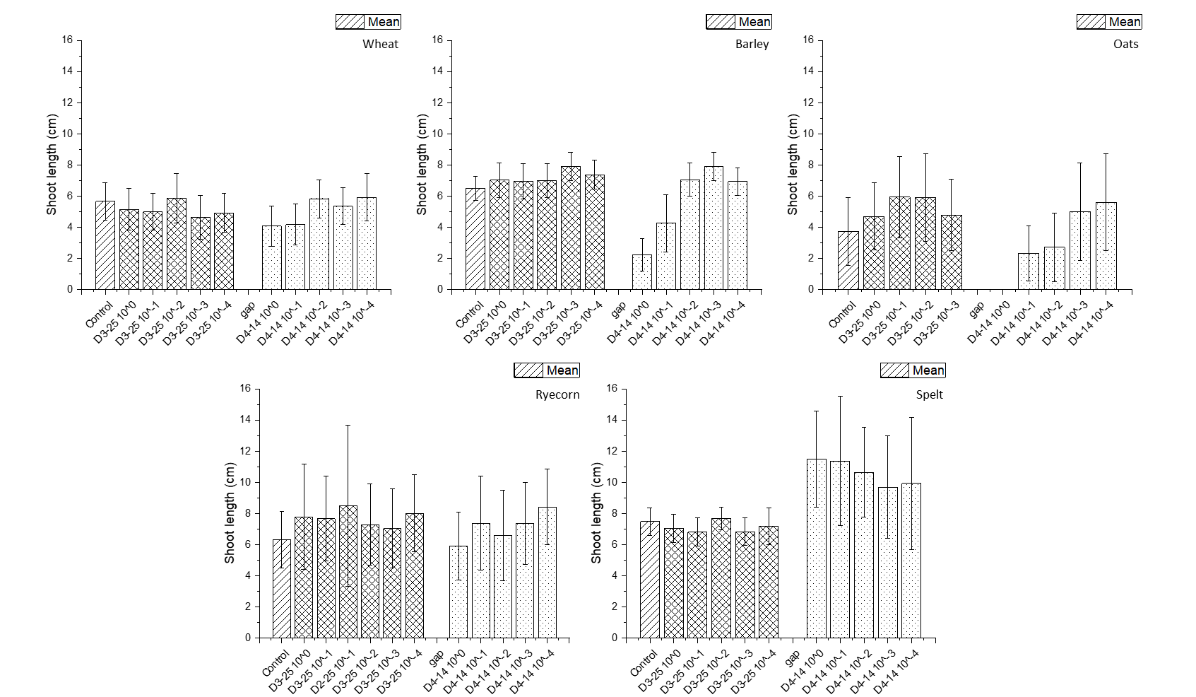
Root length (cm) of wheat, barley, oat, ryecorn and spelt seedlings seedlings inoculated with different concentrations (10⁰, 10⁻¹, 10⁻², 10⁻³ and 10⁻⁴) of CF D3-25 or Ar. sp D4-14. Stars indicate inoculum concentrations that had significantly longer roots.

