Investigation of critical binding pattern in SARS-CoV-2 spike glycoprotein with angiotensin-converting enzyme 2: an in silico analysis

Farzaneh Jafary¹, Sepideh Jafari², Mohamad Reza Ganjalikhany^{2*}

1. Core Research Facilities, Isfahan University of Medical Science, Isfahan, Iran
2 Department of Cell & Molecular Biology, Faculty of Biological Science and Technology, University of Isfahan, Isfahan, Iran
* Corresponding author: Mohamad Reza Ganjalikhany
Email: m.ganjalikhany@sci.ui.ac.ir
Tel: +98-31-37932250, P.O. Box: 81744

Supplementary Figures

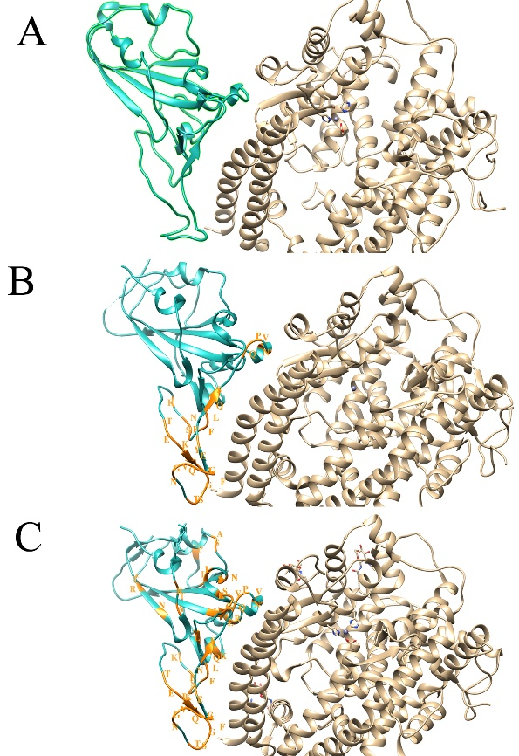
Figure S1: structural representations for three structures of spike-ACE2 complexes: (A) SARS-CoV, (B) chimeric structure and (C) SARS-CoV-2. Mutations are highlighted for chimeric and SARS-CoV-2 structures.

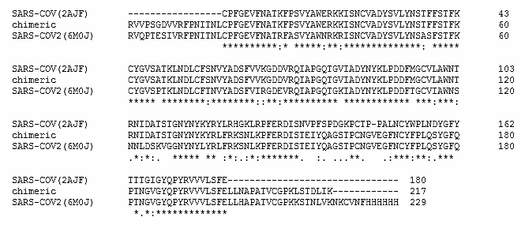

Figure S2: Sequence alignment of spike proteins: SARS-CoV (2ajf), chimeric structure (6vw1) and SARS-CoV-2 (6m0j).

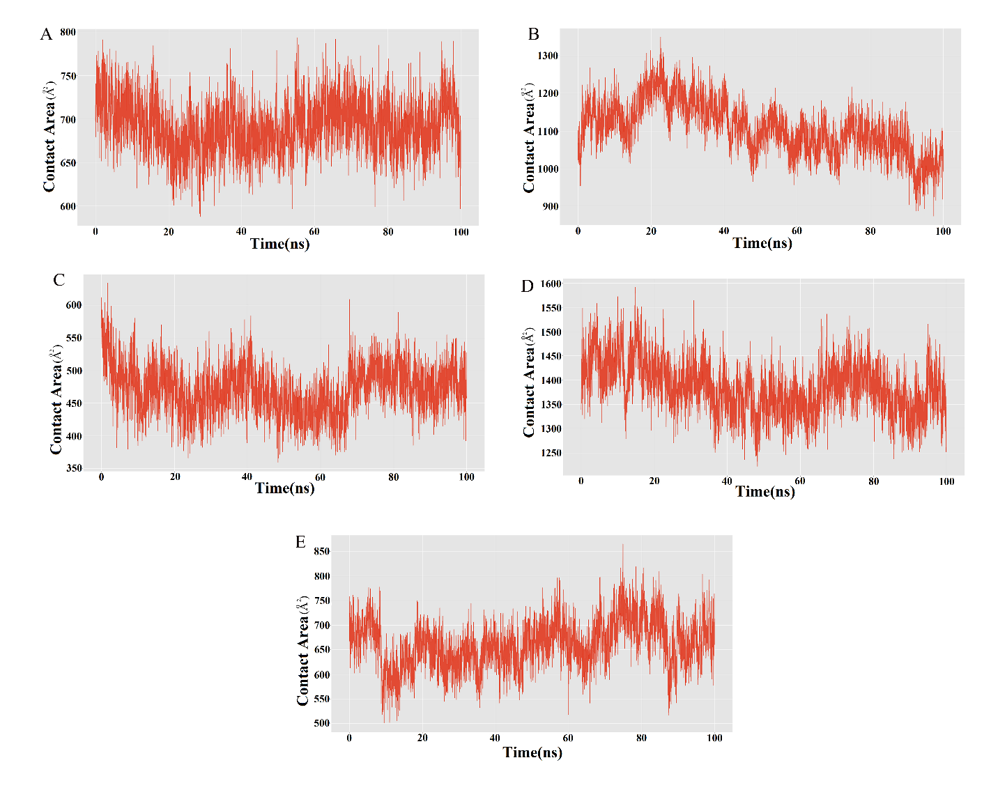
Figure S3. Contact area graphs for SARS-CoV-ACE2 complex (2ajf) during simulation. The contact areas between receptor-binding motif of SARS-CoV spike protein and different regions of ACE2 including residues 19-33 (A), 35-194 (B), 196-227 (C), 266-344 (D) and 541-616 (E).

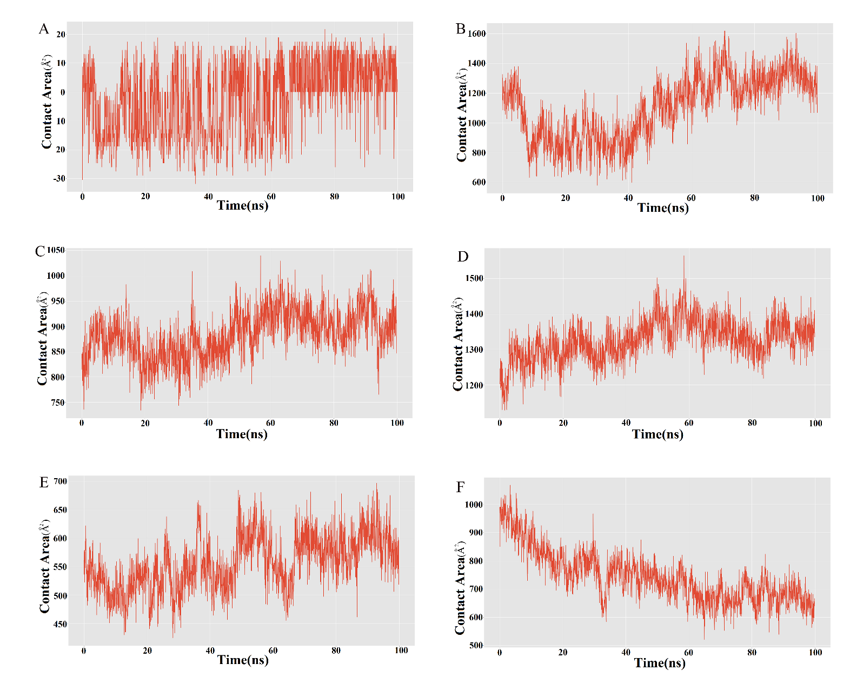

Figure S4. Contact area graphs for SARS-CoV-2-ACE2 complex (6m0j) during simulation. The contact areas between receptor-binding motif of SARS-CoV-2 spike protein and different regions of ACE2 including residues 19-33 (A), 35-194 (B), 242-264 (C), 266-344 (D), 346-372 (E) and 541-616 (F).

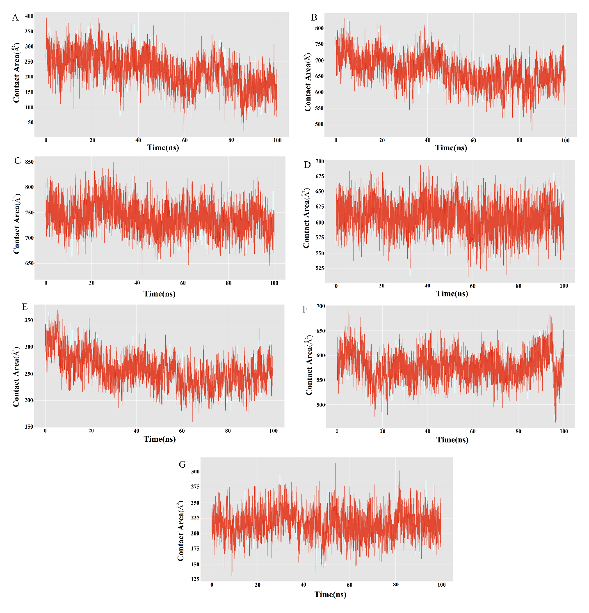

Figure S5. Contact area graphs for chimeric structure-ACE2 complex (6vw1) during simulation. The contact areas between receptor-binding motif of chimeric structure and different regions of ACE2 including residues 1-4 (A), 16-175 (B), 224-246 (C), 248-326 (D), 328-364 (E), 471-468 (F) and 523-596 (G).

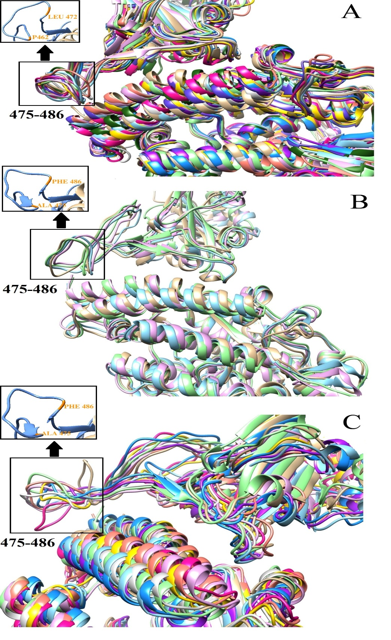
Figure S6. Comparison of proteins structures during simulation (with more focus on the binding area) showed that, the most fluctuated regions are located at residues 475-486 for SARS-COV2 and 462-472 for SARS-CoV.

Supplementary Tables

Table S1. List of amino acid mutations in receptor-binding motif of SARS-CoV-2 compared to SARS-CoV

SARS-COV | SARS-COV2
Tyr442 | Leu455
Leu443 | Phe456
His445 | Lys458
Gly446 | Ser459
Lys447 | Asn460
Arg449 | Lys462
Asn457 | Thr470
Val458 | Glu471
Pro459 | Ile472
Phe460 | Tyr473
Ser461 | Gln474
Pro462 | Ala475
Asp 463 | Gly476
Gly464 | Ser477
Lys465 | Thr478
Thr468 | Asn481
Pro469 | Gly482
Pro470 | Glu484
Ala471 | Gly485
Leu472 | Phe486
Trp476 | Phe490
Asn479 | Gln493
Asp480 | Ser494
Tyr484 | Gln498
Thr485 | Pro499
Thr487 | Asn501
Ile 489 | Val503

Table S2. Free energy decomposition of the SARS-CoV residues in spike-ACE2 complex
Residue | Van der Waals | Electrostatic | Polar Solvation | Non-Polar Solv | TOTAL
Tyr440 | -0.5155 | 0.0577 | -0.0475 | -0.0853 | -0.0861±0.1095
Arg441 | -0.06075 | -94.0605 | 94.1639 | 0.0 | 0.04274±0.0100
Tyr442 | -1.2877 | -4.4947 | 4.5442 | -0.4156 | -1.6539±0.4785
Leu443 | -0.55025 | -0.2584 | 0.4032 | -0.1094 | -0.5149±0.0363
Arg444 | 0.0387 | -87.2232 | 87.2925 | 0.0 | 0.0304±0.0070
His445 | -0.0270 | 0.9190 | -0.8239 | 0.0 | 0.0680±0.0041
Gly446 | -0.0075 | 0.33444 | -0.3127 | 0.0 | 0.01424±0.0020
Lys447 | -0.0155 | -93.0455 | 93.0662 | 0.0 | 0.00524±0.0126
Leu448 | -0.0072 | 0.00024 | 0.00599 | 0.0 | -0.00100±0.00079
Arg449 | -0.0037 | -74.6127 | 74.5985 | 0.0 | -0.0180±0.0006
Pro450 | -0.00200 | -0.439249 | 0.4385 | 0.0 | -0.002749±0.000892
Phe451 | -0.00200 | -0.695499 | 0.694750 | 0.0 | -0.002749±0.00021
Glu452 | -0.002999 | 78.6145 | -78.583 | 0.0 | 0.028500±0.0055396
Arg453 | -0.00400 | -81.79400 | 81.773,2 | 0.0 | -0.025000±0.003409
Asp454 | -0.00625 | 88.57325 | -88.497 | 0.0 | 0.069999±0.0046233
Ile455 | -0.00500 | 0.62100 | -0.610250 | 0.0 | 0.005750±0.0011
Ser456 | -0.00675 | 1.797499 | -1.7675 | 0.0 | 0.02325000±0.001138
Asn457 | -0.0127 | 0.53275 | -0.45125 | 0.0 | 0.0687499±0.01212628
VAL458 | -0.01624 | 0.667250 | 0.2663 | 0.0 | 0.027500±0.00192
Pro459 | -0.0384 | -1.5322 | 1.5877 | 0.0 | 0.017000±0.0054
Phe460 | -0.264750 | 0.847249 | -0.598749 | -0.0133379 | -0.0295880±0.04822
Ser461 | -0.17799 | -2.074 | 2.33775 | 0.0 | 0857499±0.00397
Pro462 | -2.07824 | -3.249250 | 3.6332499 | -0.3785706 | -2.0728206±0.6382928
Asp463 | -0.99375 | 94.6152 | -93.225000 | -0.1227563 | 0.27374359±0.153622
Gly464 | -0.052499 | -1.076499 | 1.1467500 | 0.0 | 0.01774999±0.015282
Lys465 | -0.219500 | -98.7687500 | 99.376 | -0.0205073 | 0.36724259±0.1875600
Pro466 | -0.021750 | 0.116749 | -0.0952500 | 0.0 | -0.0002500±0.0040369
Cyc467 | -0.04899 | -0.554749 | 0.6692499 | 0.0 | 0.065500±0.0008291
Thr468 | -0.042500 | 0.066500 | 0.108499 | 0.0 | 0.132499±0.03570
Pro469 | -0.15774 | -2.17500 | 2.35325 | 0.0 | 0.020499±0.007652
Pro470 | -0.748250 | -0.29700 | 0.7505000 | -0.177561 | -0.47231100±0.45591
Ala471 | -0.50225 | 1.0507499 | -0.559499 | -0.0628848 | -0.07388480±0.181488
Leu472 | -2.24925 | -2.41200 | 3.10499 | -0.5715666 | -2.127816±0.30896
Asn473 | -2.507749 | -2.682500 | 4.24,0 | -0.3706758 | -1.320925±0.383652
CYS 474 | -0.306250 | 1.0912500 | -0.6817500 | -0.000239400 | 0.10301060±0.0312150
TYR 475 | -3.7625 | -1.071500 | 3.24625 | -0.6433883 | -2.2311383±0.339181
TRP 476 | -0.2217500 | -2.9794999 | 1.98324999 | -0.0560771 | -1.274077200±0.807167
PRO 477 | -0.18049 | 1.034999 | -0.9515 | 0.0 | -0.096999±0.0351158
LEU 478 | -0.273749 | -1.33075 | 1.09525 | -0.0177839 | -0.5270339±0.32764
ASN 479 | -1.83100 | -7.953499 | 8.044 | -0.3598308 | -2.10033079±0.7966147
ASP480 | -1.02300 | 128.9555 | -125.962 | -0.190553 | 1.77994659±0.1701833
TYR 481 | -0.714249 | -0.01500 | 0.75899999 | -0.0959778 | -0.0662277±0.0739066
GLY 482 | -0.96150 | -0.4837499 | 0.9595 | -0.1228518 | -0.608601799±0.071494
PHE 483 | ,-0.381500 | -0.55724 | 0.685750 | 0.0 | -0.2530±0.06141
TYR 484 | -3.42924 | -6.82199 | 5.89849 | -0.64378 | -4.996536±0.813662
THR 485 | -0.39400 | 0.3257500 | 0.469249 | -0.00118 | 0.399810±0.02827
THR 486 | -2.4535 | -5.73374 | 5.51825 | -0.788527 | -3.4575277±0.423244
THR 487 | -2.80725 | -3.038999 | 3.073499 | -0.218493 | -2.991242±0.178196
GLY 488 | -1.21624 | -3.105499 | 2.88975 | 0.015074 | -1.671684±0.08438
ILE 489 | -0.9 | -1.33374 | 1.374 | -0.236890 | -1.0966408±0.26180
GLY 490 | -0.1640 | -1.80075 | 1.991750 | 0.0 | 0.02699±0.02699
TYR 491 | -3.67949 | -2.69575 | 4.369499 | -0.57746 | -2.58321±0.1613
GLN 492 | -0.37750 | -3.75749 | 4.43325 | -0.03858 | 0.259665±0.03482
PRO 493 | -0.062499 | 0.830249 | -0.8345 | 0.0 | -0.066750±0.0085

Table S3. Free energy decomposition of the SARS-CoV-2 residues in spike-ACE2 complex
Residue | Van der Waals | Electrostatic | Polar Solvation | Non-Polar Solv | TOTAL
Leu452 | -0.0620 | -0.9402 | 0.984 | 0.0 | 0.0174±0.0037
Tyr453 | -0.9207 | -0.5615 | 1.7677 | -0.1430 | 0.1424±0.0960
Arg454 | -0.0935 | -94.970 | 95.1544 | 0.0 | 0.0900±0.0066
Leu455 | -2.69 | 1.7307 | -1.5465 | -0.2712 | -2.7769±0.17222
Phe456 | -2.147 | -0.29300 | 1.1042 | -0.3387 | -1.6744±0.2814
Arg457 | -0.0742 | -87.5895 | 87.7722 | 0.0 | 0.1084±0.0092
Lys458 | -0.06699 | -83.2865 | 83.4644 | 0.0 | -0.11099±0.03423
Ser459 | -0.0197 | 0.8854 | -0.8342 | 0.0 | 0.0314±0.0028
Asn460 | -0.0179 | -1.4041 | 1.47375 | 0.0 | -0.04425±0.0170
Lus461 | -0.011 | 0.38074 | -0.3777 | 0.0 | -0.0079±0.0023
Lys462 | -0.0044 | -78.2182 | 78.2075 | 0.0 | -0.0152±0.00143
Pro463 | -0.0033 | -0.6742 | 0.6729 | 0.0 | -0.0042±0.0002
Phe464 | -0.003 | -0.9977 | 0.997 | 0.0 | -0.0037±0.00021
Glu465 | -0.00425 | 82.993 | -82.93875 | 0.0 | 0.04999±0.00372
Arg466 | -0.00574 | -83.85675 | 83.8375 | 0.0 | -0.02499±0.001499
Asp467 | -0.00999 | 89.5095 | -89.42725 | 0.0 | 0.07224999±0.006493
Ile468 | -0.008249 | 0.5979999 | -0.57775 | 0.0 | 0.012000±0.001274
Ser469 | -0.009249 | 1.7684999 | -1.73775 | 0.0 | 0.0214999±0.0046165
Thr470 | -0.01900 | 0.261249 | -0.1747499 | 0.0 | 0.0674999±0.007462
Glu471 | -0.02474 | 85.77875 | -85.59025 | 0.0 | 0.163750±0.009429
Ile472 | -0.0814999 | -1.06925000 | 1.1137499 | 0.0 | -0.0369999±0.0070799
Tyr473 | -0.751500 | -0.7197500 | 1.3787500 | -0.103559 | -0.1960594±0.0736
Gln474 | -0.374500 | -2.604999 | 3.4457500 | 0.0 | 0.4662500±0.014006
Ala475 | -2.4 | -5.4 | 0.93 | 0.0 | -6.86±0.346735
Gly476 | -1.33 | -0.819 | 0.210 | 0.0 | -1.941±-0.5075
SER477 | -0.2575 | -1.019 | 0.236 | 0.0 | -1.0412±0.285
THR478 | -0.235 | -0.319 | 0.2847 | 0.0 | -0.27024±0.099
PRO479 | -0.0482 | 2.0280 | -0.471 | 0.0 | 1.5087±0.080
CYS480 | -0.0392 | -0.10 | 0.02849 | 0.0 | -0.1107±0.485405
ASN481 | -0.02050 | -1.5867 | 0.36874 | 0.0 | -1.2385±0.2653
GLY482 insertion | -0.0130 | -0.2397 | 0.06024 | 0.0 | -0.1924±0.0615
VAL483 | -0.0657 | -0.7180 | 0.15175 | 0.0 | -0.6320±0.13198
GLU484 | -0.2472 | 94.5339 | -20.826 | 0.0 | 73.46074±2.36857
GLY485 | -0.8525, | -0.9514 | 0.3054 | 0.0 | -1.49850±0.1309
PHE486 | -4.986 | -2.78225 | 0.95475 | 0.0 | -6.81350±0.3228268
ASN487 | -2.16875 | -4.966999 | 4.66175 | -0.1221767 | -2.596176±0.462978
CYS488 | -0.40399 | 0.468250 | -0.00749 | 0.0 | 0.0567500±0.045828
TYR489 | -4.4825 | -2.253250 | 3.984 | -0.6036408 | -3.355390±0.159110
PHE490 | -0.70149 | 0.88350 | -0.406500 | -0.05899 | -0.2834949±0.28366
PRO491 | -0.1750 | 1.77700 | -1.7545 | 0.0 | -0.152499±0.027978
LEU492 | -0.2450 | -1.16200 | 1.186499 | -0.0053496 | -0.225849±0.304708
GLN493 | -2.54999 | -13.47625 | 12.46575 | -0.5655132 | -4.126013±0.46159
SER494 | -0.35450 | 2.19399 | -1.487500 | -0.0140579 | 0.33794±0.02797
TYR495 | -0.411249 | -0.23124 | 0.905999 | -0.000637 | 0.262862±0.010493
GLY496 | -1.247 | -4.69324 | 2.67925 | -0.213111 | -3.47411±0.334680
PHE497 | -0.41799 | 0.014250 | 0.34525 | 0.0 | -0.05849±0.07135
GLN498 | -1.38974 | -8.909749 | 6.52150 | -0.4337334 | -4.211733±0.50664
PRO499 | -0.43949 | 1.74700 | -1.365 | -0.035546 | -0.093046±0.0411
THR500 | -3.15799 | -1.998249 | 3.2177499 | -0.711802 | -2.650302±0.68225
ASN501 | -3.316,0 | -3.60650 | 4.4354999 | -0.189327 | -2.6763275±0.52674
GLY502 | -1.3195 | -3.22649 | 2.99075 | -0.30320 | -1.8584581±0.05986
VAL503 | -0.74 | -1.45700 | 1.67075 | -0.1462068 | -0.6724567±0.19391
GLY504 | -0.23475 | -1.84649 | 2.08875 | -0.002628 | 0.0048720±0.02468
TYR505 | -4.3575 | -2.80150 | 4.218 | -0.744759 | -3.6857590±0.3645386
GLN506 | -0.525249 | -3.357499 | 3.85425 | -0.09606 | -0.1245623±0.3135
PRO507 | -0.07099 | 0.815250 | -0.857500 | 0.0 | -0.11324±0.00537
TYR508 | -0.055750 | -0.243749 | 0.30950 | 0.0 | 0.0100±0.00791

