Supplementary Information

Bioavailability of inhaled or ingested PFOA adsorbed to house dust

Åsa Gustafsson*^{1,},Bei Wang¹, Per Gerde^{2,3}, Åke Bergman^{1,4}, Leo W.Y. Yeung¹

¹ MTM Research Centre, School of Science and Technology, Örebro University, SE-701 82 Örebro, Sweden
² Institute of Environmental Medicine, Karolinska Institutet, Stockholm, SE-171 77 Sweden
³ Inhalation Sciences AB, Hälsovägen 7-9, SE-141 57 Huddinge, Sweden
⁴ Department of Environmental Science, Stockholm University, SE-10691 Stockholm, Sweden

* Corresponding author: Åsa Gustafsson: Email: asamgus@gmail.com.se: Mobile phone: +46 72 570 9265
Table of Contents
Table S1 Summary of method performance parameters for biological matrices for PFOA analysis
Figure S1: Measured concentrations (SORT) of PFOA in vapor in the vapor pressure generation experiment with five time points (1, 3, 12, 24 and 48 hrs).

Table S1 Summary of method performance parameters for biological matrices for PFOA analysis
Matrix | LOQ | Average Accuracy (%) | Average R.S.D. (%) | Extraction Recovery  (%)
Plasma | 5.0 | 97.0 | 4.30 | 90±8%
Lung Lavage | 1.0 | 95.0 | 5.48 | 91±9%
Liver | 1.0 | 92.1 | 11.0 | 83±6%
Lung | 1.0 | 111 | 21.3 | 85±8%
Kidney | 1.0 | 101 | 19.6 | 80±8%

Vapor Pressure Measurement

Material and methods
The vapor pressure measurement of PFOA was made according to a dynamic measurement procedure developed by Scott (1986) wherein the equilibrium temperature is controlled by the water bath kept at 25±0.1°C representative of indoor environments. Approximately 30 g of pure substance was placed in around-bottom flask boiler. The OSHA versatile sample (OVS, O.D, × L 13-8 mm × 75 mm) consisting of a 0.3 µm glass or quartz fiber filter followed by a polystyrene resin sorbent XAD-2 (SKC) was the collection medium to collect headspace air samples from the outlet of the vapour pressure test apparatus using activated personal pump (AirChek XR 5000, SKC, US). Samples were collected at a flowrate of 0.5 L/min using the sampling pumps for a duration of 10mins typically for 5-L air samples to ensure no significant breakthrough occurred.

The PFOA concentrations (C_{pfoa}) measured at the outlet of the vapor pressure generation chamber is shown in Figure S1. The measurements of PFOA vapor concentration were made at 1, 3, 12, 24 and 48 hrs) at room temperature (298 K (25 °C)). Rough pre-calculations show that complete evaporation of the coating (a few grams) at the designated emission rates should be enough for the duration of the test (48 hr) due to the vapor pressure of targeted PFOA. The saturated vapor concentration was established at 24 hr already, with the concentration level of 13.7× 10⁻⁶ (μg/L) and this is the point we used as reference time point to start the adsorption of PFOA to dust in next step.
References
Scott, L. Determination of activity coefficients by accurate measurement of boiling point diagram. Fluid Phase Equilib.1986, 26, 149−163
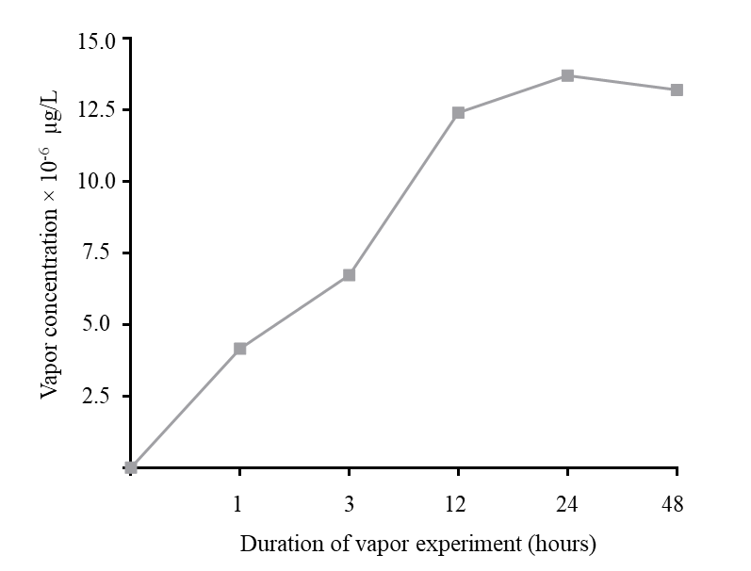

Figure S1: Measured concentrations of PFOA in vapor in the vapor pressure generation experiment with five time points (1, 3, 12, 24 and 48 hours).

