Supplementary Information
Active Optical Signal Conditioning and Monitoring System
Kalipada Chatterjee, Subrat Sahu, Venugopal Arumuru, and Rajan Jha*
Modal Interferometer:
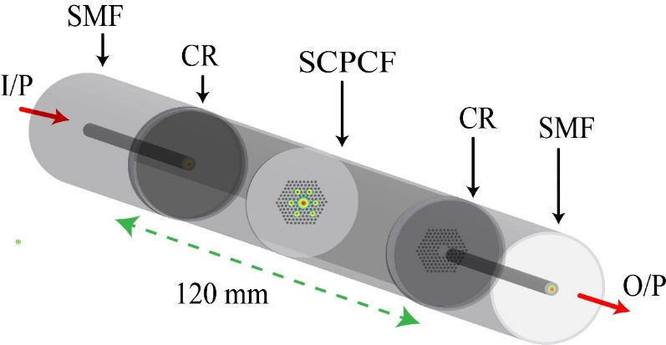
In the proposed system, the SCPCF based modal interferometer is formed by splicing a section of SCPCF along the length of SMF that causes excitation and recombination of PCF modes resulting in a stable interference spectrum. A schematic representation of the modal interferometer is shown in Figure S1.
Figure S1: Schematic representation of the modal interferometer (MI) wherein SMF: Single-mode fiber, CR: Collapse region, SCPCF: Solid core photonic crystal fiber, I/P: Input and O/P: Output.
Experimental Measurements:
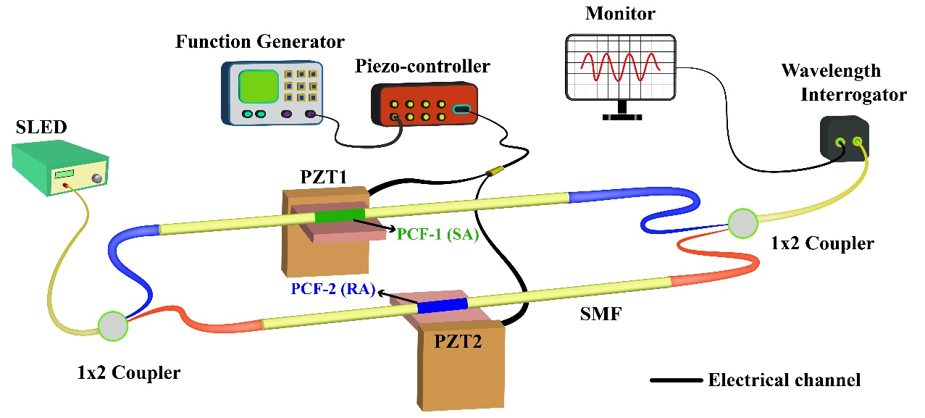
The system is characterized using a fiber interferometry setup. A similar setup is used for studying the application aspects of the systems. A schematic representation of the experimental setup is shown in Figure S2.
Figure S2: Schematic representation of the experimental set-up used for system characterisation.
Multi-point vibration sensing:
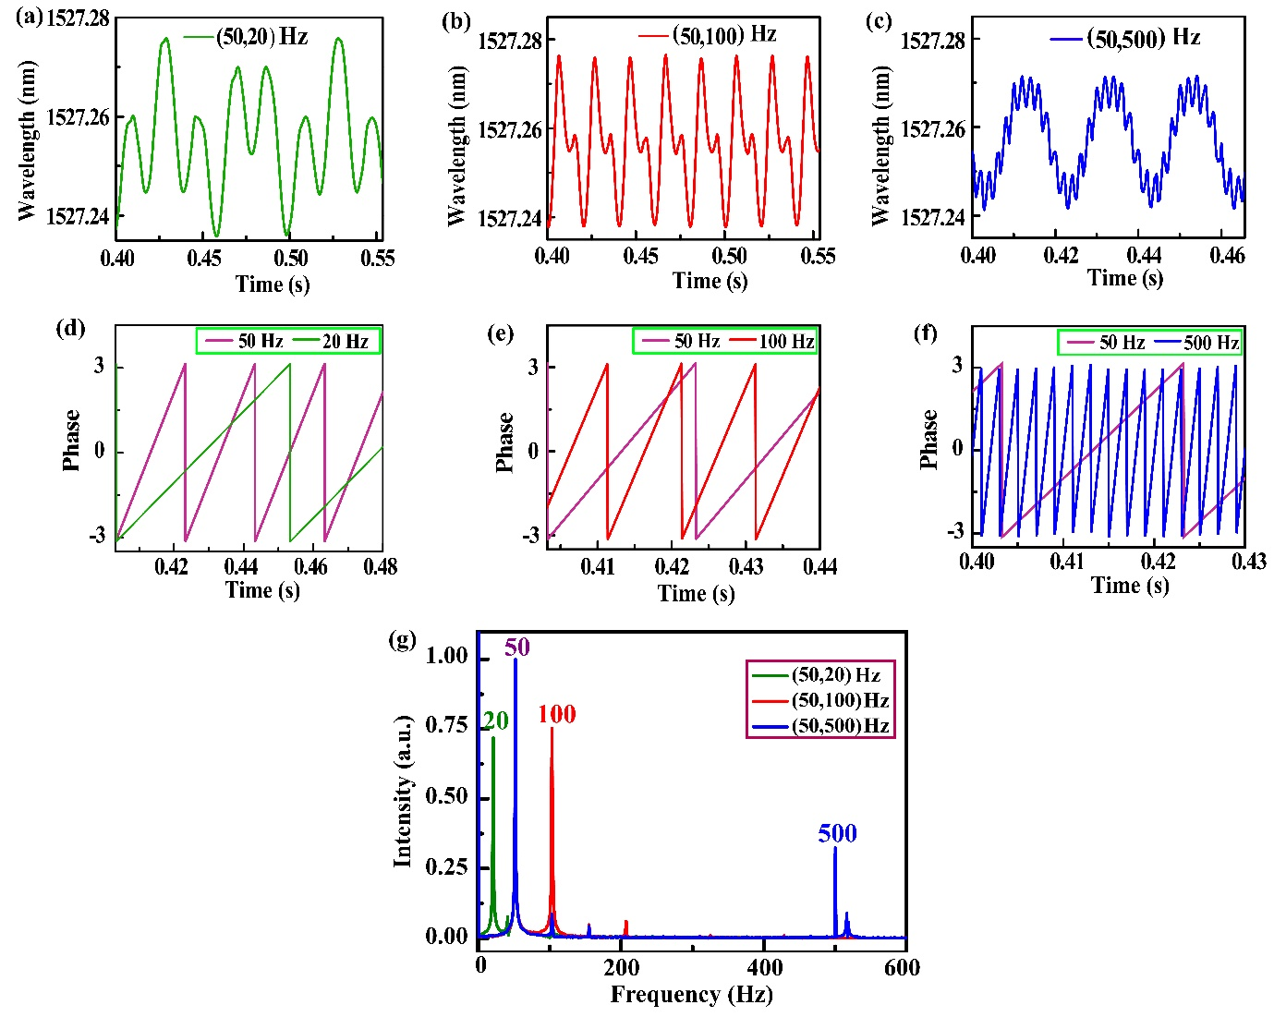
In the presence of dynamic perturbing fields about each interferometer, the resultant composite signal is a superposition of the signals of the individual interferometers with the applied frequency components. Mechanical vibrations of varied frequencies are applied about each interferometer, and the composite signals are represented in Figure S3 (a)-(c). Continuous wavelet transform (CWT) of the recorded signals enables determination of the instantaneous phase of the individual signals, shown in Figure S3 (d)-(f). Fast Fourier transform (FFT) of the signals yields the frequencies present in the signal with their respective amplitudes, shown in Figure 3(g).
Figure S3: Multipoint Dynamic Field Monitoring: (a)-(c) Real time resultant signal of parallel interferometer system for operating one of the interferometers at constant frequency of 50 Hz and varying the frequency of the dynamic field about the other at 20 Hz, 100 Hz and 500 Hz, respectively. (d)-(f) Instantaneous phase of the signal components represented in (a)-(c) obtained by CWT method. (g) FFT of the resultant spectra shown in (a)-(c) showing distinct peaks about the corresponding frequencies.

