Supplementary Figure 1：The secondary structure of the product after 1 time (A) and 5 times (B) of rolling circle transcription.

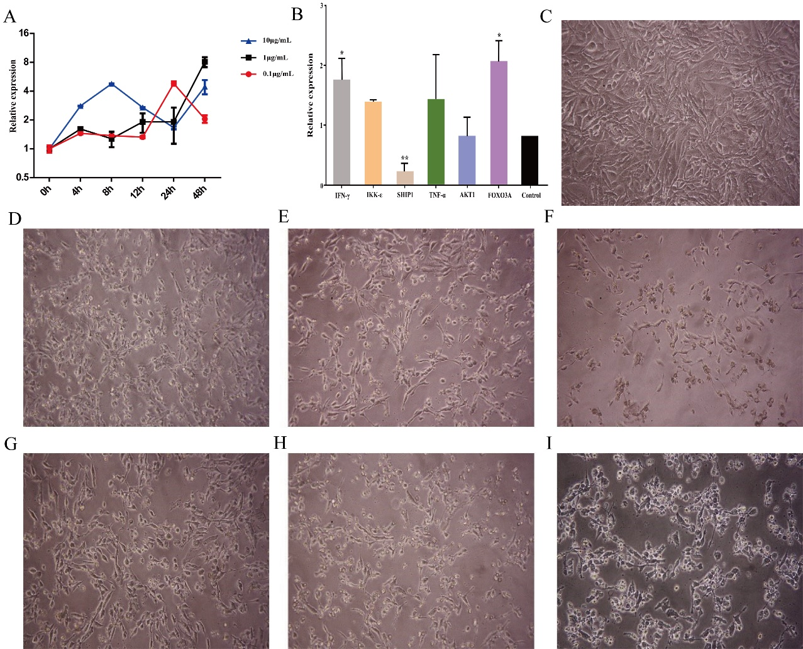
Supplementary Figure 2：(A) The expression of miR-155 after 48h of LPS treatment of cells with different concentrations. (B)Relative expression of inflammation-related factor genes 72h after NFs (M5) treatment of cells (C) The speciation diagram of HUVECs cell line under normal culture. (D-I) The speciation diagram of the HUVEC cell line stimulated by LPS at 0.1, 1, and 10μg/mL for 12 h. (F-H) The speciation diagram of the HUVEC cell line stimulated by LPS at 0.1, 1, and 10μg/mL for 24 h. (*P<0.05vs Control ；**P<0.01 vs Control）

