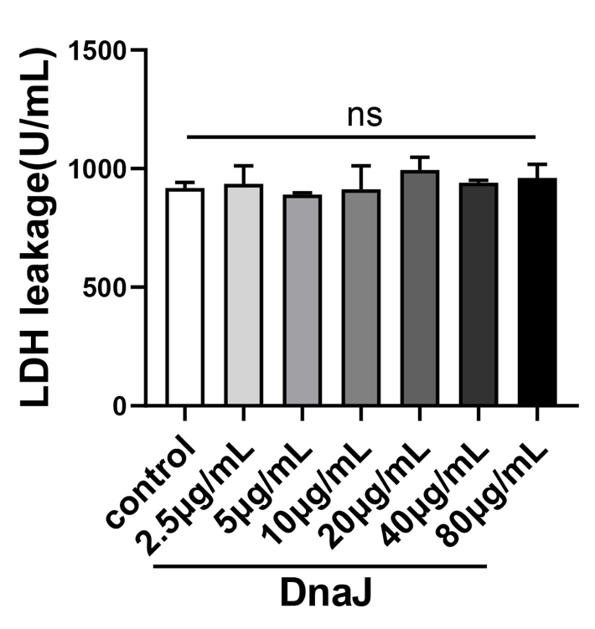
Figure S2. The noncytotoxic dose of DnaJ on BMDCs was detected. BMDCs were treated with DnaJ at a concentration from 2.5 μg/mL to 80 μg/mL with for 48 h, and the LDH activity in the supernatant was measured with a kit, ns = not significant, P > 0.05.

