moxSAASoti: first biphotochromic protein stabilized
for oxidizing environment
Nadya Marynich¹, Mariya Khrenova^{1,2}, Alexandra Gavshina¹, Ilya Solovyev¹, Alexander Savitsky^{1,2}
1 A.N. Bach Institute of Biochemistry, Research Center of Biotechnology of the Russian Academy of Sciences, Moscow, Russia
2 Lomonosov Moscow State University, Department of Chemistry, Moscow, Russia

Supplementary

Table 1. Matrix of similarity of the green-to red photoconvertible proteins.
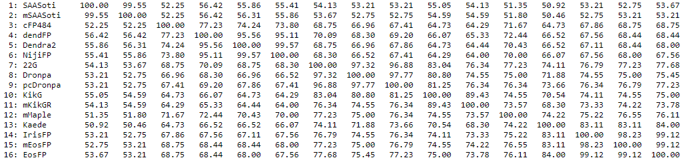

Figure S1. Phototransformations of the SAASoti protein. A and B structures represent photoindused backbone cleavage during photoconversion. C and D structures - cis- and trans- isomers of the chromophore, formed under light illumination in the proses of reversible photoswitching

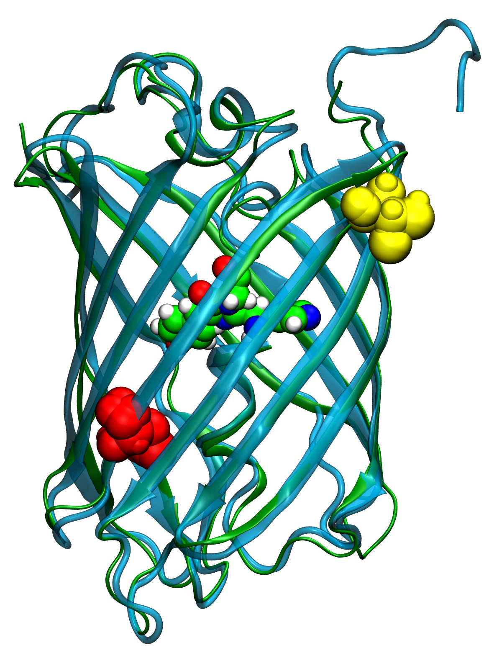
Figure S2 3D alignment of mSAASoti (cyan) and Dendra2 (green). Internal C105 residue colored in red, external C117 in yellow (numbering of residues correspond to SAASoti). The chromophore is colored by elements (carbon – green, nitrogen – blue, oxygen – red, hydrogen – white)
Table S2. Elution volume and calculated molecular weight of size-exclusion chromatography on Superdex200 column. Elution buffer 20 mM Tris-HC, 150 mM NaCl, pH 7.4
“mox” variant | V, ml | Mw, kDa
C117T | 16.8 | 25.7
C117V | 16.8 | 25.7

Figure S3. Elution profiles of size-exclusion chromatography for two “mox” variants of SAASoti protein. Superdex 200 100/20 GL column, detection by absorption at 509 nm, 20 mM Tris-HCl, 150 mM NaCl buffer (pH 7.4).

