Additional file 1: Flowchart of NICE Guideline behaviours relevant to midwifery practice grouped into thematic behaviour categories and sub-categories for communication-related behaviours and behaviour support/intervention-related behaviours.
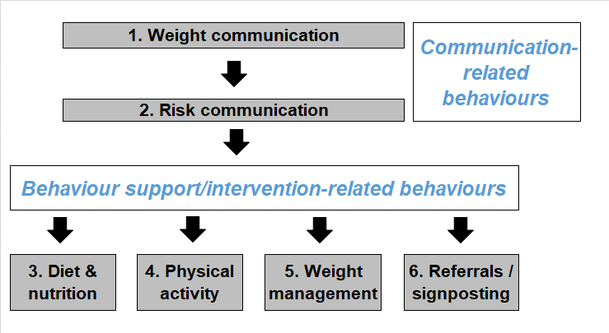
Note, Behaviour categories and sub-categories are:
1. Communication-related behaviours (sub-categories: weight communication and risk communication)
2. Support and intervention-related behaviours (sub-categories diet and nutrition, physical activity, weight management, referrals and signposting)

