De novo transcriptome assembly and development of EST-SSR markers for Pterocarpus santalinus L. f. (Red sanders), a threatened and endemic timber tree of India
Journal: Genetic Resources and Crop Evolution
Sindhu Agasthikumar, Maheswari Patturaj, Aghila Samji, Balasubramanian Aiyer, Aiswarya Munusamy, Nithishkumar Kannan, Vijayakumar Arivazhagan, Rekha R Warrier, Yasodha Ramasamy*
Division of Plant Biotechnology & Cytogenetics, Institute of Forest Genetics and Tree Breeding, Coimbatore 641 002 INDIA
*Corresponding author email: yasodha@icfre.org; Orcid: 0000-0001-9992-9992

Supplementary File 1
Supplementary document 1a: Chromosome count database of the genus Pterocarpus (Rice et al. 2015; http://ccdb.tau.ac.il/search/Pterocarpus/) (* present study)
Species Name | Gametophytic | Sporophytic | Parsed_n
Pterocarpus acerifolius Willd. | 22 | - | 22
Pterocarpus echinatus Pers. | 11 | - | 11
Pterocarpus echinatus Pers. | 22 | - | 22
Pterocarpus indicus Herb. Madr. ex Wallich | 22 | - | 22
Pterocarpus indicus Willd. | 10 | 20 | 10
Pterocarpus indicus Willd. | - | 44 | 22
Pterocarpus macrocarpus Kurz. | - | 34 | 17
Pterocarpus marsupium Roxb. | - | 22 | 11
Pterocarpus marsupium Roxb. | - | 44 | 22
Pterocarpus rohrii Vahl. | 10 | - | 10
Pterocarpus rotundifolius (Sond.) Druce | - | 24 | 12
Pterocarpus santalinoides DC. | - | 22 | 11
Pterocarpus santalinus L. f. (Present Study)* | - | 20 | 10

References
Rice A, Glick L, Abadi S, Einhorn M., Kopelman NM., Salman-Minkov A, Mayzel J, ChayO and MayroseI.(2014). The Chromosome Counts Database (CCDB) – a community resource of plant chromosome numbers. New Phytol.https://doi: 10.1111/nph.1319

Supplementary File 1b: Top 20 species hit from the annotation against SwissProt database for a de novo red sanders transcriptome assembly.
S. No | Organism name | Family name | Number of hits
1 | Medicagotruncatula | Fabaceae | 19590
2 | Actinidiachinensis var. chinensis | Actinidiaceae | 2398
3 | Cinnamomummicranthum f. kanehirae | Lauraceae | 490
4 | Aegilopstauschii subsp. strangulata | Poaceae | 293
5 | Arabisalpina | Brassicaceae | 245
6 | Musa balbisiana | Musaceae | 185
7 | Musa acuminata subsp. malaccensis | Musaceae | 183
8 | Amborellatrichopoda | Amborellaceae | 159
9 | Glycine max | Fabaceae | 96
10 | Arabidopsis thaliana | Brassicaceae | 58
11 | Arachishypogaea | Fabaceae | 43
12 | Pisumsativum | Fabaceae | 22
13 | Cicer arietinum | Fabaceae | 20
14 | Spatholobussuberectus | Fabaceae | 15
15 | Lotus japonicus | Fabaceae | 15
16 | Nicotianatabacum | Solanaceae | 15
17 | Ammopiptanthusmongolicus | Fabaceae | 14
18 | Medicagosativa | Fabaceae | 12
19 | Cajanuscajan | Fabaceae | 12
20 | Vignaradiata var. radiata | Fabaceae | 12

Supplementary File 1c: Functional annotation of assembled sequences based on COG classification of unigenes in red sanders.
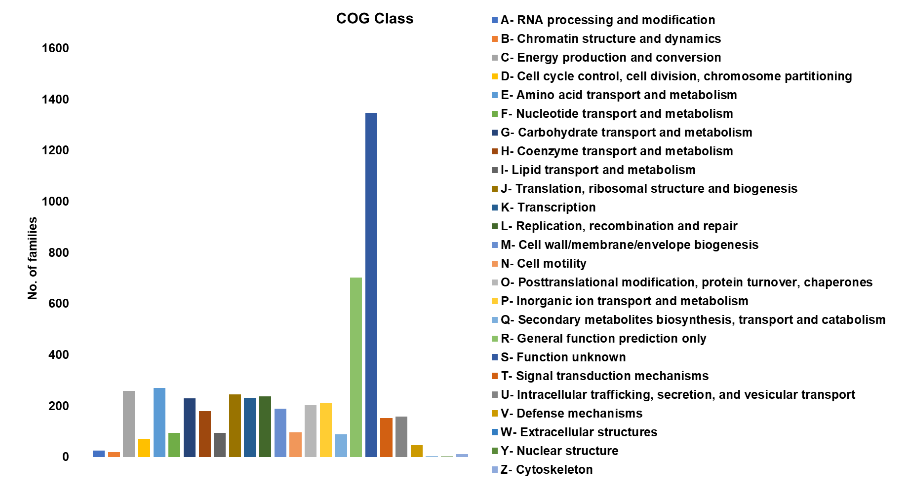

Supplementary File 1d: Functional annotation of assembled sequences based on KOG classification of unigenes in red sanders.
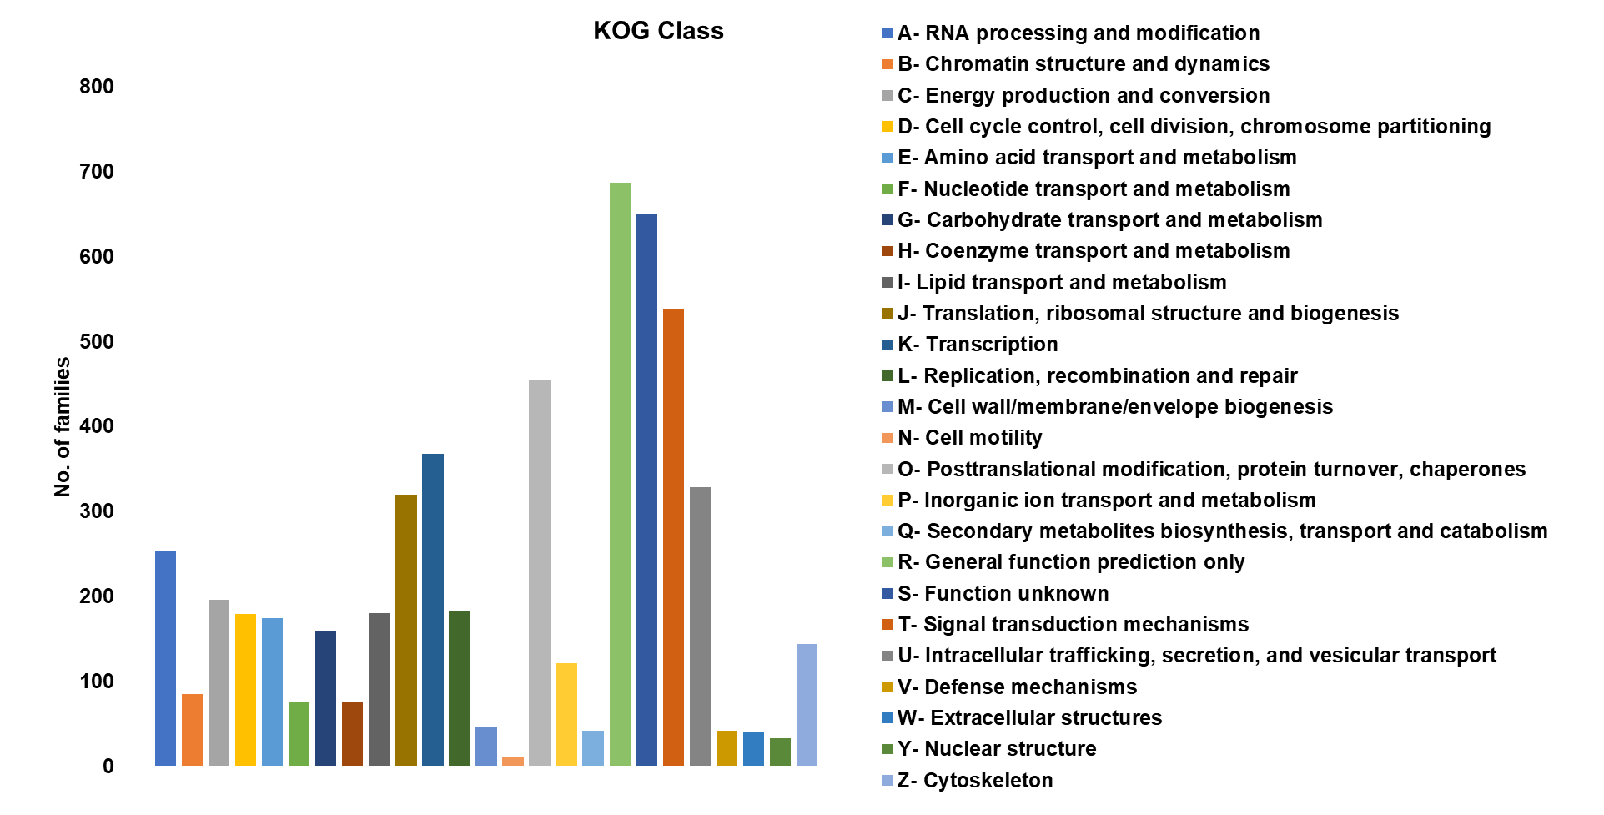

Supplementary File 1e: Information of 105 PsbHLH and TtbHLH genes
S. No | bHLH TF ID | Ath Hit | Entry | Gene | Group | Unigene ID
1 | PsbHLH10117_c0_g1.p1 | AT5G54680 | Q9FH37 | ILR3 | IVc | TRINITY_DN10117_c0_g1
2 | PsbHLH10117_c0_g2.p1 | AT5G54680 | Q9FH38 | ILR3 | IVc | TRINITY_DN10117_c0_g2
3 | PsbHLH10404_c0_g4.p1 | AT3G06590 | Q9C8Z9 | BHLH148 | IIIe | TRINITY_DN10404_c0_g4
4 | PsbHLH11005_c0_g1.p1 | AT4G16430 | O23487 | BHLH3 | IIId | TRINITY_DN11005_c0_g1
5 | PsbHLH11005_c0_g3.p1 | AT4G16430 | O23488 | BHLH3 | IIId | TRINITY_DN11005_c0_g3
6 | PsbHLH11005_c0_g4.p1 | AT4G16430 | O23489 | BHLH3 | IIId | TRINITY_DN11005_c0_g4
7 | PsbHLH11005_c0_g5.p1 | AT4G16430 | O23490 | BHLH3 | IIId | TRINITY_DN11005_c0_g5
8 | PsbHLH12112_c0_g1.p1 | AT1G59640 | Q0JXE7 | BPE | XII | TRINITY_DN12112_c0_g1
9 | PsbHLH12587_c0_g1.p1 | AT1G05805 | Q8H102 | BHLH128 | IX | TRINITY_DN12587_c0_g1
10 | PsbHLH12587_c0_g2.p1 | AT1G05805 | Q8H103 | BHLH128 | IX | TRINITY_DN12587_c0_g2
11 | PsbHLH12593_c0_g1.p1 | AT1G10120 | Q6NKN9 | BHLH74 | XII | TRINITY_DN12593_c0_g1
12 | PsbHLH13211_c0_g1.p1 | AT4G29100 | Q8S3D2 | BHLH68 | X | TRINITY_DN13211_c0_g1
13 | PsbHLH13211_c0_g2.p1 | AT4G29100 | Q8S3D2 | BHLH68 | X | TRINITY_DN13211_c0_g2
14 | PsbHLH14347_c0_g1.p1 | AT3G59060 | Q84LH8 | PIF5 | VIIa | TRINITY_DN14347_c0_g1
15 | PsbHLH1557_c0_g1.p1 | AT1G05710 | Q7XJU2 | BHLH153 | IIIe | TRINITY_DN1557_c0_g1
16 | PsbHLH1557_c0_g2.p1 | AT1G05710 | Q7XJU3 | BHLH153 | IIIe | TRINITY_DN1557_c0_g2
17 | PsbHLH16305_c0_g1.p1 | AT1G32640 | Q39204 | MYC2 | IIIe | TRINITY_DN16305_c0_g1
18 | PsbHLH16321_c0_g1.p1 | AT1G32640 | Q39205 | MYC2 | IIIe | TRINITY_DN16321_c0_g1
19 | PsbHLH1792_c0_g1.p1 | AT2G42280 | Q66GR3 | BHLH130 | IX | TRINITY_DN1792_c0_g1
20 | PsbHLH1792_c0_g2.p1 | AT2G42280 | Q66GR4 | BHLH130 | IX | TRINITY_DN1792_c0_g2
21 | PsbHLH2177_c0_g3.p1 | AT3G07340 | Q9SRT2 | BHLH62 | XII | TRINITY_DN2177_c0_g3
22 | PsbHLH237_c2_g1.p1 | AT4G34530 | Q8GY61 | BHLH63 | XII | TRINITY_DN237_c2_g1
23 | PsbHLH237_c2_g2.p1 | AT4G34530 | Q8GY62 | BHLH63 | XII | TRINITY_DN237_c2_g2
24 | PsbHLH2825_c0_g1.p1 | AT4G00050 | Q8GZ38 | UNE10 | VIIb | TRINITY_DN2825_c0_g1
25 | PsbHLH2825_c0_g2.p1 | AT4G00050 | Q8GZ39 | UNE10 | VIIb | TRINITY_DN2825_c0_g2
26 | PsbHLH2933_c1_g1.p1 | AT3G61950 | Q700E4 | BHLH67 | Ia | TRINITY_DN2933_c1_g1
27 | PsbHLH3104_c0_g2.p1 | AT3G59060 | Q84LH8 | PIF5 | VIIa | TRINITY_DN3104_c0_g2
28 | PsbHLH3214_c0_g3.p1 | AT1G32640 | Q39204 | MYC2 | IIIe | TRINITY_DN3214_c0_g3
29 | PsbHLH3214_c0_g4.p1 | AT1G32640 | Q39204 | MYC2 | IIIe | TRINITY_DN3214_c0_g4
30 | PsbHLH3628_c0_g1.p1 | AT2G40200 | Q9XEF0 | BHLH51 | IVc | TRINITY_DN3628_c0_g1
31 | PsbHLH3628_c0_g2.p1 | AT2G40200 | Q9XEF1 | BHLH51 | IVc | TRINITY_DN3628_c0_g2
32 | PsbHLH4222_c0_g2.p1 | AT5G57150 | Q2HIV9 | BHLH35 | IIIc | TRINITY_DN4222_c0_g2
33 | PsbHLH4386_c0_g2.p1 | AT5G08130 | Q9LEZ3 | BIM1 | Va | TRINITY_DN4386_c0_g2
34 | PsbHLH4386_c0_g4.p1 | AT5G08130 | Q9LEZ4 | BIM1 | Va | TRINITY_DN4386_c0_g4
35 | PsbHLH4826_c0_g1.p1 | AT1G12860 | Q9LPW3 | SCRM2 | IIIb | TRINITY_DN4826_c0_g1
36 | PsbHLH483_c0_g1.p1 | AT5G54680 | Q9FH37 | ILR3 | IVc | TRINITY_DN483_c0_g1
37 | PsbHLH483_c0_g2.p1 | AT5G54680 | Q9FH38 | ILR3 | IVc | TRINITY_DN483_c0_g2
38 | PsbHLH483_c0_g3.p1 | AT5G54680 | Q9FH39 | ILR3 | IVc | TRINITY_DN483_c0_g3
39 | PsbHLH483_c0_g4.p1 | AT5G54680 | Q9FH40 | ILR3 | IVc | TRINITY_DN483_c0_g4
40 | PsbHLH5259_c0_g2.p1 | AT1G10120 | Q6NKN9 | BHLH74 | XII | TRINITY_DN5259_c0_g2
41 | PsbHLH5348_c0_g3.p1 | AT2G42280 | Q66GR3 | BHLH130 | IX | TRINITY_DN5348_c0_g3
42 | PsbHLH6367_c0_g2.p1 | AT1G59640 | Q0JXE7 | BPE | XII | TRINITY_DN6367_c0_g2
43 | PsbHLH6676_c0_g8.p1 | AT3G26744 | Q9LSE2 | SCRM | IIIb | TRINITY_DN6676_c0_g8
44 | PsbHLH7516_c0_g4.p1 | AT1G72210 | Q9C7T4 | BHLH96 | Ia | TRINITY_DN7516_c0_g4
45 | PsbHLH7963_c0_g1.p1 | AT4G14410 | Q8L467 | BHLH104 | IV c | TRINITY_DN7963_c0_g1
46 | PsbHLH7963_c0_g3.p1 | AT4G14410 | Q8L468 | BHLH104 | IV c | TRINITY_DN7963_c0_g3
47 | PsbHLH8234_c0_g1.p1 | AT1G68810 | Q9S7Y1 | BHLH30 | IVc | TRINITY_DN8234_c0_g1
48 | PsbHLH8745_c0_g1.p1 | AT3G57800 | Q3EAI1 | BHLH60 | XII | TRINITY_DN8745_c0_g1
49 | PsbHLH8745_c0_g2.p1 | AT3G57800 | Q3EAI2 | BHLH60 | XII | TRINITY_DN8745_c0_g2
50 | PsbHLH8745_c0_g5.p1 | AT3G57800 | Q3EAI3 | BHLH60 | XII | TRINITY_DN8745_c0_g5
51 | PsbHLH9937_c0_g1.p1 | AT4G02590 | O22768 | UNE12 | XII | TRINITY_DN9937_c0_g1
52 | PsbHLH9937_c0_g2.p1 | AT4G02590 | O22769 | UNE12 | XII | TRINITY_DN9937_c0_g2
53 | TtbHLH11340_c0_seq1.p1 | AT4G00480 | Q8W2F1 | BHLH12 | IIIf | comp11340_c0_seq1
54 | TtbHLH12054_c0_seq1.p1 | AT4G02590 | O22768 | UNE12 | IIIe | comp12054_c0_seq1
55 | TtbHLH12997_c0_seq1.p1 | AT4G25400 | Q9STJ7 | BHLH118 | Ib | comp12997_c0_seq1
56 | TtbHLH12997_c0_seq2.p1 | AT4G25410 | Q9STJ6 | BHLH126 | Ib | comp12997_c0_seq2
57 | TtbHLH13124_c1_seq1.p1 | AT5G67060 | Q9FHA7 | HEC1 | VIIIb | comp13124_c1_seq1
58 | TtbHLH13124_c1_seq2.p1 | AT5G67060 | Q9FHA8 | HEC1 | VIIIb | comp13124_c1_seq2
59 | TtbHLH13245_c1_seq1.p1 | AT2G20180 | Q8GZM7 | PIF1 | VIIa | comp13245_c1_seq1
60 | TtbHLH13245_c1_seq2.p1 | AT2G20180 | Q8GZM8 | PIF1 | VIIa | comp13245_c1_seq2
61 | TtbHLH13304_c0_seq1.p1 | AT4G36930 | Q9FUA4 | SPT | VIIb | comp13304_c0_seq1
62 | TtbHLH13377_c0_seq1.p1 | AT3G21330 | Q8S3D2 | BHLH87 | VIIIb | comp13377_c0_seq1
63 | TtbHLH13547_c0_seq1.p1 | AT4G14410 | Q8L467 | BHLH104 | IV c | comp13547_c0_seq1
64 | TtbHLH13547_c0_seq2.p1 | AT3G23210 | Q9LTC7 | BHLH34 | Ivc | comp13547_c0_seq2
65 | TtbHLH16459_c0_seq1.p1 | AT4G34530 | Q8GY61 | BHLH63 | XII | comp16459_c0_seq1
66 | TtbHLH16952_c0_seq1.p1 | AT1G59640 | Q0JXE7 | BPE | XII | comp16952_c0_seq1
67 | TtbHLH17906_c1_seq1.p1 | AT1G68920 | Q9CAA9 | BHLH49 | XII | comp17906_c1_seq1
68 | TtbHLH18066_c0_seq1.p1 | AT2G22770 | Q8S3F1 | NAI1 | IVa | comp18066_c0_seq1
69 | TtbHLH18286_c2_seq1.p1 | AT2G24260 | Q9ZUG9 | LRL1 | XI | comp18286_c2_seq1
70 | TtbHLH18743_c3_seq1.p1 | AT3G50330 | Q9SND4 | HEC2 | VIIIb | comp18743_c3_seq1
71 | TtbHLH19020_c0_seq1.p1 | AT2G42300 | Q8VZ02 | BHLH48 | XII | comp19020_c0_seq1
72 | TtbHLH19488_c0_seq1.p1 | AT5G57150 | Q2HIV9 | BHLH35 | IIIc | comp19488_c0_seq1
73 | TtbHLH19488_c0_seq2.p1 | AT4G29930 | Q700E3 | BHLH27 | IIIa | comp19488_c0_seq2
74 | TtbHLH19881_c1_seq1.p1 | AT4G29100 | Q8S3D1 | BHLH68 | X | comp19881_c1_seq1
75 | TtbHLH19882_c1_seq1.p1 | AT1G51140 | Q9C690 | BHLH122 | IX | comp19882_c1_seq1
76 | TtbHLH19882_c1_seq2.p1 | AT2G42280 | Q66GR3 | BHLH130 | IX | comp19882_c1_seq2
77 | TtbHLH19932_c1_seq1.p1 | AT5G62610 | Q9LV17 | BHLH79 | XII | comp19932_c1_seq1
78 | TtbHLH19932_c1_seq2.p1 | AT1G59640 | Q0JXE7 | BPE | XII | comp19932_c1_seq2
79 | TtbHLH19932_c1_seq3.p1 | AT5G62610 | Q9LV17 | BHLH79 | XII | comp19932_c1_seq3
80 | TtbHLH19932_c1_seq4.p1 | AT1G59640 | Q0JXE7 | BPE | XII | comp19932_c1_seq4
81 | TtbHLH19934_c0_seq1.p1 | AT4G36930 | Q9FUA4 | SPT | VIIb | comp19934_c0_seq1
82 | TtbHLH20036_c1_seq1.p1 | AT1G09530 | O80536 | PIF3 | VIIa | comp20036_c1_seq1
83 | TtbHLH20298_c2_seq1.p1 | AT4G16430 | O23488 | BHLH3 | IIId | comp20298_c2_seq1
84 | TtbHLH20515_c1_seq1.p1 | AT4G02590 | O22768 | UNE12 | XII | comp20515_c1_seq1
85 | TtbHLH20515_c1_seq2.p1 | AT4G02590 | O22769 | UNE12 | XII | comp20515_c1_seq2
86 | TtbHLH20740_c0_seq1.p1 | AT4G29100 | Q8S3D2 | BHLH68 | X | comp20740_c0_seq1
87 | TtbHLH21025_c0_seq1.p1 | AT5G54680 | Q9FH37 | ILR3 | IVc | comp21025_c0_seq1
88 | TtbHLH21025_c0_seq2.p1 | AT5G54680 | Q9FH38 | ILR3 | IVc | comp21025_c0_seq2
89 | TtbHLH22497_c0_seq1.p1 | AT5G54680 | Q9FH39 | ILR3 | IVc | comp22497_c0_seq1
90 | TtbHLH24058_c0_seq1.p1 | AT2G43010 | Q8W2F3 | PIF4 | VIIa | comp24058_c0_seq1
91 | TtbHLH24742_c0_seq1.p1 | AT5G08130 | Q9LEZ3 | BIM1 | Va | comp24742_c0_seq1
92 | TtbHLH26182_c0_seq1.p1 | AT5G08130 | Q9LEZ3 | BIM1 | Va | comp26182_c0_seq1
93 | TtbHLH27561_c0_seq1.p1 | AT4G37850 | Q9T072 | BHLH25 | IVa | comp27561_c0_seq1
94 | TtbHLH29284_c0_seq1.p1 | AT5G46760 | Q9FIP9 | MYC3 | IIIe | comp29284_c0_seq1
95 | TtbHLH7898_c0_seq1.p1 | AT5G48560 | Q9FJL4 | BHLH78 | XII | comp7898_c0_seq1
96 | TtbHLH7955_c0_seq1.p1 | AT2G31280 | Q58G01 | BHLH155 | IIIe | comp7955_c0_seq1
97 | TtbHLH8004_c0_seq1.p1 | AT2G22760 | Q1PF16 | BHLH19 | Iva | comp8004_c0_seq1
98 | TtbHLH8393_c0_seq1.p1 | AT4G20970 | F4JIJ7 | BHLH162 | Ib | comp8393_c0_seq1
99 | TtbHLH8482_c1_seq1.p1 | AT4G17880 | O49687 | MYC4 | IIIe | comp8482_c1_seq1
100 | TtbHLH8636_c1_seq1.p1 | AT1G32640 | Q39204 | MYC2 | IIIe | comp8636_c1_seq1
101 | TtbHLH8854_c0_seq1.p1 | AT1G01260 | Q9LNJ5 | BHLH13 | IIId | comp8854_c0_seq1
102 | TtbHLH8912_c0_seq1.p1 | AT3G26744 | Q9LSE2 | SCRM | IIIb | comp8912_c0_seq1
103 | TtbHLH9284_c0_seq1.p1 | AT4G37850 | Q9T072 | BHLH25 | IVa | comp9284_c0_seq1
104 | TtbHLH9319_c0_seq1.p1 | AT1G05805 | Q8H102 | BHLH128 | IX | comp9319_c0_seq1
105 | TtbHLH9369_c0_seq1.p1 | AT4G37850 | Q9T072 | BHLH25 | IVa | comp9369_c0_seq1

Supplementary File 1f: The number of PsbHLH and TtbHLH in each species analysed
S. No | Group | Subgroup | PsbHLH numbers | TtbHLH numbers | Total Numbers
1 | I | a | 2 | 0 | 2
2 | I | b | 0 | 3 | 3
3 | III | a | 0 | 1 | 1
4 | III | b | 2 | 1 | 3
5 | III | c | 1 | 1 | 2
6 | III | d | 4 | 2 | 6
7 | III | e | 7 | 5 | 12
8 | III | f | 0 | 1 | 1
9 | IV | a | 0 | 5 | 5
10 | IV | c | 11 | 5 | 16
11 | V | a | 2 | 2 | 4
12 | VII | a | 2 | 4 | 6
13 | VII | b | 2 | 2 | 4
14 | VIII | b | 0 | 4 | 4
15 | IX |  | 5 | 3 | 8
16 | X |  | 2 | 2 | 4
17 | XI |  | 0 | 1 | 1
18 | XII |  | 12 | 11 | 23
 |  | Total | 52 | 53 | 105

Supplementary File 1g: Information of 77 PsERF and TtERF genes
S. No | ERF TF ID | Ath Hit | Entry | Gene | Group | Unigene ID
1 | PsERF11572_c0_g1.p1 | AT2G40350 | Q9SIZ0 | DREB2H | IVa | TRINITY_DN11572_c0_g1
2 | PsERF11572_c1_g1.p1 | AT2G40350 | Q9SIZ1 | DREB2H | IVa | TRINITY_DN11572_c1_g1
3 | PsERF12706_c0_g1.p1 | AT4G34410 | Q9SZ06 | ERF109 | Xb | TRINITY_DN12706_c0_g1
4 | PsERF12706_c0_g2.p1 | AT4G34410 | Q9SZ07 | ERF109 | Xb | TRINITY_DN12706_c0_g2
5 | PsERF13199_c0_g1.p1 | AT5G51190 | Q8VY90 | ERF105 | IXb | TRINITY_DN13199_c0_g1
6 | PsERF13199_c0_g2.p1 | AT5G51190 | Q8VY91 | ERF105 | IXb | TRINITY_DN13199_c0_g2
7 | PsERF1360_c0_g1.p1 | AT5G25390 | Q3E958 | SHN3 | Va | TRINITY_DN1360_c0_g1
8 | PsERF14345_c0_g1.p1 | AT1G46768 | Q8LC30 | RAP2-1 | IIa | TRINITY_DN14345_c0_g1
9 | PsERF14356_c0_g2.p1 | AT1G64380 | Q9C7W2 | ERF061 | Ib | TRINITY_DN14356_c0_g2
10 | PsERF15106_c0_g1.p1 | AT5G07580 | Q9LY05 | ERF106 | IXb | TRINITY_DN15106_c0_g1
11 | PsERF15476_c0_g1.p1 | AT1G68550 | Q9CA27 | ERF118 | VI-L | TRINITY_DN15476_c0_g1
12 | PsERF15487_c0_g1.p1 | AT5G25390 | Q3E959 | SHN3 | Va | TRINITY_DN15487_c0_g1
13 | PsERF15538_c0_g1.p1 | AT1G01250 | Q1ECI2 | ERF023 | IIIa | TRINITY_DN15538_c0_g1
14 | PsERF1580_c0_g2.p1 | AT1G78080 | Q8H1E4 | RAP2-4 | Ib | TRINITY_DN1580_c0_g2
15 | PsERF1649_c0_g2.p1 | AT3G16770 | P42736 | RAP2-3 | VII | TRINITY_DN1649_c0_g2
16 | PsERF1729_c0_g1.p1 | AT4G17500 | O80337 | ERF1A | IXa | TRINITY_DN1729_c0_g1
17 | PsERF1831_c0_g1.p1 | AT3G15210 | O80340 | ERF4 | VIIIa | TRINITY_DN1831_c0_g1
18 | PsERF1831_c0_g2.p1 | AT3G15210 | O80341 | ERF4 | VIIIa | TRINITY_DN1831_c0_g2
19 | PsERF1831_c0_g4.p1 | AT3G15210 | O80342 | ERF4 | VIIIa | TRINITY_DN1831_c0_g4
20 | PsERF2319_c0_g1.p1 | AT1G19210 | Q84QC2 | ERF017 | IIb | TRINITY_DN2319_c0_g1
21 | PsERF2319_c0_g2.p1 | AT1G19210 | Q84QC3 | ERF017 | IIb | TRINITY_DN2319_c0_g2
22 | PsERF2319_c0_g3.p1 | AT1G19210 | Q84QC4 | ERF017 | IIb | TRINITY_DN2319_c0_g3
23 | PsERF2319_c0_g3.p3 | AT1G19210 | Q84QC5 | ERF017 | IIb | TRINITY_DN2319_c0_g3
24 | PsERF2541_c0_g1.p1 | AT5G44210 | Q9FE67 | ERF9 | VIIIa | TRINITY_DN2541_c0_g1
25 | PsERF2541_c0_g2.p1 | AT5G44210 | Q9FE68 | ERF9 | VIIIa | TRINITY_DN2541_c0_g2
26 | PsERF2541_c0_g3.p1 | AT5G44210 | Q9FE69 | ERF9 | VIIIa | TRINITY_DN2541_c0_g3
27 | PsERF2541_c0_g4.p1 | AT5G44210 | Q9FE70 | ERF9 | VIIIa | TRINITY_DN2541_c0_g4
28 | PsERF2588_c0_g1.p1 | AT1G50640 | O80339 | ERF3 | VIIIa | TRINITY_DN2588_c0_g1
29 | PsERF2588_c0_g2.p1 | AT1G50640 | O80340 | ERF3 | VIIIa | TRINITY_DN2588_c0_g2
30 | PsERF3449_c3_g1.p1 | AT1G01250 | Q1ECI3 | ERF023 | IIIa | TRINITY_DN3449_c3_g1
31 | PsERF3449_c4_g1.p1 | AT1G01250 | Q1ECI4 | ERF023 | IIIa | TRINITY_DN3449_c4_g1
32 | PsERF3667_c0_g2.p2 | AT1G50640 | O80341 | ERF3 | VIIIa | TRINITY_DN3667_c0_g2
33 | PsERF3814_c0_g1.p1 | AT2G23340 | O22174 | ERF008 |  | TRINITY_DN3814_c0_g1
34 | PsERF3814_c0_g2.p1 | AT3G50260 | Q9SNE1 | ERF011 | IIa | TRINITY_DN3814_c0_g2
35 | PsERF4263_c0_g1.p1 | AT4G13040 | Q56XP9 | At4g13040 |  | TRINITY_DN4263_c0_g1
36 | PsERF5156_c0_g1.p1 | AT5G07580 | Q9LY06 | ERF106 | IXb | TRINITY_DN5156_c0_g1
37 | PsERF525_c0_g1.p1 | AT5G47230 | O80341 | ERF5 | IXb | TRINITY_DN525_c0_g1
38 | PsERF525_c1_g1.p1 | AT5G47230 | O80342 | ERF5 | IXb | TRINITY_DN525_c1_g1
39 | PsERF5602_c0_g1.p1 | AT5G47230 | O80343 | ERF5 | IXb | TRINITY_DN5602_c0_g1
40 | PsERF5602_c0_g2.p1 | AT5G47230 | O80344 | ERF5 | IXb | TRINITY_DN5602_c0_g2
41 | PsERF6068_c0_g3.p1 | AT1G50640 | O80342 | ERF3 | Va | TRINITY_DN6068_c0_g3
42 | PsERF6252_c0_g2.p1 | AT1G68550 | Q9CA28 | ERF118 | VI-L | TRINITY_DN6252_c0_g2
43 | PsERF6404_c0_g1.p1 | AT4G17500 | O80338 | ERF1A | IXa | TRINITY_DN6404_c0_g1
44 | PsERF6937_c0_g2.p1 | AT1G15360 | Q9XI33 | WIN1 | Va | TRINITY_DN6937_c0_g2
45 | PsERF8159_c1_g1.p1 | AT4G17500 | O80339 | ERF1A | IXa | TRINITY_DN8159_c1_g1
46 | PsERF9270_c0_g1.p2 | AT5G11590 | Q9LYD3 | DREB3 | IIIe | TRINITY_DN9270_c0_g1
47 | PsERF9270_c0_g2.p2 | AT5G11590 | Q9LYD4 | DREB3 | IIIe | TRINITY_DN9270_c0_g2
48 | PsERF9606_c0_g2.p1 | AT2G40340 | Q8LFR2 | DREB2C | IVa | TRINITY_DN9606_c0_g2
49 | PsERF990_c0_g1.p1 | AT1G78080 | Q8H1E5 | RAP2-4 | Ib | TRINITY_DN990_c0_g1
50 | PsERF990_c0_g2.p1 | AT1G78080 | Q8H1E6 | RAP2-4 | Ib | TRINITY_DN990_c0_g2
51 | PsERF990_c0_g3.p1 | AT1G78080 | Q8H1E7 | RAP2-4 | Ib | TRINITY_DN990_c0_g3
52 | TtERF10593_c0_seq1.p1 | AT3G16770 | P42737 | RAP2-3 | VII | comp10593_c0_seq1
53 | TtERF12935_c0_seq1.p1 | AT5G61890 | Q9FH54 | ERF114 | Xa | comp12935_c0_seq1
54 | TtERF13336_c1_seq1.p1 | AT1G68550 | Q9CA29 | ERF118 | VI-L | comp13336_c1_seq1
55 | TtERF15970_c2_seq1.p1 | AT1G72570 | Q1PFE1 | AIL1 |  | comp15970_c2_seq1
56 | TtERF18492_c1_seq1.p1 | AT3G16770 | P42738 | RAP2-3 | VII | comp18492_c1_seq1
57 | TtERF18712_c0_seq1.p1 | AT3G14230 | Q9LUM4 | RAP2-2 | VII | comp18712_c0_seq1
58 | TtERF18712_c0_seq2.p1 | AT3G14230 | Q9LUM5 | RAP2-2 | VII | comp18712_c0_seq2
59 | TtERF18712_c0_seq3.p1 | AT3G14230 | Q9LUM6 | RAP2-2 | VII | comp18712_c0_seq3
60 | TtERF19151_c1_seq1.p1 | AT5G47230 | O80345 | ERF5 | IXb | comp19151_c1_seq1
61 | TtERF19151_c1_seq2.p1 | AT4G17490 | Q8VZ91 | ERF6 | IXb | comp19151_c1_seq2
62 | TtERF19900_c1_seq1.p1 | AT3G25730 | Q9LS06 | ARF14 |  | comp19900_c1_seq1
63 | TtERF20119_c0_seq1.p1 | AT1G78080 | Q8H1E8 | RAP2-4 | Ib | comp20119_c0_seq1
64 | TtERF20119_c2_seq1.p1 | AT1G78080 | Q8H1E9 | RAP2-4 | Ib | comp20119_c2_seq1
65 | TtERF20277_c5_seq2.p1 | AT5G44210 | Q9FE71 | ERF9 | VIIIa | comp20277_c5_seq2
66 | TtERF20277_c5_seq3.p1 | AT3G15210 | O80343 | ERF4 | VIIIa | comp20277_c5_seq3
67 | TtERF20277_c5_seq4.p1 | AT3G15210 | O80344 | ERF4 | VIIIa | comp20277_c5_seq4
68 | TtERF20277_c5_seq5.p1 | AT5G44210 | Q9FE72 | ERF9 | VIIIa | comp20277_c5_seq5
69 | TtERF22519_c0_seq1.p1 | AT5G07580 | Q9LY07 | ERF106 | IXb | comp22519_c0_seq1
70 | TtERF23985_c0_seq1.p1 | AT2G40350 | Q9SIZ2 | DREB2H | IVa | comp23985_c0_seq1
71 | TtERF26957_c0_seq1.p1 | AT5G51190 | Q8VY92 | ERF105 | IXb | comp26957_c0_seq1
72 | TtERF42323_c0_seq1.p1 | AT1G68550 | Q9CA30 | ERF118 | VI-L | comp42323_c0_seq1
73 | TtERF641_c0_seq1.p1 | AT4G28140 | Q9M0J3 | ERF054 | Ia | comp641_c0_seq1
74 | TtERF7718_c0_seq1.p1 | AT1G01250 | Q1ECI5 | ERF023 | IIIa | comp7718_c0_seq1
75 | TtERF8828_c0_seq1.p1 | AT1G50640 | O80343 | ERF3 | VIIIa | comp8828_c0_seq1
76 | TtERF8891_c0_seq1.p1 | AT1G78080 | Q8H1E10 | RAP2-4 | Ib | comp8891_c0_seq1
77 | TtERF8891_c1_seq1.p1 | AT5G65130 | Q9FJQ2 | ERF057 | Ib | comp8891_c1_seq1

Supplementary File 1h: The number of PsERFand TtbERF in each species analysed
S. No | Group | Subgroup | PsERF numbers | TtERF numbers | Total numbers
1 | I | a | 0 | 1 | 1
2 | I | b | 5 | 4 | 9
3 | II | a | 2 | 0 | 2
4 | II | b | 4 | 0 | 4
5 | III | a | 3 | 1 | 4
6 | III | e | 2 | 0 | 2
7 | IV | a | 3 | 1 | 4
8 | V | a | 4 | 0 | 4
9 | VI | L | 2 | 2 | 4
10 | VII |  | 1 | 5 | 6
11 | VIII | a | 10 | 5 | 15
12 | IX | a | 3 | 0 | 3
13 | IX | b | 8 | 4 | 12
14 | X | a | 0 | 1 | 1
15 | X | b | 2 | 0 | 2
16 |  | Unclassified | 2 | 2 | 4
 |  | Total | 51 | 26 | 77

Supplementary File 1i: Gel profile of 42 P. santalinus DNA samples amplified with IFGTB442 EST- SSR marker
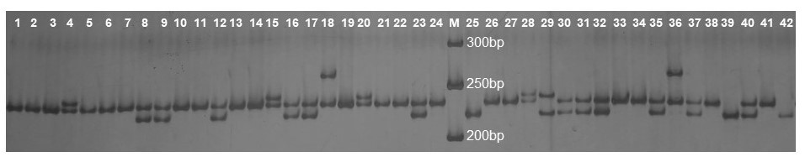
1 – 4: Chitoor East (CE), 5 – 6: Puttur (PU), 7 – 10: Srikalakasti (SKH), 11 – 14: Mamandur North (MN), 15 – 18: Mamandur South (MS), 19 – 29: Chamala (CH), 30 – 38: Tirupathi (TR), 39 – 42: Balapalli (BP), M – 50bp ladder.

