Interannual variability of the occurrence of MJO at different phases and its association with two ENSO modes
Panini Dasgupta^{1,2*}, M K Roxy¹, Rajib Chattopadhyay³, C. V. Naidu², Abirlal Metya^{1,4}
¹ Centre for Climate Change Research, Indian Institute of Tropical Meteorology, Ministry of Earth Sciences, Pune 411008, India
²Department of Meteorology and Oceanography, College of Science & Technology, Andhra University, Visakhapatnam, Andhra Pradesh 530003, India
³Indian Institute of Tropical Meteorology, Ministry of Earth Sciences, Pune 411008, India
⁴Department of Atmospheric and Space Sciences, Savitribai Phule Pune University, Pune, India
*Correspondence to panini.dasgupta@tropmet.res.in

Supplementary Figures
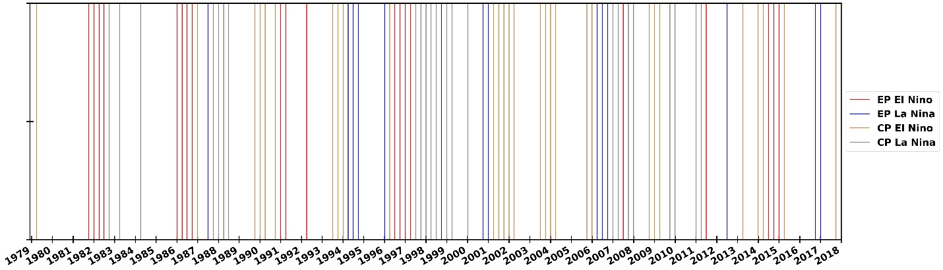
Supplementary Figure 1. CP type and EP type ENSO seasons from 1979-2018. Each bar represents a three-month season (i.e., DJF, MAM, JJA, SON).

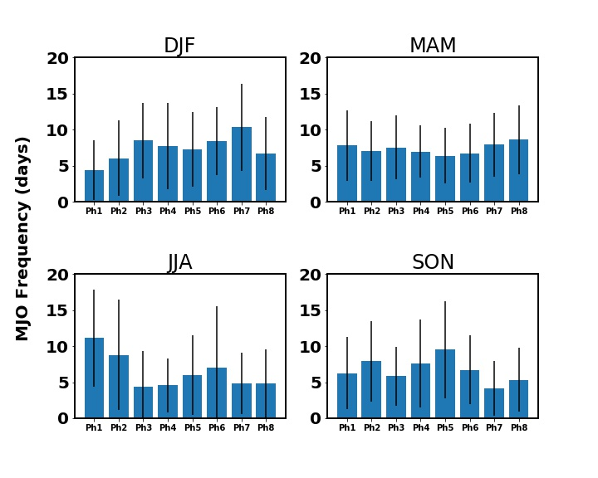
Supplementary Figure 2. Mean and standard deviation of MJO frequency in DJF, MAM, JJA and SON.

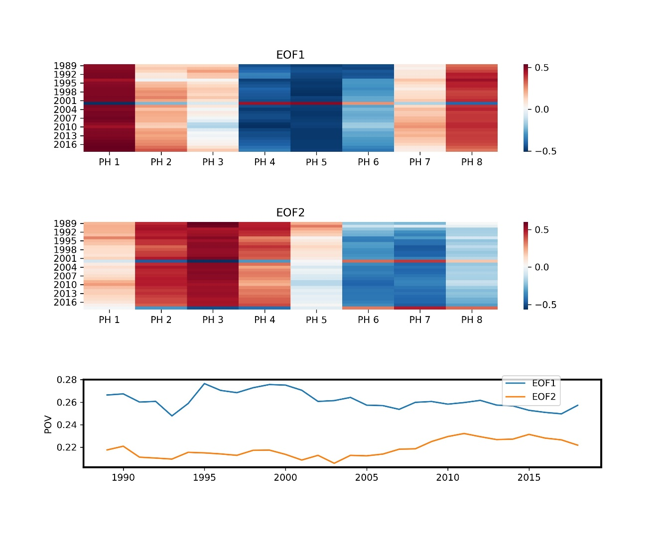
Supplementary Figure 3. (a) Time evolution of EOF1 of MJO frequency from 1979-1989 to 1979-2018. (b) Time evolution of EOF2 of MJO frequency from 1979-1989 to 1979-2018. (c) Time evolution of percentage of variance explained by EOF1 and EOF2 from 1979-1989 to 1979-2018.

Supplementary Table 1:
Positive CP ENSO | Negative CP ENSO | Positive EP ENSO | Negative EP ENSO
1980-MAM,  1987-DJF,  1990-SON,  1990-DJF,  1991-MAM,  1991-SON,  1994-JJA,  1994-SON,  1994-DJF,  1997-MAM,  2002-MAM,  2002-JJA,  2002-SON,  2002-DJF,  2003-MAM,  2004-JJA,  2004-SON,  2004-DJF,  2005-MAM,  2006-SON,  2006-DJF,  2009-SON,  2009-DJF,  2010-MAM,  2014-MAM,  2014-DJF,  2015-MAM,  2016-MAM,  2018-SON | 1983-SON,  1984-MAM,  1985-MAM,  1988-SON,  1988-DJF,  1989-MAM,  1989-JJA,  1998-JJA,  1998-SON,  1998-DJF,  1999-MAM,  1999-JJA,  1999-DJF,  2000-MAM,  2000-DJF,  2007-DJF,  2008-MAM,  2008-SON,  2008-DJF,  2010-SON,  2010-DJF,  2011-DJF,  2012-MAM | 1982-SON,  1982-DJF,  1983-MAM,  1983-JJA,  1986-DJF,  1987-MAM,  1987-JJA,  1987-SON,  1991-DJF,  1992-MAM,  1993-MAM,  1997-JJA,  1997-SON,  1997-DJF,  1998-MAM,  2008-JJA,  2012-JJA,  2015-JJA,  2015-SON,  2015-DJF | 1988-JJA,  1995-MAM,  1995-JJA,  1995-SON,  1996-DJF,  1999-SON,  2001-SON,  2001-DJF,  2007-MAM,  2007-JJA,  2007-SON,  2013-JJA,  2017-SON,  2017-DJF

