Study | TKI | Design | N | Age in TKI  group (range) | MAC | CR at  transplant | NPM1  mutation | High-risk  cytogenetics | Length of  follow-up | MRD before  transplant | MRD after  transplant
Ahmed 2017 | Sorafenib | retrospective | 13  26 | NR | NR | NR | NR | NR | 12 months  30 months | NR | NR
Bazarbachi 2019 | Sorafenib | retrospective | 34  118 | 48  51 | 23  56 | 18  72 | 14  41 | NR | 22.69 months  19.74 months | NR | 23  50
Brunner 2016 | Sorafenib | retrospective | 26  43 | 55  56 | 14  27 | NR | 14  21 | 2  4 | 27.2months | NR | NR
Burchert 2020 | Sorafenib | phase II trial | 43  40 | 54.17  53.39 | 18  19 | 9  12 | 8  7 | 1  3 | 41.8 months | 25  24 | 9  10
Chappell 2019 | Sorafenib | retrospective | 29  55 | 49  54 | NR | NR | NR | NR | 12 months | NR | NR
Li Xuan 2018 | Sorafenib | retrospective | 32  50 | 37  34 | NR | 30  28 | NR | NR | 707 days | NR | NR
Li Xuan 2020 | Sorafenib | phase 3 trial | 100  102 | 35  35 | NR | 73  79 | 29  26 | 7  5 | 21·3 months | 5  13 | 9  11
Maziarz 2020 | Midostaurin | a phase 2 | 30  30 | 48  56 | NR | NR | NR | NR | 24 months | NR | NR
Shi 2020 | Sorafenib | retrospective | 24  32 | 24  40 | NR | NR | NR | NR | 24 months | NR | NR
TABLE 1 | Study characteristics of 9 studies with control.
TKI, tyrosine kinase inhibitor; N, number; CR, complete remission; HSCT, hematopoietic stem-cell transplantation; MAC, myeloablative conditioning; NR, not reported.

Study | TKI | Design | N | Age | MAC | CR at  transplant | NPM1  mutation | High-risk  cytogenetics | Length of  follow-up | MRD before  transplant | MRD after  transplant
Battipaglia 2017 | Sorafenib | prospective | 27 | 54 | 20 | 22 | 7 | NR | 18 months | 12 | NR
Chen 2014 | Sorafenib | prospective | 22 | 54 | 12 | 16 | 12 | NR | 16.7 months | NR | NR
Metzelder 2017 | Sorafenib | retrospective | 29 | 45 | 11 | 14 | 2 | NR | 7.5 years | NR | NR
Pratz 2020 | Sorafenib | prospective | 44 | 52 | 16 | NR | 25 | NR | 27.6 months | 17 | NR
Sandmaie 2017 | quizartinib | prospective | 13 | 43 | NR | 10 | 6 | NR | NR | NR | NR
Tarlock 2015 | Sorafenib | retrospective | 15 | 14 | NR | NR | NR | NR | 3.4 years | NR | NR
TABLE 2 | Study characteristics 6 studies without control.
TKI, tyrosine kinase inhibitor; N, number; CR, complete remission; HSCT, hematopoietic stem-cell transplantation; MAC, myeloablative conditioning; NR, not reported.

Fig.S1.1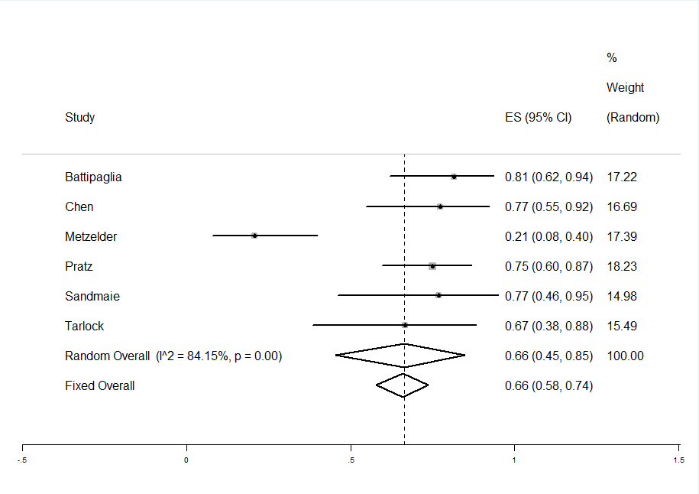
Fig.S1.2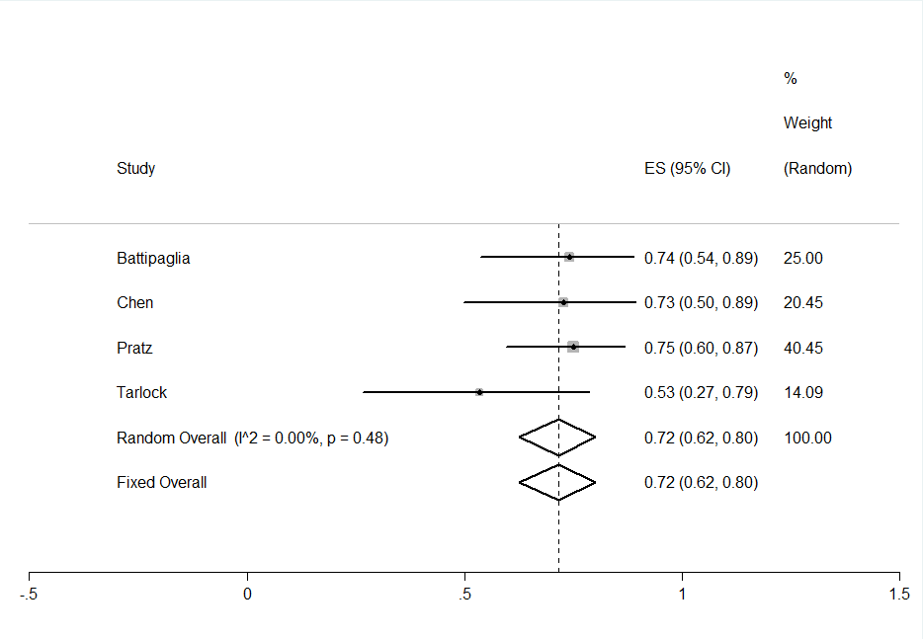
Fig.S1.3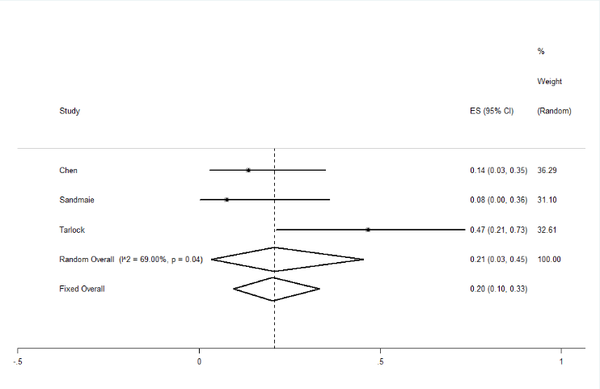
Supplemental Fig. 1 Pooled results of tumor response in the FLT3 Inhibitors group
Fig.S1.1 Pooled results of OS was 66% (95% CI, 45–85%, I2 = 84.15%). Fig.S1.2 The pooled LFS rate was 72% (95% CI, 62–80%, I2 = 0%;). Fig.S1.3 Pooled results of relapse rate was 21% (95% CI, 3–45%, I2 = 69%).

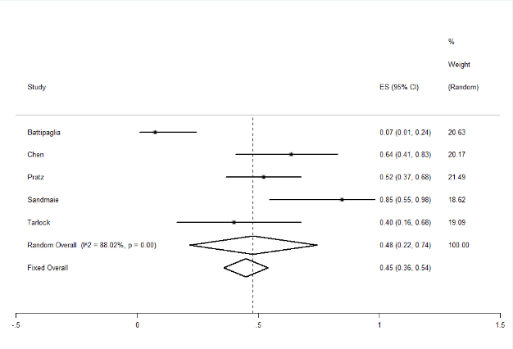 | 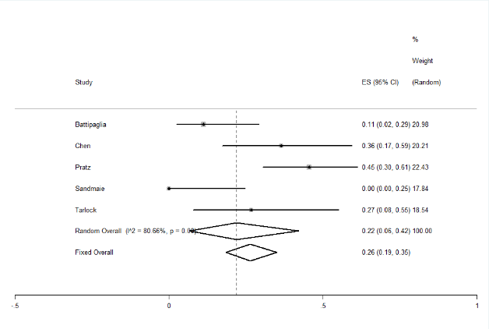
Fig.S2.1 | Fig.S2.4
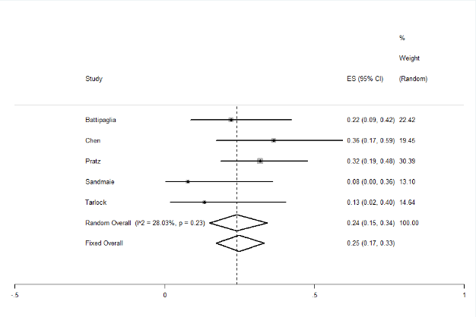 | 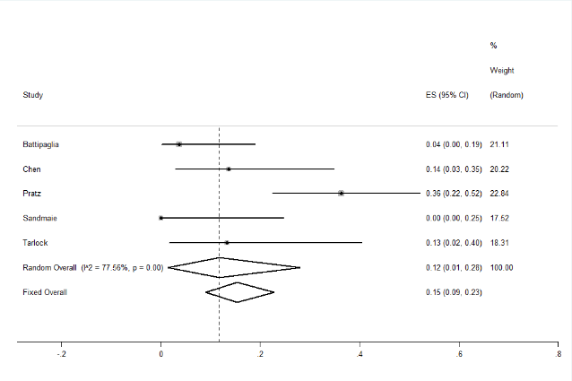
Fig.S2.2 | Fig.S2.5
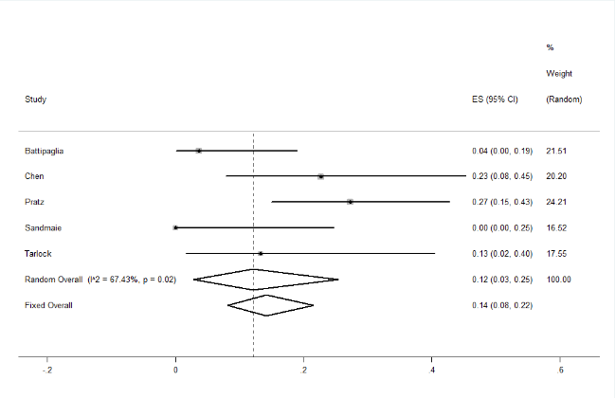 | Supplemental Fig. 2 Pooled results of toxic effects in the FLT3 Inhibitors group  Fig.S2.1 Pooled results of hematological toxic effects rate was 46% (95% CI, 22–74%, I2 = 88.02%). Fig.S2.2 The pooled gastrointestinal effects rate was 24% (95% CI, 15–34%, I2 = 28.03%). Fig.S2.3 Pooled results of cardiovascular effects rate was 12% (95% CI, 3–25%, I2 = 67.34%). Fig.S2.4 Pooled results of
Fig.S2.3 | cutaneous effects rate was 22% (95% CI, 6–42%, I2 = 80.66%). Fig.S2.5 Pooled results of biochemical effects rate was 12% (95% CI, 1–28%, I2 = 77.56%).

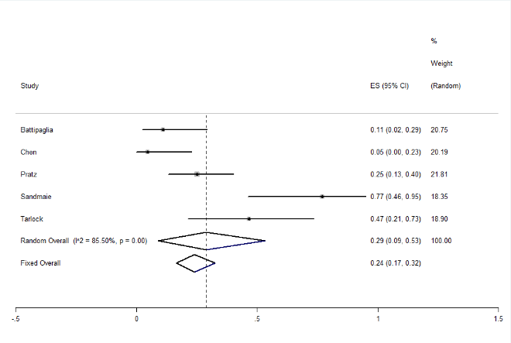
Fig.S3.1

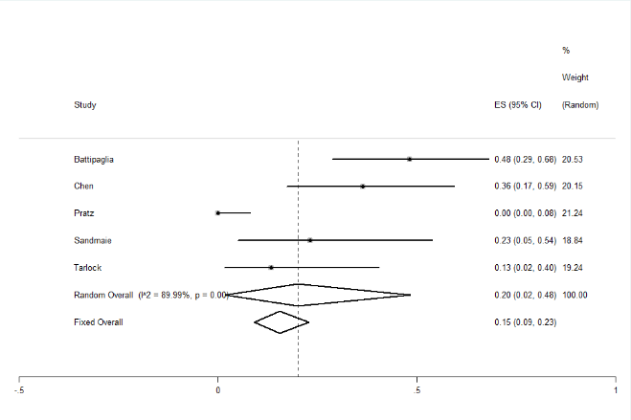
Fig.S3.2

Supplemental Fig. 3 Pooled results of GVHD rate in the FLT3 Inhibitors group
Fig.S3.1 Pooled results of aGVHD rate was 29% (95% CI, 9–53%, I2 = 85.50%). Fig.S3.2 The pooled cGVHD rate was 70% (95% CI, 2–48%, I2 = 89.99%).
Supplemental strategy
((((((((((((((((((((((((("FF-10101" [Supplementary Concept]) OR "TTT-3002" [Supplementary Concept]) OR "G-749 compound" [Supplementary Concept]) OR "cabozantinib" [Supplementary Concept]) OR "tandutinib" [Supplementary Concept]) OR "gilteritinib" [Supplementary Concept]) OR "quizartinib" [Supplementary Concept]) OR "lestaurtinib" [Supplementary Concept]) OR "midostaurin" [Supplementary Concept]) OR "Sunitinib"[Mesh]) OR "Sorafenib"[Mesh]) OR "crenolanib" [Supplementary Concept]) OR ("FF-10101"[Title/Abstract] OR "(E)-N-((2R)-1-(5-(2-(4-cyanoanilino)-4-(propylamino)pyrimidin-5-yl)pent-4-ynylamino)-1-oxopropan-2-yl)-4-(dimethylamino)-N-methylbut-2-enamide"[Title/Abstract])) OR ("TTT-3002"[Title/Abstract])) OR ("2-hydroxy-1-(2-((9-(4-methylcyclohexyl)-9H-pyrido(4',3'-4,5)pyrrolo(2,3-d)pyrimidin-2-yl)amino)-7,8-dihydro-1,6-naphthyridin-6(5H)-yl)ethenone"[Title/Abstract] OR "AMG 925"[Title/Abstract])) OR ("G-749 compound"[Title/Abstract])) OR (("Cabozantinib"[Title/Abstract] OR "Cometriq"[Title/Abstract] OR "XL*"[Title/Abstract] OR "BMS*"[Title/Abstract]))) OR ("Crenolanib"[Title/Abstract] OR "CP-868,596"[Title/Abstract])) OR ("Gilteritinib"[Title/Abstract] OR "ASP* "or"Xospata"[Title/Abstract])) OR ("Quizartinib"[Title/Abstract] OR "AC220 compound"[Title/Abstract])) OR ("Lestaurtinib"[Title/Abstract] OR "CEP*"[Title/Abstract] OR "KT*"[Title/Abstract])) OR ("Midostaurin"[Title/Abstract] OR "benzoylstaurosporine"[Title/Abstract] OR "4'-N-benzoyl*"[Title/Abstract] OR "N-((9S,10R,11R,13R)-10-methoxy-9-methyl-1-oxo-2,3,10,11,12,13-hexahydro-9,13-epoxy-1H,9H-diindolo(1,2,3-GH:3',2',1'-lm)pyrrolo(3,4-j)(1,7)benzodiazonin-11-yl)-n-methylbenzamide"[Title/Abstract] OR "PKC*"[Title/Abstract] OR "Rydapt"[Title/Abstract] OR "CGP*"[Title/Abstract])) OR ("Sunitinib*"[Title/Abstract] OR "5-(5-Fluoro-2-oxo-1,2-dihydroindolylidenemethyl)-2,4-dimethyl-1H-pyrrole-3-carboxylic acid (2-diethylaminoethyl)amide"[Title/Abstract] OR "Sutent"[Title/Abstract] OR "SU*"[Title/Abstract])) OR ("Sorafenib*"[Title/Abstract] OR "Nexavar"[Title/Abstract] OR "BAY*"[Title/Abstract] OR "4-(4-(3-(4-Chloro-3-trifluoromethylphenyl)ureido)phenoxy)pyridine-2-carboxylic acid methyamide-4-methylbenzenesulfonate"[Title/Abstract])) OR ("flt3 inhibitor*"[Title/Abstract] OR "flt3 inhibition"[Title/Abstract])) AND ((((ASCT[Title/Abstract] OR ABMT[Title/Abstract] OR PBPC[Title/Abstract] OR PBSCT[Title/Abstract] OR PSCT[Title/Abstract] OR BMT[Title/Abstract] OR SCT[Title/Abstract]) OR ("Hematopoietic Stem Cell Transplantation"[Mesh])) OR ((((((homotransplant*[Title/Abstract] OR homo‐transplant*[Title/Abstract] OR homotrasplant*[Title/Abstract] OR homo‐trasplant*[Title/Abstract]) OR (homograft*[Title/Abstract] OR homo‐graft*[Title/Abstract])) OR (allogen*[Title/Abstract] OR allo‐gen*[Title/Abstract])) OR (allotransplant*[Title/Abstract] OR allo‐transplant*[Title/Abstract] OR allotrasplant*[Title/Abstract] OR allo‐trasplant*[Title/Abstract])) OR (allograft*[Title/Abstract] OR allo‐graft*[Title/Abstract])) OR ("Transplantation, Homologous"[Mesh]))) AND ((((aml[Title/Abstract]) OR ("Leukemia, Myeloid, Acute"[Mesh])) OR ((acut*[Title/Abstract] OR akut*[Title/Abstract] OR agud*[Title/Abstract] OR aigu*[Title/Abstract]) AND ((myelo*[Title/Abstract] OR nonlympho*[Title/Abstract] OR granulocytic*[Title/Abstract] OR mielo*[Title/Abstract] OR myeloid*[Title/Abstract] OR myelocytic*[Title/Abstract]) AND (Leukem*[Title/Abstract] OR leukaem*[Title/Abstract] OR leuc*[Title/Abstract])))) OR (("Leukemia, Myeloid"[Mesh]) AND "Acute Disease"[Mesh])))

