Supplementary Material for the article: Manuscript Changes in ciliate communities reveal modification of lake functioning over the last century

Methods Sections
At every steps of the analysis of paleoenvironmental DNA, strict laboratory protocols and various methodological precautions were taken to achieve robust results and ensure the validity of our molecular data:
- Sterile disposable materials (labware, gloves, etc.) were used for all lab procedures; during sediment core subsampling, sediment slices were taken using sterilised metal plates.
- Separate stations were organized for subsampling, DNA extractions and PCR amplifications. To prevent contamination with modern DNA, the extraction of DNA from sediment is carried out in specific rooms dedicated to rare DNA, and PCR are prepared under designated working stations. These laboratories are physically separated from other molecular biology laboratories.
- Negative controls are included at 3 steps of the procedure: during subsampling (open tubes containing pure water), extraction (treatment of pure water) and PCR preparation (blank PCR tube). All blanks were found negative for the amplification of 18S rRNA markers; consequently, the blanks were not included in the sequencing library.
- We selected short barcodes adapted to the work on sedimentary DNA. The choice of the barcode region was previously explained in Capo et al¹ based on verifications of the coverage of primers for micro-eukaryotic diversity, the ability to amplify the DNA with these primers, and the quality of taxonomic assignment obtained, the probes 960F and NSR1438 were selected.
- To evaluate the potential influence of co-extracted inhibitors present in sedimentary DNA extracts (that may reduce the efficiency of downstream PCR), we assessed the inhibition level using quantitative PCR assays. The approach applied is based on the assumption that inhibitors are diluted out when a log-linear relationship is achieved between Cq and the dilution factor². No inhibition effect was found.
- We performed a duplicate extraction for each strata and verified the similarity of DNA results obtained for the replicates of a given strata (see Keck et al. Supplemental Material).
- In compacted lake sediments, vertical advection of pore water is minimal, and multivalent metals and organic compounds (pigments, organic molecules with more than 15 carbon atoms) are immobilized in the sediment matrix³. Large organic molecules such as DNA are likely to adhere to solid-phase sediments (particles, particulate organic matter) or are locked in dead cells or ancient dormant resting cells. Therefore, leaching of DNA is unlikely to occur in lake sediment and lake sedimentary DNA is assumed to give an accurate temporal reconstruction of the biological community succession^{3,4}. The level of DNA preservation in the sediment (from one lake to another or when aging in sediment) is a sensitive point to be taken into account for paleo-reconstruction studies. Given the mechanisms of DNA protection by binding to mineral and organic particles and due to the absence of oxygen and UV radiation, aquatic sediments are, a priori, suitable environments for DNA preservation^{5,6}. However, several processes can alter DNA sequences in marine⁷ and freshwater sediments⁸. It was thus important to consider whether the differences observed between top and bottom strata could be induced by diagenetic processes responsible for the modification of DNA signal over time. Though shotgun sequencing allows to differentiate ancient DNA that has been damaged (typical damage patterns of ancient DNA marked by increase in T and A at the ends of DNA fragments), the limited number of samples that can be treated in parallel and the associated cost per sample still limit routine application when a large number of samples are to be treated (as here with 96 × 2 samples). The potential distortions to lake sediment DNA records due to taphonomic processes (production, transfer, preservation of DNA) that affect DNA in sediments are not fully known; we know however that:
  - At sites with favourable DNA preservation conditions like in lake sediments, the DNA signal is proven to be reliable for several centuries. The signal can be preserved for several millennia if the preservation conditions are very good⁹.
  - The first few years after deposition are critical for DNA preservation due to the biological activity at the sediment interface and the physical and chemical changes that occur in the uppermost sediment layers¹. Consequently, we chose to avoid the very recent deposits (for the sampling of modern periods) to overcome this issue; the top samples were sampled a few centimeters below the sediment surface (~year 2000).
- Different levels of taxonomy were considered throughout the data analysis in order to circumvent the potential risk associated with the use of OTUs (artifact increase of OTUs number, or loss of OTUs due to degradation/fragmentation). The choice of thresholds for the delineation of OTUs is critical, with potential risk of inflation of rare OTUs or, inversely, of lumping together OTUs with different distribution patterns. Universal thresholds also do not consider differences in substitution rates among lineages and may therefore not capture equivalent units of diversity.
- In the present study, the top strata were selected to be a few centimeters down the surface of the core in order to minimize bias associated with early diagenesis processes and living taxa. However, the presence of 59 OTUs specific to the top strata could either be related to the changes in environmental conditions in recent time or be an artifact associated with taxa living in the subsurface layers of the sediment. Importantly, the number of OTUs specific to the top strata remains low (~2% of the total OTUs) and the increase of Metopus genera, a ciliate associated with anoxic conditions, in the top strata supports that the observed changes likely track changes in the community composition over time. Nonetheless, a better understanding of post-depositional survival and activity of microorganisms is still required, and becomes even more important when using the top-bottom paleolimnological technique in order to insure the authenticity of the sed-DNA molecular signal as an archive of past environmental conditions¹⁰.
- It is important to note that although the set of ciliate-specific primers used (CS322F and 1147R) are known to be highly specific and resolutive, the amplification of a long DNA fragment (i.e. 800 bp) is not optimal when working on ancient DNA. As such, future studies might consider a different set of ciliate-specific primers which would target a shorter region more suitable for sed-DNA studies¹¹.
- Molecular studies of protist communities present some challenges related to the lack of a robust reference database for ciliates¹². More robust reference database would improve functional traits affiliation which would allow for a better understanding of the functional ecology of ciliates and associated studied of lake ecosystem functioning.
- The high variability in the number of copies of a gene can also present another challenge as it can result in the overrepresentation of some species that contains numerous copies of the gene¹³. However, for the few ciliates for which we have information about their number of copies per cells there was no clear relationship between the number of reads and the number of copies of gene per cells (Supplemental Fig. S4). Moreover, analytical methods such as the DeSeq2 analysis applied on our comparative top-bottom approach reduce interpretation errors related to these potential biases¹⁴.
1. Capo, E. et al. Tracking a century of changes in microbial eukaryotic diversity in lakes driven by nutrient enrichment and climate warming: Long-term dynamics of microbial eukaryotes. Environ Microbiol 19, 2873–2892 (2017).
2. Lloyd, K. G., MacGregor, B. J. & Teske, A. Quantitative PCR methods for RNA and DNA in marine sediments: maximizing yield while overcoming inhibition. FEMS Microbiology Ecology 72, 143–151 (2010).
3. Anderson-Carpenter, L. L. et al. Ancient DNA from lake sediments: Bridging the gap between paleoecology and genetics. BMC Evol Biol 11, 30 (2011).
4. Ficetola, G. F. et al. DNA from lake sediments reveals long-term ecosystem changes after a biological invasion. Sci. Adv. 4, eaar4292 (2018).
5. Ogram, Andrew., Sayler, G. S., Gustin, Denise. & Lewis, R. J. DNA adsorption to soils and sediments. Environ. Sci. Technol. 22, 982–984 (1988).
6. Parducci, L. et al. Shotgun Environmental DNA, Pollen, and Macrofossil Analysis of Lateglacial Lake Sediments From Southern Sweden. Front. Ecol. Evol. 7, 189 (2019).
7. Pedersen, M. W. et al. Ancient and modern environmental DNA. Phil. Trans. R. Soc. B 370, 20130383 (2015).
8. Domaizon, I., Winegardner, A., Capo, E., Gauthier, J. & Gregory-Eaves, I. DNA-based methods in paleolimnology: new opportunities for investigating long-term dynamics of lacustrine biodiversity. J Paleolimnol 58, 1–21 (2017).
9. Epp, L. S. A global perspective for biodiversity history with ancient environmental DNA. Mol Ecol 28, 2456–2458 (2019).
10. Capo, E. et al. Lake Sedimentary DNA Research on Past Terrestrial and Aquatic Biodiversity: Overview and Recommendations. Quaternary 4, 6 (2021).
11. Pitsch, G. et al. Seasonality of Planktonic Freshwater Ciliates: Are Analyses Based on V9 Regions of the 18S rRNA Gene Correlated With Morphospecies Counts? Front. Microbiol. 10, 248 (2019).
12. Sagova-Mareckova, M. et al. Expanding ecological assessment by integrating microorganisms into routine freshwater biomonitoring. Water Research 191, 116767 (2021).
13. Zhao, F., Filker, S., Stoeck, T. & Xu, K. Ciliate diversity and distribution patterns in the sediments of a seamount and adjacent abyssal plains in the tropical Western Pacific Ocean. BMC Microbiol 17, 192 (2017).
14. Love, M. I., Huber, W. & Anders, S. Moderated estimation of fold change and dispersion for RNA-seq data with DESeq2. Genome Biol 15, 550 (2014).

Table S1a: Summary of the effect of the bioinformatics steps on the DNA reads per sample. Filtering code (1) raw data obtained from the sequencing plateform, (2) conserve DNA sequences of 350±50 bp in length, with no ambiguities (N=0), 10 or less homopolymer (max homopolymer=10), (3) conserve DNA sequences with primers (no mismatch was allowed in the primer sequence), (4) ISUs aligned using an aligned version of the Silva 18S database restrained to the V7 region, removal of ISUs that were not fully aligned to the Silva 18S barcode, (5) Removal of Chimera, (6) taxonomic assignment of the ISU, and (7) removal ISU represented with only one read or that were identified as “unknown” or “Eukaryota_unclassified”. The Final column corresponds to the final number of reads obtained after OTU clustering using the furthest neighbor approach with a similarity threshold of 97%.
Filtering code | 1 | 2 | 3 | 4 | 5 | 6 | 7
Sample_ID | Contigs | Trim  length_homop_N | Trim  primer | Trim  Alignment | Trim  Chimera | Trim  tax | Trim  ISU>1 | Final
ABB_B | 32791 | 32768 | 29622 | 29555 | 29388 | 29381 | 20827 | 20827
ABB_T | 31861 | 31835 | 29198 | 29016 | 27994 | 27991 | 20817 | 20817
AIG_B | 23743 | 23716 | 21009 | 20872 | 20858 | 20840 | 16319 | 16315
AIG_T | 25576 | 25550 | 22907 | 22785 | 22322 | 22308 | 16349 | 16349
ALA_B | 18905 | 18894 | 16552 | 16500 | 16472 | 16471 | 11087 | 11087
ALA_T | 25684 | 25662 | 23206 | 23149 | 23075 | 23075 | 15149 | 15149
ARA_B | 26113 | 26071 | 22740 | 22636 | 22096 | 22095 | 16729 | 16729
ARA_T | 30682 | 30647 | 27609 | 27515 | 26455 | 26455 | 18960 | 18960
AYD_B | 37525 | 37490 | 34131 | 34048 | 33669 | 33665 | 25618 | 25618
AYD_T | 41700 | 41655 | 37913 | 37146 | 34746 | 34731 | 25419 | 25419
AYE_B | 24459 | 24447 | 21933 | 21900 | 21406 | 21406 | 14921 | 14921
AYE_T | 25970 | 25952 | 23678 | 23619 | 22775 | 22775 | 16077 | 16077
BAR_B | 32700 | 32604 | 26234 | 25989 | 25955 | 25911 | 20372 | 20372
BAR_T | 20525 | 20515 | 18587 | 18386 | 17796 | 17791 | 12142 | 12142
BARR_B | 27241 | 27222 | 24693 | 24628 | 24570 | 24226 | 16646 | 16646
BARR_T | 17787 | 17780 | 16188 | 16159 | 16131 | 16131 | 11947 | 11945
BES_B | 27130 | 27117 | 24869 | 24831 | 24350 | 24349 | 16453 | 16453
BES_T | 17272 | 17254 | 15599 | 15188 | 14646 | 14644 | 9510 | 9510
BLAC_B | 44998 | 44964 | 40729 | 40633 | 39364 | 39364 | 28729 | 28729
BLAC_T | 30069 | 30030 | 27020 | 26577 | 24945 | 24942 | 17960 | 17960
BON_B | 19598 | 19573 | 17741 | 17527 | 17462 | 17412 | 12900 | 12900
BON_T | 38813 | 38791 | 35711 | 35593 | 34818 | 34818 | 25822 | 25822
BOR_B | 23568 | 23555 | 21570 | 21542 | 21486 | 21485 | 17195 | 17195
BOR_T | 20319 | 20301 | 18324 | 18271 | 17992 | 17992 | 14058 | 14058
BOUR_B | 26926 | 26912 | 24603 | 24492 | 24486 | 24472 | 20502 | 20502
BOUR_T | 44554 | 44529 | 40417 | 39039 | 37663 | 37658 | 28434 | 28434
CHA_B | 29127 | 29104 | 26549 | 26498 | 26475 | 26475 | 21528 | 21528
CHA_T | 37443 | 37411 | 33999 | 33864 | 32964 | 32962 | 24208 | 24208
CHE_B | 33782 | 33756 | 30189 | 30129 | 28904 | 28848 | 19326 | 19324
CHE_T | 25315 | 25295 | 22671 | 22617 | 22219 | 22183 | 16748 | 16748
COR_B | 38132 | 38111 | 34800 | 34748 | 32022 | 32011 | 23333 | 23333
COR_T | 32550 | 32536 | 29913 | 29804 | 28480 | 28480 | 20190 | 20190
CRE_B | 24472 | 24462 | 22352 | 22313 | 20099 | 20097 | 13925 | 13925
CRE_T | 29874 | 29837 | 27087 | 26171 | 23394 | 23389 | 16842 | 16842
ESP_B | 31863 | 31831 | 28945 | 28842 | 28064 | 28064 | 19627 | 19624
ESP_T | 32238 | 32219 | 29378 | 29265 | 28458 | 28453 | 19155 | 19155
ETI_B | 13157 | 13138 | 11657 | 11173 | 11168 | 10661 | 8785 | 8785
ETI_T | 29965 | 29941 | 27232 | 27153 | 26713 | 26712 | 19473 | 19473
GEN_B | 35088 | 35062 | 32136 | 31998 | 30073 | 30073 | 22675 | 22673
GEN_T | 35280 | 35252 | 31584 | 31353 | 28337 | 28337 | 21815 | 21815
GER_B | 36483 | 36440 | 33084 | 33018 | 31926 | 31924 | 24362 | 24362
GER_T | 24057 | 24040 | 22016 | 20119 | 18631 | 18631 | 13532 | 13532
GOD_B | 28919 | 28812 | 23738 | 23697 | 22845 | 22845 | 16949 | 16949
GOD_T | 25504 | 25476 | 22170 | 22148 | 22135 | 22135 | 17107 | 17107
GOU_B | 24522 | 24501 | 21746 | 21695 | 21617 | 21599 | 15550 | 15550
GOU_T | 28835 | 28822 | 26479 | 26380 | 25551 | 25547 | 18715 | 18715
GUE_B | 39150 | 39104 | 32940 | 32805 | 32393 | 32391 | 24929 | 24929
GUE_T | 15706 | 15681 | 13783 | 13679 | 12626 | 12626 | 9037 | 9037
ILA_B | 21376 | 21356 | 18935 | 18919 | 18785 | 18785 | 13824 | 13824
ILA_T | 20210 | 20198 | 18588 | 18506 | 17282 | 17279 | 12525 | 12525
ISA_B | 40458 | 40387 | 35698 | 35555 | 35031 | 35030 | 27756 | 27756
ISA_T | 23029 | 23013 | 20800 | 20682 | 19834 | 19834 | 14277 | 14277
LAG_B | 22377 | 22360 | 20331 | 20289 | 20203 | 20202 | 15328 | 15328
LAG_T | 42294 | 42269 | 38125 | 37982 | 35856 | 35856 | 26161 | 26161
LAM_B | 42929 | 42879 | 38936 | 38863 | 37615 | 37615 | 26347 | 26347
LAM_T | 21474 | 21446 | 19155 | 18925 | 18083 | 18078 | 12484 | 12484
LAN_B | 34345 | 34325 | 30921 | 30848 | 29449 | 29449 | 20328 | 20328
LAN_T | 24805 | 24783 | 22539 | 22350 | 20576 | 20573 | 15320 | 15320
LEM_B | 22926 | 22906 | 20640 | 20613 | 20609 | 20609 | 17155 | 17155
LEM_T | 33926 | 33873 | 29554 | 29309 | 28095 | 28093 | 21740 | 21740
LON_B | 25589 | 25578 | 23143 | 23009 | 22764 | 22762 | 15399 | 15399
LON_T | 26738 | 26724 | 24594 | 24432 | 23227 | 23210 | 16800 | 16800
MAI_B | 24442 | 24414 | 21442 | 21389 | 21293 | 21293 | 14537 | 14537
MAI_T | 17318 | 17309 | 15519 | 15467 | 15041 | 15038 | 9664 | 9664
MAR_B | 48321 | 48278 | 43800 | 43623 | 41680 | 41620 | 32126 | 32126
MAR_D | 30125 | 30112 | 27600 | 27543 | 27059 | 27059 | 18813 | 18813
MAR_T | 27336 | 27282 | 23737 | 23622 | 22603 | 22601 | 16795 | 16795
MOU_B | 38355 | 38305 | 34143 | 34077 | 33928 | 33869 | 25620 | 25620
MOU_T | 17129 | 17094 | 15269 | 15104 | 14076 | 14076 | 9999 | 9999
MTC_B | 24874 | 24857 | 21735 | 21665 | 21366 | 21364 | 14993 | 14993
MTC_T | 26554 | 26543 | 24301 | 24199 | 23072 | 23070 | 17210 | 17210
NAN_B | 51480 | 51449 | 47115 | 46975 | 46863 | 46839 | 38312 | 38312
NAN_T | 16929 | 16911 | 15223 | 14332 | 13593 | 13593 | 9842 | 9842
PAR_B | 48770 | 48706 | 43414 | 43372 | 43128 | 43126 | 33337 | 33337
PAR_T | 27870 | 27853 | 25451 | 24999 | 24109 | 24109 | 15961 | 15961
PEY_B | 42136 | 42104 | 37801 | 37557 | 36065 | 36064 | 29130 | 29130
PEY_T | 37270 | 37129 | 29381 | 29215 | 27188 | 27188 | 20764 | 20764
POR_B | 42691 | 42619 | 39115 | 39005 | 38468 | 38468 | 30898 | 30898
POR_T | 35385 | 35356 | 32382 | 32315 | 31804 | 31801 | 24469 | 24467
ROU_B | 30732 | 30710 | 28002 | 27964 | 26631 | 26631 | 18243 | 18243
ROU_T | 26952 | 26916 | 24473 | 23545 | 22833 | 22832 | 16646 | 16646
ROUM_B | 32782 | 32754 | 29649 | 29588 | 28963 | 28957 | 21399 | 21399
ROUM_T | 14109 | 14006 | 9203 | 9178 | 8693 | 8692 | 5821 | 5821
SAI_B | 27519 | 27503 | 25062 | 24605 | 24490 | 24490 | 18906 | 18906
SAI_T | 13604 | 13585 | 12266 | 11739 | 11021 | 11021 | 8213 | 8213
SEV_B | 40381 | 40339 | 35517 | 35426 | 33335 | 33325 | 23383 | 23383
SEV_T | 10530 | 10501 | 9030 | 8993 | 8977 | 8976 | 5790 | 5790
SOUC_B | 24161 | 24147 | 22114 | 22056 | 21265 | 21265 | 15823 | 15823
SOUC_T | 19759 | 19717 | 17194 | 17157 | 16709 | 16708 | 12377 | 12377
VAL_B | 14168 | 14145 | 12307 | 12212 | 12203 | 12168 | 9665 | 9665
VAL_T | 18145 | 18129 | 16368 | 16252 | 15268 | 15266 | 10653 | 10653
VALL_B | 32212 | 32199 | 29646 | 29548 | 29190 | 29188 | 23101 | 23101
VALL_T | 13506 | 13484 | 12200 | 12148 | 11813 | 11813 | 9252 | 9252
VER_B | 34985 | 34958 | 31315 | 31242 | 30443 | 30443 | 22147 | 22147
VER_D | 31295 | 31258 | 27911 | 27867 | 26439 | 26439 | 18844 | 18844
VER_T | 29516 | 29470 | 25749 | 25666 | 23814 | 23814 | 17350 | 17350
VERT_B | 23939 | 23923 | 21897 | 21657 | 21465 | 21395 | 15673 | 15671
VERT_T | 22012 | 21985 | 19848 | 19814 | 19744 | 19742 | 13253 | 13253

Table S2: Summary of the total number of OTUs and Reads taxonomically assigned or assigned to a functional trait.
 | OTU | Equivalent Percentage OTU | Number of Reads | Equivalent Percentage  Number of Reads
Taxonomic Rank
Kingdom | 2446 | 100 | 1,745,549 | 100
Class | 2410 | 99 | 1,741,121 | 99.7
Subclass | 1622 | 66 | 1,525,556 | 87
Order | 1256 | 51 | 1,282,246 | 73
Family | 1126 | 46 | 943,172 | 54
Genus | 660 | 27 | 722,244 | 41
Species | 523 | 21 | 392,650 | 22
Functional Traits
Foraging Traits | 1135 | 46 | 1,105,563 | 63
Limnetic Habitat | 1234 | 50 | 792,622 | 45

Table S3: Summary of known physical characteristics and trophic status of the 48 studied lakes (Z_{max}=Maximum Depth, SA= Surface Area).
Lake Name | Lake Code | Elevation  (m) | Z_{max}  (m) | SA  (m²) | Watershed Area (m²) | Trophic Status
Abbaye | ABB | 910 | 19.5 | 82 | 245.8 | MESOTROPHIC
Aiguebelette | AIG | 374 | 71 | 545 | 5306.2 | OLIGO-MESOTROPHIC
Alate | ALA | 1868 | 10 | 2 | UNKNOWN | ULTRA-OLIGOTROPHIC
Arratille | ARA | 2247 | 12 | 16 | 329.9 | OLIGOTROPHIC
Aydat | AYD | 825 | 15 | 60.3 | 2551.1 | EUTROPHIC
Ayes | AYE | 1694 | 10 | 1.7 | UNKNOWN | OLIGROTROPHIC
Balcere | BAL | 1765 | 14 | 4.5 | UNKNOWN | MESOTROPHIC
Barroude | BARR | 2355 | 9 | 9.4 | 484 | UNKNOWN
Barterand | BAR | 295 | 15 | 21 | 793.1 | MESOTROPHIC
Besse | BESS | 245 | 10 | 2 | 163.3 | UNKNOWN
Blanchemer | BLA | 984 | 15 | 9 | 208.9 | UNKNOWN
Borderes | BOR | 1765 | 18 | 6.5 | UNKNOWN | OLIGOTROPHIC
Bourget | BOUR | 231 | 147 | 4396 | 57408 | OLIGO-MESOTROPHIC
Chalain | CHA | 490 | 32 | 232 | 3468.4 | MESOTROPHIC
Cheserys | CHE | 2135 | 6 | 0.4 | 35.6 | OLIGOTROPHIC
Corbeaux | COR | 887 | 27 | 10 | 91.8 | UNKNOWN
Cregut | CRE | 900 | 26 | 35.5 | 8999.7 | EUTROPHIC
Espingo | ESP | 1882 | 8 | 7.6 | UNKNOWN | OLIGOTROPHIC
Etival | ETI | 795 | 10 | 15 | 391.5 | MESOTROPHIC
Gentau | GEN | 1950 | 20 | 9.3 | 205 | MESOTROPHIC
Gerardmer | GER | 660 | 38 | 116 | 1365 | MESOTROPHIC
Godivelle | GOD | 1239 | 44 | 13.8 | 12.3 | OLIGOTROPHIC
Gour de Tazenat | GOU | 630 | 66 | 32.9 | 102.8 | OLIGO-MESOTROPHIC
Guery | GUE | 1246 | 20 | 26.8 | 790.1 | MESO-EUTROPHIC
Ilay | ILA | 778 | 32 | 72 | 165.7 | MESO-EUTROPHIC
Isaby | ISA | 1562 | 6 | 6.3 | 755.8 | OLIGOTROPHIC
Lagardelle | LAG | 2387 | 27 | 5.8 | UNKNOWN | OLIGOTROPHIC
Lamoura | LAM | 1156 | 9 | 3.5 | 1064.8 | UNKNOWN
Landie | LAN | 1000 | 21 | 23.9 | 298.4 | MESO-EUTROPHIC
Leman | LEM | 372 | 309 | 58100 | 739500 | MESOTROPHIC
Longemer | LON | 736 | 34 | 76 | 665.2 | MESOTROPHIC
Maix | MAI | 678 | 15 | 1.5 | 17.2 | UNKNOWN
Marion | MAR | 50 | 22.8 | 3.8 | 46.3 | UNKNOWN
Mont Coua | MTC | 2797 | 10 | 2.43 | 73.5 | OLIGOTROPHIC
Mouriscot | MOU | 21 | 10 | 23 | 119 | EUTROPHIC
Nantua | NAN | 475 | 43 | 141 | 1639.8 | MESOTROPHIC
Parentis | PAR | 19 | 20 | 3502 | 53739.1 | EUTROPHIC
Peyrelade | PEY | 1919 | 28 | 9.7 | UNKNOWN | MESOTROPHIC
Port Bielh | POR | 2313 | 19 | 16.4 | 234.5 | OLIGOTROPHIC
Remoray | REM | 850 | 27 | 85 | 2486.4 | UNKNOWN
Roumazet | ROUM | 2163 | 10 | 1.8 | 22.4 | OLIGOTROPHIC
Rousses | ROS | 1059 | 18 | 90 | 2143.7 | OLIGO-MESOTROPHIC
Saint-Point | SAI | 850 | 42 | 398 | 21598.2 | MESO-EUTROPHIC
Serviere | SER | 1200 | 29 | 16.2 | 49.43 | MESOTROPHIC
Soucarrane | SOU | 2291 | 10 | 4.4 | 100.57 | OLIGOTROPHIC
Val | VAL | 520 | 25 | 64 | 2038.6 | MESOTROPHIC
Verdet | VER | 2736 | 12 | 1.9 | 56.2 | OLIGOTROPHIC
Vert | VERT | 1266 | 9 | 1.4 | 176.3 | NA

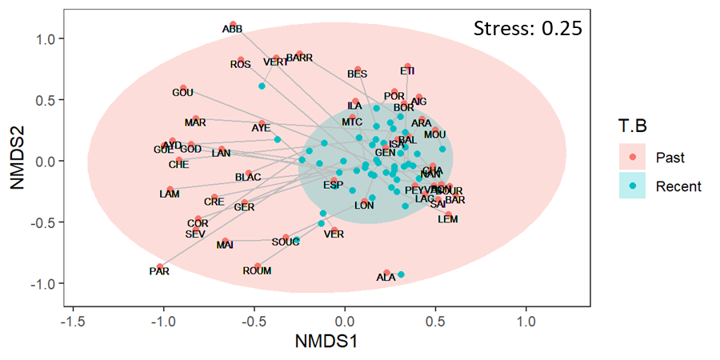
Figure S1: NMDS of community compositions of the recent (black dots) and past (purple dots) samples with 95% confidence ellipses represented for each group based on the Bray-Curtis distances of the OTU table. Only the past samples are labelled with their corresponding lake code (cf. Table S1), the gray lines connect recent and past samples from the same lake. Note: some labels are missing to avoid overlapping labels.

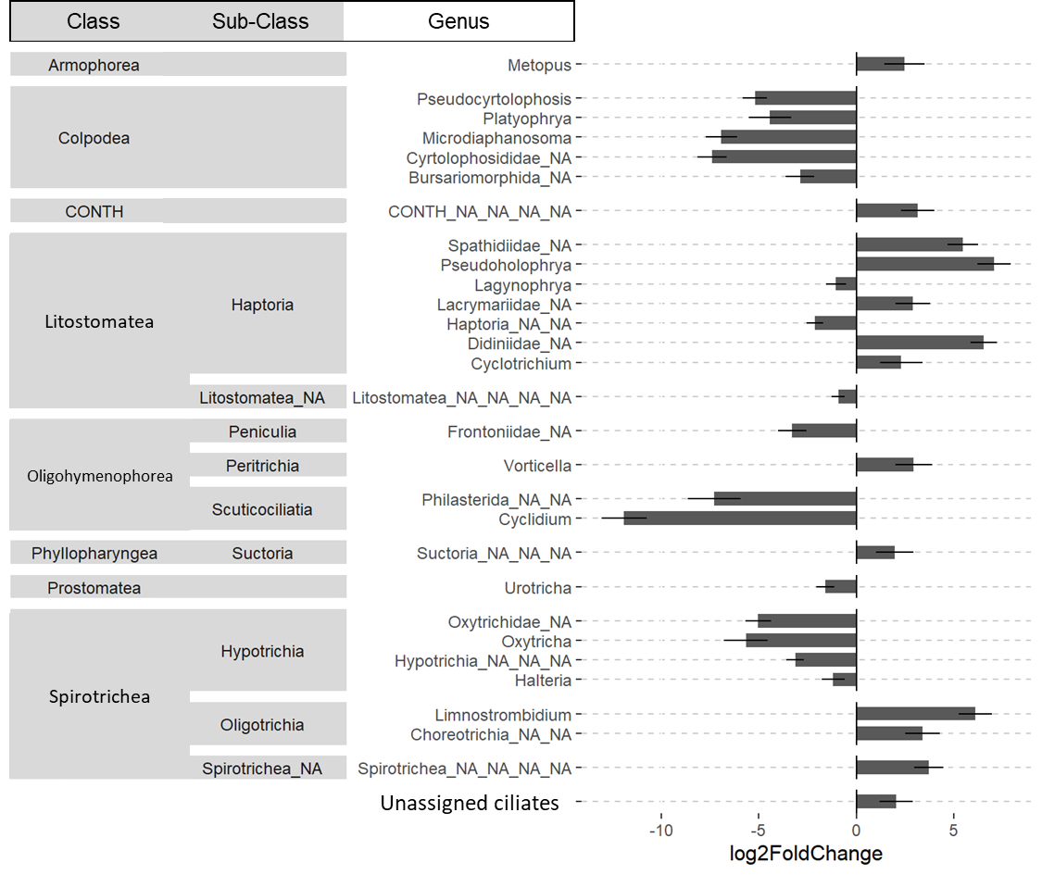
Figure S2: Amplitude of change of ciliates community applied at the Genus level between the past and recent strata. Magnitude of change is expressed in log2 fold change, as estimated by the DESeq2 analysis (n= 48 lakes). Only the Genus for which the amplitude of change was significant are presented (two-sided Wald test corrected with the Benjamini and Hochberg method p-value < 0.05). Horizontal lines show the standard error. Any Genus terminating with one “_NA”, two “_NA_NA”, or three “_NA_NA_NA”, corresponds to an assignment at the Familly, Order or Class, respectively (i.e. OTUs for which the assignment stopped at the Class level the pattern “_NA” is repeated three times corresponding to an unknown Order, an unknown Family, and an unknown Genus).
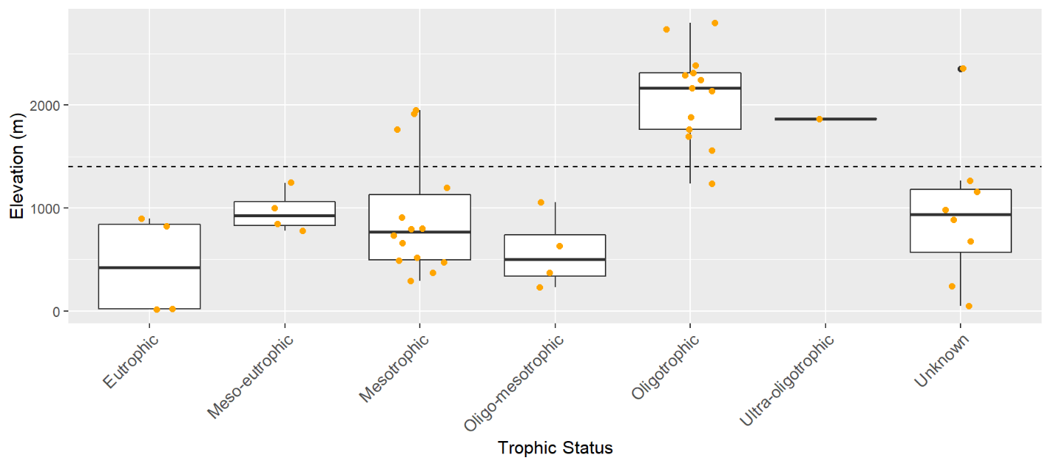
Figure S3: Distribution of the elevation gradient among the lake Trophic Status. The dotted line indicates the elevation of 1400 m corresponding to the split identified by the univariate regression tree analysis applied on the Bray-Curtis dissimilarity matrix. The elevation was significantly higher for the oligotrophic lakes than the other trophic status categories (Kruskal-Wallis test: χ²=27, df=5, p < 0.05; Post Hoc Wilcoxon-rank test p_{ajusted} <0.05 for Oligotrophic Lake against all other Trophic Status categories; for the pairwise comparison the p values were adjusted using the False Discovery Rate approach by Benjamini and Hochberg¹).
(1) Benjamini Y, Hochberg Y (1995) Controlling the False Discovery Rate: A Practical and Powerful Approach to Multiple Testing. Journal of the Royal Statistical Society: Series B (Methodological) 57:289–300. https://doi.org/10.1111/j.2517-6161.1995.tb02031.x

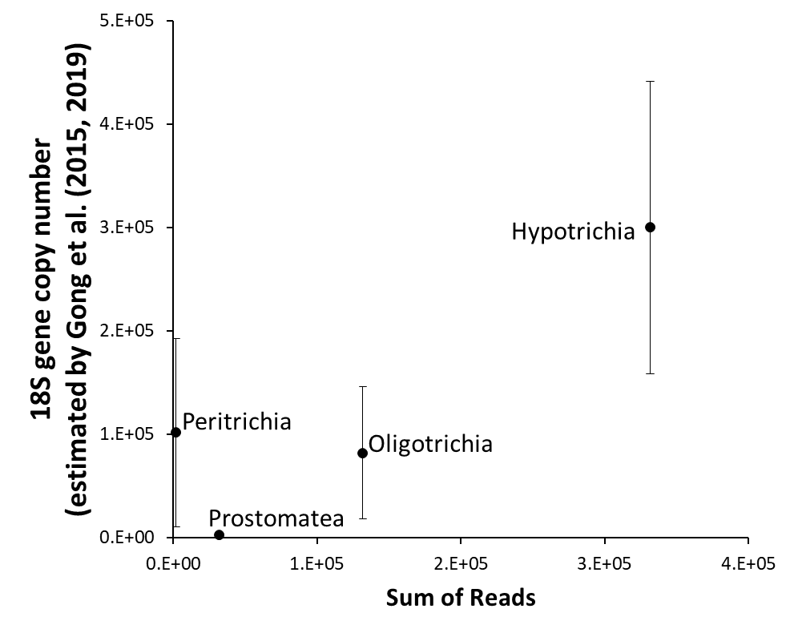
Figure S4: Relationship between the number of 18S gene copies as estimated by Gong et al.¹ and Gong and Marchetti² and the total number of reads all samples included for the Hypotrichia, Scuticociliatia, Oligohymenomorphorea, Prorodontida and Strombidida.
(1) Gong J, Dong J, Liu X, Massana R (2013) Extremely High Copy Numbers and Polymorphisms of the rDNA Operon Estimated from Single Cell Analysis of Oligotrich and Peritrich Ciliates. Protist 164:369–379. https://doi.org/10.1016/j.protis.2012.11.006
(2) Gong W, Marchetti A (2019) Estimation of 18S Gene Copy Number in Marine Eukaryotic Plankton Using a Next-Generation Sequencing Approach. Front Mar Sci 6:219. https://doi.org/10.3389/fmars.2019.00219

