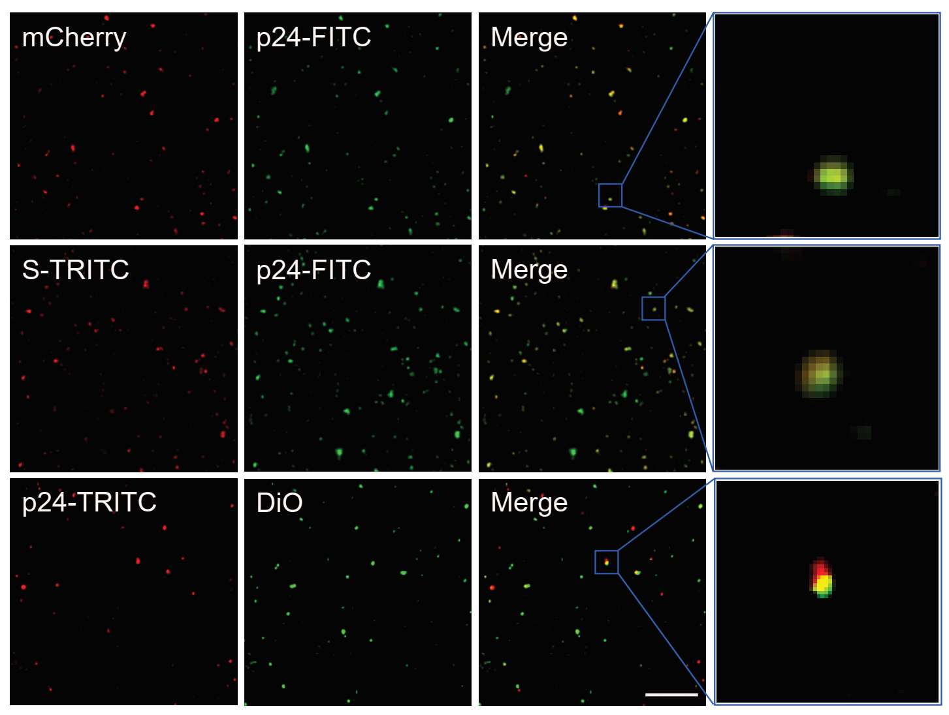
Supplementary Figure 1. Co-localization of mCherry fluorescent proteins and anti-p24 antibody (FITC) signals in pseudo-SARS-CoV-2. Co-localization of anti-S antibody (TRITC) and anti-p24 antibody (FITC) signals in pseudo-SARS-CoV-2. Co-localization of anti-p24 antibody (TRITC) and DiO signals in pseudo-SARS-CoV-2. The insert (right) is a zoomed view of the co-localized dots (Scale bar: 2 µm).
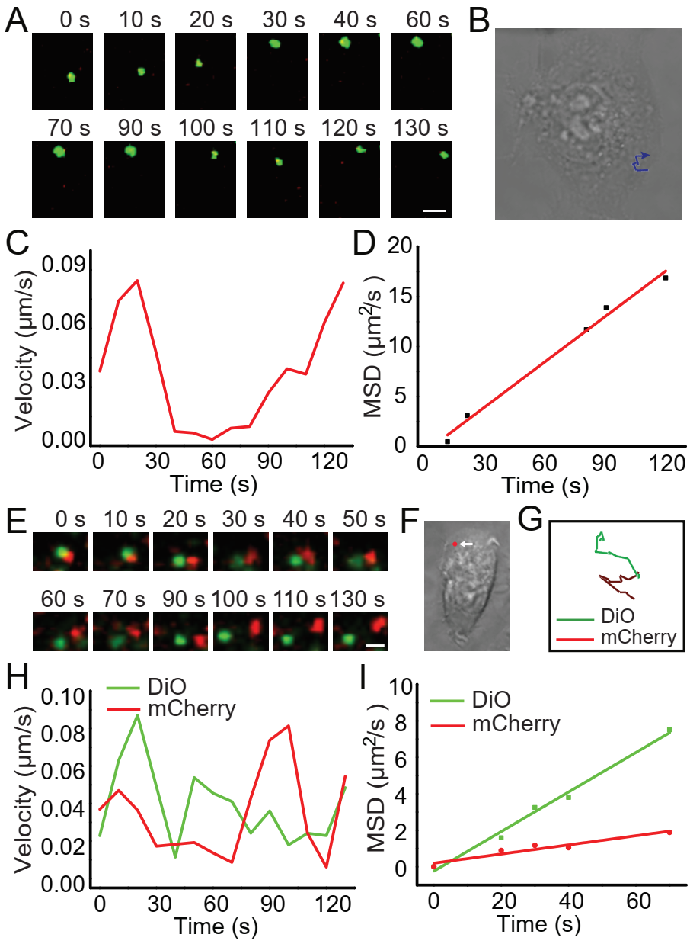
Supplementary Figure 2. (A) Sequential snapshots of the entry of the VSV-G pseudotyped virus into the HNEpC cell (Scale bar: 1 µm). (B) DIC image of the host cell. The blue line shows the trajectory of the virus. (C-D) Analysis of mean velocity (C) and MSD plot (D) of the virus particle shown in (A). (E) Sequential images of the separation of mCherry-Vpr and DiO of VSV-G pseudotyped virus in an HNEpC cell (Scale bar: 1 µm). (F) DIC image of the host cell. The red spot indicates the separation site. (G-I) Trajectories (G), mean velocities (H), and MSD plots (I) of mCherry-Vpr and DiO.
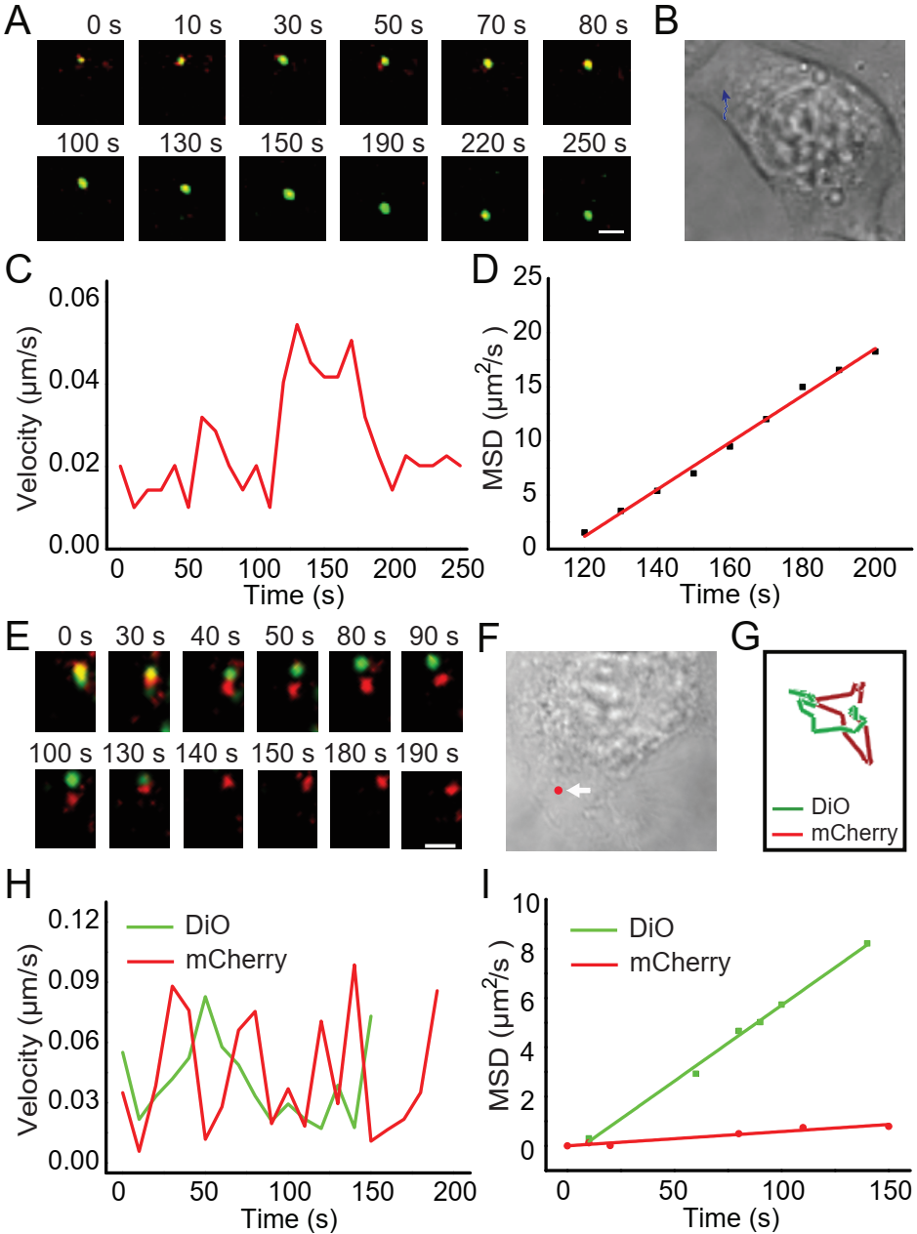
Supplementary Figure 3. (A) Sequential snapshots of the entry of the VSV-G pseudotyped virus into an HPAEpiC cell (Scale bar: 1 µm). (B) DIC image of the host cell. The blue line shows the trajectory of the virus. (C-D) Analysis of mean velocity (C) and MSD plot (D) of the virus particle shown in (A). (E) Sequential images of the separation of mCherry-Vpr and DiO of VSV-G pseudotyped virus in an HPAEpiC cell (Scale bar: 1 µm). (F) DIC image of the host cell. The red spot indicates the separation site. (G-I) Trajectories (G), mean velocities (H), and MSD plots (I) of mCherry-Vpr and DiO.
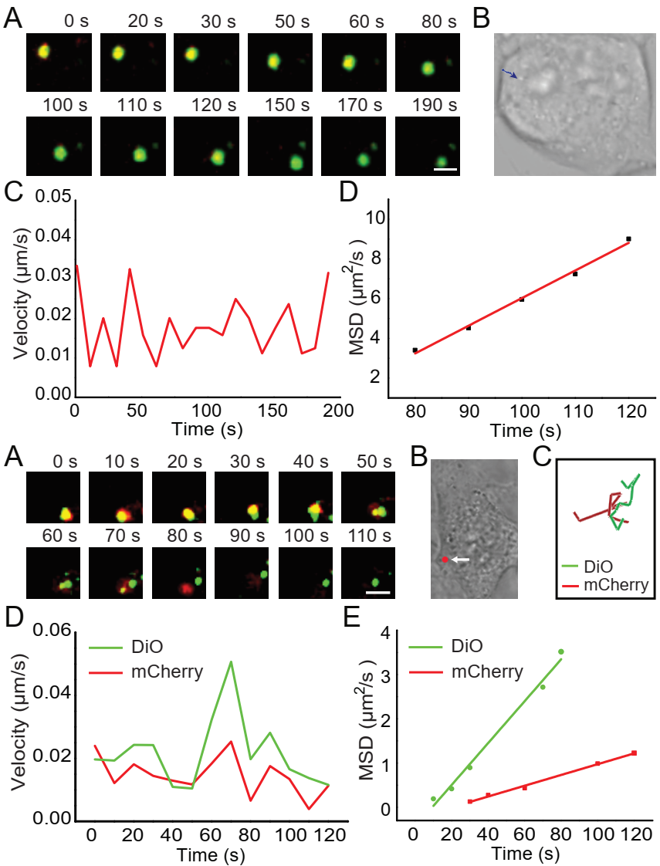
Supplementary Figure 4. (A) Sequential snapshots of the entry of the VSV-G pseudotyped virus into a BEP-2D cell (Scale bar: 1 µm). (B) DIC image of the host cell. The blue line shows the trajectory of the virus. (C-D) Analysis of mean velocity (C) and MSD plot (D) of the virus particle shown in (A). (E) Sequential images of the separation of mCherry-Vpr and DiO of VSV-G pseudotyped virus in a BEP-2D cell (Scale bar: 1 µm). (F) DIC image of the host cell. The red spot indicates the separation site. (G-I) Trajectories (G), mean velocities (H), and MSD plots (I) of mCherry-Vpr and DiO.
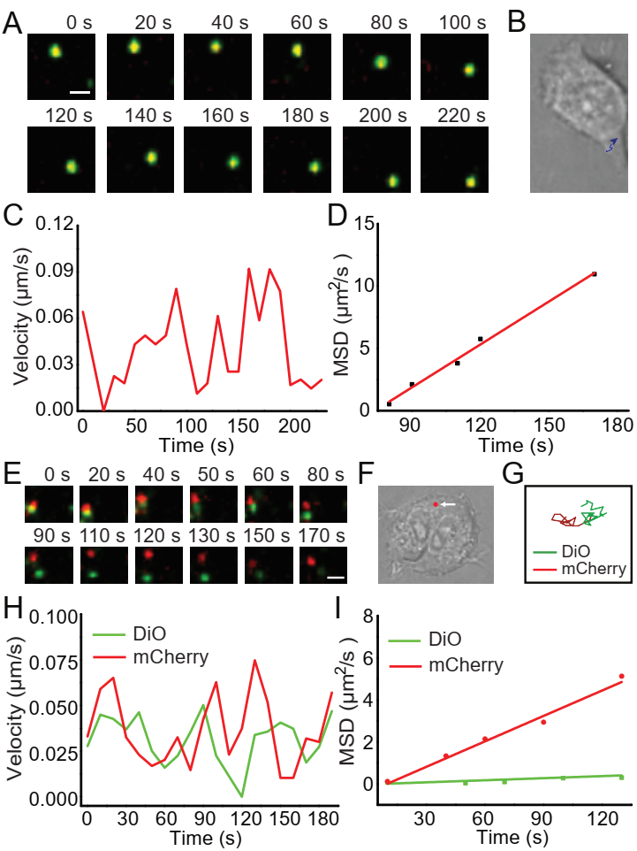
Supplementary Figure 5. (A) Sequential snapshots of the entry of the VSV-G pseudotyped virus into a HOEC cell (Scale bar: 1 µm). (B) DIC image of the host cell. The blue line shows the trajectory of the virus. (C-D) Analysis of mean velocity (C) and MSD plot (D) of the virus particle shown in (A). (E) Sequential images of the separation of mCherry-Vpr and DiO of the VSV-G pseudotyped virus in a HOEC cell (Scale bar: 1 µm). (F) DIC image of the host cell. The red spot indicates the separation site. (G-I) Trajectories (G), mean velocities (H), and MSD plots (I) of mCherry-Vpr and DiO.
Supplementary Movie 1. Dynamic tracking of the endocytic entry of pseudo-SARS-CoV-2 into the HNEpC cells.
Supplementary Movie 2. Dynamic tracking of the viral core of pseudo-SARS-CoV-2 release from the envelope membrane in HNEpC cells.
Supplementary Movie 3. Dynamic tracking of the endocytic entry of pseudo-SARS-CoV-2 into the HPAEpiC cells.
Supplementary Movie 4. Dynamic tracking of the viral core of pseudo-SARS-CoV-2 release from the envelope membrane in HPAEpiC cells.
Supplementary Movie 5. Dynamic tracking of the endocytic entry of pseudo-SARS-CoV-2 into the BEP-2D cells.
Supplementary Movie 6. Dynamic tracking of the viral core of pseudo-SARS-CoV-2 release from the envelope membrane in BEP-2D cells.
Supplementary Movie 7. Dynamic tracking of the endocytic entry of pseudo-SARS-CoV-2 into the HOEC cells.
Supplementary Movie 8. Dynamic tracking of the viral core of pseudo-SARS-CoV-2 release from the envelope membrane in HOEC cells.
Supplementary Movie 9. Dynamic tracking of the endocytic entry of VSV-G pseudovirions into the HNEpC cells.
Supplementary Movie 10. Dynamic tracking of the viral core of VSV-G pseudovirions release from the envelope membrane in HNEpC cells.
Supplementary Movie 11. Dynamic tracking of the endocytic entry of VSV-G pseudovirions into the HPAEpiC cells.
Supplementary Movie 12. Dynamic tracking of the viral core of VSV-G pseudovirions release from the envelope membrane in HPAEpiC cells.
Supplementary Movie 13. Dynamic tracking of the endocytic entry of VSV-G pseudovirions into the BEP-2D cells.
Supplementary Movie 14. Dynamic tracking of the viral core of VSV-G pseudovirions release from the envelope membrane in BEP-2D cells.
Supplementary Movie 15. Dynamic tracking of the endocytic entry of VSV-G pseudovirions into the HOEC cells.
Supplementary Movie 16. Dynamic tracking of the viral core of VSV-G pseudovirions release from the envelope membrane in HOEC cells.

