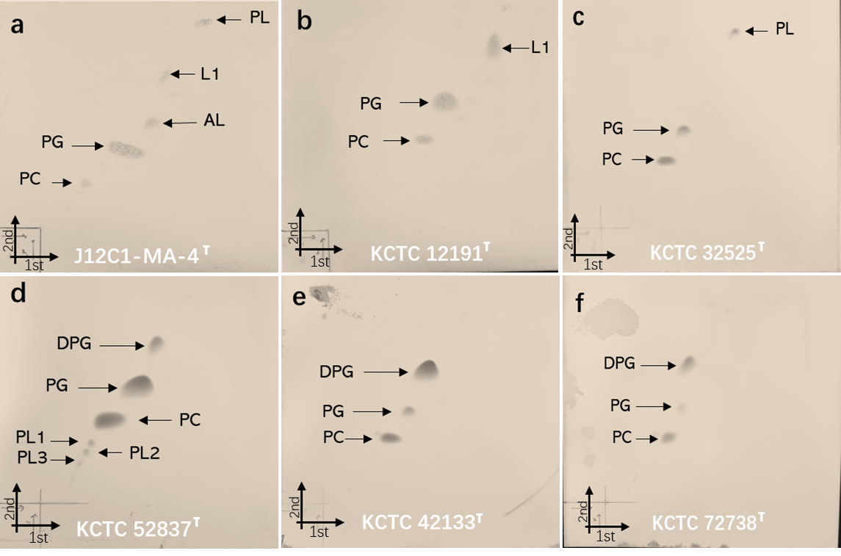
Supplementary Fig. S1. The polar lipid profiles of strain J12C1-MA-4^{T} and closely related strains. (a) Jannaschia koreensis J12C1-MA-4^{T}, (b) J. helgolandensis KCTC 12191^{T} (AJ438157), (c) Pseudooctadecabacter jejudonensis KCTC 32525^{T} (KF515220), (d) Loktanella acticola KCTC 52837^{T} (KY817315), (e) Loktanella ponticola KCTC 42133^{T} (KJ855314), (f) Alterinioella_nitratireducens KCTC 72738^{T} (MK880579). DPG: Diphosphatidylglycerol; PG: Phosphatidylglycerol; APL: unidentified aminophospholi; PE, phosphatidylethanolamine; AL, unidentified aminolipid; PL：phospholipids; PC：phosphatidylcholine; L：lipids.

