Genetic structure in neotropical birds with different tolerance to urbanization

Authors and affiliations:
Mauricio Rodríguez-Bardía^{1,2,*}, Eric J. Fuchs², Gilbert Barrantes², Ruth Madrigal-Brenes²,Luis Sandoval²

1: Programa de Posgrado en Biología, Sistema de Estudios de Posgrado, Universidad de Costa Rica. San Pedro, San José, 11501-2060.
2: Escuela de Biología, Universidad de Costa Rica. San Pedro, San José, 11501-2060
*Corresponding author: maurod.96@gmail.com, alejandro.rodriguezbardia@ucr.ac.cr

Supplementary tables S1, S2, S3, S4 and supplementary figure S1.

Supplementary Table S1. Observed heterozygosity (H_{o}), Expected heterozygosity (H_{e}), inbreeding coefficient (F_{IS}) and allele number (A) for polymorphic locus used in this study for white-eared ground-sparrow (Melozone leucotis) and house wren (Troglodytes aedon).
Species | Locus | H_{o} | H_{e} | F_{IS} | A
Melozone leucotis | Mme2 | 0.514 | 0.397 | -0.294 | 3
 | Mme7† | 0.601 | 0.530 | -0.134 | 5
 | Mme8 | 0.562 | 0.503 | -0.117 | 4
 | Asµ15 | 0.903 | 0.854 | -0.057 | 14
 | Escµ6 | 0.616 | 0.565 | -0.090 | 5
 | Gf05 | 0.347 | 0.368 | 0.057 | 7
 | Gf01 | 0.892 | 0.891 | -0.001 | 21
Troglodytes aedon | Th-PI14 | 0.904 | 0.870 | -0.039 | 16
 | Ta-C6-7 | 0.384 | 0.550 | 0.302 | 7
 | Ta-A5-15 | 0.351 | 0.335 | -0.048 | 3
 | Ta-A5-2 | 0.558 | 0.628 | 0.111 | 7
 | Ta-B4-2 | 0.610 | 0.605 | -0.008 | 9
 | Th-Pl17 | 0.107 | 0.101 | -0.056 | 2
 | Ta-C3(B)-2 | 0.320 | 0.302 | -0.059 | 5
† Z-linked locus.

Supplementary Table S2. Pairwise Weir and Cockerham FST [95% CI, 9999 bootstraps over loci] between populations for white-eared ground-sparrow (Melozone leucotis) (above diagonal) and house wren (Troglodytes aedon) (below diagonal).
 | HDA | JBL | UCR | MTV
HDA |  | 0.059  [0.008_0.100] | 0.019  [-0.004_0.060] | 0.065  [0.0140_0.126]
JBL | 0.017  [-0.009_0.037] |  | 0.070  [0.024_0.108] | 0.161  [0.080_0.250]
UCR | 0.031  [-0.017_0.077] | 0.035  [0.003_0.055] |  | 0.123  [0.014_0.255]
MTV | 0.046  [0.027_0.070] | 0.057  [0.023_0.099] | 0.083  [0.056_0.110]
COR | 0.084  [0.057_0.111] | 0.086  [0.030_0.167] | 0.089  [0.038_0.125] | 0.098  [0.027_0.190]

Supplementary Table S3. Primer mixes and PCR thermal conditions used for the study.
Species | Mix | Primer | Reference | Thermal profile
Melozone leucotis | 1 | Mme2 | ¹ | 95 °C for 15 min; 33 cycles of 94 °C for 30 s, 58 °C for 1:30 min, 72 °C for 1:00 min; followed by 60 ° C for 30 min
 |  | Mme7 | ¹
 |  | Mme8 | ¹
 | 2 | Asµ15 | ² | 95 °C for 15 min; 30 cycles of 94 °C for 30 s, 55 °C for 1:30 min, 72 °C for 1:00 min; followed by 60 °C for 30 min
 |  | Asµ18 | ²
 |  | Escµ6 | ³
 |  | Gf05 | ⁴
 | - | Gf01 | ⁴ | 94 °C for 3 min; 33 cycles of 94 °C for 1:00 min, 50 °C for 1:30 min, 72 °C for 1:00 min; followed by 72 °C for 10:00 min
Troglodytes aedon | 3 | ThPl-01 | ⁵ | 95 °C 15 min; 25 cycles of 94 °C for 30 s, 60 °C for 1:30 min, 72 °C for 1:00 min; followed by 60 °C for 30 min
 |  | ThPl-14 | ⁵
 |  | Ta-C6-7 | ⁶
 | 4 | Ta-A5-15 | ⁶
 |  | Ta-A5-2 | ⁶
 |  | Ta-B4-2 | ⁶
 | 5 | Ta-C3(B)-2 | ⁶ | 95 °C for 15 min; touchdown 13 cycles of 94 °C for 30 s, 63-51 °C for 1:30 min decreasing 1 °C per cycle, 72 °C for 1:00 min; followed by 12 cycles of 94 °C for 1:00 min, 50 °C for 1:00 min, 72 °C for 1:00 min; followed by 60° C for 30 min
 |  | ThPl-17 | ⁵

Supplementary Table S4. Resistance value of each category of land cover and altitude designated for white-eared ground-sparrow (Melozone leucotis) and house wren (Troglodytes aedon).
Layer | Category | Resistance value for M. leucotis | Resistance value for T. aedon
Land Cover | Non Forestal | 20 | 20
 | Water | 80 | 80
 | Secondary forest | 1 | 1
 | Forest | 20 | 20
 | Mangrove swamp | 100 | 100
 | Forestry | 20 | 20
 | Non classified | 100 | 100
 | Clouds | 20 | 20
 | Agriculture | 40 | 40
 | Páramo | 40 | 40
 | Palm forest | 20 | 20
 | Limits | 100 | 100
 | Deforestation | 40 | 40
 | Coffee | 1 | 1
 | Urban use | 100 | 100
 | Burned areas | 100 | 100
Altitude (m.a.s.l) | 0-200 | 100 | 1
 | 200-400 | 100 | 1
 | 400-600 | 100 | 1
 | 600-800 | 50 | 1
 | 800-1000 | 1 | 1
 | 1000-1200 | 1 | 1
 | 1200-1400 | 1 | 1
 | 1400-1600 | 1 | 1
 | 1600-1800 | 1 | 1
 | 1800-2000 | 50 | 1
 | 2000-2200 | 100 | 1
 | 2200-2400 | 100 | 1
 | 2400-2600 | 100 | 1
 | 2600-2800 | 100 | 1
 | 2800-3000 | 100 | 50
 | 3000-3200 | 100 | 100
 | 3200-3400 | 100 | 100
 | 3400-3600 | 100 | 100
 | 3600-3818 | 100 | 100

Supplementary Figure S1. Structure Harvester results: mean L(K) (a and c) and Delta K (b and d) for both white-eared ground-sparrow (Melozone leucotis) (a and b) and house wren (Troglodytes aedon) (c and d). 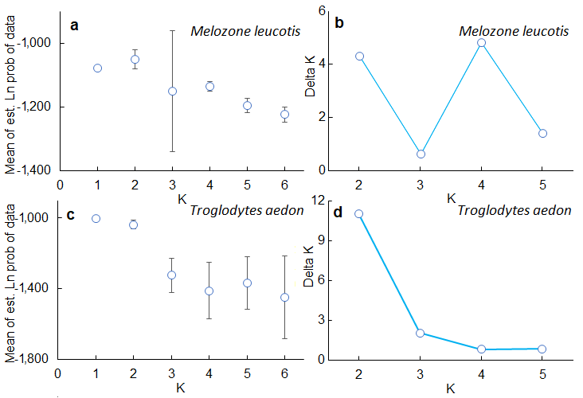
References
1. Jeffery, K. J., Keller, L. F., Arcese, P. & Bruford, M. W. The development of microsatellite loci in the song sparrow, Melospiza melodia (Aves) and genotyping errors associated with good quality DNA. Mol. Ecol. Notes 1, 11–13 (2001).
2. Bulgin, N. L., Gibbs, H. L., Vickery, P. & Baker, A. J. Ancestral polymorphisms in genetic markers obscure detection of evolutionarily distinct populations in the endangered Florida grasshopper sparrow (Ammodramus savannarum floridanus). Mol. Ecol. 12, 831–844 (2003).
3. Hanotte, O. et al. Isolation and characterization of microsatellite loci in a passerine bird: the reed bunting Emberiza schoeniclus. Mol. Ecol. 3, 529–530 (1994).
4. Petren, K. Microsatellite primers from Geospiza fortis and cross-species amplification in Darwin’s finches. Mol. Ecol. 7, 1782–1784 (1998).
5. Brar, R. K. et al. Eleven microsatellite loci isolated from the banded wren (Thryothorus pleurostictus). Mol. Ecol. Notes 7, 69–71 (2007).
6. Cabe, P. R. & Marshall, K. E. Microsatellite loci from the house wren (Troglodytes aedon). Mol. Ecol. Notes 1, 155–156 (2001).

