Supporting Information
Erythrocyte Membrane-Enveloped Molybdenum Disulfide Nanodots for Biofilm Elimination on Implants via Toxin Neutralization and Immune Modulation
Tingwang Shi^{1†}, Zesong Ruan^{1†}, Jianrong Wu^{1*}, Weijuan Zou¹, Xiaojun Cai¹, Yuanyi Zheng^{1,2*} and Yunfeng Chen^{1*}

* Correspondence: wujr_028@126.com, zhengyuanyi@sjtu.edu.cn, chenyf@sjtu.edu.cn
† These authors contribute equally to this work.
¹ Department of Orthopedic Surgery, Department of Ultrasound in Medicine, Shanghai Jiao Tong University Affiliated Sixth People's Hospital, Shanghai 200233, P. R. China
² State Key Laboratory of Oncogenes and Related Genes, School of Medicine, Shanghai Jiao Tong University, Shanghai 200233, P. R. China

Additional details on experimental section
Materials.
Ammonium tetrathiomolybdate ((NH₄)₂MoS₄), polyvinylpyrrolidone (PVP, M_{w}: 10 kDa), and hydrazine hydrate were purchased from the Shanghai Aladdin Bio-Chem technology Co., LTD (Shanghai, China). The BCA kit, 3,3′,5,5′-Tetramethylbenzidine (TMB), TMB stopping buffer, DAPI, crystal violet solution, Triton-X-100 solution, bovine serum albumin (BSA), 5(6)-Carboxyfluorescein diacetate succinimidyl ester (CFDA-SE), and 2',7'-Dichlorodihydrofluorescein diacetate (DCFH-DA) were purchased from Beyotime Biotechnology (Shanghai, China). Polycarbonate membranes (100, 200, and 400 nm) were purchased from Avanti Polar Lipids, Inc (Alabaster, AL, USA). The CCK-8 reagent was purchased from Dojindo Molecular Technologies (Kumamoto, Japan). α-hemolysin derived from staphylococcus aureus, rabbit anti-Staphylococcal α-toxin polyclonal antibody were purchased from Merck (Darmstadt, Germany). 4% paraformaldehyde was purchased from Wuhan Servicebio Technology Co., (Wuhan, China). Rhodamine-labeled phalloidin was purchased from Yeasen Biotechnology (Shanghai) Co., Ltd. (Shanghai, China). Tryptone soy broth was purchased from Solarbio Science & Technology Co., Ltd. (Beijing, China). LIVE/DEAD BacLight Bacterial Viability Kit, CellTraker Red CMTPX dyes were purchased from Thermo Fisher Scientific (Waltham, MA, USA). Rabbit anti-mouse CD197 monoclonal antibody, rabbit anti-mouse Arg-1 polyclonal antibody, rat anti-mouse CD86 monoclonal antibody, Alexa Fluor 594 labeled goat anti-rabbit polyclonal antibody, Alexa Fluor 594 labeled goat anti-rat polyclonal antibody, and Alexa Fluor 488 labeled goat anti-rabbit polyclonal antibody were purchased from Abcam (Cambridge, UK). APC-labeled CD86 monoclonal antibody, PE-labeled CD206 monoclonal antibody were purchased from BioLegend (San Diego, CA, USA). Moreover, ELISA kits (TNF-α, IL-1β, MCP-1, IL-10) were purchased from Anogen (Mississauga, Canada). The RNA Purification Kit, Color Reverse Transcription Kit, 2Color SYBR Green qPCR Master Mix were purchased from EZBionscience (Roseville, USA). Primers (TNF-α, IL-1β, MCP-1, and IL-10) were purchased from BioTNT (Shanghai, China). The TRIzol reagent was purchased from TaKaRa (Kusatsu, Japan).
Cell lines and bacteria
We purchased RAW 264.7 and L-929 cell lines from the Cell Bank of Type Culture Collection of Chinese Academy of Sciences. Methicillin-resistant Staphylococcus aureus (MRSA; ATCC43300) was provided by the Department of Clinical Laboratory of Shanghai Jiaotong University affiliated Sixth People’s Hospital.
Extraction of erythrocyte membrane fragments
Erythrocyte membrane fragments (EMFs) were harvested and purified according to previously established protocols.[1] In brief, 2 mL of whole blood was drawn from male Balb/c mice (7-8 weeks) by cardiac puncture using a heparin-containing syringe. After centrifugation (800 g, 5 min, 4 ℃), the whole blood was layered and its upper layers including plasma and buffy coat were discarded. Thereafter, erythrocytes were washed with icy heparin-containing 1 × PBS for three times, following which they were hemolyzed in a hypotonic solution (0.25 × PBS) in ice bath for 30 min. Subsequently, the mixture was centrifuged at 20000g for 10 min to collect lower pink pellet. Next, the pellet was washed and further centrifuged thrice to harvest purified EMFs. Finally the resulting EMFs were resuspended in PBS and stored at -80 ℃ for further use. Meanwhile, a BCA kit was employed to determine the protein contents of EMFs.
Characterization of EM@MoS₂
Transmission electron microscopy (TEM) images of MoS₂ and EM@MoS₂ were recorded on a JEM-2100F field emission TEM (JEOL, Ltd., Tokyo, Japan). The physical form and chemical composition of MoS₂ NDs was measured by X-ray photoelectron spectroscopy (XPS, ESCALAB 250Xi, Thermo Fisher, Waltham, MA, USA). Ultraviolet-visible-near-infrared (UV-vis-NIR) spectra were recorded using a Lambda 750 spectrometer (PerkinElmer, USA). The hydrodynamic particle size and zeta potentials of MoS₂ NDs and EM@MoS₂ were determined using a Malvern zetasizer Nano ZS unit (Nano ZS90, Malvern Panalytical, UK). To compare the protein profiles of EM@MoS₂ nanocomposite with that of EMFs, sodium dodecyl sulfate-polyacrylamide gel electrophoresis (SDS-PAGE) was employed to isolate and further identify their protein component as previously reported.[2]
Photothermal effect of MoS₂ NDs and EM@MoS₂
MoS₂ NDs (200 mg/L, 500 μL), EM@MoS₂ (200 mg/L, 500 μL) or EMFs (with 200 mg/L membrane protein, 500 μL) were exposed to 808 nm NIR irradiation (1 W/cm², 10min), respectively, and their temperature-time curves were recorded using an infrared thermal imager (Fotric 220, ZXF, USA). Then their temperature changes from the beginning to the end of irradiation were calculated, respectively. To test the photothermal-conversion performance of EM@MoS₂ at different concentrations (0, 25, 50, 100, and 200 mg/L), corresponding temperature profiles under NIR irradiation (1 W/cm², 10min) were recorded. Similarly, the temperature profiles under different laser power density (0.6, 0.8, 1.0, 1.2 W/cm²) were also recorded. Furthermore, the photostability of EM@MoS2 at 200 mg/L was examined for four repeated cycles of laser on/off.
Peroxidase activity of EM@MoS₂
The ability of EM@MoS₂ to catalyze the decomposition of H₂O₂ was evaluated using 3, 3’,5, 5’-tetramethylbenzidine (TMB) as the substrate (10 mg/mL). Firstly, EM@MoS₂ (200 mg/L) and TMB were added to NaAc buffer (pH = 4.5) containing a series of concentrations of H₂O₂ (5 mM, 10 mM, 15 mM, and 20mM). After incubation for 5 min, the absorbance of oxidized TMB (ox-TMB) at 635 nm was recorded using UV-vis spectra (Shimadzu, Tokyo, Japan). Subsequently, the catalyzing reactions under various concentrations (0, 25, 50, 100, and 200 mg/L) of the EM@MoS₂ or different buffer pH (3.0, 4.5, 6.0, and 7.5) were also monitored as descried above.
Biocompatibility of MoS₂ NDs and EM@MoS₂
A standard CCK-8 assay was conducted on RAW 264.7 cells to evaluate the biocompatibility of MoS₂ NDs and EM@MoS₂. Briefly, RAW 264.7 cells were seeded in 24-well plate at a density of 5×10⁴ cells per well and incubated under standard condition (37 ℃, 5% CO₂) overnight. Then cells were treated with a series of graded concentrations of MoS₂ NDs or EM@MoS₂ (0, 25, 50, 100, 200, and 400 mg/L) for 24 h. Finally, the relative cell viabilities were detected using CCK-8 reagent according to specifications. The experiment was repeated three times under the same conditions.
In vitro antibiofilm effect and mechanisms
The MRSA strain ATCC43300 was used to cultivate bacterial biofilms. The antibiofilm effects of MoS₂ NDs and EM@MoS₂ were evaluated in five experimental groups: control, NIR (808 nm, 1.0 W/cm², 10 min), MoS₂, EM@MoS₂, and EM@MoS₂ + NIR laser (808 nm, 1.0 W/cm², 10 min). In addition, polyether-ether-ketone (PEEK) small discs (10 mm in diameter and 0.5 mm in thickness) were chosen as the substances to culture biofilms. The peek tablets were pre-sterilized by 50kGy electron beam irradiation for 1 min. To cultivate MRSA biofilm, 500 μL of bacteria suspension (10⁶ CFU/mL) was added onto the PEEK disc placed in 24-well plates and then incubated at 37 ℃ for 24 h. After that, the tryptone soy broth in each well was replaced with pure PBS (control and NIR groups) or nanomaterial solutions [MoS₂ NDs or EM@MoS₂ (200 mg/L)], and all samples were incubated for another 6 hours at 37 ℃. Specially, NIR and EM@MoS₂ + NIR groups were irradiated under 808 nm NIR for 10min. Finally, the small discs in each group were rinsed three times for the following experiments.
For standard plate counting tests, samples of each group were transferred into EP tubes containing 1mL PBS under aseptic conditions. Then the bacterial suspensions were collected by rapid vibration, subsequent sonication, and 10-fold gradient dilution. Next, 100 μL suspension of each diluted gradient of each sample was used to coat blood agar plates. After all the plates were incubated overnight in 37 °C, bacterial colonies were counted. For crystal violet staining, the treated PEEK discs were firstly fixed with 99% methanol for 15 min, and then stained with 2% crystal violet solution for 5 minutes. To visually monitor the residual crystal violet (equivalent to remaining biomass of biofilms), all the samples were fully rinsed and dried before photographed. Meanwhile, quantitative analysis was performed by dissolving remaining crystal violet with 33% acetic acid and detecting the absorbance of resultant eluent at 550 nm by an Epoch-2 microplate reader (BioTek Instruments, Winooski, VT, USA).
Cell culture and intervention for the assessment of Immunoregulatory potential
RAW264.7 cells were seeded in 6-well plates or confocal dishes (for immunofluorescence staining) at a density of 210⁵ cells per well (110⁵ cells per dish), and cultured for 12 h. Afterwards, MoS₂ NDs were added to each well or dish and the final concentrations were adjusted to 25, 50, 100, and 200 mg/L, respectively. Meanwhile, 200 mg/L of EM@MoS₂ was used to stimulate RAW 264.7 cells as well. After 24 h incubation, the nanomaterial-containing medium was removed and cells were rinsed for subsequent trails. The PBS-treated group was considered as the control.
Immuno-antibiofilm therapy mediated by EM@MoS₂
In order to visually explore the potency of EM@MoS₂-pretreated macrophages to penetrate biofilms and phagocytose bacteria, CellTraker Red CMTPX dyes and CFDA-SE were selected to label living macrophages and living bacteria, respectively.
To obtain activated macrophages (AM), RAW 264.7 cells were pretreated with EM@MoS₂ (200 mg/L) as described above. Meanwhile, the cells treated with PBS were considered as unactivated macrophages (UM). After stained with CellTracker Red CMTPX dye working solution (5 μM) for 20 min, AM and UM were gently scraped and washed for subsequent usage. At the same time, MRSA biofilms without any treatment were set as intact biofilms (IB), whereas biofilms pretreated with EM@MoS₂ + NIR were grouped as cracked biofilms (CB). Then, IB and CB were labeled with CFDA-SE (5 μM) in a dark room for 30 minutes, following which excess dyes were removed. Thereafter, 3 × 10⁵ red fluorescence-labeled AM or UM were added onto the green fluorescence-labeled biofilms and incubated at 37 °C for two hours. Eventually, the interaction between macrophages and biofilms was observed and imaged by CLSM. Additionally, we evaluated the difference between the groups by counting the number of cells penetrating the biofilms.
Furthermore, the phagocytic potency and bactericidal abilities of AM and UM were investigated. In this part of the experiment, CB were collected from IB by vibration and sonication and further stained with CFDA-SE. Subsequently, stained IB suspension (100 μL, 1 × 10⁷ CFU/ml) and CellTracker Red-labeled AM or UM suspensions (1mL, 1 × 10⁵/mL) were mixed and cocultured in confocal dishes for 2 h. Afterwards, the cells were gently scraped and centrifuged (1500 rpm, 5 min) to remove the bacteria that had not been phagocytosed. Later, cell samples were cultured in new confocal dishes for 30 min until attachment for subsequent CLSM observation. Moreover, to quantitatively explore the bactericidal potency of AM, biofilm fragments (100 μL, 1 × 10⁷ CFU/mL) and AM or UM suspension (1 mL, 1 × 10⁵/mL) were mixed and cocultured for 3 h. Afterwards, mixed suspensions were used for plate counting tests and bacterial viabilities was determined in each group.

References1. Jiang Q, Liu Y, Guo R, Yao X, Sung S, Pang Z, et al. Erythrocyte-cancer hybrid membrane-camouflaged melanin nanoparticles for enhancing photothermal therapy efficacy in tumors. Biomaterials. 2019;192:292–308.
2. Hu C-MJ, Zhang L, Aryal S, Cheung C, Fang RH, Zhang L. Erythrocyte membrane-camouflaged polymeric nanoparticles as a biomimetic delivery platform. Proc Natl Acad Sci U S A. 2011;108:10980–5.

Supplementary Tables and Figures

Table S1. Primers used in the RT-PCR experiment.
Gene | Upper primer sequence (5’ to 3’) | Lower primer sequence (5’ to 3’)
TNF-α | TAGCCAGGAGGGAGAACAGA | CCAGTGAGTGAAAGGGACAGA
IL-1β | TACATCAGCACCTCACAAGC | AGAAACAGTCCAGCCCATACT
MCP-1 | CATCCACTACCTTTTCCACAA | CATCACAGTCCGAGTCACAC
IL-10 | AGTGTGTATTGAGTCTGCTGG | GAGAGAGGTACAAACGAGGTT
GAPDH | AAATGGTGAAGGTCGGTGTG | AGGTCAATGAAGGGGTCGTT

Fig. S1. The XPS survey spectrum of MoS₂ NDs.

Fig. S2. Line-scan TEM-EDS elemental distribution curves of PVP-modified MoS₂ NDs along the yellow line in inset TEM image.

Figure S3. Zeta potentials of EMFs, MoS₂ NDs, and EM@MoS₂ dispersions in DI water.

Figure S4. Temperature changes of EMFs, MoS₂ NDs, and EM@MoS₂ dispersions under irradiation of 808 nm laser at the power density of 1.0 W cm⁻² for 10 min.

Figure S5. The temperature-time curve for EM@MoS₂ dispersion during four laser on/off cycles.

Figure S6. UV-vis absorbance spectra of ox-TMB in the presence of H₂O₂ and EM@MoS₂ at different pH values.

Figure S7. Cell viability of RAW 264.7 cells measured by CCK8 assay after treated by different concentrations of MoS₂ NDs or EM@MoS₂ for 24 h. Note: * (p<0.05).

Figure S8. In vitro antibiofilm effect of MoS₂ NDs and EM@MoS₂. (a) Representative images of bacterial colonies from different groups. (b) Crystal violet staining images of residual biofilms after different treatments. (c) Quantitative analysis of bacterial colonies from different groups using standard plate counting tests. (d) Quantitative analysis of residual biofilm masses. Note: * (p<0.05), ** (p<0.01), *** (p<0.001), **** (p<0.0001).

Figure. S9. RNA-seq analysis of RAW 264.7 gene expression. (a) Heatmap of correlation analysis between samples. (b) GO analysis of differential expressed genes.

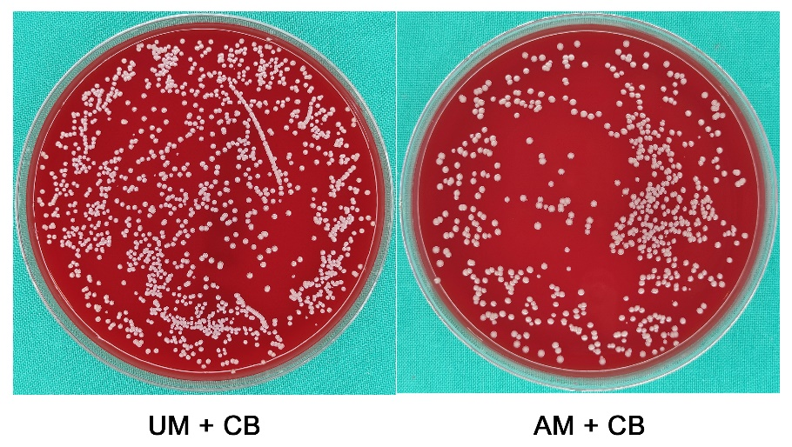
Figure. S10. Representative photographs of bacterial colonies from UM + CB and AM + CB groups using standard plate counting tests.

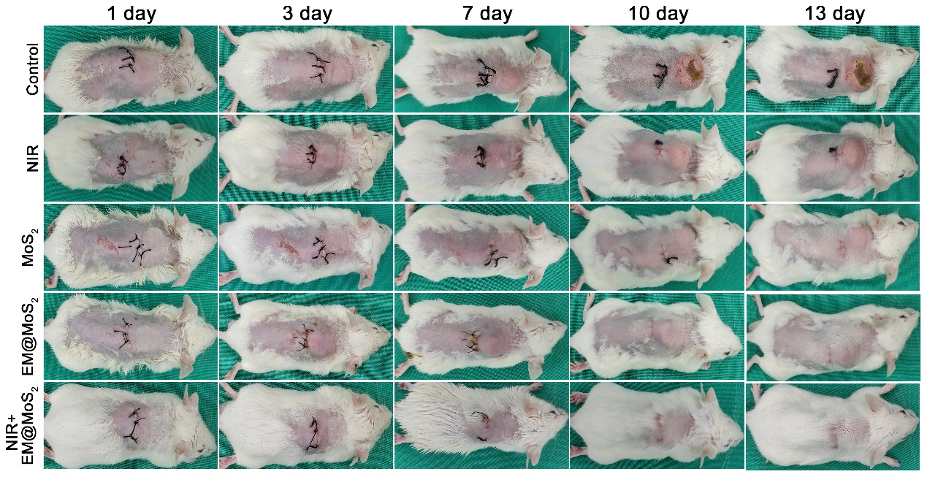
Figure. S11. Typical photos of mouse subcutaneous implant-related infection models after different treatments over the course of thirteen-day observation.

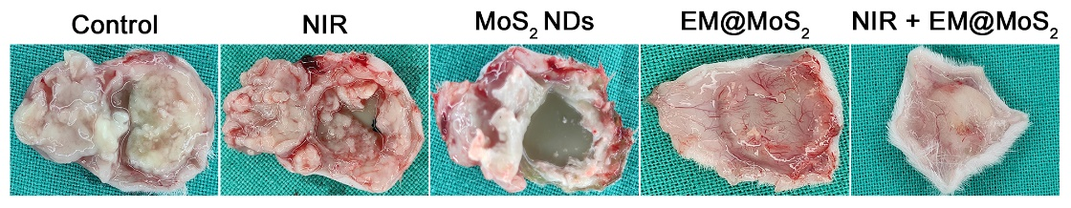
Figure. S12. General observation of implants together with peri-implant soft tissues incised from infection area.

Figure S13. Giemsa staining image showing residual biofilms in peri-implant soft tissues.

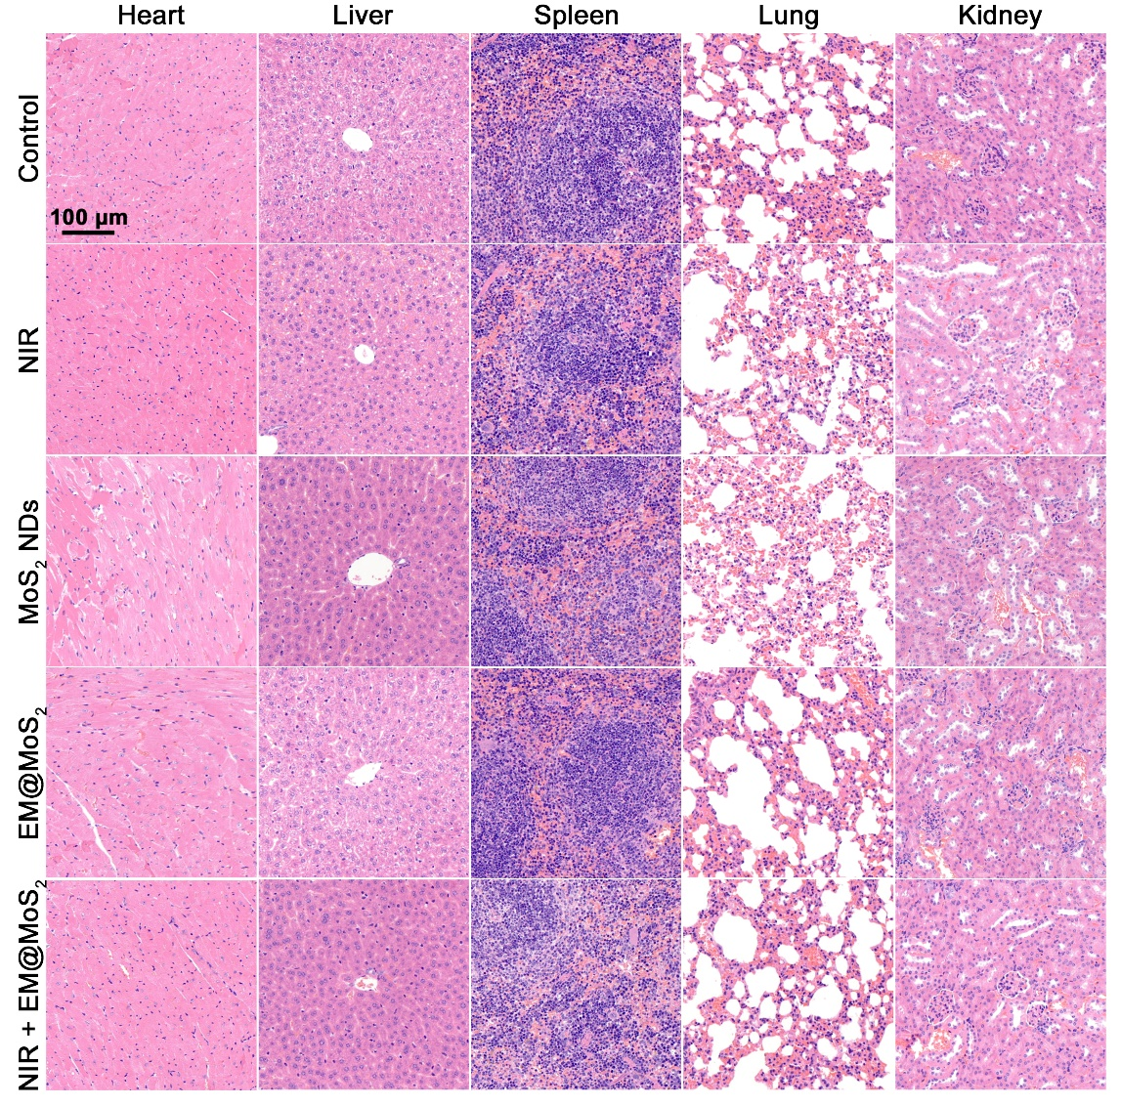
Figure. S14. Images of H&E-stained sections of major organs (heart, liver, spleen, lung and kidney) after different treatments.

