Online Tables
Table E1 Prediction of major adverse cardiovascular events (MACE) during follow-up. Univariable Cox proportional regression models with covariates as continuous variables
 | MACE
 | Hazard ratio (95% CI) | p-value
Global MFR | 2.24 (1.5-3.3) | <0.001
Global stress MBF | 2.21 (1.5-3.2) | <0.001
Global MFC radius | 1.88 (1.4-2.5) | <0.001
Minimum regional MFR | 2.34 (1.6-3.5) | <0.001
Minimum regional stress MBF | 2.32 (1.6-3.4) | <0.001
Minimum regional MFC radius | 1.98 (1.5-2.7) | <0.001
MFR – myocardial flow reserve; MBF – Myocardial blood flow; MFC – myocardial flow capacity

Table E2 Comparison between adjusted models (along with covariates: male gender, known coronary artery disease (CAD) and history of myocardial infarction) using a likelihood ratio chi-square test
 | p-value
 | With MFR, stress MBF and MFC radius as binary variables | With MFR, stress MBF and MFC radius as continuous variables
Global
MFR vs. MFR + MFC | 0.061 | 0.16
Stress MBF vs. stress MBF + MFC | 0.087 | 0.16
Stress MBF vs. stress MBF + MFR | 0.04 | 0.15
MFR vs. MFR + stress MBF | 0.004 | 0.15
Minimum regional
MFR vs. MFR + MFC | 0.023 | 0.083
Stress MBF vs. stress MBF + MFC | 0.016 | 0.13
Stress MBF vs. stress MBF + MFR | 0.026 | 0.17
MFR vs. MFR + stress MBF | 0.019 | 0.12
Global + Minimum regional
Global MFR vs. Global MFR + Minimum regional MFR | 0.40 | > 0.9
Global stress MBF vs. Global stress MBF + Minimum regional stress MBF | 0.65 | 0.56
Global MFC vs. Global MFC + Minimum regional MFC | 0.078 | 0.51
MFR – myocardial flow reserve; MBF – Myocardial blood flow; MFC – myocardial flow capacity

Online Figures
Fig. E1 MACE-free Survival Curves (n = 234) According to Global and Regional MFR and stress MBF, based on thresholds using the Youden Index. (A) Global MFR, (B) Global stress MBF, (C) Minimum regional MFR, (D) Minimum regional stress MBF
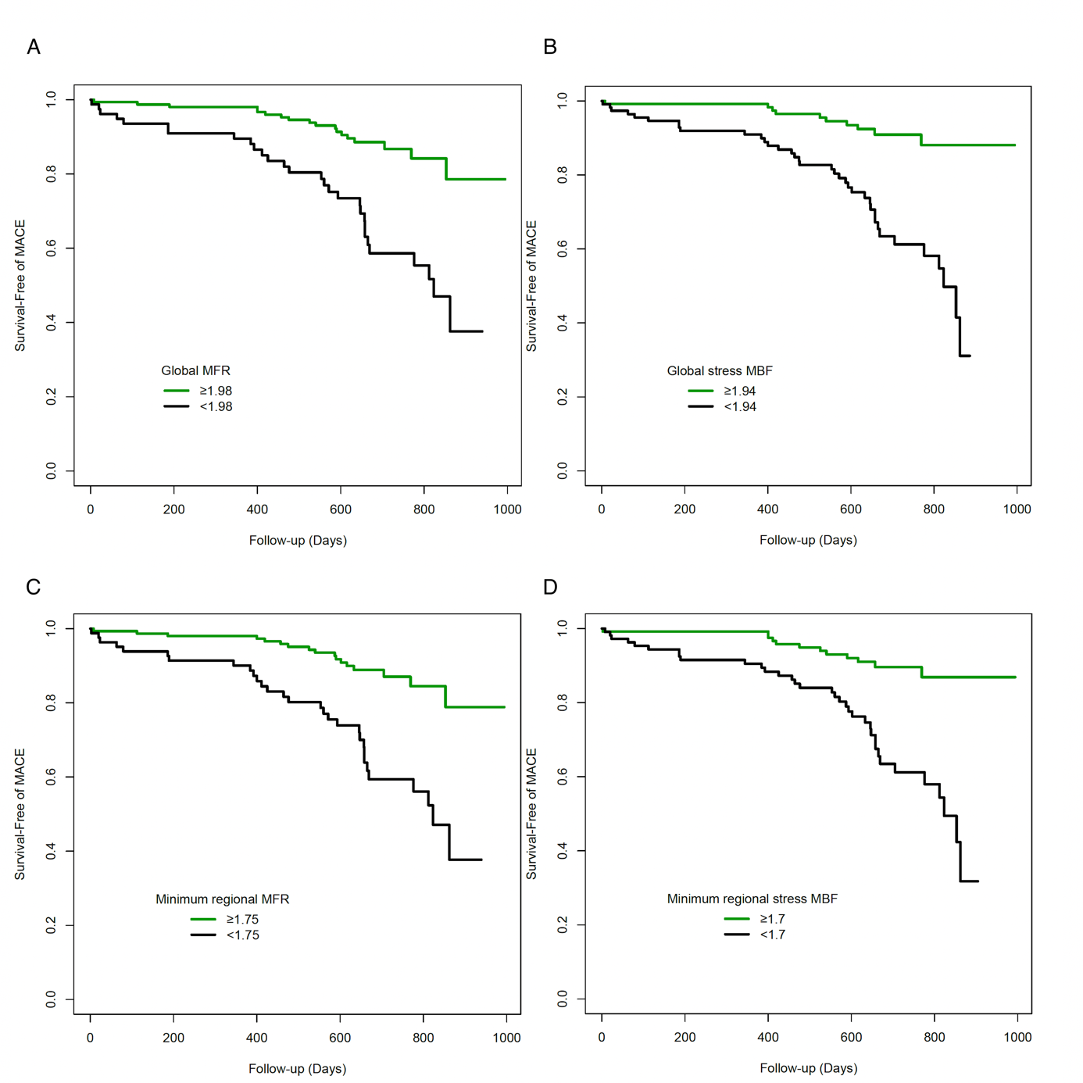

Fig. E2 MACE-free Survival Curves (n = 234) According to Global and Regional MFC radius, based on thresholds using the Youden Index. (A) Global MFC radius, (B) Minimum regional MFC radius
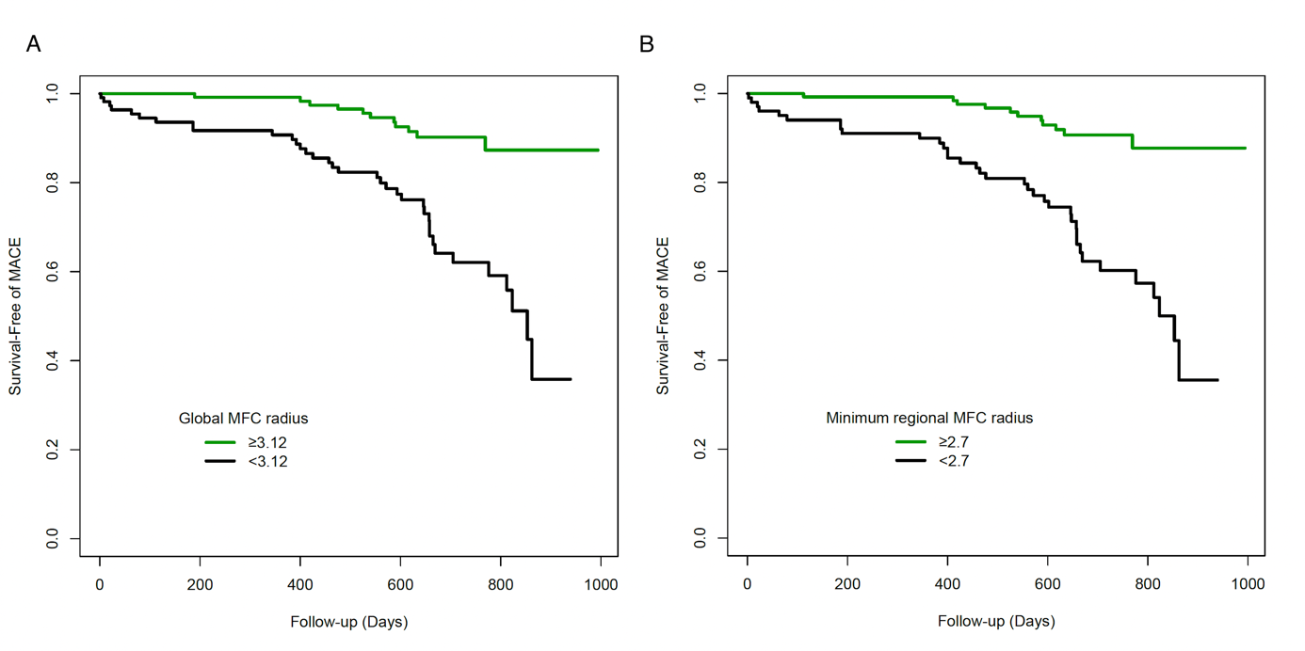

Fig. E3 Predictors of MACE on Cox Proportional Hazards Modeling models with MFR, stress MBF and MFC radius as continuous variables. Forest plots of hazard ratios derived from multivariable modeling with 95% confidence intervals for global MFR (A), global stress MBF (B), global MFC radius (C), minimum regional MFR (D), minimum regional stress MBF (E), and minimum regional MFC radius (F), along with covariates: male gender, known CAD, and history of myocardial infarction

