Supplemental Figures and tables
Supplementary Table 1: MAP subject maternal and household clinical characteristics

MAP  sample ID | Gestational Age at Birth | Gender |  |  | Ethnicity | Maternal Age |  |  | Household Smoking | Household Pet | Older Siblings | Self-Reported antibiotic Use |  | Maternal Atopy History
J7 | 32.5 | M | Hispanic |  |  |  | 36 | No |  | Dog | Yes | Yes |  | No
J8 | 31.1 | F | Hispanic |  |  |  | 28 | No |  | No | Yes | Yes |  | No
J9 | 27.4 | M | Hispanic |  |  |  | 33 | No |  | No | Yes | No |  | No
J10 | 31.3 | M | Hispanic |  |  |  | 31 | Yes |  | No | Yes | No |  | Asthma and seasonal allergies
J11 | 33.5 | M |  | Hispanic |  |  | 30 | No |  | Dog | Yes | No | No
J12 | 29.2 | M |  | Hispanic |  |  | 24 | No |  | Dog | No | No | No

Supplementary Figure 1:
Peptide alignment maps of a) Felis Catus and b) Beta-Lactoglobulin

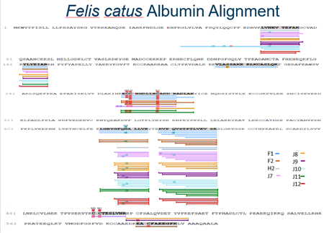
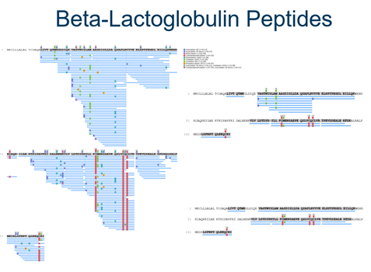

Supplemental Figure 2 Relative Quantification Bovine Caseins
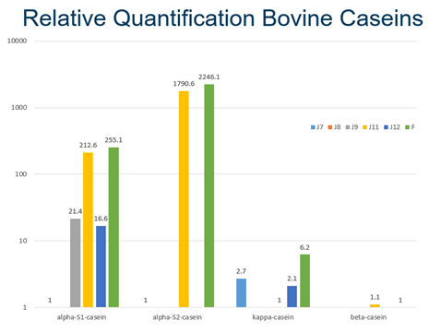
MAP samples and non-hydrolyzed fortifier were quantified for bovine caseins. J11 (fortified preterm formula) and the formula sample showed the highest expression of bovine caseins.

