**Supplementary Fig. S1**



**Supplementary Fig. S2**



**C**

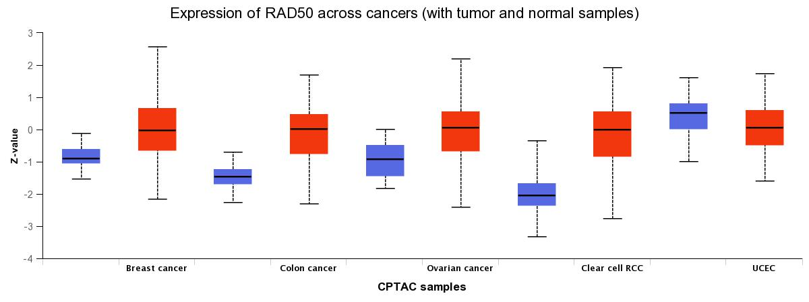

**D**



**Supplementary Fig. S3**



**Supplementary Fig. S4**



**Supplementary Fig. S5**



**Supplementary Fig. S6**

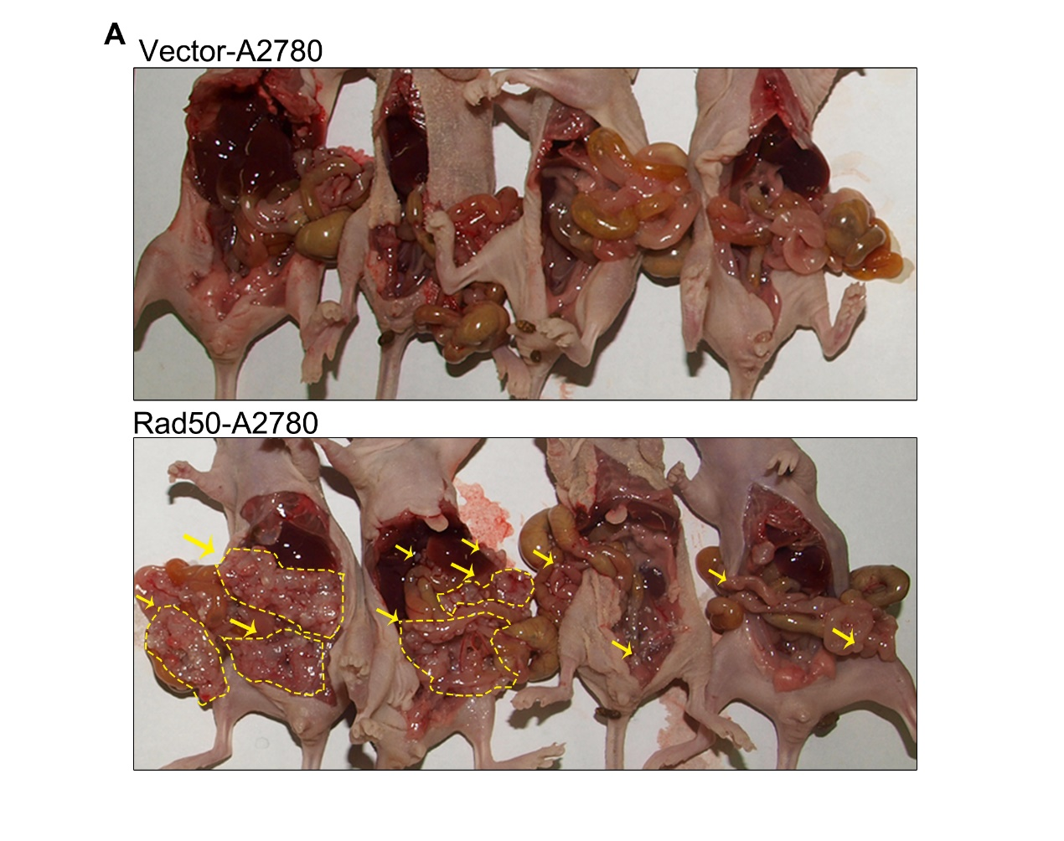

**Supplementary Fig. S7**

