Supplementary Material

Supplementary Figures
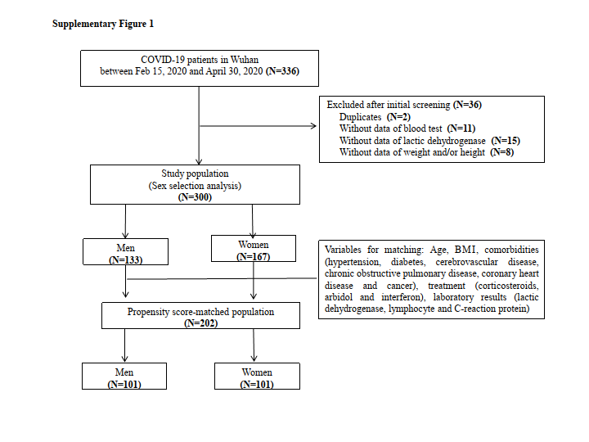Supplementary Figure 1. Flow diagram of the study. COVID-19, Coronavirus Disease 2019; BMI, body mass index.

