Supporting Information

Facile synthesis of cadmium doped graphite carbon nitride for photocatalytic degradation of tetracycline under visible light irradiation

Yin Zhao ^{a,b}, Hong Qin ^{a,b}, Ziwei Wang ^{a,b}, Han Wang ^{a,b}, Yangzhuo He ^{a,b}, Quyang Tian ^{a,b}, Qianlan Luo ^{c}, Piao Xu ^{a,b,*}

ª College of Environmental Science and Engineering, Hunan University, Lushan South Road, Yuelu District, Changsha 410082, P. R. China
^{b} Key Laboratory of Environmental Biology and Pollution Control (Hunan University), Ministry of Education, Lushan South Road, Yuelu District, Changsha 410082, P.R. China
^{c} Changsha Liuyang Eco-environmental Monitoring Station, No. 1 Fuxing Middle Road in Liuyang, Changsha, P. R. China

*Corresponding Author at: College of Environmental Science and Engineering, Hunan University, Changsha 410082, PR China; E-mail addresses: piaoxu@hnu.edu.cn (P. Xu).
Table S1 Cadmium chloride contents in carbon nitride material samples.
Samples | CdCl₂（wt. %）
g-C₃N₄ | 0.00
5-Cd-g-C₃N₄ | 0.05
10-Cd-g-C₃N₄ | 0.10
15-Cd-g-C₃N₄ | 0.15

Table S2 The proportion of each element in the 10-Cd-g-C₃N₄ material.
Elements | Weight ratio% | Atomic percentage
C K | 25.73 | 32.09
N K | 61.98 | 66.28
Cd L | 12.28 | 1.64
Table S2 illustrated the elements weight ratio of 10-Cd-g-C₃N₄ sample, where elements C was 25.73%, N was 61.98% and Cd was 12.28%. The atomic concentrations of Cd in the 10-Cd-g-C₃N₄ sample are 1.64%, which confirmed the cadmium doped in the g-C₃N₄ with a slight atomic ratio.

Table S3 Surface area, pore volume and pore size parameters for pure g-C₃N₄ and 10-Cd-g-C₃N₄.
Samples | Surface area¹ (m² /g) | Pore volume² (cm³ /g) | Pore size³ (nm)
g-C₃N₄ | 13.467 | 0.077 | 22.131
10-Cd-g-C₃N₄ | 16.460 | 0.123 | 25.917

Table S4 The comparison with other similar types research of this work.
Samples | Experimental conditions | Degradation rate | Reference
Bi-g-C₃N₄ | [TC]₀ =20 mg/L  [Catalyst]₀=0.2 g/L  300 W Xe lamp | 94.1% in 50 min | (Wang et al. 2019)
K-g-C₃N₄ | [TC]₀ =20 mg/L  [Catalyst]₀=1.0 g/L  300 W Xe lamp | 85.1% in 1 h | (Wang et al. 2018)
P-g-C₃N₄ | [TC]₀ =20 mg/L  [Catalyst]₀=0.5 g/L  300 W Xe lamp | 93.7% in 120 min | (Zhang et al. 2020)
Pt²⁺-g-C₃N₄ | [RhB]₀ =4 mg/L  [Catalyst]₀=1 g/L  white LED (4.6 V, 2 A) | 90% in 120 min | (Chen et al. 2021)
NiO/Cd/g-C₃N₄ | [MB]₀=3*10⁻⁵ mol/L  [Catalyst]₀=1.0 g/L  50 W LED lamp | 81.8% in 90 min | (Karimi et al. 2020)
g-C₃N₄/Cd-ZnO | [MB]₀ =10 mg/L  [Catalyst]₀=0.5 g/L | 95% in 120 min | (Sher et al. 2021)
Cd-g-C₃N₄ | [TC]₀ =10 mg/L  [Catalyst]₀=0.8 g/L  300 W Xe lamp | 98.1% in 60 min | This work

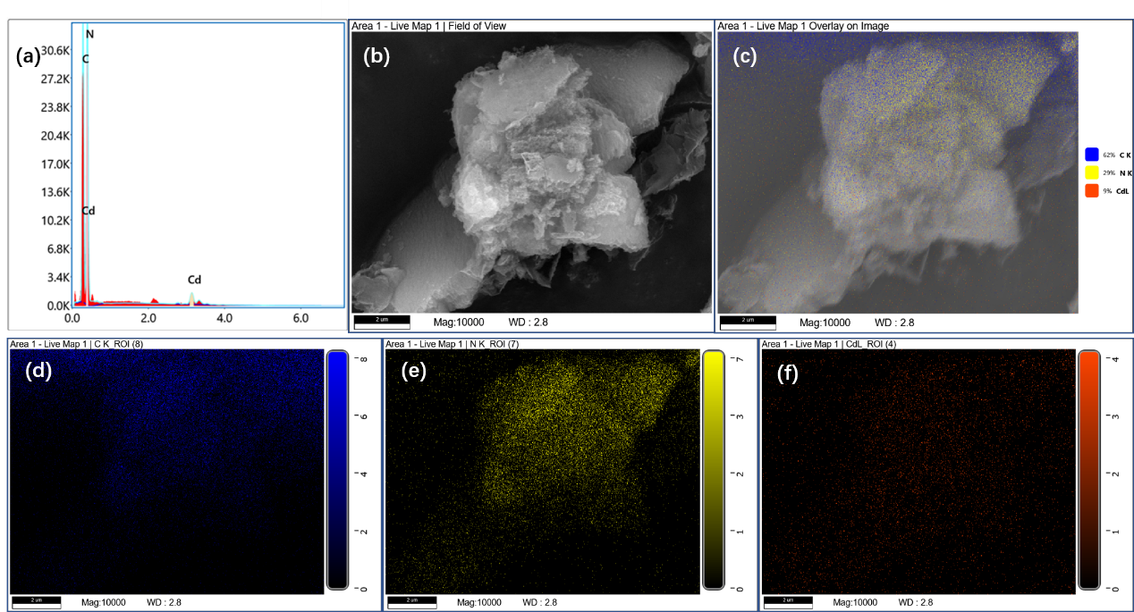
Fig. S1 (a) EDS spectrum of 10-Cd-g-C₃N₄. (b-f) Elemental mapping of 10-Cd-g-C₃N₄.

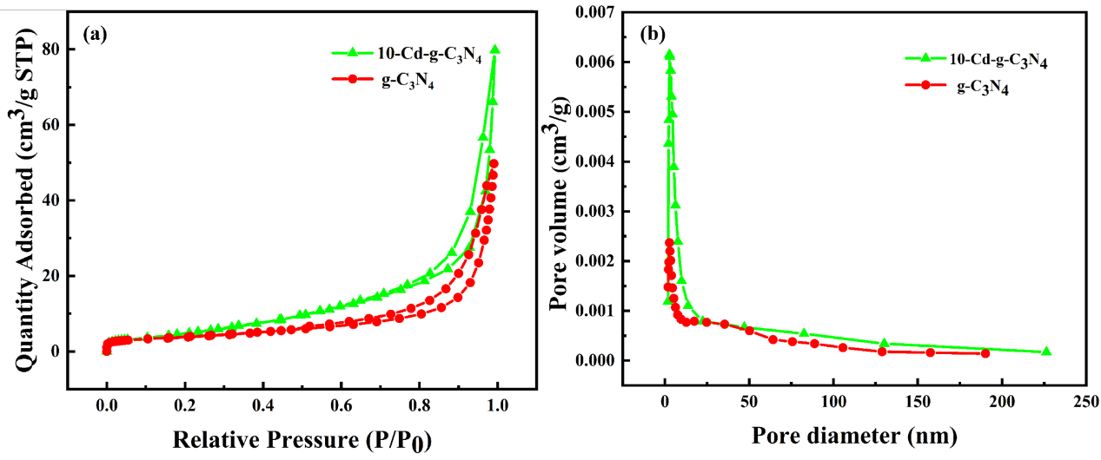
Fig. S2 (a) N₂ adsorption−desorption isotherms of pure g-C₃N₄ and 10-Cd-g-C₃N₄. (b) The pore size distributions image of pure g-C₃N₄ and 10-Cd-g-C₃N₄.

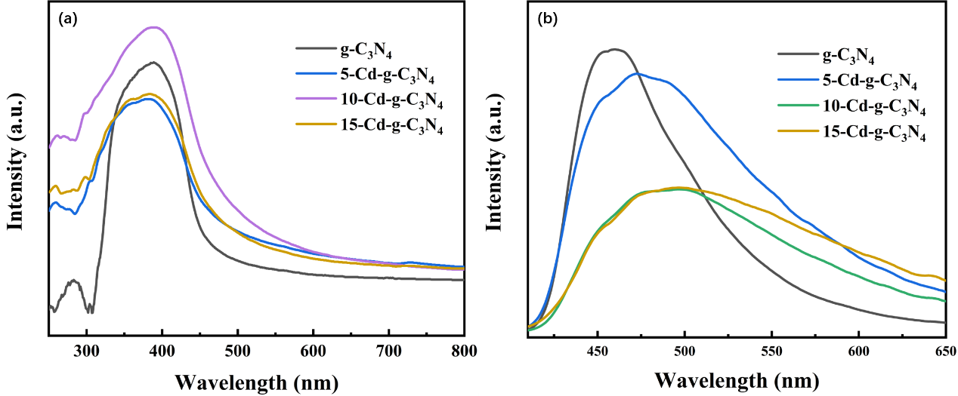
Fig. S3 (a) The UV–vis diffuse reflectance spectra of pure g-C₃N₄ and Cd-g-C₃N₄. (b) The PL spectra of pure g-C₃N₄ and Cd-g-C₃N₄.

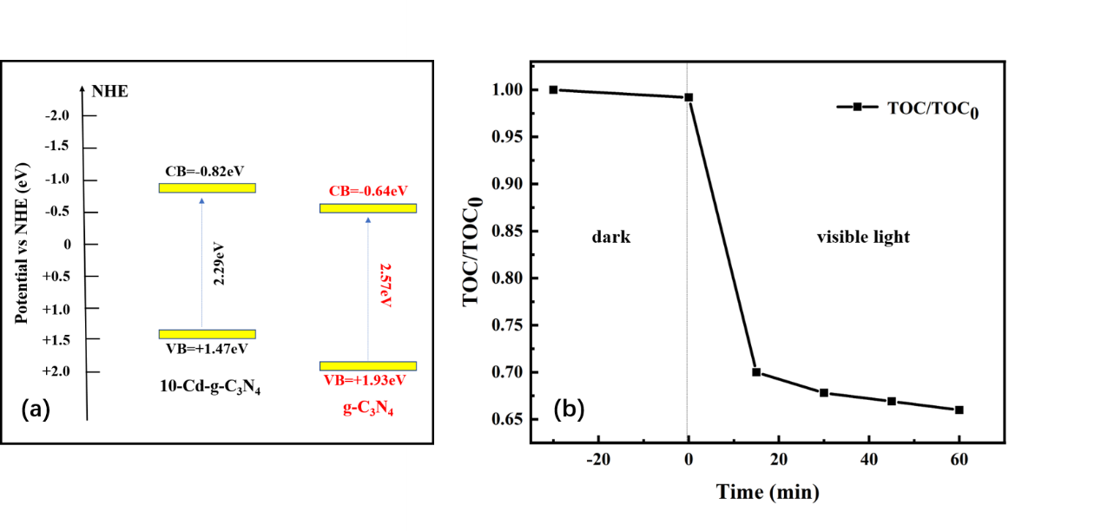
Fig. S4 (a) Band structure diagram of pristine g-C₃N₄ and 10-Cd-g-C₃N₄. (b) TOC removal curves of TC on 10-Cd-g-C₃N₄.

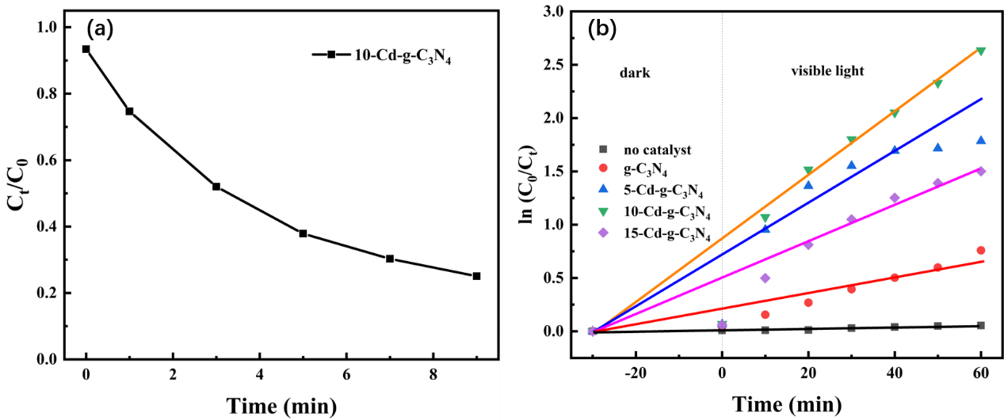
Fig. S5 (a) The photocatalytic degradation of 10-Cd-g-C₃N₄ catalyst within 10 min. (b) First-order plots of photocatalytic degradation with different amounts cadmium catalysts.

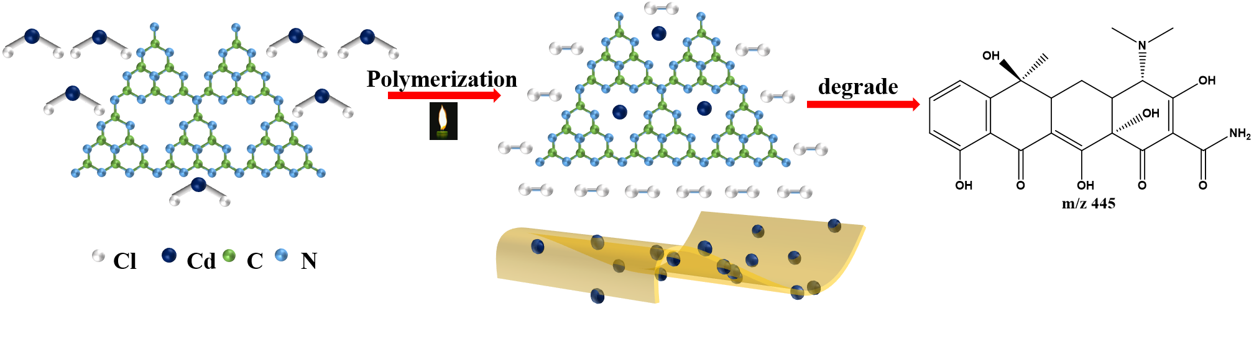
Scheme S1 The brief diagram of 10-Cd-g-C₃N₄ prepared process.

Reference:
Chen Q, Wan B, Zhu P, Xu S, Huang Y (2021) The synergy of adsorption and photosensitization of platinum-doped graphitic carbon nitride for improved removal of rhodamine B. Environmental Science and Pollution Research. DOI: 10.1007/s11356-021-15340-0
Li Z, Liu Z, Li B, Li D, Ge C, Fang Y (2016) Novel CdS nanorods/g-C₃N₄ nanosheets 1-D/2-D hybrid architectures: an in situ growth route and excellent visible light photoelectrochemical performances. Journal of Materials Science: Materials in Electronics 27: 2904-2913. DOI：10.1007/s10854-015-4108-7
Karimi MA, Atashkadi M, Ranjbar M, Habibi-Yangjeh A (2020) Novel visible-light-driven photocatalyst of NiO/Cd/g-C₃N₄ for enhanced degradation of methylene blue. Arabian Journal of Chemistry 13: 5810-5820. DOI: 10.1016/j.arabjc.2020.04.018
Sher M, Javed M, Shahid S, Iqbal S, Qamar MA, Bahadur A, Qayyum MA (2021) The controlled synthesis of g-C₃N₄/Cd-doped ZnO nanocomposites as potential photocatalysts for the disinfection and degradation of organic pollutants under visible light irradiation. RSC Advances 11: 2025-2039. DOI: 10.1039/d0ra08573a
Wang M, Jin C, Li Z, You M, Zhang Y, Zhu T (2019) The effects of bismuth (III) doping and ultrathin nanosheets construction on the photocatalytic performance of graphitic carbon nitride for antibiotic degradation. Journal of Colloid and Interface Science 533: 513-525. DOI：10.1016/j.jcis.2018.08.113
Wang W, Xu P, Chen M, Zeng G, Zhang C, Zhou C, Yang Y, Huang D, Lai C, Cheng M, Hu L, Xiong W, Guo H, Zhou M (2018) Alkali Metal-Assisted Synthesis of Graphite Carbon Nitride with Tunable Band-Gap for Enhanced Visible-Light-Driven Photocatalytic Performance. ACS Sustainable Chemistry & Engineering 6: 15503-15516. DOI：10.1021/acssuschemeng.8b03965
Zhang Y, Zhang M, Tang L, Wang J, Zhu Y, Feng C, Deng Y, He W, Hu Y (2020) Platinum like cocatalysts tungsten carbide loaded hollow tubular g-C₃N₄ achieving effective space separation of carriers to degrade antibiotics. Chemical Engineering Journal 391: 123487. DOI：10.1016/j.cej.2019.123487

